|  |  |
| --- | --- |
| Artist | Gibson |
| Title | Tinted Venus |
| Date | 1851-56 |
| Medium | White Marble Sculpture |
| Scale |  |
| Scope | Female figure in sculpture |
| Style | Neo-Classical (Academic) |
| Patron | No commission |

|  |  |
| --- | --- |
| Formal features | |
| Composition | * Venus, goddess of love, stands nude and contrapposto holding a golden apple awarded to her by Paris * Symmetrical + refined facial features * Vertical * Negative space in-between arms and legs |
| Colour or texture | * White varnish applied onto the white marble + tinted pink to provide flesh tones. * Hair, eyes lips are coloured realistically * Gold appears on patterns of the robe, jewellery and apple * The colouring of the statue removed the appearance of purity which was associated with white marble * Polychrome (multiple colours) |
| Light & tone | * Polished form to make her shine more |
| Relief | * Rough, unpolished base contrasts with her polished form |
| Line or brushwork |  |

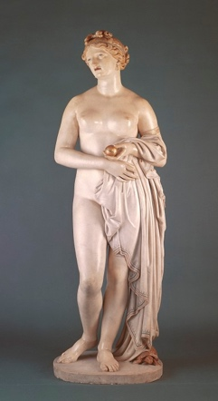

Critical text quote:

Barrett Browning had “Seldom seen so indecent a statue”

Influence from cultural/social factors:

During this time, research showed that Classical sculptors would apply colour to their work to give a sense of realism.

Gibson does the same with this figure which was seen as radical at the time as the general public had come to accept Classical sculptures as pure white marble

The figure is otherwise depicted in an idealised and academic manner

Use or development of materials, techniques & processes:

Stylistic comment and artistic influence: