*Unit 21.2 P3*

For this unit I am going to produce a written proposal to present to the client for the brief that I have chosen which is the Christmas party for 200 employees in a budget of £5000. This proposal will have many different aspects involved in it and the costs will be continuously calculated to ensure that it all remains in budget.

*Concept File*

1. *Range of ideas and themes*

The theme of this event will be a traditional Christmas theme. This is appropriate because of the time of year and it’s a humble thing to do to get people into the Christmas feel.

The dress code will be Christmassy, so most people will either dress up as different Christmas characters or have subtle tinsel etc. Decorations will also be Christmassy and this will include Christmas trees, banners, snowflakes etc. This will give the venue a Christmas theme. The food will consist of Christmas themed snacks like reindeer cookies and Santa cupcakes but there will also be a main roast dinner which will be made by hired caterers.

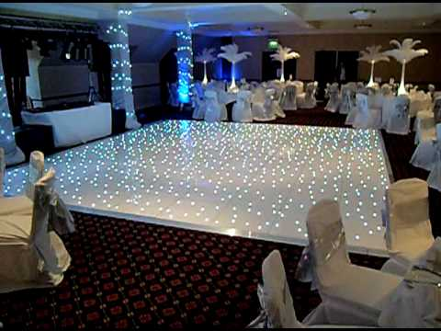The entertainment will be a DJ and a dance floor. The music will all be Christmassy with a slight club vibe intertwined in it. The dance floor will be white LED lighting because white is associated with snow and so it fits in with the Christmas feel.

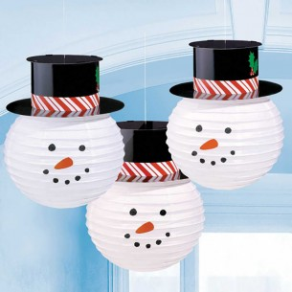

1. *Suitable event venues*

The type of venue I’m thinking of using for this event is the company’s function room as it’ll be easy access for the guests coming as they are all employees of this company and it won’t cost any extra so it’ll mean more can be spent on decorations etc.

1. *Venue appearance*

The venue will be decorated with hanging snowmen and flakes from the ceiling, LED lights, Christmas trees etc. This links to the theme because it all intertwines with the Christmas vibe. The colours scheme of all the decorations will be red, green and white as these are all seasonal colours for the theme. There will be an area where table, the DJ and dancefloor, and the food. The tables will all have linen on them and there will be Christmassy decorations on the tables with Christmas crackers and candles. These ideas are appropriate for the client’s even because it all links with the desired theme.

1. *Sourcing suitable materials, suppliers and contractors:*

For the event that we are planning, we will use suppliers for catering and the DJ. We will supply the decorations and props via online purchases.

**DECORATIONS:**

The decorations I have chosen to provide for this event include:

Giant hanging snowflakes - I wish to order 200 of these to fill up the area on the ceiling and create a Christmas theme with extravagant décor and designs. These 200 giant snowflakes will cost £500.

Christmas trees – to really make this a Christmas party, there must be as much Christmas feel as possible and by achieve thing this I bringing in some traditional trees will be a success. The idea was to have 4 large, lit up Christmas trees in each corner of the room. This’ll cost £219

Hanging snowmen lanterns – to make a moody, Christmassy lighting, I thought that having some lit up, hanging snowmen would achieve this. 120 of them costs £240

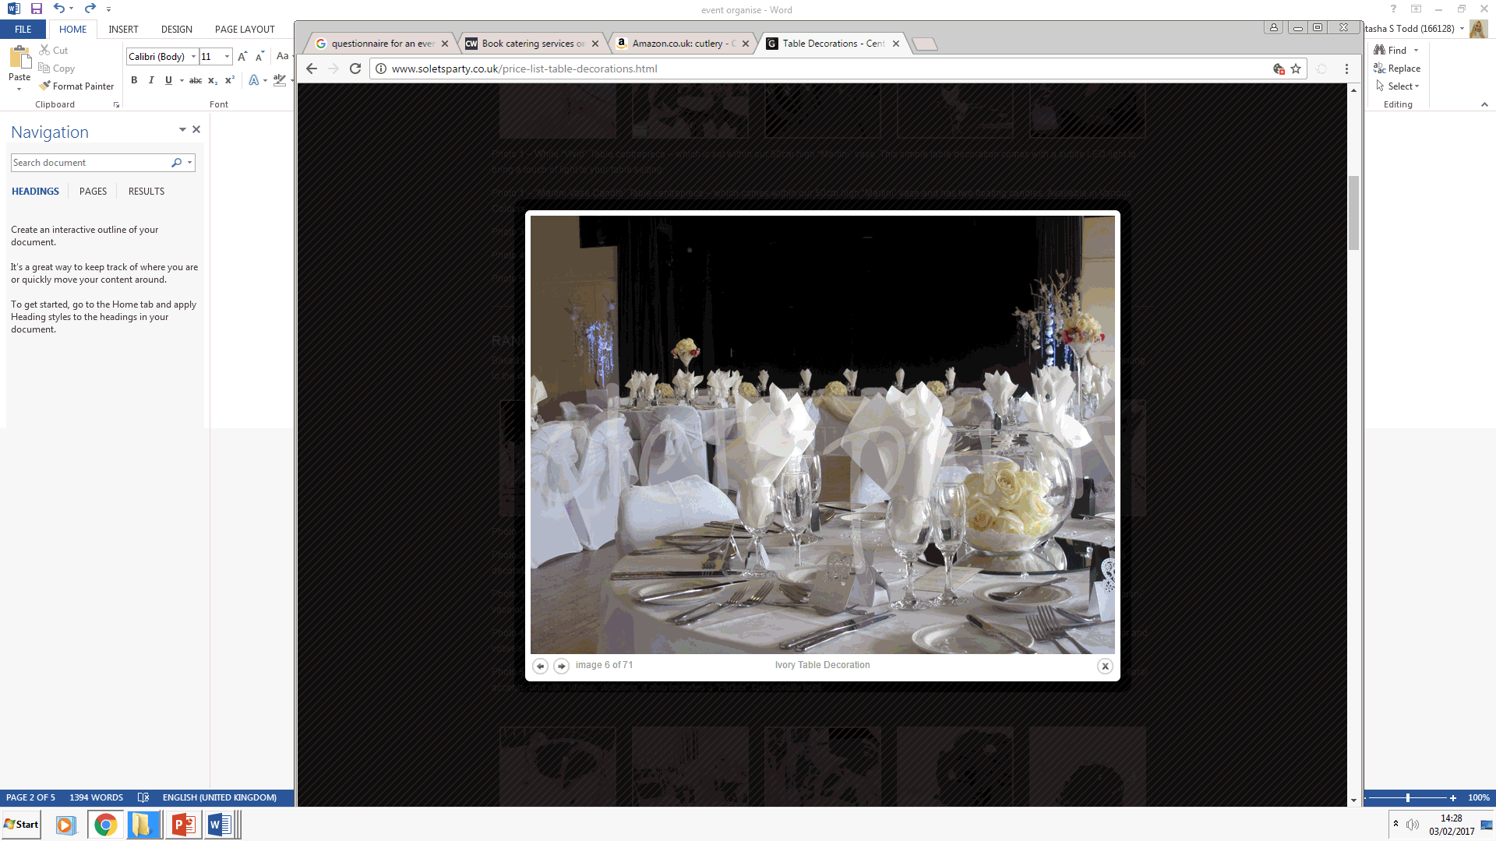Blanket of snow – I have thought of having a section in the room of which will have false snow and light up glowing reindeer and Santa Claus to create a Christmas scene. This blanket of snow will cost £66

Light up reindeer & life size Santa – These will be put upon the false snow and will be lit up. It’ll cost £236 for 6. The life size Santa moves and sings. It costs £135.

Table decorations - “Ivory Topiary” Low Table centrepiece – with our “Better-than-Real” floral detailing set within a “Bubble” Vase placement. It’ll cost £412.

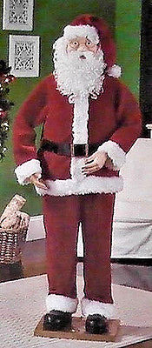**FURNITURE:**

Tables – Round 9-seater tables will be provided and will cost £200 for 25.

Round table linen- this will be white linen which’ll be placed on each table for a more sophisticated look. It’ll cost £175 for 25.

Chairs – The chairs will be white with a curved back. They are very elegant and give off a ‘white Christmas’ feel. They cost £1160 for 200.

Table cutlery - £56 for 200 sets.

Plates - £30 for 200 plates.

**FOOD AND DRINK:**

Basic snacks will be bought by me however there will be a catering service for a buffet which’ll serve Christmas-styled buffet food for all guests. A bar will also be hired meaning that people can have drinks.

The bar is Alex Crimson Bar hires and will cost a total of £4200 but will include unlimited free drinks and cocktails to all guests and full service.

The catering service is Caterwings and it will cost £1000 with £5 a head.

**ENTERTAINMENT:**

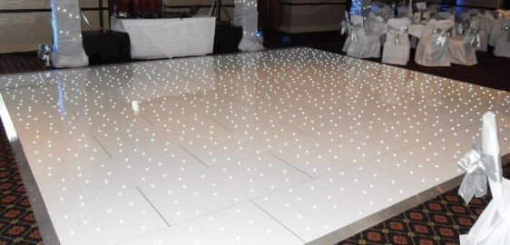The DJ, photo booth and LED lighting – The DJ will be playing Christmas music and dressed to fit the theme. There will be a photo booth for people to be able to take photos and props will be provided. LED lighting is also included in the package which altogether costs £699.

Dance Floor – There will also be a white, light up LED dance floor by the DJ for people to dance on. The dance floor will cost £500

1. *Identifying Marketing Strategies*

Emails will be given out to guests under their company email so they know exactly where the event will be held, at what time and who is attending. This is useful because it doesn’t cost anything and is still confidential and formal. The email may have some Christmas animations to jazz it up and give the guests an exact idea of the theme. Information presented will include:

* Time and date of event
* What to wear (Christmas-styled outfits)
* How long the event will be
* What entertainment and food will be provided
* Location of the event (company function room)

1. *Health and Safety*

All staff there will have a health and safety course in order to make sure that all guests are safe and are aware of what to do if an issue occurs which could risk their safety. The risks that may exist include:

* Site hazards and control measures – All staff onsite will be informed of all the possible hazards and dangers that may come up during the event. There will be certain procedures shown and practiced by staff so they know how to treat a cause for danger.
* Buried services such as electric cables – A fire exit will be visible in the building for guests to safely exit out of.
* First aid, toilets and wash facilities – In case of any accidents there will be a first aid kit on site to treat people. There will also be facilities such as toilets in the premises and because of it being in their function room of their company, they will most likely know where the toilets and facilities are which means faster action.
* Emergency arrangements – the emergency services are only a call away if something horrendous was to happen.

The basics for these procedures that are needed to be known will be taught and all exits will be shown to all contractors and guests. All contractors will have had health and safety training within their contract to ensure that all events they do are carried out in a safe environment and so they are aware of possible dangers.

1. *Third parties*

Because this event is a Christmas party with 200 guests, a third party is not needed as everything that is needed for the event is done via contractors etc. As this event is small, it won’t need any more company intertwined with it. The only legal requirements needed is for the owner of the company to agree to hold this event in their company building.

1. *Feedback*

Feedback is important for any organisation planning a client’s event because it lets the organisation know what they did well and what they need to improve so their organisation can strive and they can improve their strategies in future events that they plan. They can receive feedback by:

* Visual feedback (seeing visible emotion from guests during event)
* Questionnaires (Get the client or guests to do a questionnaire to see what they enjoyed/didn’t enjoy about the event)
* Through social media – open a Facebook page on the event and have a rating scale so people who went to the event can rate what they thought of the event.

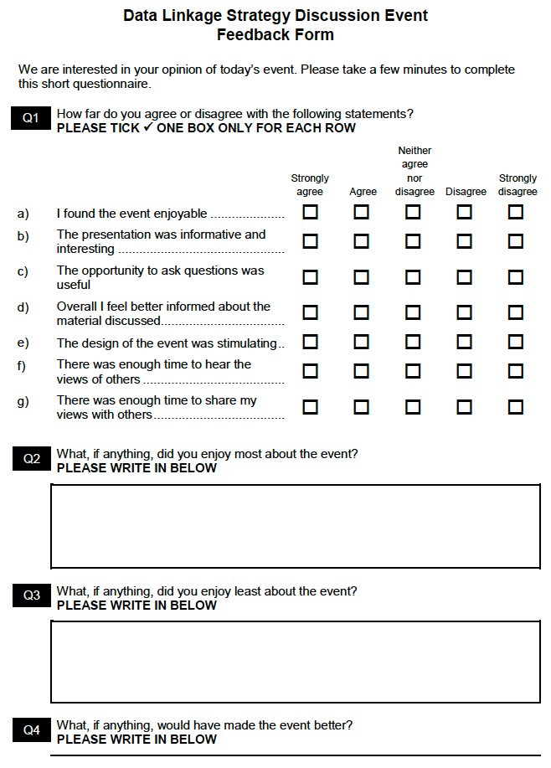



1. *Cashflow*

|  |  |
| --- | --- |
|  | Costs |
| Venue | FREE |
| Decorations | £1,808 |
| Catering | £5200 |
| Equipment | £1160 |
| Entertainment | £1199 |
| Marketing | £0 |
| **Total** | £ |

UNIT 2.1 part 2: Second Proposal

For the second part of this unit I am going to produce another proposal with the same event but with different aspects involved. For the last proposal, I did a basic, traditional Christmas themed party within a budget of £9,500. For this proposal, I am going to continue with the Christmas theme but add a Narnia theme within it. This means that the decorations, dress code and other parts that tie in within the event will all be unique and will differ to the previous proposal.

1. *Range of ideas and themes*

I think doing a Narnia theme within the Christmas theme is a good idea as it adds uniqueness to the idea of Christmas and adds a bit of extravagancy to the event. It also makes sure that the event held is unforgettable.

Because the theme is also Narnia as well as traditional Christmas I think that it would be a good idea for guests to choose whether to dress as Narnia characters or Christmassy as this will put less stress on them to have to buy a costume for Narnia or Christmas so they have a variety of different outfits to choose. The decorations provided will also be Christmassy such as giant hanging snowflakes, false snow area, etc. But there will also be Narnia decorations such as a lamppost with snow around it replicating the first-time Naira is founded. The food will be Christmas snacks with canapes and there will be a bar with unlimited drinks.

The entertainment will include a dance floor and photo booth. This is useful because it means that people can dance, sit down and chat, join friends in the photo booth to remember the night. The dance floor also has white LED lights around it to create that Christmassy feel.

*2. Suitable event venue*

Because the guests are colleges working in the same company building, this means that if the owner of the company agrees, they can hold the Christmas party in one of their function rooms within the building which means that the price for the venue will not cost anything and all that’s needed for this type of event in a large room so using a function room would be perfect.

The guests will also probably already know where all the toilet facilities and fire exits are which is useful.

*3. Venue appearance*

The venue itself will be decorated with many Christmas and Narnia themed décor. These decorations will all link with the theme so that a Christmas vibe is given off throughout the day. One side of the venue will have tables, chairs and canapes will be served around this area. The other side of the room will have the bar, photo booth and false snow with a lamppost to tie in with the Narnia theme. The middle of the room will include the DJ and dance floor. There will be LED lights surrounding the areas and the tables will have tealights on to give a calm, moody feel. The tables will all have linen on and all will have fancy decorations to make the event formal.

Round table linen- this will be white linen which’ll be placed on each table for a more sophisticated look. It’ll cost £175 for 25.

Table decorations - “Ivory Topiary” Low Table centrepiece – with our “Better-than-Real” floral detailing set within a “Bubble” Vase placement. It’ll cost £412.

Giant hanging snowflakes - I wish to order 200 of these to fill up the area on the ceiling and create a Christmas theme with extravagant décor and designs. These 200 giant snowflakes will cost £500.

**Christmas trees – to really make this a Christmas party, there must be as much Christmas feel as possible and by achieve thing this I bringing in some traditional trees will be a success. The idea was to have 4 large, lit up Christmas trees in each corner of the room. This’ll cost £219

Fake snow machine – to create real-looking snow for guests to enjoy and it’ll give off a very Christmassy vibe as snow is a very important theme within Christmas. £220 for 2.

Large Narnia lamppost – To create the recognisable scene in Narnia, the lamppost and snow machines will give this effect and link in with the Narnia theme. - £79

*4. Sourcing suitable materials, suppliers and contractors*

The decorations and props such as the giant snowflakes will be bought online and props such as the large lamppost will also be bought online. Other services such as catering is to be hired out by Caterwings and will provide canapes for all guests throughout the day.

The furniture is also being hired online and will include round tables that fit 9 people on each.

Tables – Round 9-seater tables will be provided and will cost £200 for 25

Chairs – The chairs will be white with a curved back. They are very elegant and give off a ‘white Christmas’ feel. They cost £1160 for 200.

Table cutlery - £56 for 200 sets.

Plates - £30 for 200 plates

Another contractor includes the bar service of which I wish to hire as it’ll cost £4200 however they provide free unlimited drinks and cocktails and provide the bar and glasses as well. This will be useful as it means that guests won’t have to pay for their drinks and also, they can have as many as they wish to have to create a relaxed day for them. The DJ, and phot booth is also in a package of £699.

The LED dancefloor is also being hired and will cost a total of £500.

The catering service Caterwings costs £5 a head, and £1000.

5*. Identifying Marketing Strategies*

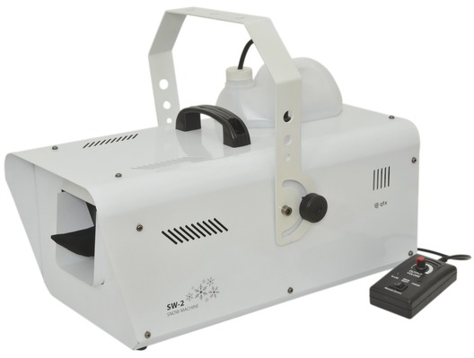Because all guests going are all colleges, it would be easier to drop an email invitation to all as they will then be aware of who is going and the type of environment that it’ll be. This also means that more of the budget can be spent on more important things such as decorations etc. The email will include:

* Time and date of event
* What to wear (Christmas-styled outfits)
* How long the event will be
* What entertainment and food will be provided.
* Location of the event (company function room)

*6. Health and Safety*

All staff there will have a health and safety course in order to make sure that all guests are safe and are aware of what to do if an issue occurs which could risk their safety. The risks that may exist include:

* Site hazards and control measures – All staff onsite will be informed of all the possible hazards and dangers that may come up during the event. There will be certain procedures shown and practiced by staff so they know how to treat a cause for danger.
* Buried services such as electric cables – A fire exit will be visible in the building for guests to safely exit out of.
* First aid, toilets and wash facilities – In case of any accidents there will be a first aid kit on site to treat people. There will also be facilities such as toilets in the premises and because of it being in their function room of their company, they will most likely know where the toilets and facilities are which means faster action.
* Emergency arrangements – the emergency services are only a call away if something horrendous was to happen.

The basics for these procedures that are needed to be known will be taught and all exits will be shown to all contractors and guests. All contractors will have had training in this department for other events that they also all cater for.

1. *Third parties*

Because this event is a Christmas party with 200 guests, a third party is not needed as everything that is needed for the event is done via contractors etc. As this event is small, it won’t need any more company intertwined with it. The only legal requirements needed is for the owner of the company to agree to hold this event in their company building.

1. *Feedback*

Feedback is important for any organisation planning a client’s event because it lets the organisation know what they did well and what they need to improve so their organisation can strive and they can improve their strategies in future events that they plan. They can receive feedback by:

* Visual feedback (seeing visible emotion from guests during event)
* Questionnaires (Get the client or guests to do a questionnaire to see what they enjoyed/didn’t enjoy about the event)
* Through social media – open a Facebook page on the event and have a rating scale so people who went to the event can rate what they thought of the event.



1. *Cashflow*

|  |  |
| --- | --- |
|  |  |
| Venue | £0 |
| Decorations | £1605 |
| Catering | £1000 |
| Equipment | £5646 |
| Entertainment | £1199 |
| Marketing | £0 |
| Total | £9450 |