Two written proposals for my event
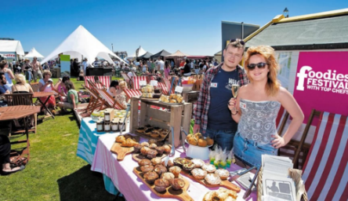
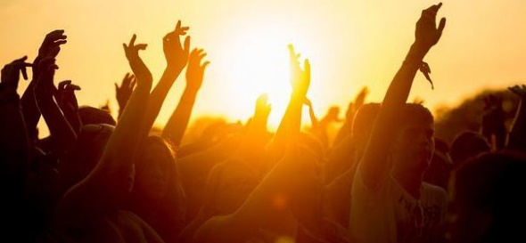
For this section of work I have to prepare two drafts of written proposals which I have to show to the client for the brief that I have chosen. For each proposal I will be selecting ideas for different parts of the event, which will add up to make a picture of what the event will look like. I will be presenting my ideas in the form of concept file, this is using imagery to present the details of each proposal.
Proposal 1
Range of ideas and themes
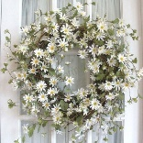
For proposal 1 I am going to be creating a festival theme. I think this is appropriate for the event as if it in summer and everyone’s happy, music’s playing, and everyone is more likely to have a good time. In the view of the clients they want something that will promote their food, and this theme will help get their food well-known. The theme will be made clear as the event will have some happy summery music which will help create the theme. There will be décor that symbolise festivals, however this festivals main focus is the food, so it will have many seating areas available.
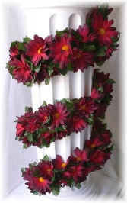
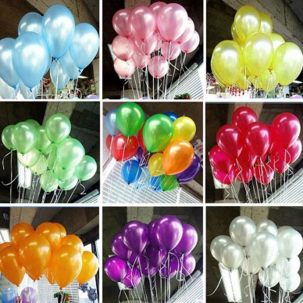
For the dress code, the employees on the stalls will be wearing their logos or they are able to wear attire from the culture of the food they are serving. However the dress code for the customers is simple, they can wear what they want, as it will be held in a public space. If people come to have a look then they will not stand out, this will attract more people to come. For decoration there will be festival décor, things like flowers, flags, things to make the location feel festive.

The food given at this festival is purely by the stalls, the producers and suppliers in the local area. This will help them promote themselves and entice potential customers, which is the aim of the festival. The entertainment that the festival will provide is lively, chilled music and good food. They will do this by having a DJ. that plays summery, happy music so people are able to have a good time.
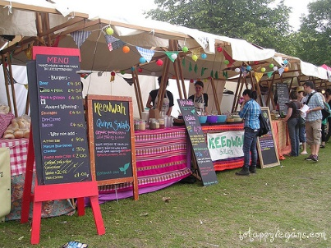
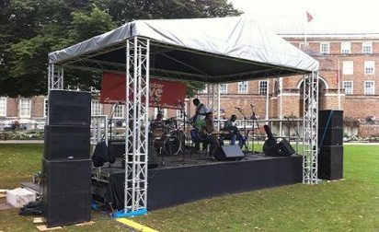
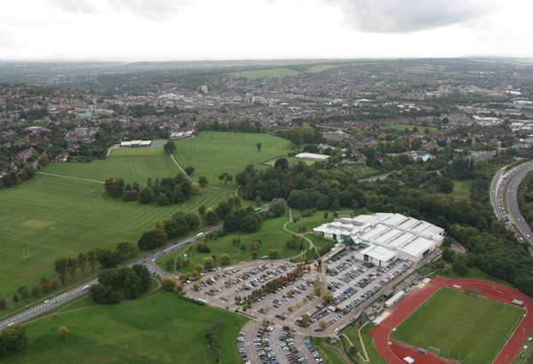
Suitable event venues
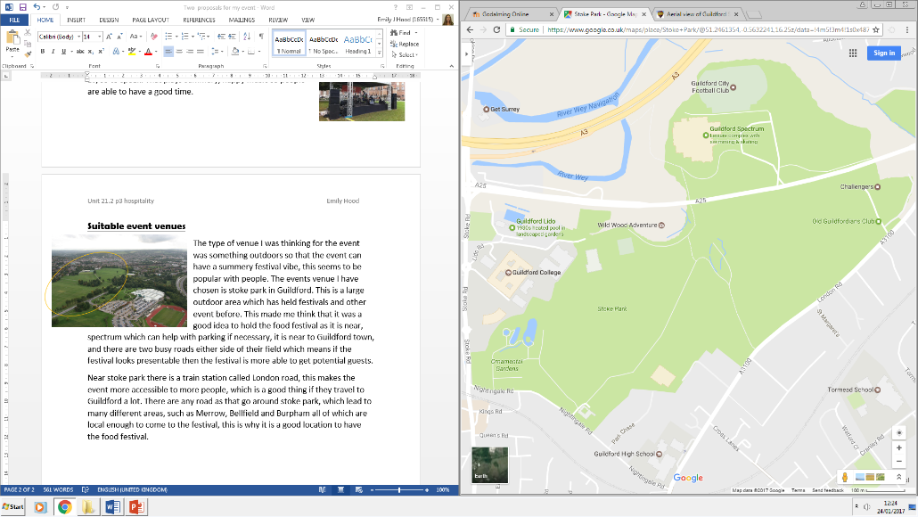
The type of venue I was thinking for the event was something outdoors so that the event can have a summery festival vibe, this seems to be popular with people. The events venue I have chosen is Stoke Park in Guildford. This is a large outdoor area which has held festivals and other event before. This made me think that it was a good idea to hold the Food Festival as it is near, Spectrum which can help with parking if necessary. It is near to Guildford town and there are two busy roads either side of the field which means if the festival looks presentable and appealing, then the festival is more likely to attract passing trade and get potential guests. This venue is good for our event as there is a lot of access to this park, from many places and because it is so central the park will be able to attract guests that are passing by.
The land shaded in green is stoke park.
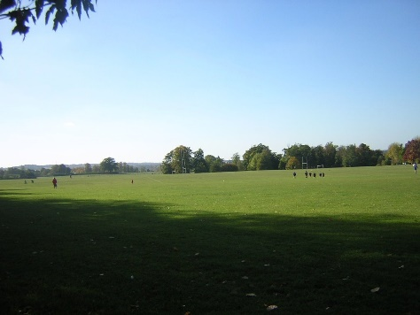
Near Stoke Park there is a train station called London Road Station, this makes the event more accessible to more people, which is a good thing if they travel to Guildford a lot. There are many roads that go around Stoke Park, which lead to many different areas, such as Merrow, Bellfield and Burpham, the residents of which are local enough to come to the Festival, this is why it is a good location to have the Food Festival. Because Stoke Park is pubic land the owners are Guildford Borough Council this mean that they have to approve of the event. To hire the park there are steps of the website. https://www.guildford.gov.uk/hirepublicparks
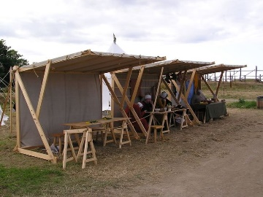
Venue appearance
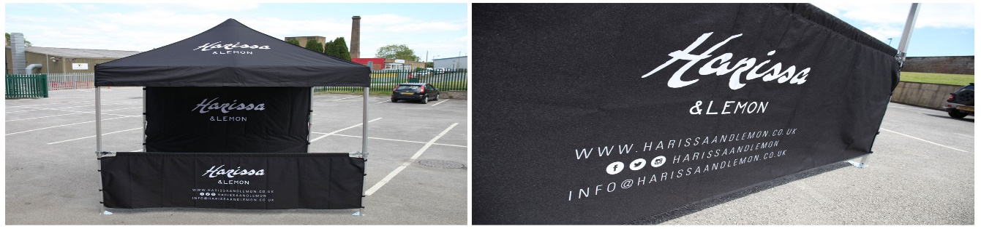
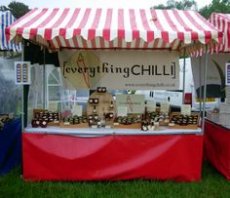
Stoke Park is a massive field, this means that there is plenty of space to work out what the client wants the event to look like. Whether it is stalls along the outside or if the stalls are in rows or if the stalls are in a circular space, there is so much land to play with, so the event can be exactly what the client wants. The way that the venue will be decorated will be rows which go into a square shape, this is because it makes it easier for people if they are walking up and down, also makes the stalls more easy to see. However there will be seating areas so that when they have got food and want to sit down there are many seating options. The following diagram is an example of how it could look.

Key
Stalls
Seating

Stage

F

Or the stalls could be in a circular shape.

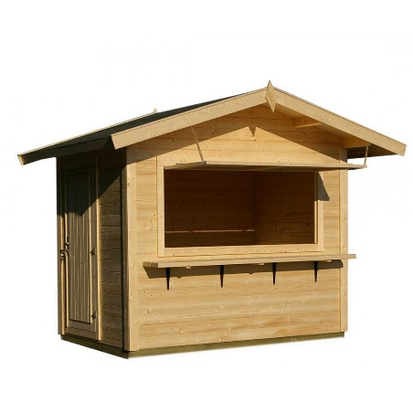
This links to my theme as they are able to enjoy the festival more if the structure is like this. If there is a lot of seating and a stage, then they are able to get the full experience. The venue’s appearance will be colourful and inviting and it will have a lot of space. All of which will help the visitors get in a happy mood and will help them to enjoy the event.
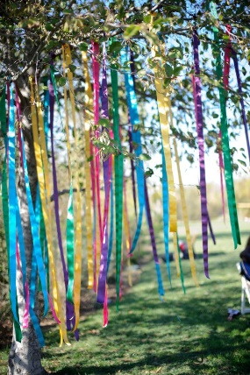
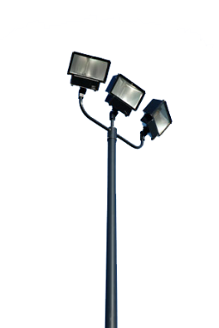

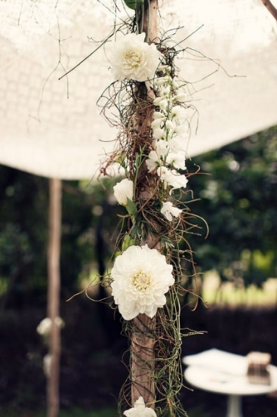
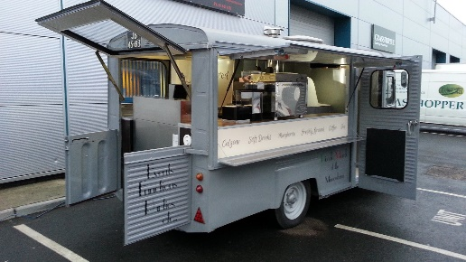
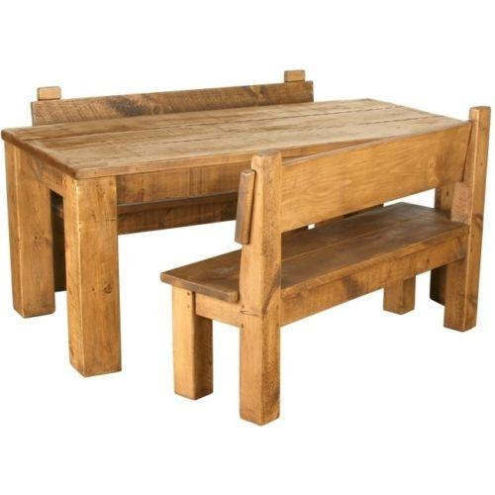
There are two main areas of the event, one being the stalls and the seating and the other being the stage. These two areas need, examples above, to help give the festival feel to the event. Both areas are able to sit and enjoy their time at the event enjoying the entertainment provided. All of the colours at the festival are going to be happy light colours, things like yellow, orange, green, pink, etc. The decorations are both flowy and fun, such as flowers and balloons, the festival can also have ribbons connected to the surrounding trees and stalls. The stalls are either going to be wooden ones or portable stalls which the clients can provide for themselves. Because the event is outside it will need to have lights, for when it starts to get dark. The table I am going to use from the event will be a bench like table, so that there is a festively outdoors vibe going on, which fits in with the theme we are trying to create.
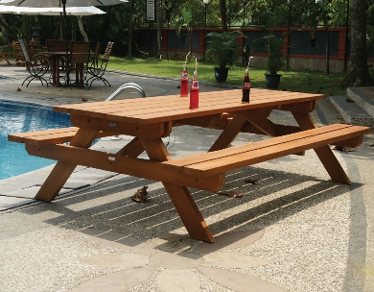
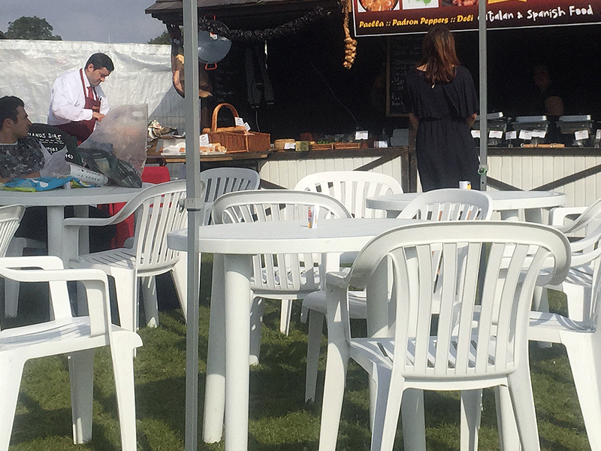
Most of the décor will not be too expensive, however hiring stalls, lights, tables, etc. may all add up. This is why all of the suppliers and producers will have to give to the budget to make the event a success. All these ideas are perfect for the event that we are trying to create as they are setting the event to been a happy joyful event that people will remember.
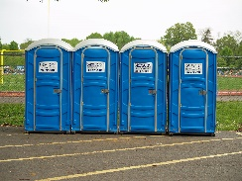
For the event there will also have to be toilets at the event, this is because it is a basic need ad it will help the visitors to stay longer.
Sourcing suitable materials, suppliers and contractors
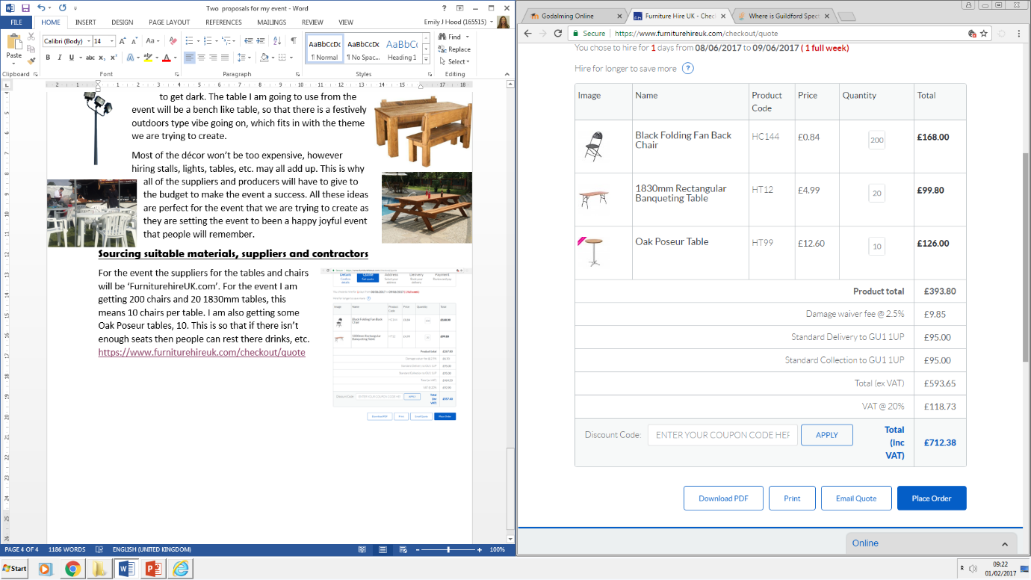
For the event the suppliers for the tables and chairs will be ‘FurniturehireUK.com’. For the event I am getting 200 chairs and 20 1830mm tables, this means 10 chairs per table. I am also getting some Oak Poseur tables, 10. This is so that if there is not enough seats then people can rest their drinks, etc. https://www.furniturehireuk.com/checkout/quote
All of which costs a total of £712.38, which is a reasonable price for the amount I am hiring.
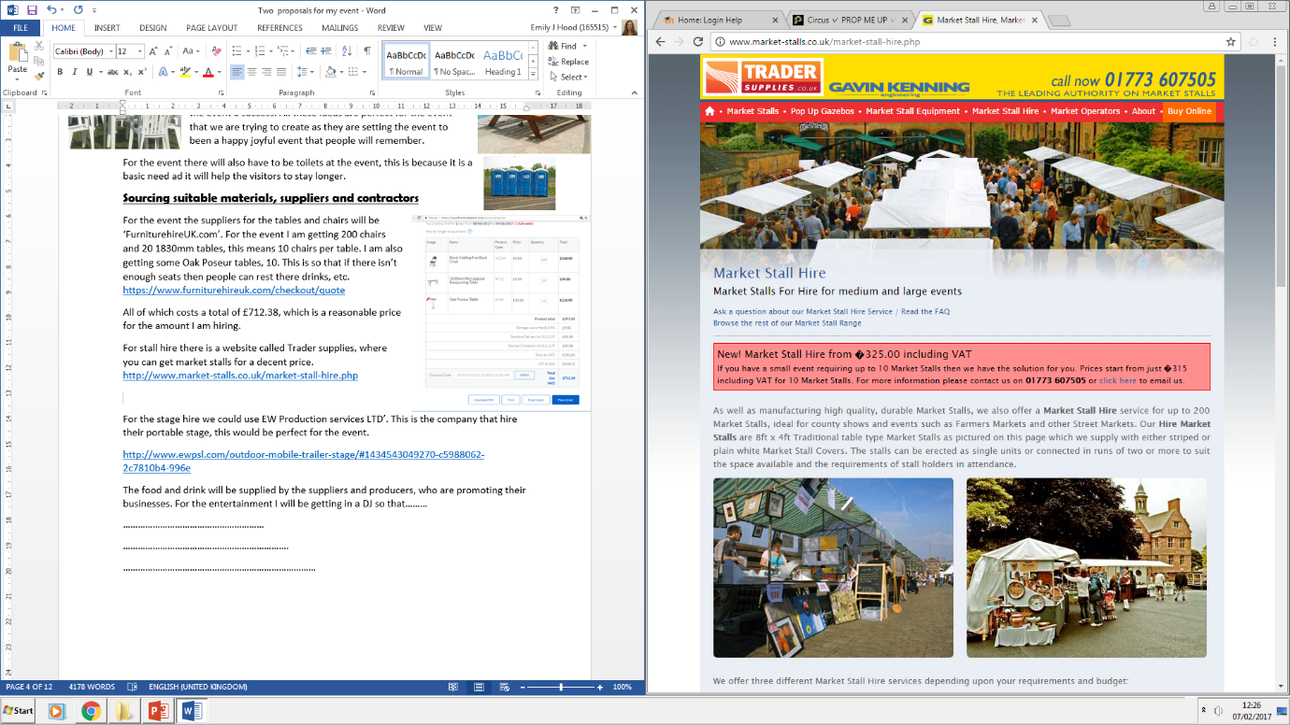
For stall hire there is a website called Trader supplies, where you can get market stalls for a decent price. http://www.market-stalls.co.uk/market-stall-hire.php

For the stage hire we could use EW Production services LTD’. This is the company that hire their portable stage, this would be perfect for the event.
http://www.ewpsl.com/outdoor-mobile-trailer-stage/#1434543049270-c5988062-2c7810b4-996e
The food and drink will be supplied by the local suppliers and producers, who are promoting their businesses. For the entertainment I will be getting in a DJ so that, people are entertained and want to stay and have a good time, which helps promote the local suppliers and producers. For a DJ one I found was Surrey DJ, who has does other events, like parties, wedding, etc.
http://surreydj.co.uk/?gclid=CIvL6LP-_dECFcG37Qod9I4O6A

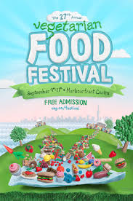
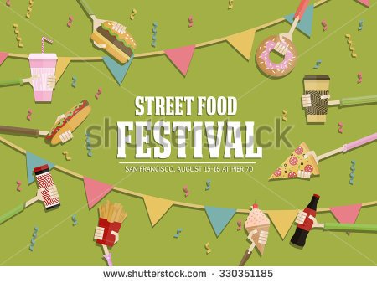
Identifying marketing strategies
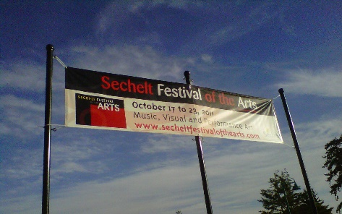
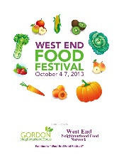
How the event will be promoted is; the event will have leaflets/ posters made and will be scattered all around Guildford, from Burpham to Merrow. All of which are locals to the suppliers and producers that the event is promoting. This means that the client is able to get their businesses out to as many ‘locals’ as they can. The event will also be promoted by social media, like Facebook. Because yes they want locals, but if there are potential customers that are not too far away, then they should be given the opportunity to attend the event. Then they can also have banner for advertisement, which can be set near Stoke Park or on the side of the road around the area of the event. These three ways of promoting will get the visitors that the suppliers and producers will need.

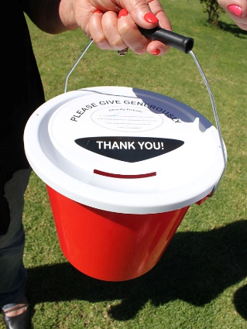
For the entrance there will be staff at the entrance that are holding buckets, so that the visitors can put in some money on the way in, this will help fund future events. I think this event will have a walk in system, meaning that people do not need to have a ticket to enter, otherwise it will limit how many people can access the event meaning that they may lose out on potential customers.
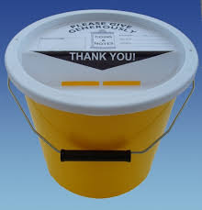
All of this links to the theme ‘festival’ as all of the promoting is going to be bright coloured and fun, this is what we want our event to be like. All of the equipment going into to this event will fit into the theme and will help achieve their purpose, which is to promote the suppliers and producers. Most of this advertising will not be too expensive as social media advertisement will be cheap, depending on what department of social media the advert is in. For the posters, they will be a bit more costly due to having to buy paper and other utensils needed. And for the banner they will need to have permission to have the banner in the location wanted, but it will not be too expensive.
Timing for the event will be at around 12 to around 4, this is the time that people will be hungry and will want to check it out to get some free food. The timing will not only get them more visitors but it will help them get more potential customers. On a summers day people will be travelling to a destination meaning, people passing on the road will be able to see what is going on and are able to check the event out.
Health and Safety
What needs to be considered is the safety of the visitors and the employees. This means that all the stalls that have food in need to make sure that the food they are giving is safe to give out, meaning that it has been kept and transported in clean conditions.
Any legal requirements that fit my event will have to be done to the best of the events capability, meaning that all the food will have to be kept safe. There is an Act which has the objective of protecting the public’s health, in relation to food, which is called The Food Standards Act 1999. This means that events that manage foods have to make sure that everything is cooked right and is fit to be served.
For the risk assessment, the festival will have to make sure that all their food is prepared and clean, so the risk of poisoning someone is extremely slim. Then there will have to be measures that make the stage safe. So that people cannot access it if they do not work for the event, or Stage Company. Stage staff are employed by the stage company, the security will be employed through a company and all the suppliers and producers will have staff of their own. All of these people will get instructed on what to do by the event manager.
Third Parties
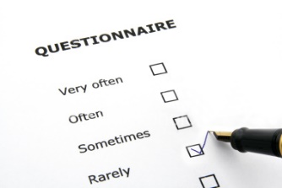
Other organisations that are involved with this event are the local suppliers and producers who are hosting the event and the businesses that are supplying the equipment, etc. all of who will want the event to go well, as they want to get paid. First Aid may have to come to the event as with any big event, the First Aid are needed in case of an emergency. Another party that is involved is Licensing Authorities as alcohol may be at the event depending on what the Hosts want.
Evaluation& Feedback
The feedback from the guests will be recorded by giving them mini questionnaires, these are quick and easy which can be given on the way out and dropped in a box. Then the average scores will be decided and then the event manager will have the feedback they need to improve or to know they have done well. Another way that the event could get feedback is if they just ask the guests their options. Feedback is collected so that the client can measure the success of their event, and decide if they have done well.
Cash Flow
In terms of cost, all of which will be paid for by the local suppliers. These are the businesses and people that are going to benefit from the event. The event will be excepting donations which can hopefully cover some of the cost of the event and other events to come. The Cost for marketing, leaflets/ posters , social media, banners for advertisement will be large amount as if they aren’t marketed right they won’t be able to processed or get there businesses known. For leaflet and posters they are going to be printing a lot if they are going to skater them throughout Guildford meaning it may be expensive due to the amount of ink and paper being used. But if the local supplier’s wanted to help they could do some of it themselves. In terms of social media advertising this won’t be expensive as social media is free to use. But if they wanted to get the locals even more interest they may sponsor a local celebrity to come to their event and advertise it. This will be more costly. In terms of banner advertisement, using a local business to print it may processed to be cheaper than a chain brand. As well as paying for the marketing. The festival would also have to pay for hire costs, and the venue, even though the council doesn’t disclose the price on the website.

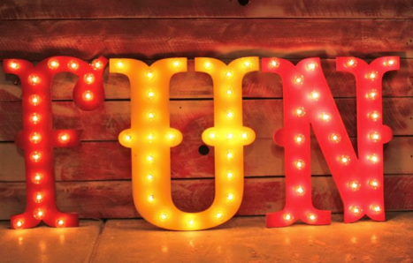

Proposal 2
Range of ideas and themes
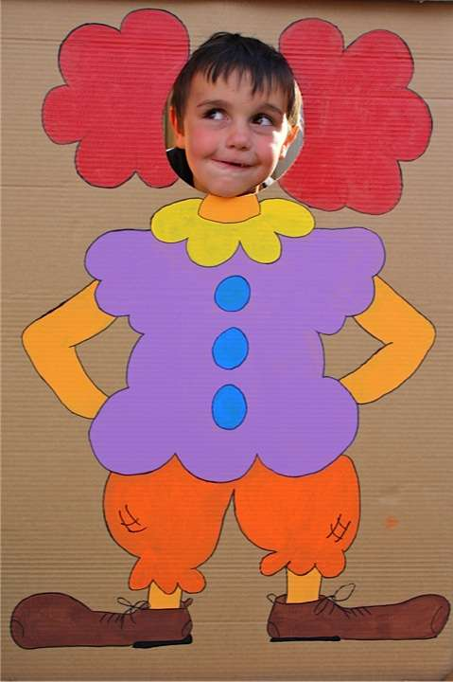

For the second theme I am going to be doing a circus/ fun fair theme. This is because it is a fun theme that will be able to draw people to the event. It is appropriate for the event as it will help draw in people which is the aim of the event. The clients, who are the local suppliers and producers will want to promote their food. What better way than an event that is entertaining and helps promote the food. The time of year the event will be held at is spring time, this is because the weather is just right. With the weather being cool and slightly warm it is the perfect time to host a circus fun fair, with delicious local foods.
This theme will be incorporated with loads of decorations, themed everything, such as themed napkins, themed cups, fun fair stalls to keep people entertained while eating their delicious food. Staff will dress up to portray the theme across the event, on the entertainment stalls. These will all help the theme be known across the event.
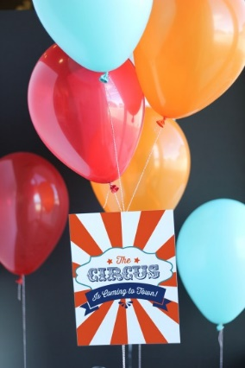
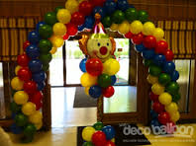
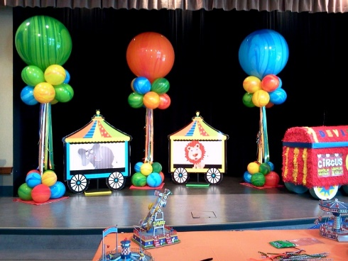
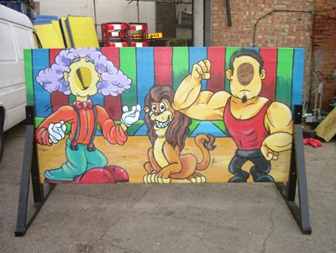
For this event there is not a dress code, this is due to the fact the event will be in an open space in which anyone can attend, meaning if everyone was dressed up then people may not attend due to not being dressed properly. For decorations, there are going to be loads of fun fair, circus themed décor, for example there is going to be cut outs, so people can take pictures and then maybe hashtag the event so the event gets even more promotion. I will also put balloons, white, and red, yellow, blue and green all of which go with the theme. Maybe even start the event off with a balloon arch, so people will understand the theme straight away. The food will be provided by the local suppliers and producers on their stalls.
However some foods for the purpose of the theme will be served such as cotton candy, popcorn, etc. these stalls along with other stalls will be at the event for entertainment, so while people are enjoying their food they are able to have fun, which means they will stay long, and will eat more good which helps promote how good the local suppliers and producers are.
This image shows Stoke Park and the roads and area around, which shows that it is in a good location
Suitable event venues
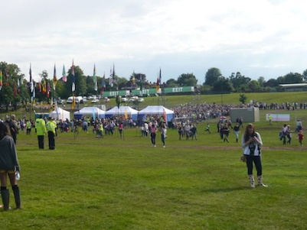
The venue for this event will have to be outside to pull off the theme, as fun fairs and circuses are usually outside. The venue will be outside on Stoke Park, as it is a massive open space and that is near Guildford town and Spectrum, all of which means that if the event is held there then it will have more opportunities to have more people attend.
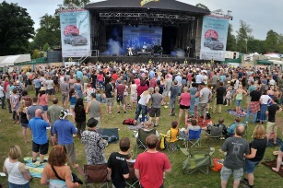
The venue that I have chosen is Stoke Park, this is because it is a good open space in the middle of a village, and it is set where many people can access the event and is an ideal space for it.
For transport there are many ways that people can get there, for example there are buses that stop at Spectrum, which is next door to the venue. So the venue can be accessed by the town, and the places around, for example Burpham or Merrow, etc. There is also a train station that is very close to the park, which means that people that do not live too far out are able to get to the event as well as locals.
The services provided by this venue is just the location, as it is owned by Guildford Borough Council, which means that the event that hire the location out have to provide everything for themselves. For the cost of the event it does say the price unless you go through the process of hiring the venue, through the website.
This venue is a good place to use as I have said that it is in the prime location and it could potentially help the event been more successful. The clients want a venue and theme that will get them noticed and will help them promote their produce and food. They would like idea of the event being in a prime location so that many people can access and ‘pop’ in if they are curious, which is what we want people to do.


Venues appearance
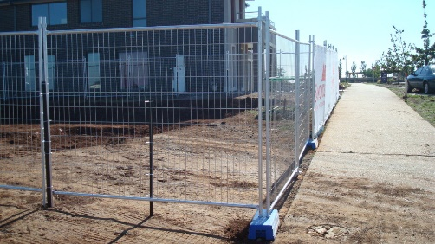
The decoration for the venue is going to be entwined with the theme, meaning that all decorations must link back to the theme in some way.
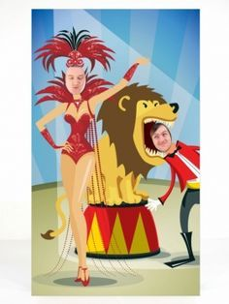
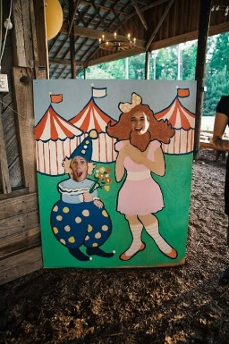
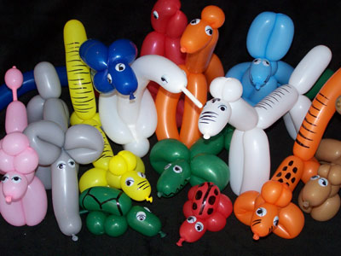
The event will need to have fencing around, so that all the visitors and clients are kept safe. For the decoration there is going to be balloons, normal and animal ones, and these link in with the circus / fun fair theme. Both of these are able to be purchased in party stores, there are around 3 party shops in Guildford town. Then there will also be cut outs, for decoration and for entertainment. These will be cut outs related to the theme, which is the circus and fun fairs.
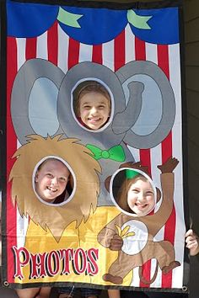
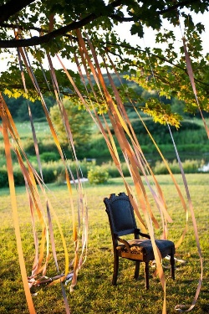
Some more decorations that could be at the event is ribbons from trees or stalls, to make it more fun and festive for everyone. I could also put in some statues of circus animals, to support the theme even more. These are just a few ideas that could possibly be used to decorate the event.
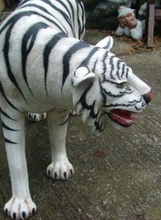
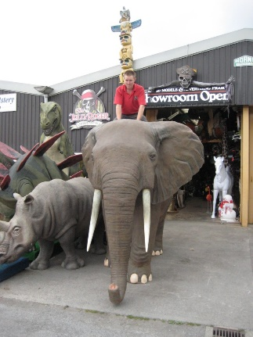
Colours for the event are going to be mainly red, white, yellow, and blue and green all the colours that are associated with the circus or fun fair. All the colours are light and happy colours as that is what we want for the event, to be light hearted and fun for the visitors. I will also be putting lights around the event so that the event is well lit, if it starts to get dark.
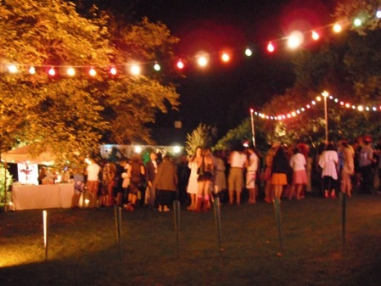
The layout of the food stalls will be dotted around, same as the entertainment stalls, this is so when people go to an entertainment stall they are able to visit the stalls around easily. This helps the businesses get better known and get the local producers and supplier promoted. I am also putting in some seating, so that people can stay longer, because they are able to sit down and rest.
Layout suggestion:
Key
Food stalls
Entertainment stalls
Seating

This idea for the lay out is a good idea for my clients as they want the local suppliers and producers to be promoted, which they will be if the entertainment stalls are near the food stalls. Because they are in front of the food stalls they will be enticed to see what is behind, and what the smell of food is.
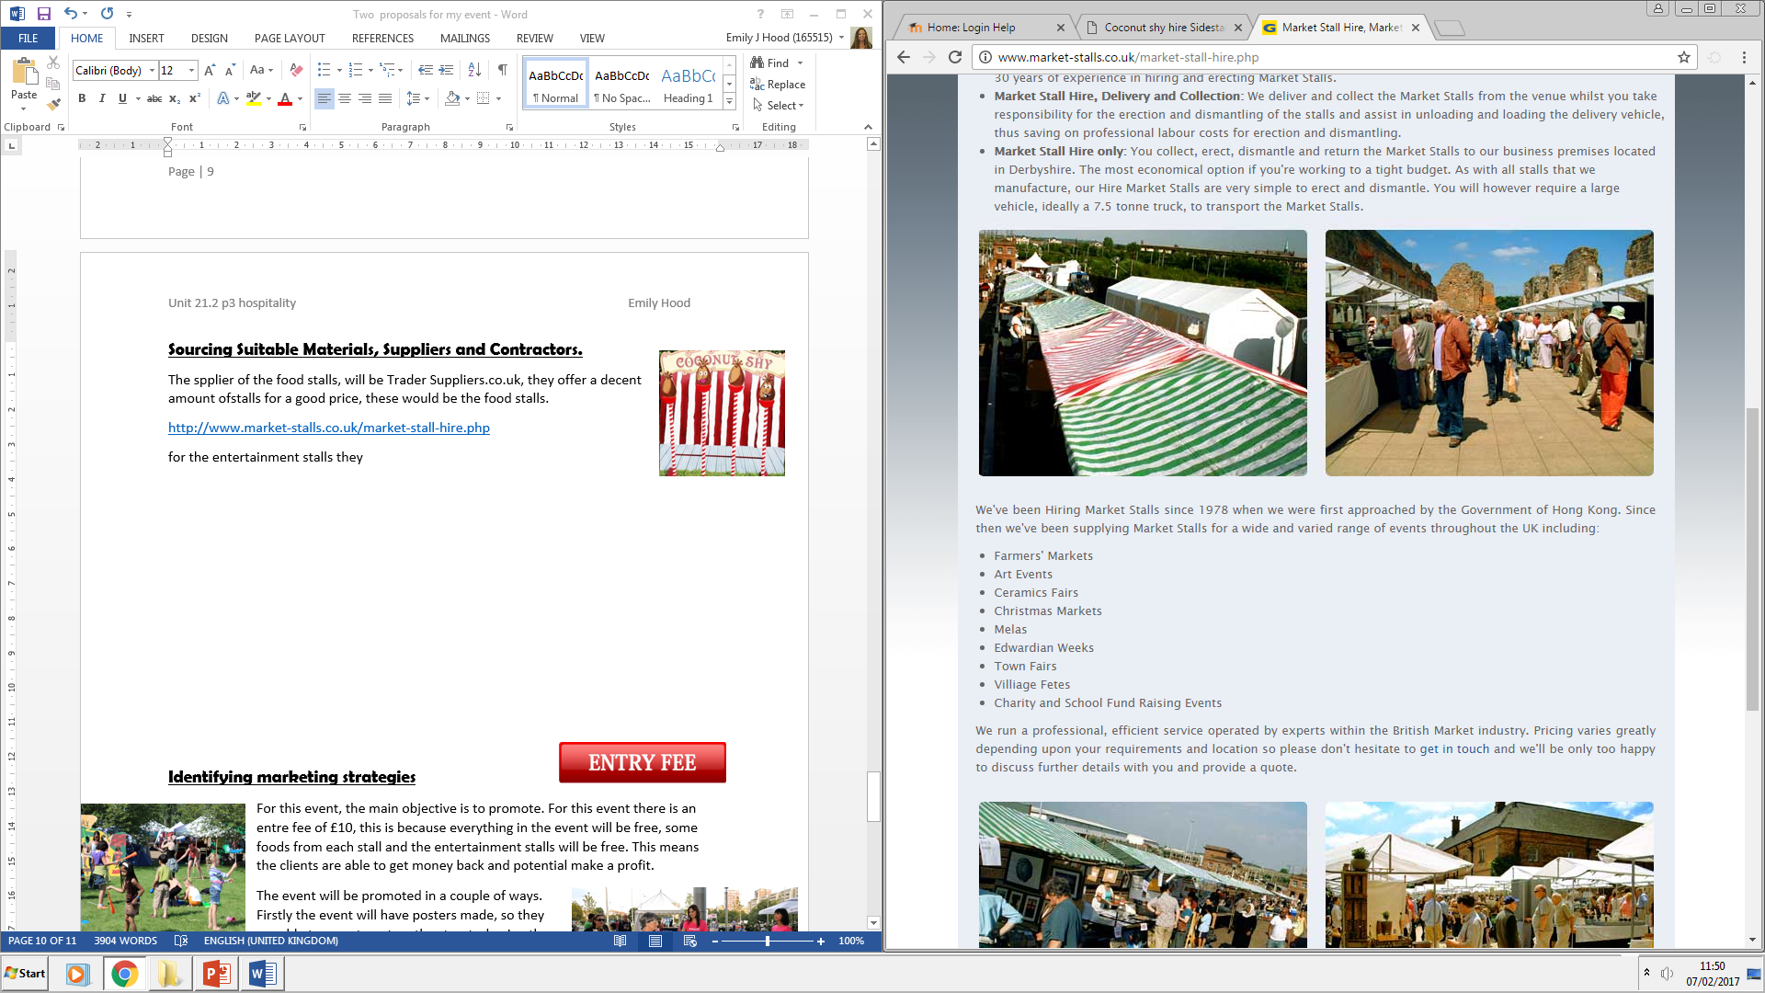
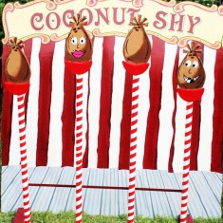
Sourcing Suitable Materials, Suppliers and Contractors.
The supplier of the food stalls, will be Trader Suppliers.co.uk, they offer a decent amount of stalls for a good price, these would be the food stalls.
http://www.market-stalls.co.uk/market-stall-hire.php
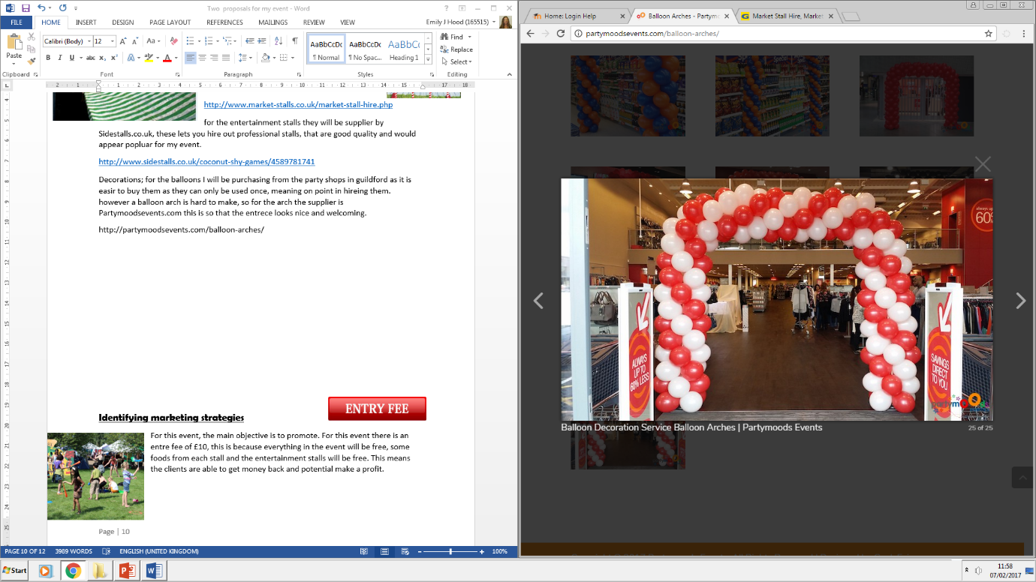
For the entertainment stalls they will be supplied by Sidestalls.co.uk, they lets you hire out professional stalls, that are good quality and would appear popluar for my event.
http://www.sidestalls.co.uk/coconut-shy-games/4589781741
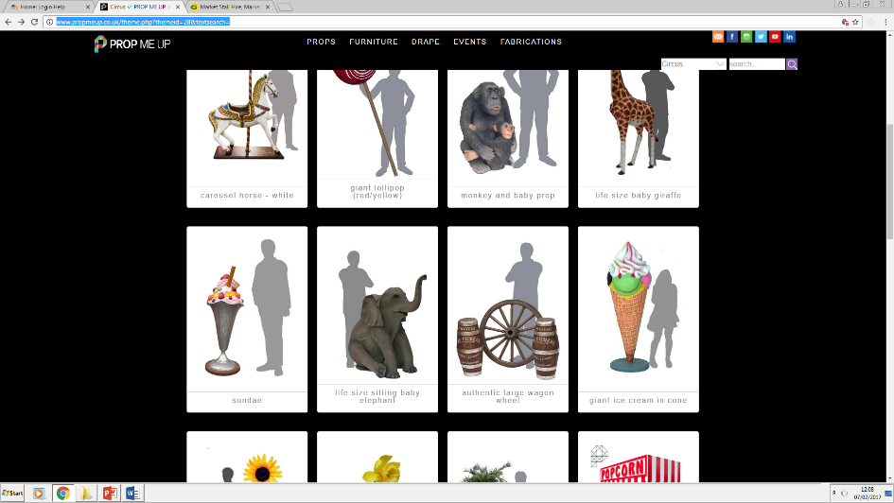
Decorations; for the balloons I will be purchasing from the party shops in Guildford as it is easier to buy them as they can only be used once, meaning no point in hiring them. However a balloon arch is hard to make, so for the arch the supplier is Partymoodsevents.com this is so that the entrance looks attractive and welcoming.
http://partymoodsevents.com/balloon-arches/
For other props, like life sized animals, this website has all of what we are looking for. They even have a candy floss booth and a popcorn booth which are both completely functional.
http://www.propmeup.co.uk/theme.php?themeid=28&textsearch=
Food and drink will be supplied by the clients of the event as the main aim is to promote the local suppliers and producers. Other than the candyfloss and popcorn, the local suppliers and producers are the only ones suppling food at the event. For the entertainment it is the stalls that will be having funfair/ circus games. These will be the entertainment for the guests.

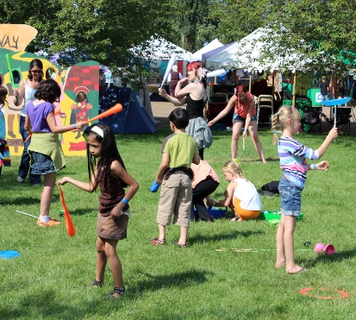
Identifying marketing strategies
For this event, the main objective is to promote. For this event there is an entrance fee of £10, this is because everything in the event will be free, some foods from each stall and the entertainment stalls will be free. This means the clients are able to get money back and potential make a profit.
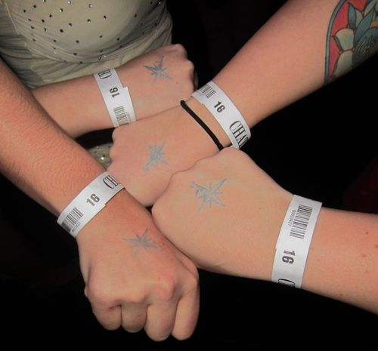
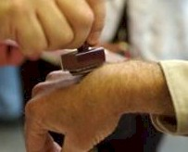
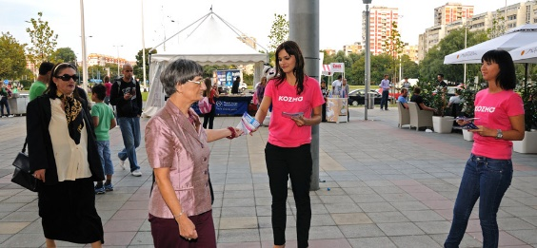
The event will be promoted in a couple of ways. Firstly the event will have posters made, so they are able to promote out on the streets, having them in window shops, on poles, and maybe event in schools, this is a possiblity as fun fair/ circus are popular with children. Another way of promoting the event through posters is handing them out, for example they could hand out posters in town to people. Another way that they could promote the event is use social media as a lot of young people would be able to access the event easier online. However Facebook has older middle-aged people using their site, meaning that if we promoted it on there then we would get more older customers that are more able to afford what the supplier and producers can offer.
These both link to the theme as the posters would be made with the theme in mind, which is circus/ fun fair. After they have paid their entry fee, they could get a stamp on their hand or a wrist band, showing that they have paid so they can enjoy the event.
The event will be around spring time. I chose spring as it is not too hot weather but not cold either, meaning it is perfect weather to hold an outdoor event. Because the event is a circus/ fun fair theme, it is going to be set in the afternoon, around 2 to 5 pm. This will hopefully attract the most customers.

Health and Safety
What needs to be considered is that all the food stalls are hygienic and the food is safe for people to eat. If there is alcohol, then there will need to be a licence to provide it to customers. The Act that’s main objective is to protect the public’s health in relation to food is called the Food Standards Act 1999. On this website it tell you all about what legal requirements needed when having an event. https://www.kingston.gov.uk/info/200344/public_events/1063/organising_an_event/4
For staff, I am going to have already trained security. For the entertainment stall I am going to have the employees that come with the entertainment. Then for my food stalls the producers and suppliers will have employees that can help them out so that they are already experienced with their food on their stalls. I am hiring security as it will hopefully be a decent sized event, meaning that we have to take into consideration the safety of our guests, meaning a quick bag search at the gate, and to make sure that the people coming in have paid their entry fee. All of which helps the clients and the customers.
Third parties
For my event I will have to have First Aid at the event, due to cooking being involved and there will be many people there. So just in case an incident occurs, first aid should be there. Another third party that is involved would be Licensing Authorities, this is because the event may have alcohol or have any other products/ equipment needing to be licenced.


Evaluation and Feedback
For the events feedback, I would do, a questionnaire, and to encourage the customers, give them a free meal for two from one of the suppliers and producers. This will make people want to give feedback as they also get something out of it also. This helps both parties. Events want feedback so that the client can measure how well their event was.
Cash Flow
In terms of cost for this festival it will be paid for by the selling of the tickets but firstly but the fee of having a stall at the food festival. All other expenses will be paid by the local supplier of which are holding the event to draw in more customers. The marketing that this event will need to be a success is, posters, both putting them in windows and handing them out or use social media. The cost for the marketing will be the biggest part of the cost for the event. In terms of the posters it will be expensive to prink due to the cost of paper and ink. However this is balanced out by using social media to promote as that is free. As well a marketing cost there will be hiring cost. This may become quite expensive due to them hiring circus stalls etc.

