**Two proposals for the client**

**Proposal 1- James Bond Themed Party**

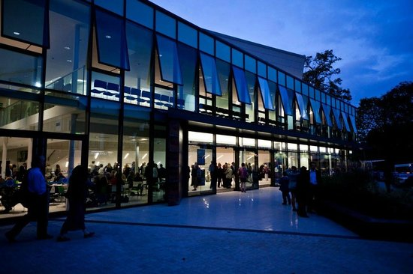**Range of Ideas and Themes**

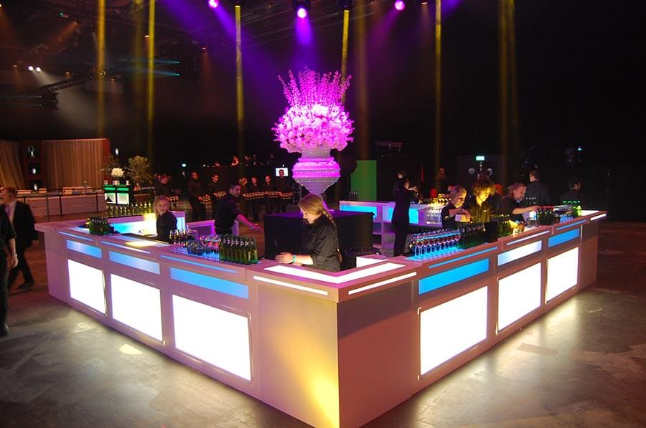The idea that I have for the client for their 500 people university party is a James Bond themed ball. I feel that this idea will be appropriate as people have to come as characters from any bond movie and that means that the women can still wear beautiful gowns but still have an edge with maybe fake guns attached to their thighs and the guys can either wear a classic suit in whatever colour their character wears or can wear a roll neck and glasses if they have chosen to be Q. I feel this will give the event a bit of excitement and will make it unique. The decorations will include martini glasses with red candles inside on each table, fake guns on each plate for each university student to take home, a plaque of the classic James Bond backdrop for people to take photos at- photographer will be provided and finally there will be some black party glasses in a pot on each table. The venue will be at G-Live in Guildford town centre, my idea of having a hotel attached or the event being at a hotel is so that students don’t walk home drunk or tipsy nor drive. Opposite the venue is a hotel in which the students can stay- I would ask the two university students who are helping plan the event to ask all the students to sign up for accommodation so that I know how many rooms to book. The food supplier will be G-Live as they will supply the food with the hiring of the venue. I will also be hiring my own bar for the event with 5 complimentary drinks for each student. After that the students will have to pay for their drinks. The bar I will be hiring is called Liquid Chefs who are a designer drinks and cocktails company. Left is a picture of the sized unit I will be needing for the event which is 9m.

**Suitable Event Venue**

I have chosen G-Live because it is a cheaper alternative than a hotel. G-Live has all the facilities needed to accommodate and look after the 500 students. G-Live is at the top of the north/high street in Guildford, opposite the Mandolay hotel where they can stay following the event. Students can get there with either a taxi or get the 36 bus towards Merrow which will stop directly outside of the venue. It leaves from Guildford Friary Station and from the bus stops at Surrey University campus. G-Live will supply the catering and will have staff check the tickets at the doors before entering the venue so that no one who hasn’t paid or doesn’t go to the university enters. It will cost £5000 to hire out the venue for the night going from the morning of the event to the end of the event (ending at 1am). I feel because this event has tables big enough for 10, only needing 50 tables 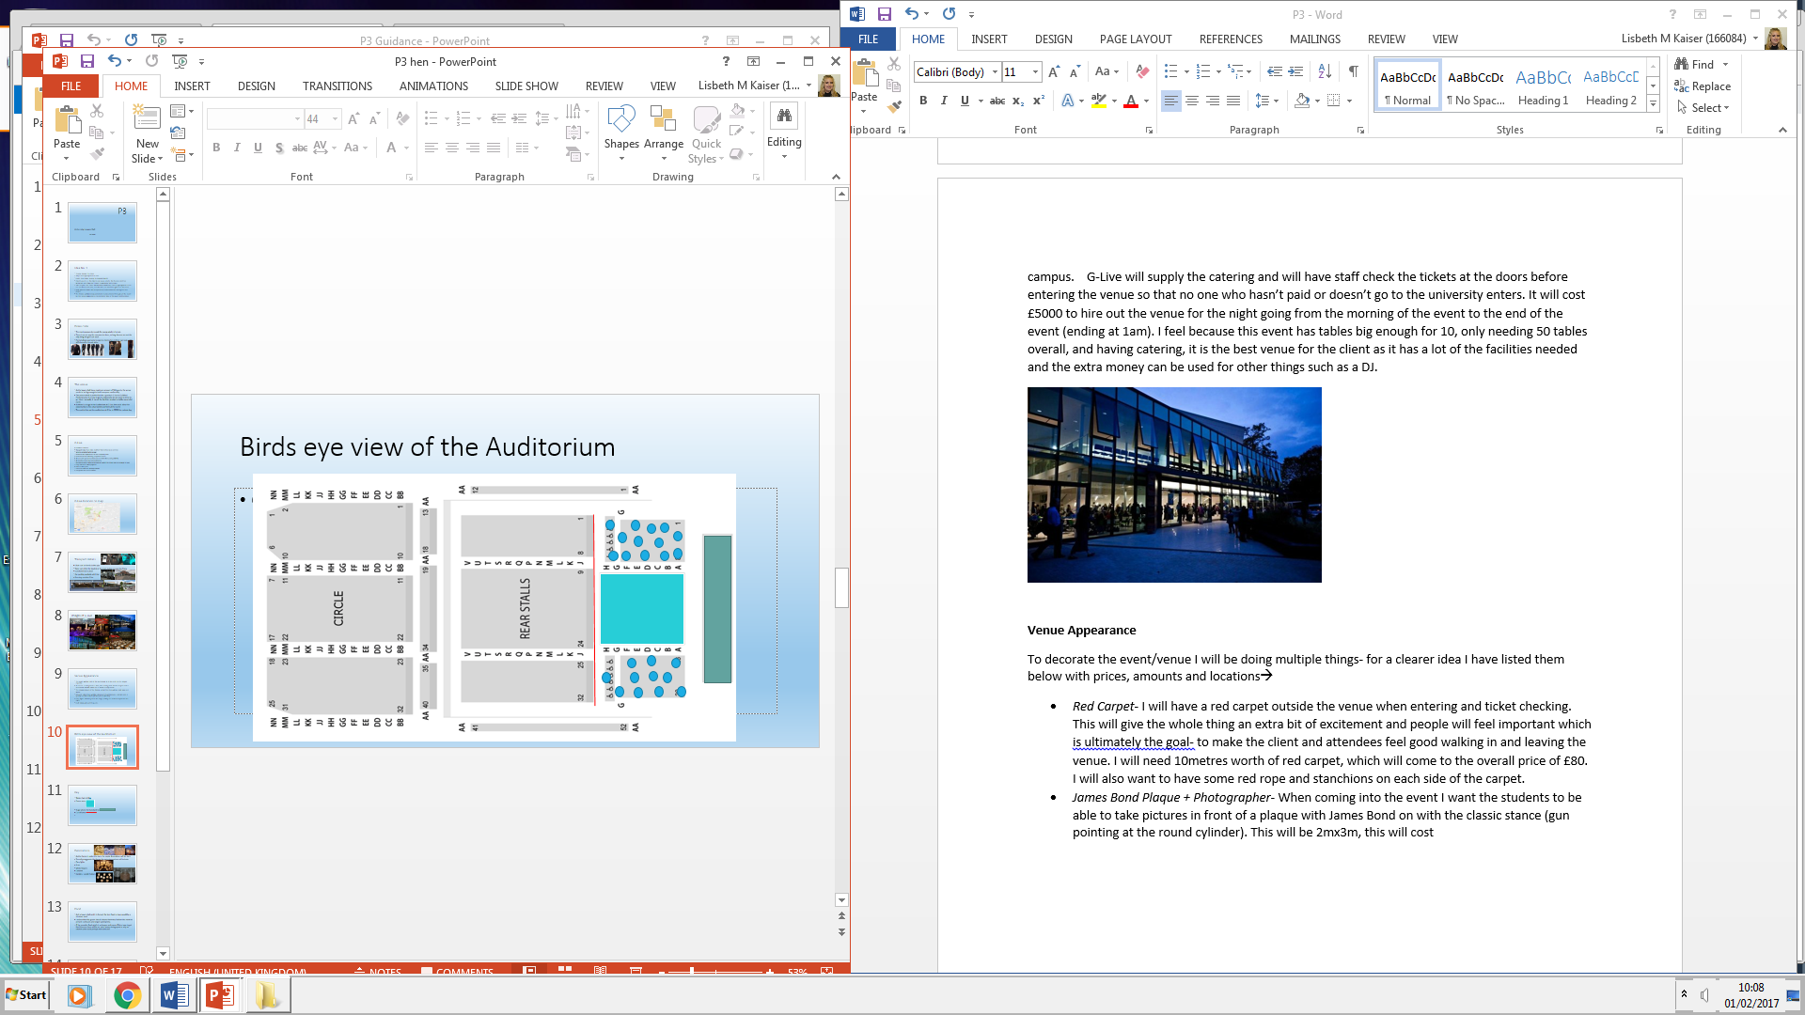overall, and having catering, it is the best venue for the client as it has a lot of the facilities needed and the extra money can be used for other things such as a DJ.

**Venue Appearance**

To decorate the event/venue I will be doing multiple things- for a clearer idea I have listed them below with prices, amounts and locations🡪

* *Red Carpet*- I will have a red carpet outside the venue when entering and ticket checking. This will give the whole thing an extra bit of excitement and people will feel important which is ultimately the goal- to make the client and attendees feel good walking in and leaving the venue. I will need 10metres worth of red carpet. I will also want to have some red rope and stanchions on each side of the carpet.
* *James Bond cut out + Photographer-* When coming into the event I want the students to be able to take pictures in front of a cut out with James Bond. This will be 2mx3m.
* *Fake Guns-* I will place 5 fake guns on each table for the students. This will further add to the James Bond appearance and feel. I will need 25 guns
* *Black Sunglasses-* I will also be putting fake black sunglasses on each table- one for each student with ‘Leavers ‘17’ written on the side. I will need 500
* *Large Martini Glasses-* There will be 3 martini glasses on each table containing the guns and glasses, I will need 150
* *Confetti-* I will be sprinkling confetti hearts onto all the tables to decorate the white plain table cloths. I will need 500 confetti hearts
* *Red Tealights-* I will be placing 6 red fake tealights on each table to further increase the atmosphere of blood and James Bond. I will need 300

**Raffle**

We will be supplying the students with a raffle of the following things.

* Trip to Paris for 4 for 3 days, 2 nights- Hotel Jarry Confort- £380
* Nandos Gift card - £50
* Skydiving for 3- SkyGoDive- £954
* Magnum Champagne Bottle- £48.84

**Sourcing Suitable Materials, Suppliers and Contractors**

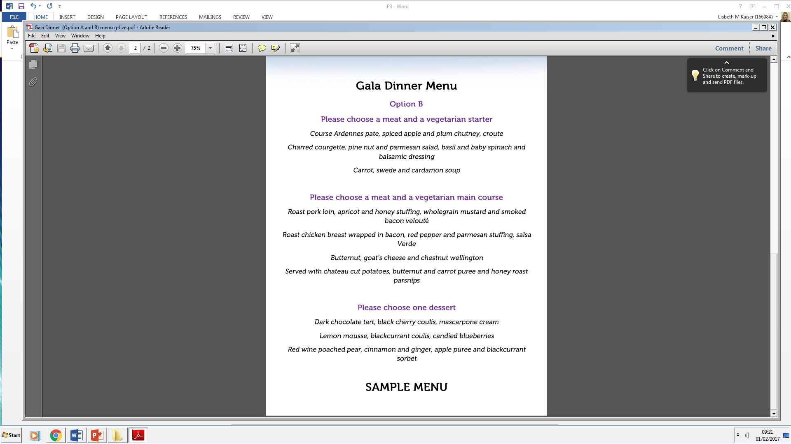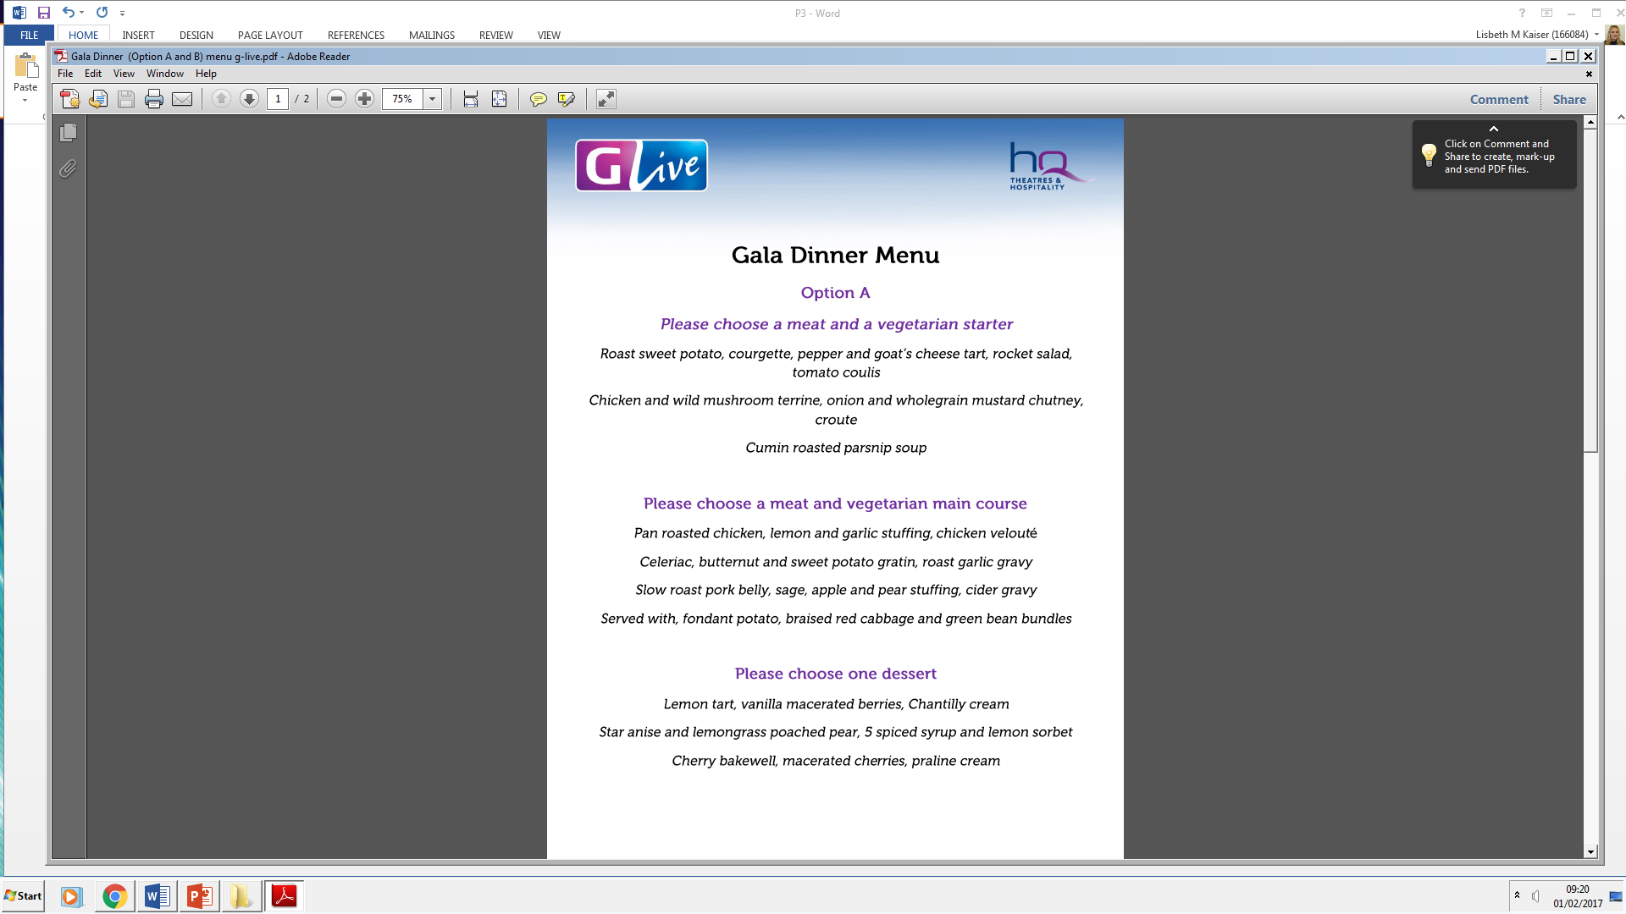

1. Red Carpet- Dashing London- 10metres
2. James Bond cut-out- Ebay- 2x3m
3. Fake Guns- Wish- 25
4. Rope and Stanchions- Dashing London- 6
5. Black Sunglasses- Amazon- 500
6. Large Martini Glasses- Ebay- 150
7. Confetti Hearts- Etsy- 5Packs
8. Red Tea Lights- Ebay- 300

**Identifying Marketing Strategies**

This is how we will get the word to the students about the event. As the target audience is young adults, the easiest way to promote the event would be through social media as this is both fast, easy and free. An event on Facebook can be made with all of the information needed about the event. Someone from the university who is helping organise the event can help with how students can pay for the event. The tickets will be sold at a price of £30 per person. This is due to only being given £1000 by the university and the rest has to be gained through the ticket sales, without this the budget would be very limited and it would mean we cannot give the students the best of the best at their leavers ball, after all it is the last thing they will remember from the university and their friends.

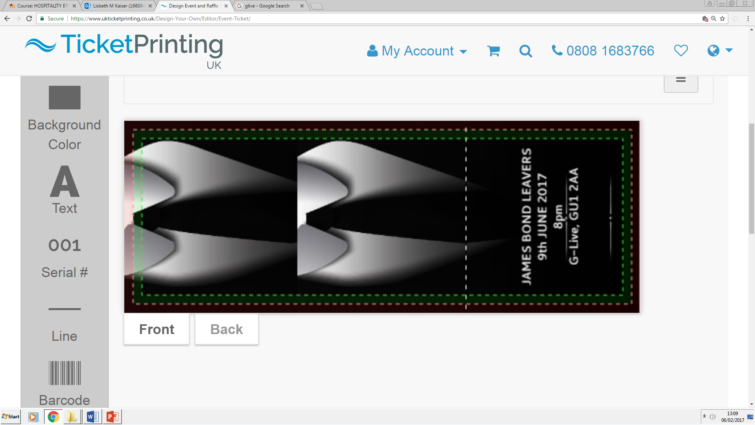The tickets will look like the following-

Front

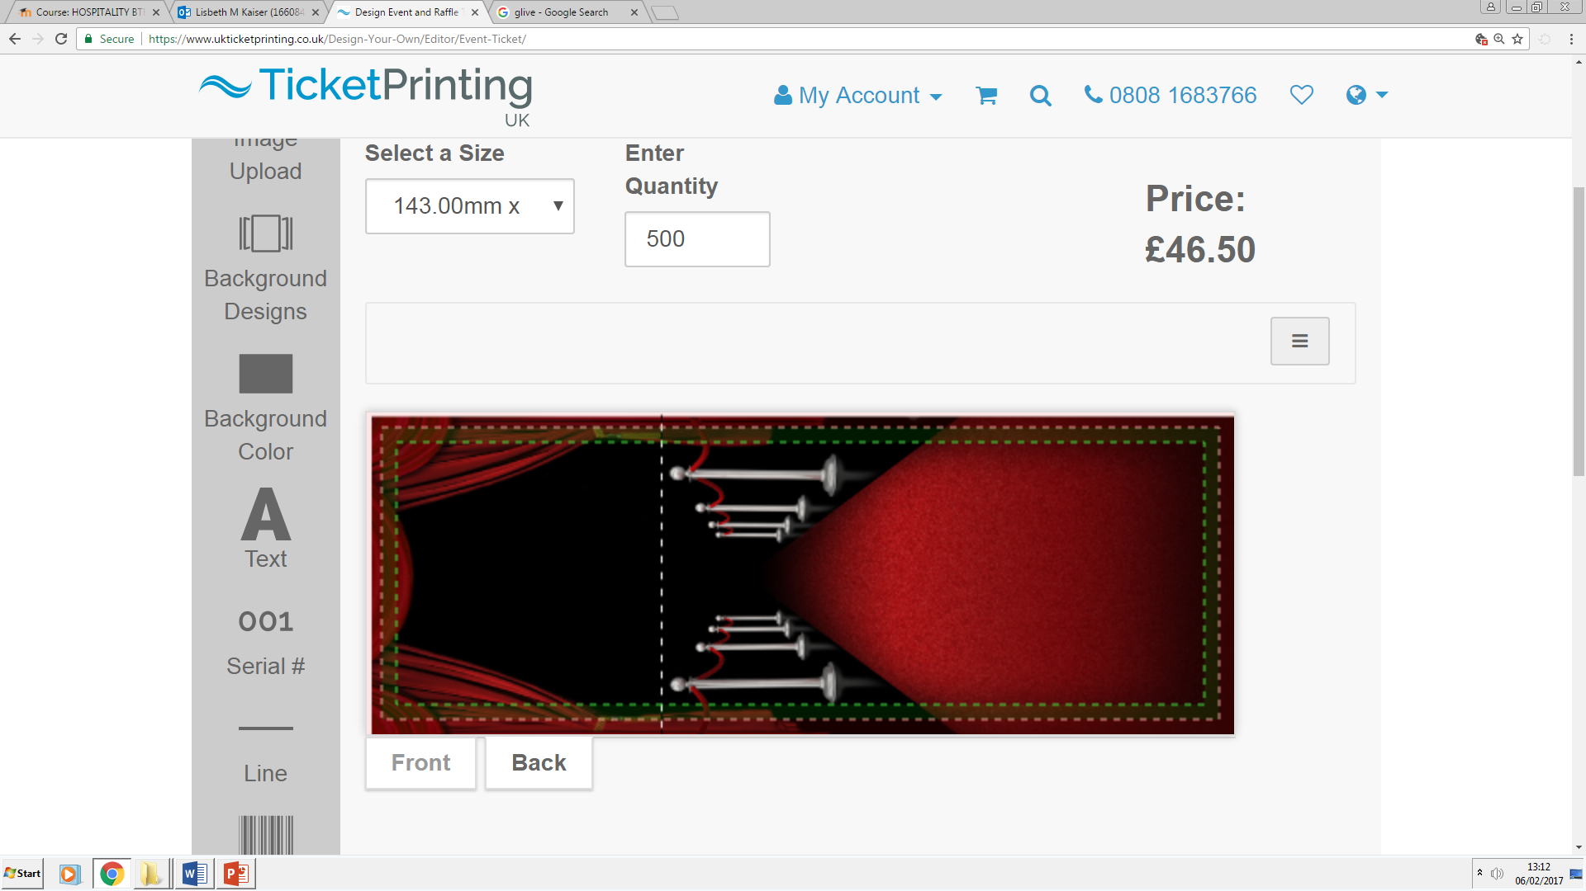

Back

The tickets will not have this green line around it- this is just the prototype.

**Health & Safety**

What needs to be considered when talking about health and safety are issues with drinking such as making sure students don’t get too drunk, legal requirements such as making sure that all the bar staff have a bar licence, that all staff know where the emergency exits are and finally all the staff must be fully trained to deal with any emergencies that might come up. Security will be provided by G-Live but also students from the university might be at the doors to check that only people from the university are attending.

**Third Parties**

Police will usually be on standby in situations where a large amount of people are involved. This is not to make students feel uncomfortable but to make sure that they are safe and taken care of in case anything happens that puts other students in danger such as someone getting too drunk and becoming aggressive. The ambulance will not be involved unless in something happens and they are needed in which case, G-Live will call them. I will give the ambulance a heads up so that they know an event is happening and what is happening if called.

**Evaluation and Feedback**

I will be providing a questionnaire to the students when they leave to see how much they liked the event. This is the easiest and quickest way to get feedback on a large scale.

Question: on a scale of 1 to 10, 1 being the lowest, how successful do you think the event was? Please tick a box below.

1 2 3 4 5 6 7 8 9 10

If there is anything you think would have improved the event please state below

|  |  |
| --- | --- |
| **Cashflow** | **Price** |
| G-Live Venue | £5,000 |
| 10metres of Red Carpet | £18.99 |
| Rope and Stanchions (6x) | £75 |
| James Bond Cutout (2x3m) | £35.79 |
| Fake Guns (25) | £75 |
| Black Sunglasses (500) | £500 |
| Large Martini Glasses (150) | £249.75 |
| Confetti Hearts (pack of 100, 5packs) | £20.25 |
| Red Tea lights (300) | £120 |
| Bar (includes staff and alcoholic drinks for 500 people) | £4,000 |
| DJ | £400 |
| Tickets (500) | £45 |
| Photographer | £0 |
| Trip to Paris for 4 for 3 days, 2 nights- Hotel Jarry Confort | £380 |
| Nandos Gift card | £50 |
| Skydiving for 3- SkyGoDive | £954 |
| Magnum Champagne Bottle | £48.84 |
| Tickets (500) | £46.50 |
| Raffle Tickets | £3.99 |
|  |  |
| **Budget** | **£16,000** |
| **Total** | **£12,023.11** |
| **Profit** | **£3,976.89** |

**Proposal 2- Alice in Wonderland**

**Range of Ideas and Themes**

For the second proposal I have decided to do an Alice in Wonderland themed leavers ball. I feel that this idea will be appropriate because everyone knows how to dress and what is to be expected. I feel that this will make the event different from the usual black tie events and a lot of the students can have fun with what they will wear. The decorations will include things such as cardboard cut-outs of the characters, tea cups, buntings with teacups and lampshades and the tables will be covered with checked table clothes but only on the middle strip of the table as it will come on top of the normal white tablecloth. The venue will be at G-Live in Guildford town centre, my idea of having a hotel attached or the event being at a hotel is so that students don’t walk home drunk or tipsy nor drive. Opposite the venue is a hotel in which the students can stay- I would ask the two university students who are helping plan the event to ask all the students to sign up for accommodation so that I know how many rooms to book. The food supplier will be G-Live as they will supply the food with the hiring of the venue for which I will be given a menu but will ask to make the food in specific designs or I will create a menu with the kitchen that will link in with the theme. I will also be hiring my own bar for the event with 5 complimentary drinks for each student. After that the students will have to pay for their drinks. The bar I will be hiring is called Liquid Chefs who are a designer drinks and cocktails company. Left is a picture of the sized unit I will be needing for the event which is 9m.

**Suitable Event Venue**

I have chosen G-Live because it is a cheaper alternative than a hotel. G-Live has all the facilities needed to accommodate and look after the 500 students. G-Live is at the top of the north/high street in Guildford, opposite the Mandolay hotel where the students can stay following the event. The students can pay an extra amount of money for them to be able to stay in the hotel and I will also organise a couple rooms more in case they decide to stay at the hotel at last minute. Students can get to G-Live with either a taxi or get the 36 bus towards Merrow which will stop directly outside of the venue. It leaves from Guildford Friary Station and from the bus stops at Surrey University campus. G-Live will supply the catering and will have hired security and also university organisers check the tickets at the doors before entering the venue so that no one who hasn’t paid or doesn’t go to the university enters. It will cost £5000 to hire out the venue for the night going from the morning of the event to the end of the event (ending at 1am). I feel because this event has tables big enough for 10, I only needing 50 tables overall, and having catering, it is the best venue for the client as it has a lot of the facilities needed and the extra money can be used for other things such as a DJ.

**Venue Appearance**

To decorate the event/venue I will be doing multiple things- for a clearer idea I have listed them below with amounts and locations🡪

* *Truly Alice Napkins-* I feel the small details will make the larger ones so much better and that is why I feel that if even the napkins are themed then it ties everything together and gives a better atmosphere. These will be distributed across the tables, one for each person. I will need 500.
* *Truly Alice Plates-* The desert plates have different Alice in Wonderland quotes on and are decorated with pink and blue lace around the edges. These will be placed on the tables with general little nibbles. I will need 60.
* *Truly Alice Props-* The truly Alice props are big cut outs of clocks and playing cards which will be placed around the room to create the effect that the students are tiny and they actually are in the Wonderland. I will need 120.
* *Alice in Wonderland Cut outs-* These are big cut outs of the characters which I will place around the room so that the students can take pictures with them and that it further increases the experience of the event. I will need 20 as they are very large.
* *Tea Cup and Lampshade Bunting-* As previously described, the buntings will be hung around the edges of the venue to make it seem like the students are going to a tea party. I will need 20 8m buntings.
* *Checked Table Runner-* This will be placed across the white table cloths to add to the craziness of the decorations due to nothing matching at the Hatters tea party and everything being crazy. I will need 50 2m runners.
* *Large Mushrooms-* The large mushrooms will be placed around the room at random points (even between the tables), these mushrooms are known for being Alice in Wonderland inspired and it will allow students to have fun with the props around the room. I will need 50.
* *Mad Hatter Hat-* The mad hatter hat has orange hair attached to it and each table will have one mad hatter hat on it. This is just for the students to have some fun and take pictures with friends, this is especially good if the students are waiting for food or for everyone to get seated. I will need 50.
* *Teapot-* Each table will have one teapot on for the show purposes to again, further stimulate the mad hatter experience, later after the food has been served students also have the choice to have tea which will be brought in that teapot per table. I will need 50.
* *Moss-* Fake moss will be placed around the room to act as if the event were to be outside and it will also be covering the floors which will really help increase the feeling of being outside and at a picnic tea party. I will need 19x22m worth of it.
* *Confetti-* I will sprinkle confetti tea pots on the tables to add an extra bit of glam to the event. I will need 500

**Raffle**

We will be supplying the students with a raffle of the following things.

* Trip to Paris for 4 for 3 days, 2 nights- Hotel Jarry Confort- £380
* Nandos Gift card - £50
* Skydiving for 3- SkyGoDive- £954
* Magnum Champagne Bottle- £48.84

**Sourcing Suitable Materials, Suppliers and Contractors**





1. Truly Alice Napkins- Party Delights- 500
2. Truly Alice Plates- Party Delights- 60
3. Truly Alice Props- Party Delights- 120
4. Alice in Wonderland Cut outs- Party Delights- 20
5. Tea Cup Bunting- Party Delights- 40m
6. Checked Table Runner- Party Delights- 100m
7. Large Mushrooms- Ebay- 50
8. Mad Hatter Hat- Amazon- 50
9. Teapot- Etsy- 50
10. Fake Moss- Wickes- 19x22m
11. Photobooth Props- Party Delights- 20
12. Confetti Teapots- Etsy- 500

**Identifying Marketing Strategies**

This is how we will get the word to the students about the event. As the target audience will be young adults, the easiest way to promote the event would be through social media as this is both fast, easy and free. An event on Facebook can be made with all of the information needed about the event. Someone from the university who is helping organise the event can help with how students can pay for the event i.e. by online transaction or with cash (No IOU’s). The tickets will be sold at a price of £35 per person. This is due to only being given £1000 by the university and the rest has to be gained through the ticket sales, without this the budget would be very limited and it would mean we cannot give the students the experience they deserve at their leavers ball, after all it is the last thing they will remember from the university and want to be able to enjoy the night with their friends.

The tickets will look like the following-

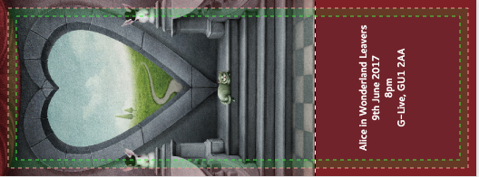

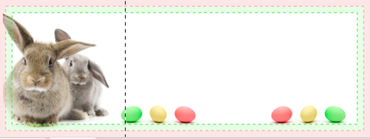Front

Back

**Health & Safety**

What needs to be considered when talking about health and safety are issues with drinking such as making sure students don’t get too drunk, legal requirements such as making sure that all the bar staff have a bar licence, that all staff know where the emergency exits are and finally all the staff must be fully trained to deal with any emergencies that might come up. Security will be provided by G-Live but also students from the university might be at the doors to check that only people from the university are attending.

**Third Parties**

Police will usually be on standby in situations where a large amount of people are involved. This is not to make students feel uncomfortable but to make sure that they are safe and taken care of in case anything happens that puts other students in danger such as someone getting too drunk and becoming aggressive. The ambulance will not be involved unless in something happens and they are needed in which case, G-Live will call them. I will give the ambulance a heads up so that they know an event is happening and what is happening if called.

**Evaluation and Feedback**

I will be providing a questionnaire to the students when they leave to see how much they liked the event. This is the easiest and quickest way to get feedback on a large scale.

Question: on a scale of 1 to 10, 1 being the lowest, how successful do you think the event was? Please tick a box below.

1 2 3 4 5 6 7 8 9 10

If there is anything you think would have improved the event please state below

|  |  |
| --- | --- |
| **Cashflow** | **Price** |
| G-Live Venue | £5,000 |
| Truly Alice Napkin (20pack, 25) | £87.50 |
| Truly Alice Plates (12pack, 5) | £19.95 |
| Truly Alice Props (8pack, 15) | £134.85 |
| Alice in Wonderland Cut outs (20) | £487.80 |
| Tea Cup & Lampshade Bunting (8m, 10) | £79.90 |
| Checked Table Runner (2m, 50) | £349.50 |
| Confetti Teapots (pack of 100, 5packs) | £13.65 |
| Large Mushrooms (5pack, 10) | £120.30 |
| Mad Hatter Hat (50) | £170.50 |
| Tea Pot (50) | £150 |
| Fake Moss (19mx22m) | £179.70 |
| Bar (includes staff and alcoholic drinks for 500 people) | £4,000 |
| DJ | £400 |
| Tickets (500) | £45 |
| Photographer | £0 |
| Trip to Paris for 4 for 3 days, 2 nights- Hotel Jarry Confort | £380 |
| Nandos Gift card | £50 |
| Skydiving for 3- SkyGoDive | £954 |
| Magnum Champagne Bottle | £48.84 |
| Tickets (500) | £46.50 |
| Raffle Tickets | £3.99 |
|  |  |
| **Budget** | **£17,500** |
| **Total** | **£10,793.65** |
| **Profit** | **£6,706.35** |

Bibliography

<http://www.liquidchefs.co.uk/dry-hire/>

<http://www.dashinglondon.com/furniture-hire/red-carpet-hire/>

[https://glive.co.uk/Online/conferencing-venue-hire-guildford-surrey?menu_id=C4819B40-2AEE-45E4-B025-7B5265997ADA&sToken=1%2C731f2ed2%2C5891a823%2CEE6AF957-9954-49DE-AF76-E45D0FF62836%2CDDhF4AnnLdq6%2FUEbilIL8fPbiY8%3](https://glive.co.uk/Online/conferencing-venue-hire-guildford-surrey?menu_id=C4819B40-2AEE-45E4-B025-7B5265997ADA&sToken=1%2C731f2ed2%2C5891a823%2CEE6AF957-9954-49DE-AF76-E45D0FF62836%2CDDhF4AnnLdq6%2FUEbilIL8fPbiY8%253)

<http://www.ebay.co.uk/itm/SECRET-AGENT-James-Bond-SILHOUETTE-STYLE-CARDBOARD-CUTOUT-Great-For-Spy-Party-/111631750107?hash=item19fdc553db:m:mdbDZgQIZ-cjODC-KXXnEvg>

<https://www.wish.com/c/57075b4cfa6bee58fe07c68d?hide_login_modal=true&from_ad=pla4&_display_country_code=GB&gclid=CIjDl73X8dECFS6T7QodFqQDKQ>

<https://www.etsy.com/uk/listing/463772799/silver-glitter-black-confetti-wedding?utm_source=google&utm_medium=cpc&utm_campaign=shopping_uk_en_gb_d-paper_and_party_supplies-party_supplies-party_decor&utm_custom1=7819f89c-f4ec-4b30-8c1a-fc1972a4bf22&gclid=Cj0KEQiAzsvEBRDEluzk96e4rqABEiQAezEOoL7khYa9YTXGWgCU-4DvbEirwawyxbwvHO3iGHsA_r4aAvnp8P8HAQ>

<http://www.ebay.co.uk/itm/SmartLight-Flameless-Flickering-Steady-Battery-LED-Tea-Light-Candles-Tealights-/381241335412?var=650500914281&hash=item58c3c11e74:g:JKkAAOSwnipWZw02>

<https://www.ukticketprinting.co.uk/Design-Your-Own/Editor/Event-Ticket/>

<https://www.partydelights.co.uk/themes/alice-in-wonderland-decorations.aspx?pmo=paadultthemes>

<http://www.wickes.co.uk/cart>

<https://www.etsy.com/uk/listing/182914065/100-pastel-tea-pot-teapot?&utm_source=google&utm_medium=cpc&utm_campaign=shopping_uk_en_gb_e-paper_and_party_supplies-party_supplies-party_decor&utm_custom1=7631994f-bc30-40a2-8d09-06eb927db60e&gclid=Cj0KEQiAot_FBRCqt8jVsoDKoZABEiQAqFL76MLAH4SeScpLDXIbYV2tEfY7OT8vqCQ23aamAY5KWv8aAhBz8P8HAQ>