**Communicating with Stakeholders**

You now need to discover how your key stakeholders feel about your project. You also need to work out how best to engage them, and how to communicate with them.

Key questions that can help you understand your stakeholders include:

1. What financial or emotional interest do they have in the outcome of your work? Is it positive or negative?
2. What motivates them most of all?
3. What information do they want from you, and what is the best way of communicating with them?
4. What is their current opinion of your work? Is it based on good information?
5. Who influences their opinions generally, and who influences their opinion of you? Do some of these influencers therefore become important stakeholders in their own right?
6. If they aren’t likely to be positive, what will win them around to support your project?
7. If you don't think that you’ll be able to win them around, how will you manage their opposition?
8. 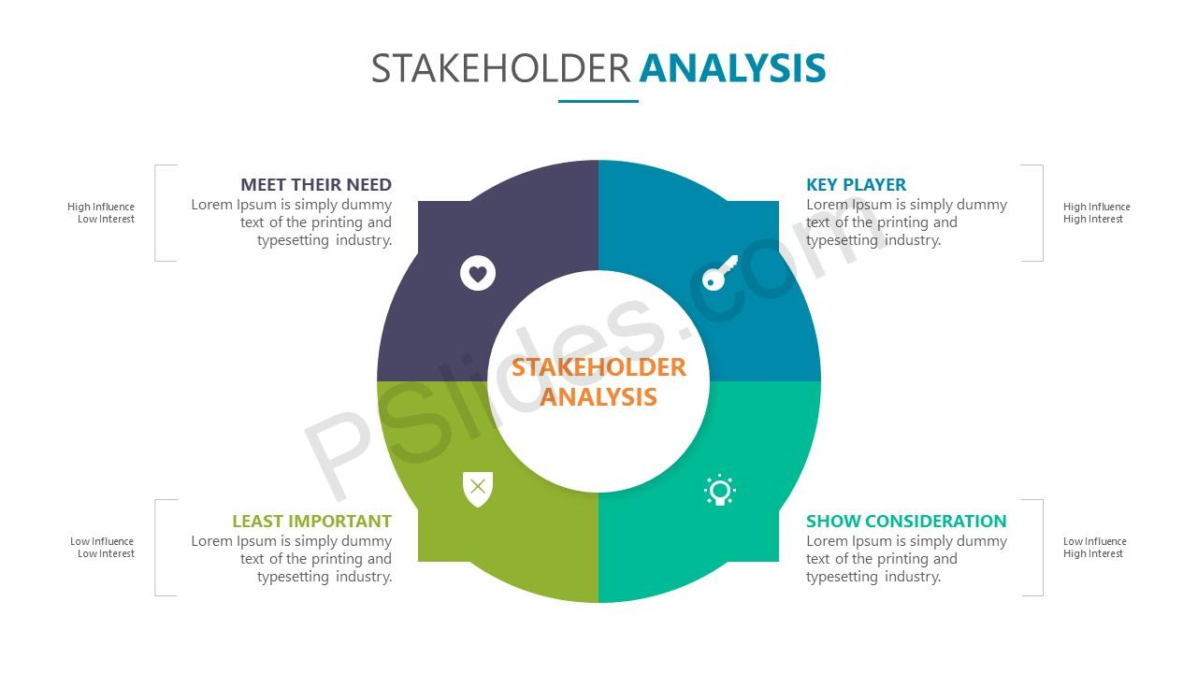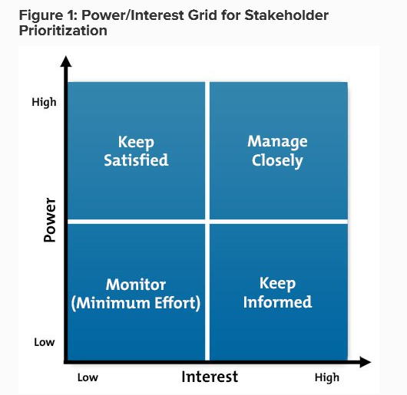Who else might be influenced by their opinions? Do these people become stakeholders in their own right?