**Environmental influences (PESTLE)**

It is important for every business organization to interact and transact with its environment because the business environment has direct relationship with the organization. The success or failure of an organization is primarily established by the effectiveness of its interaction with its environment.

**Analysis**

Business is affected by different factors which collectively form the business environment. These include economic, social, legal, technological and political factors. Business environment is therefore, the total of all external forces, which affect the organization and the business operations (Kotler &Armstrong 2004). These forces include customers, creditors, competitors, government, socio-cultural organizations, and political parties, national and international organizations. Some of these forces affect the business directly but others affect business indirectly.

Business environment are categorized into three main categories; internal environment; operational environment; and general/external environment.

**1. Environment Analysis-Political environment**

The political environment of any country influences the business to a larger extent. This political environment is influenced by the political organization, philosophy, government ideology, nature and extent of bureaucracy, the country’s political stability, its foreign policy, defense and military policy, the country’s image and that of its leaders both locally and internationally (Shaikh 2010). For example a country’s policy that restricts the growth of multinationals in the market will automatically limit the business operations of the company hence its growth. Similarly, government policy that allows licensing that is liberal, liberal exportation and importation, inflow of foreign capital and technology, affects the business operation. Globalization as government policy too has influence on the business. Burberry was able to establish its first foreign outlets in Paris, United States and South America, and export its first shipment of raincoat to Japan because of the government’s globalization policy.

**2. Economic environment**

Economic factors that influence the business are the collective of the nature of the country’s economic system, its structures, and economic policies, how the capital market is organized, and nature of factors of production, business cycles, and socio-economic infrastructure. Any successful organization pictures out the external factors that affect the business, anticipates the prospective market situations and work to minimize the costs while maximizing the profits.

In all economic situations low rates of interest encourage borrowing and the Federal government in a bid to improve this lowered the Federal fund rate from 6.5% to 1%. This was meant to better business the economic situation after the 9/11. The demand for further lowering of the interest rates however, continued due to rising and high U.S current account deficit as portrayed by the above graph. This deficit peaked alongside the housing bubble whose onset began in 2006. The deficits elicited foreign borrowing to cushion effects by enhancing exports. The spin off led to a high demand of financial assets and this lowered interest rates whilst raising prices of the respective assets. The high borrowing fueled high citizen consumption in the period before the onset of the crisis and this consequently led to the raising of Feds fund rate which turned things in the situation that resulted. This trend portrayed by the graph shows how the economic situation may affect the economy and general spending and therefore the performance of any business within such an economy.

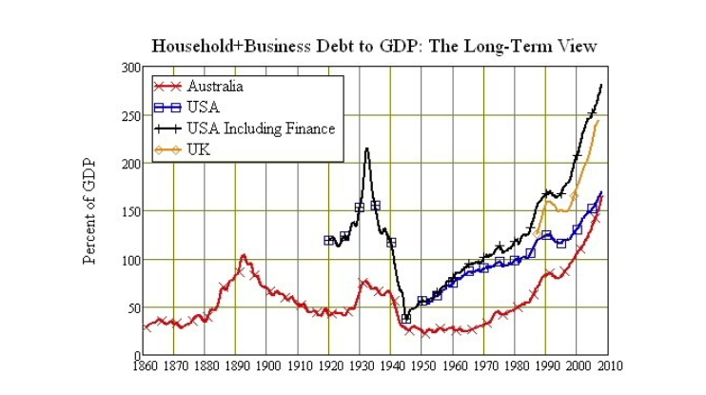Similarly, the long-term view of the graphical representation below shows how the economic trends in business and household debt to Gross domestic product change with times and it is easily notable that in the periods of peak moments of the rate there is a high level of economic challenges such as the 1930s period and the 2000 to 2010 period. Therefore, it can be concluded that economic trends are indeed significant determinants of general economic and business performance.

**3. Social environment**

The country’s social environment affects the functioning of the business since it determines the value system of the society. Sociological factors establish the culture of work, labor mobility, work groups etc, hence, business operation of an enterprise. These factors include cost structure, customs and conventions, cultural heritage, peoples’ view towards wealth and income and scientific methods, seniority respect, mobility of labor (Shaikh 2010). All these factors have big impact on the business. For example, peoples’ demand determine the kind of products to be offered for sale; this demand is consequently affected by peoples’ attitudes, customs, cultural values, fashion and other related forces.

**4. Technological environment**

Technological factors affects business concerning technological investment, technological application and the effect of technology on markets.  Therefore, any technological advancement affects highly the business in a country. The type and quality of goods and services to be produced and the type and quality of plant and equipment to be used in a company, is determined by the kind of technology employed by that company

**5. Legal environment**

The legal environment affects the business and its managers greatly. Legal factors involve how flexible and adaptable the law and legal rules that govern the business are. It also includes the exact rulings and courts decision. Legal provisions may also contribute to more or less income depending on the environment of operation.