**Porter’s Five Forces Model**

**Porter’s five forces model helps in accessing where the power lies in a business situation.**

Porter’s Model is a business strategy tool that helps in analysing the attractiveness in an industry structure. It lets you access current strength of your competitive position and the strength of the position that you are planning to attain.

Porters Model is considered an important part of planning tool set. When you’re clear about where the power lies, you can take advantage of your strengths and can improve the weaknesses and can compete efficiently and effectively.

Porter’s model of competitive forces assumes that there are five competitive forces that identify the competitive power in a business situation. These five competitive forces identified by the Michael Porter are:

1. Threat of substitute products
2. Threat of new entrants
3. Intense rivalry among existing players
4. Bargaining power of suppliers
5. Bargaining power of Buyers

[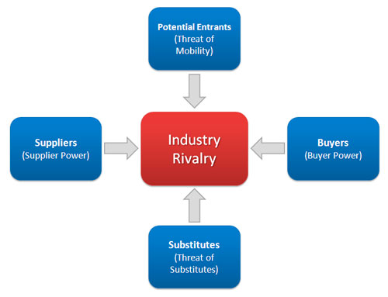](http://notesdesk.com/wp-content/uploads/2009/04/porters-five-forces-model.jpg)

**Threat of substitute products**

Threat of substitute products means how easily your customers can switch to your competitors product.

Threat of substitute is high when:

* There are many substitute products available
* Customer can easily find the product or service that you’re offering at the same or less price
* Quality of the competitors’ product is better
* Substitute product is by a company earning high profits so can reduce prices to the lowest level.

In the above mentioned situations, Customers can easily switch to substitute products. So substitutes are a threat to your company. When there are actual and potential substitute products available then segment is unattractive.

Profits and prices are affected by substitutes so, there is need to closely monitor price trends. In substitute industries, if competition rises or technology modernizes then prices and profits decline.

**Threat of new entrants**

A new entry of a competitor into your market also weakens your power. Threat of new entry depends upon entry and exit barriers.

Threat of new entry is high when:

* + Capital requirements to start the business are less
  + Few economies of scale are in place
  + Customers can easily switch (low switching cost)
  + Your key technology is not hard to acquire or isn’t protected well
  + Your product is not differentiated

There is variation in attractiveness of segment depending upon entry and exit barriers. That segment is more attractive which has high entry barriers and low exit barriers.  
Some new firms enter into industry and low performing companies leave the market easily.

When both entry and exit barriers are high then profit margin is also high but companies face more risk because poor performance companies stay in and fight it out. When these barriers are low then firms easily enter and exit the industry, profit is low.

The worst condition is when entry barriers are low and exit barriers are high then in good times firms enter and it became very difficult to exit in bad times.

**Industry Rivalry**

Industry rivalry means the intensity of competition among the existing competitors in the market. Intensity of rivalry depends on the number of competitors and their capabilities. Industry rivalry is high when:

* There are number of small or equal competitors and less when there’s a clear market leader.
* Customers have low switching costs
* Industry is growing
* Exit barriers are high and rivals stay and compete
* Fixed cost are high resulting huge production and reduction in prices

These situations make the reasons for advertising wars, price wars, modifications, ultimately costs increase and it is difficult to compete.

**Bargaining power of suppliers**

Bargaining Power of supplier means how strong is the position of a seller. How much your supplier has control over increasing the price of supplies? Suppliers are more powerful when

* Suppliers are concentrated and well organized
* Only a few substitutes available to supply
* Their product is most effective or unique
* Switching cost, from one suppliers to another, is high
* You are not an important customer to Supplier

When suppliers have more control over supplies and its prices that segment is less attractive. It is best way to make win-win relation with suppliers. It’s good idea to have multi-sources of supply.

**Bargaining power of Buyers**

Bargaining Power of Buyers means how much control the buyers have to drive down your products price, Can they work together in ordering large volumes. Buyers have more bargaining power when:

* Few buyers chasing too many goods
* Buyer purchases in bulk quantities
* Product is not differentiated
* Buyer’s cost of switching to a competitors’ product is low
* Shopping cost is low
* Buyers are price sensitive
* Credible Threat of integration

Buyer’s bargaining power may be lowered down by offering differentiated product.

If you’re serving a few but huge quantity ordering buyers, then they have the power to dictate you.

**Michael Porters five forces model provides useful input for SWOT Analysis and is considered as a strong tool for industry competitive analysis.**

<http://www.notesdesk.com/notes/strategy/porters-five-forces-model-porters-model/>

An Interview with Michael E. Porter, Professor, Harvard University. Porter's five competitive forces is the basis for much of modern business strategy. Understand the framework and how to put it into practice. 2008 – 13 mins

<https://www.youtube.com/watch?v=mYF2_FBCvXw>