|  |  |
| --- | --- |
| Artist | N/A |
| Title | Benin Plaque: Soldiers and attendants and the Oba’s palace doors |
| Date | 1500s (16th Century) |
| Medium | Copper |
| Scale | 50cm wide |
| Scope | Ethnic identity in 2D or 3D works (pre- and post-1850) |
| Style | N/A |
| Patron | Oba Esigie |
| Location | West Africa, Benin Empire  Now located at British Museum, London |
| Function | Decoration of the audience hall in the palace. |

History of the Benin Bronzes

There are over 850 other bronze plaques across the globe, any many more were destroyed in the burning of Benin City in 1897.

Oba Esigie commissioned the Bronzes at a time when the courts of the palace were in upheaval. These bronzes showed what the Benin Empire should be like. They assured the kings dominance over his subjects.

The plaques covered the pillars in the audience hall of the palace.

The plaques were polished in the palace, so were shiny and bright. When taken by the British, they were oiled to suit the aesthetic of Europe.

When the bronzes were taken by colonial Britain, they took a 1/3rd for themselves, and sold the rest across Europe. People were fascinated by this ‘primitive’ art.

How are the Benin Bronzes made?

They are made in the ’lost wax’ method, where bronze is cast in wax moulds. Once the mould is made, the wax is melted and drained away.

This method has been used from the 3rd millennium BC and has not changed since.

Benin Empire:

The Benin or Edo Empire was a large pre-colonial state in modern Nigeria. Whilst it existed it was an economic and political power that ruled over 2 million people.

It was ruled by an Oba, or King.

The capital Benin City was turned into a military fortress protected by moats and walls, from which military attacks were launched to gain more lands.

The state also developed an advanced artistic culture, especially in bronze, iron and ivory, including bronze wall plaques and life sized bronze heads of the Obas of Benin. The guild of artisans enjoyed royal patronage.

The Benin Empire made its money trading slaves from enemy states to the Americas in Dutch and Portuguese ships. They also traded ivory, palm oil and pepper.

They had a close relationship with Portugal.

The Benin Empire was destroyed in 1897 by the colonial power of Great Britain. They burnt down their city and destroyed their royal treasury.

Image: 

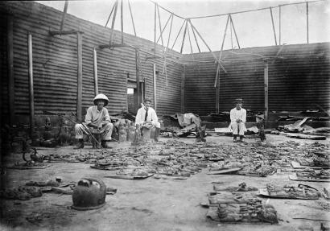

Use of materials

Copper was used as money in the Benin Empire. The King lined his palace walls with plaques made from ‘money’, showing his wealth and power.

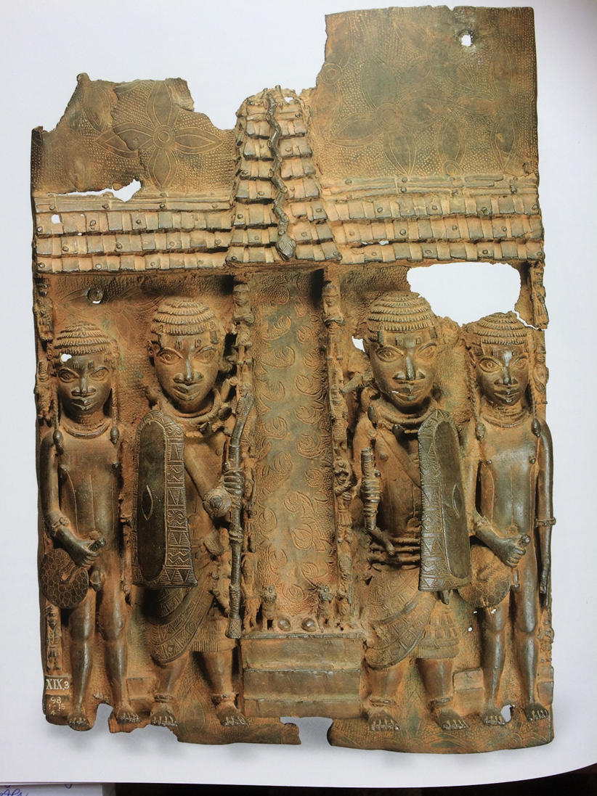

All 4 figures facial features have been stereotyped. The heavy outline of their facial features shows their collective identity as part of the Benin Empire. It show their uniqueness as a group.

All 4 figures wear coral headdresses. Coral links to the Goddess Olokan, who symbolises wealth and lived under water.

Two outer figures are slaves, holding fans for the king. Their long hair signifies youth. They are smaller than the soldiers to signify their lesser status.

Ornate decoration of the palace walls, showing immense wealth and status, but also artist’s skill and talented craftsmen, they are a cultural society.

Decoration is of the River Leaf. The God of wealth Olokan lived in the river, linking wealth to god.

Shield is decorated ornately-ceremonial, instead of for battle.

Two inner figures are soldiers/guards, they are clothed compared to the slaves. They have higher status.

Snake is a python. King of the snakes.

Fans are decorated- for the king.

Two leopards-king of the cats. Signifying the Oba’s power.