|  |  |
| --- | --- |
| Architect | Zaha Hadid |
| Title | MAXXI Museum |
| Date | 2000-2010 |
| Medium | Concrete, steel and glass |
| Scale | 24,000 sqm (including car park and land surrounding building) |
| Scope | Identity in Architecture, Work by Key Artist |
| Style | Parametricism |
| Patron | Italian Government |
| Location | Rome, Italy (outside city centre and located on old military grounds) |
| Function | Contemporary Art gallery |

|  |  |
| --- | --- |
| **Formal features** | |
| Composition | Waves of bending concrete tubes that are layered on top of one another. Fluid lines run throughout the building. Referred to as a “snaking stage”. |
| Colour or texture | Smooth and grey coloured. Lacks any texture due to the use of concrete, glass and steel. Small areas of light grey and white create a clean looking building. |
| Light & tone | Concrete absorbs light so doesn’t make building look luxurious, instead celebrates the beauty of the materials. |
| Space & depth/relief | Large scale, part of building wraps round the side next to the traditional local buildings. Low to ground but fluid lines, emphasising the ideas of rivers and journeys. |
| Line or brushwork | Fluid lines with straight edges occurring in areas such as windows and pilotis. Material is smooth and lacks detail, shows beauty of natural materials. |

**Critical text quote:** Could use “Ornamentation is a crime”- Sullivan

“There are 360 degrees, so why stick to one?” – Hadid

“I really believe in the idea of the future.”- Hadid

**Influence from technological factors:**

The invention of concrete that the Romans made, influenced Hadid to use the material throughout her work. In doing this she creates an authentic feel towards the building as it is such a controversial building compared to traditional Italian buildings.

**Influence from political factors:**

At the time Italy was struggling economically, similar to how Greece is nowadays. Therefore, there had been a huge lack of investment within the construction industry. “No major public buildings have been built in Italy in the last 20 years” said Gianluca Racana, project architect. It was calculated that the final out- come cost was £5541 per sqm and an overall cost of £133 million. The excessive amount going towards this museum that differed so much from the architecture surrounding it created a huge controversy between the local residents and the government.

**Influence from cultural/social factors:**

Rivers surrounding Rome that were once such an important aspect of the city influenced Hadid to create the same fluidity within this museum. She thought it was fitting as art is also constantly changing and therefore suits the constant changing exhibitions within the building. The fluidity she involves shows the journey of art as well as a small amount of history about Rome.

**Image:** 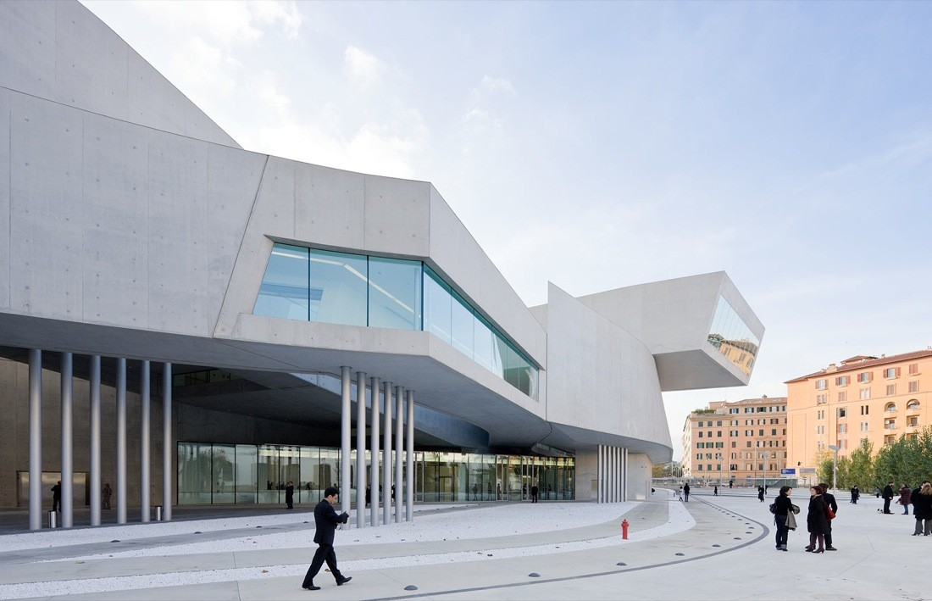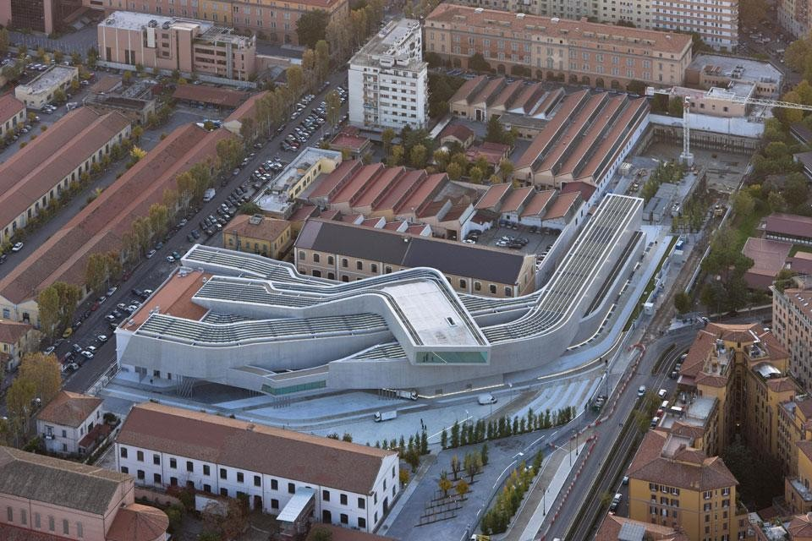

**Use or development of materials, techniques & processes:**

Used concrete, steel and glass and lacked decoration as she believed the natural beauty of the materials was enough. Uses pilotis to make building look less heavy despite the fact its concrete, so that it creates a more light, airy and fluid feel. Ribbon windows add large amounts of light into the building, useful for an art gallery.

**Stylistic comment and artistic influence:**

Influenced by the creation of concrete by the Romans as well as their use of curves, such as curved arches of ancient Rome but simplifying these architectural features. Created curved and fluid shapes to represent the rivers surrounding Rome that once transported all goods as well as suggesting that art is a journey in its self because it never stays the same.