|  |  |
| --- | --- |
| Artist | Marc Quinn |
| Title | Siren |
| Date | 2008 |
| Medium | 18ct gold |
| Scale | 88h x 65w x 50d cm |
| Scope | Female figure |
| Style |  |
| Patron | N/A |
| Location | The British Museum (2008) |
| Function |  |

|  |  |
| --- | --- |
| Formal features | |
| Composition | The figure is in an awkward yoga position. This is Quinn suggesting that perfection isn’t achievable, so he has cast it in an uncomfortable position, suggesting that perfection is not attainable. |
| Colour or texture | The polished gold shows that humans strive for the unachievable, but we forget that we created the unachievable image ourselves. Just as humans created the fact that gold is a precious metal. |
| Light & tone | The sculpture is a reflective surface and it is very bright this links to the name of the piece as sirens are mythological mermaids/creatures who lured sailors onto the rocks. |
| Space & depth or relief | The structure is relatively flat showing the figures dexterity and flexibility. |

Influence from technological factors:

N/A

Critical text quote: “Gold is a metal that humans have decided is one of the most valuable materials in the world, but like their invented images of perfection, gold itself is a belief system- inherently no more valuable than any other metal”.- Marc Quinn

Stylistic comment and artistic influence:

This work was produced as part of the ‘Sphinx’ series three years after ‘The complete marbles’ which featured Alison Lapper pregnant (2005). They were very contrasting projects as Siren is about the idealised body which strives for perfection.

Use or development of materials, techniques & processes:

In Quinn’s early career he learned to cast in bronze, so this may have influenced siren because this would’ve made the piece more lifelike. The fact that it’s cast in gold reinforces the theme of perfection. Quinn got a yoga professional to pose for this piece and cast her, although he then modelled it into Kate Moss’s measurements and features.

Image: 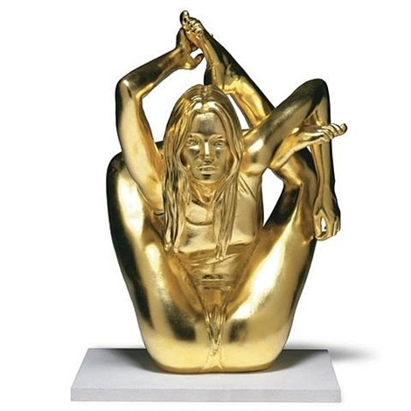

Influence from political factors:

When this sculpture was shown in the British Museum in 2008 alongside its classical counterparts, it also coincided with the beginning of the global financial crisis further emphasising the fragility of the belief system that expensive metals are of actual value, rather than just of value created by humans. much as it also represents the strive for perfection that is an impossible goal.

Influence from cultural/social factors:

In 2005 Quinn created ‘The complete marbles’ which was a response to the Elgin marbles which came from the Parthenon. Included in this was Alison Lapper pregnant. After that his next project was Sphinx (including Siren) exploring the way in which humans strive for perfection and beauty which are unattainable.