|  |  |
| --- | --- |
| Artist | Mimar Sinan |
| Title | Suleymaniye Mosque |
| Date | 1550-1557 |
| Medium | Marble, granite, porphyry |
| Scale | Interior 59m2, Dome 53m high |
| Scope | Mosque - Religious |
| Patron | Sultan Suleyman I |
| Location | Istanbul, Turkey |
| Function | Mosque |

Political factors:

Suleyman was the 10th and longest reigning Sultan in the Ottoman empire.

Under his rule the empire had financial, military and cultural success. Gained a lot of territory.

Signed a peace treaty with the Holy Roman Empire, Spain and Austria – celebrated by building the Mosque

Known as Suleyman the Lawgiver to give changes to society, education, taxation and criminal law.

Wanted to turn Constrantinople into the Islamic centre, built bridges, mosques, palaces and social establishments.

Historical context/subject of work:

Byzantine influences – Emperor Constantine adopted Christianity and moved the capital from Rome to Constantinople. Christianity overtook Greco-Roman Gods that had once defined religion and culture. The shift influenced the art across the empire. The Hagia Sophia was built under Emperor Justinian and Suleyman wanted to surpass the structure.

How does this example fit the scope of work:

Religious identity – central fountain, high dome, stained glass, light from high windows and low hanging lights give a connection from God, stained glass on qibla, mihrab and minhbar, functions of a mosque and to educate in Islam and teach reading and writing

Critical text quote:

“The most celebrated architect of the premodern Islamic lands is bolstered by his affinity between his centrally planned domed Mosques and Italian Renaissance churches”

How does this example fit the scope of work:

Identity of Sultan Suleyman I – wanted to be the law giver and improve the empire. Empire grew and took over a lot of Roman territory – wanted it to be bigger than Hagia Sophia – built baths and schools – four minarets with 10 galleries

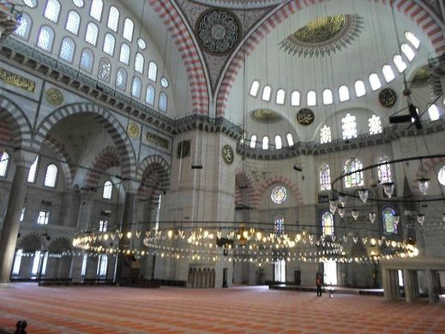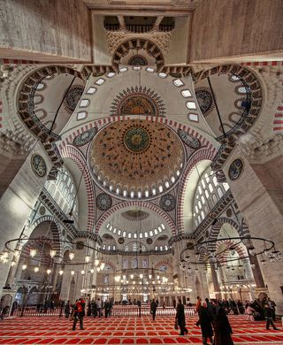 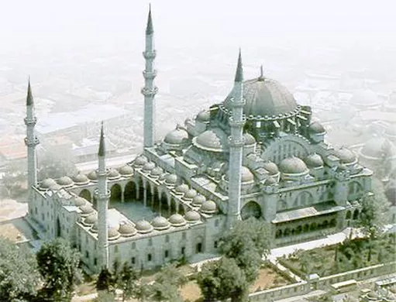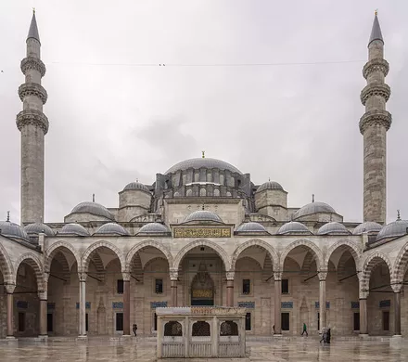

Cultural/social factors:

Schools were built in the Mosque and funded by religious foundations to provide largely free education.

Suleyman increased the number of primary schools and colleges to teach reading and writing and teachings of Islam.

Educational buildings, libraries, baths, soup kitchens residences and hospitals for the public were built surrounding the courtyard.

Artist’s involvement:

Mimar Sinan was the Sultan’s chief architect for 12 years

Earlier career in the military meant he travelled across the Ottoman Empire.

Sometimes called the ‘Turkish Michelangelo’ or the ‘Grand master of the Turkish renaissance’

|  |  |
| --- | --- |
| Formal features | |
| Composition | Exterior   * Outer courtyard is entered by 11 portals. * Inner rectangular courtyard is entered by 3 portals – central portal decorated with fine stonework * On either side of the portal there are three rows of cells and 12 windows * 4 minarets in either corner of the courtyard – 2 taller with 3 galleries and 2 shorter with 2 * Main dome in the centre - when it was built it was the highest dome in the Ottoman empire. * Dome in flanked by 2 semi-domes * Smaller domes are repeated throughout the rest of the roof * An arcade of arches surround the courtyard.   Interior   * Almost a square (59x58m) forming an open space * North and South arches have tympana- filled windows supported by porphyry monoliths * Sinan incorporated the buttresses into the walls to hide them in the architecture – idea of the dome floating in the heavens * Stained glass windows limited to the Qibla wall * Iznik tiles used around the mihrab with floral patterns on a white ground with blue, turquoise, red or black. * On either side of the mihrab there are quotes from the Quran * Glass windows surround the base of the dome creating a sense of the heavens being above them and a lot of light shines down creating a link with God * Lamps hang down from the ceiling highlighting the size and gap between God and the visitor |
| Materials | * Stone carvings and inscriptions in Islamic around the doorways * Courtyard paved in marble * Marble, granite and porphyry columns surround the courtyard * Central fountain * Northwest façade is decorated with rectangular Iznik tile windows * White marble mimbar in a simple design, woodwork is restrained with simple designs in ivory and mother of pearl * A gold pinnacle on top of the top dome |

|  |  |
| --- | --- |
| Courtyard | Large courtyard on West Side |
| Hypostyle mosque | Many columns in the mosque |
| Four minarets | (towers) to call for prayer – 4 of them shows it has been endowed by a Sultan |
| 10 galleries (serifes) around the minarets | Shows Suleman was the 10th Ottoman Sultan |
| Central plan |  |
| Square Interior |  |
| Dome | 53 m high, 27.5m diameter. Represents the vault of heaven |
| Dome flanked by semi-domes | With buttresses in the walls |
| Pendentives | Supports that lift the dome above the piers |
| Mihrab | A niche in the wall which indicates the direction of Mecca, the direction in which all Muslims pray |
| Minbar | Pulpit or elevated platform from which the Imam leads the service |
| Muqarnas | Ornamental vaulting |
| Iznik tiles | Richly coloured tiles for architectural decoration |
| Qibla | Wall in which the mihrab is set |
| Porphyry | Stone including large grained crystals |
| monolith | carved, cast or excavated from a single piece of material, historically from rock |
| tympana | semi-circular or triangular decorative wall surface over an entrance, door or window |