|  |  |
| --- | --- |
| Artist | Graham Sutherland |
| Title | The Crucifixion |
| Date | 1946 |
| Medium | Oil on hardboard |
| Scale | 2.75m x 2.62 |
| Scope | The divine |
| Style | Neo-Romanticism |
| Patron | Sir Walter Hussey |
| Location | Northampton Church |
| Function | N/A |

|  |  |
| --- | --- |
| Formal features | |
| Composition | Square shaped canvas, an unusual shape to choose for a vertically emphasised image. Christ is central in the painting. He is the focal point and only figure. |
| Colour | Christs body is white-purity, drainage of blood, death, isolation  Background is blue-Virgin Mary, superiority, sea sky, emptiness, isolation  Blue/orange-complimentary colours |
| Light & tone | Light and tone captured on the figure of Christ. Shadow under his ribcage to emphasises his emaciation. Light source shining onto his body and the cross. |
| Space & depth or relief | Lack of space and depth. High relief of the figure and the flatness of the rest. |
| Line or brushwork | Use of angular lines across the background encourage the viewer to see the canvas as flat. |

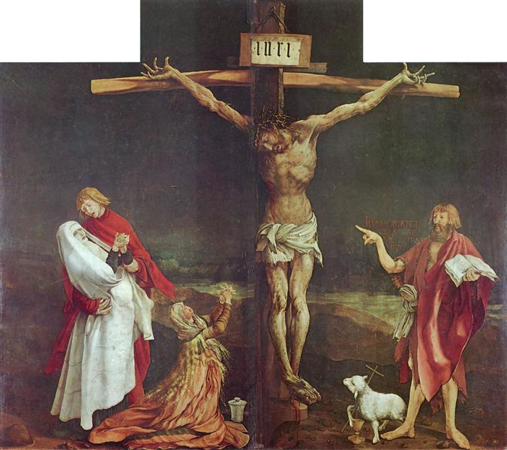

Critical text quote: the anguish implied by some of the scenes of devastation will cause one to invent forms which are the pictorial essence of sordidness and anguish-Sutherland

Style

Neo romanticism links to landscape painting. Influenced by 19th century artists, French Cubist and post cubist artists. It was motivated as part of a response to the threat of invasion.

This painting is a religious scene, so does not fall under subject matter preference of the style, but motivations for the movement are visible in the subject matter.

Graham Sutherland

Sutherland converted to Catholicism in 1926, meaning his art had a deep connection to religion.

1940 he was employed as an official war artist in WW2. He painted mining, industry and bomb damage.

A new depiction of the crucifixion

Just before this was painted, pictures were released from Nazi concentration camps. The world now knew the true horrors of the depravity of the Nazis. British society was shocked and wanted to retaliate towards this innate cruelty. These images of endless cruelty towards each other is visible in the painting.

Many depictions of the crucifixion fail to depict the true nature of the event, instead favouring accurate depiction of physical details instead of emotions.

Sutherland seeked to bring home the horrific reality of death by crucifixion. He depicts the nobility of Christ’s sacrifice, which is exploited to convey the consequences of human sin.

This painting does not depict a historical event, but presents reality. The constructional cross represents present day and the lack of detailed background represents unspecified time and space.

The figure is alone, not surrounded by friends or family, showing isolation and many of the WW2 prisoners who also died alone through torture and violence.

Christ’s head is bowed and on either side of him is two pockets of blackness, suggesting the two thieves who died beside Christ.

The suggestion of a brick wall at the foot of Christ emphasizes the background of civilisation that has crucified Christ. The little railing stresses the sacredness of the event and also our position of merely and spectator. We cannot understand his pain.

Artistic influence:

Sutherland was influenced by many artist, notably:

Francis Bacon’s Three Studies for Figures at the Base of a Crucifixion, 1944

Grunewald’s Crucifixion in the Isenheim Altarpiece, 1516-

* Lack of background, taught and claw-like hands, head bowed, legs bent, figure emaciated, unusual cross, lack of colour range to highlight focal point

Image: 