|  |  |
| --- | --- |
| Artist | Titian |
| Title | Venus of Urbino |
| Date | 1534 |
| Medium | Oil on canvas (High Renaissance style) |
| Scale | Big |
| Scope | Nude female figure |
| Patron | Duke of Urbino |
| Location | Florence |
| Function | To inform of the ‘proper’ way to be a wife. |

Image: 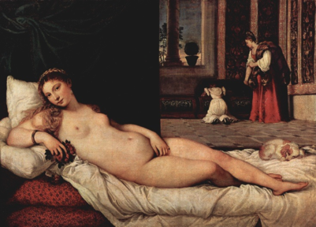

Historical context/subject of work:

The Duke of Urbino commissioned this work to show his future wife the proper way for a wife to act. The central figure, being labeled as Venus (the Roman Goddess of love and beauty), is made out to be the ideal woman – submissive, beautiful and made to prioritize virtue over character and individuality.

The figures in the back show the other roles she should adhere to as a wife; firstly a mother (shown by the younger girl leaning in to look in the chest); and secondly she should also give domestic household work attention (shown by the second woman who seems to be caring for the younger girl, and carrying a dress over her shoulder).

The setting itself emphasizes a domestic setting, and the main figures’ direct and open appearance implies that she is awaiting the arrival of her husband, as (it is implied) should always be her priority.

Critical text quote:

How does this example fit the scope of work:

Shows a nude female figure subjected to the male gaze. She is characterized by her possessions and things she is surrounded by. (flowers for feminity, jewelry to show her prestige, dog to show submissiveness).

How does this example fit the scope of work:

The painting shows all the roles a woman was expected to fill, (an idealized, submissive wife, a mother and a domestic household worker).

|  |  |
| --- | --- |
| Formal features | |
| Composition | Nude female figure draped across a bed, two other figures in the background looking to be doing household work. |
| Colour or texture | Hidden brushstrokes. Red mattress, flowers and dress in the background. White sheets to show purity. |
| Light & tone | The main figure is in direct light. |
| Space & depth or relief | The background is divided into two sections, to the left hand side is a heavy rich green velvet curtain and in the right hand side are two female figures giving the scene a more domestic setting. Bar in the window implies a restriction to the house. |
| Line or brushwork | Smooth brushwork, idealized finish. |

Cultural/social factors:

In the 16th century, women were objectified far more, and were expected to belong to their husbands. This painting represented what was normal of the time, that women should feel a specific role.

Political factors:

Politics had little to do with women’s role as wives, and little to do with women’s roles in general. The lack of a political factors within this painting shows that it was not considered necessary for women to have anything to do with politics.

Artist’s involvement:

Colours are rich and typical of those used by Titian and other artists working in Venice during the Renaissance. Both the red and greens complement each other.

Titian creates space and depth through the receding tiled floor, the lightly coloured sky outside the window provides atmospheric perspective. Titian connects the foreground of the painting with the background by including the deep red colour of the chaise longue with the dress of the female attendant. He also scales objects and figures accurately to create a realistic scene.