Artist | Frida Kahlo  Image: 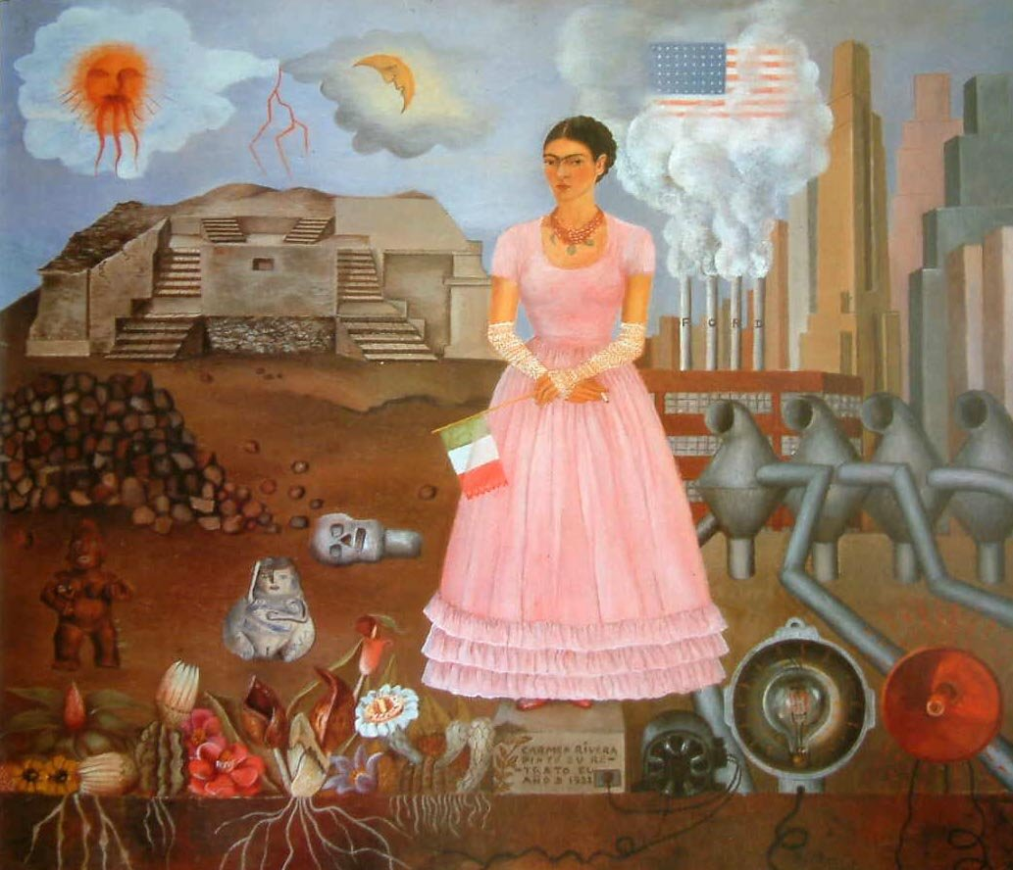
Title | Self Portrait On The Borderline Between Mexico And The USA
Date | 1932
Medium | Oil on canvas
Scale | 28cm x 35cm
Scope | Portrait in 2D. Gender identity. Ethnic identity. Beyond European tradition
Style
Patron
Location | In a private collection
Function
Formal features
Composition | Frida stands centrally on a boundary stone, wearing an uncharacteristically sweet pink dress and lace gloves. Her face has a mischievous expression. As a symbol of her defiance to north America, she holds a cigarette in her right hand and a Mexican flag in the other, showing her loyalty to Mexico, as are the roots seen at the bottom of the canvas. There is a sun and a quarter moon, both in clouds in the top left corner that create a bolt of lightning as they touch. On the right side of the painting (USA) a single cloud hangs above smothering the flag of the USA, formed by the fumes of four chimneys spelling out ‘FORD’. On the Mexican side, lies a partially ruined pre-Columbian temple. USA has skyscrapers, Mexico has pre-Columbian fertility idols, a skull, a pile of rubble and at the bottom are exotic plants with white roots. At the bottom of the USA side, there is only machines and electrical cords.
Colour or texture | Realistic use of colour, applied in blocks areas, with some attention to detail.
Light & tone | This work was painted indoors, therefore there is no natural light visible here. The whole canvas is well lit however the more shaded side of the photo is the Mexican side.
Space & depth or relief | Realistic sense of space, linear perspective with Frida’s figure and the background objects such as skyscrapers. Depth is not accurately depicted, there is an emphasis on the flatness of the canvas, shown by the outlining of objects such as machinery and with the application of large areas of colour.
Line or brushwork
Stylistic comment and artistic influence:
Influence from political factors:
As in many of Frida’s works, her nipples show through the material of her dress, this links to her ideas about feminism. It plays with the ‘pretty in pink’ stereotype.
The boundary stone marks the borderline between Mexico and the United states. It is engraved with “Carmen Rivera painted her portrait in 1932” using her Christian name and her husbands surname, expressing how she felt she always pretended to be ‘proper’
Use or development of materials, techniques & processes:
Symbolism – flag, roots, cigarette, machinery. Pre-Columbian idols. Mexico has a lot of connections with life cycles and the idea of death.
Critical text quote:
Influence from technological factors:
Modern city scene in right hand side of painting, depicting North America. Includes machinery, electrical cords, skyscrapers, factories.
Influence from cultural/social factors:
At the time this painting was made, Frida and her husband Diego Rivera, a muralist, were living in North America, while Diego completed a commission for the Detroit Institution of Arts. Frida longed to return to the ancient Agricultural culture of her hometown Mexico.

