|  |  |
| --- | --- |
| Artist | Jan Van Eyck |
| Title | Arnolfini Portrait |
| Date | 1434 |
| Medium | Oil on oak |
| Scale | 82 x 60 |
| Scope | Early Rennaisace/ Northern Rennaisance |
| Patron | Arnolfini |
| Location | National gallery, London |
| Function |  |

Image:

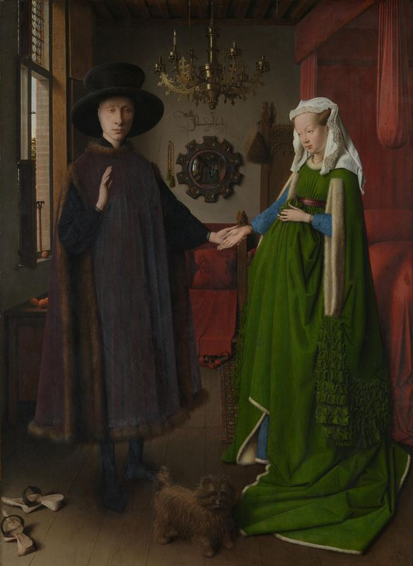

Critical text quote:

“There is a virility about van Eyck’s portraits: the composition is strong, and the subjects themselves seem warm-blooded and muscular” – Eugene Fromentin, 1876

|  |  |
| --- | --- |
| Formal features | |
| Composition | Balanced composition with use of line, as well as negative space and with rectangular forms opposite each other. |
| Colour or texture | Bright colours used to highlight the wealth of the individuals. In Italy, the colour green was reserved for those involved in banking, so this represents her business class. |
| Light & tone | In this painting van Eyck uses both direct and indirect light. The light from the window provides the direct light into the scene which can be seen on the shading of the oranges and the reflection on the chandelier and other surfaces. Layered pint and minimal use of oil contributes to this appearance. |
| Space & depth or relief | Intense levels of detail throughout the painting, no sense of a main focus on the figures. Scientific ideas regarding perspective etc had not occurred yet. |
| Line or brushwork | Very detailed throughout, especially on the mirror in the background which depicts the scene again, which it is thought he used a magnifying glass for. |

How does this example fit the scope of work:

Work by a specified artist.

Pre 1850 portrait

Historical context/subject of work:

The Arnolfini Portrait was originally believed to be a portrait of Giovanni di Arrigo Arnolfini and his wife Giovannna Cenami, but it is now thought that the couple married 13 years after the painting was painted.  
  
The painting depicts a rich couple, both from the largest banking families in Lucca, convening in a parlor of French fashion. The couple is warmly and finely dressed, their garments are cut with fur, even though the fruit outside the windows on the tress suggest that it is summer time.

There are many different interpretations of the painting;  
  
• A memorial for a dead wife   
• A gift for the Arnolfini that had the purpose of showing their wealth   
• That the painting shows a betrothal and not a marriage   
• Grant of legal authority from husband to wife to conduct business in his name   
• To show Giovanni's good character, possibly to promote business relations   
• The signature on the back wall is a legal document of a marriage   
• That none of the symbols have any deeper meaning   
• It is only a double portrait and nothing else.

Religious iconography:

Rosary - A string of beads for keeping count in a rosary or in the devotions of some other religions. It can be seen next to the mirror in the background of the painting.

Mirror - This mirror is in the background of this painting, it contains various religious images around the mirror. On the right side it contains images of death and on the left images of life.

The positioning/ stance - The positioning in this painting is somewhat like many religious images. His hand is raised vertically, much alike the pose used when blessing someone.

The chandelier - The chandelier is located above the couple at the top of the painting. It contains only one lit candle which can also be interpreted as God’s all seeing eye, it can also represent life and devotion.

Artist’s involvement: