|  |  |
| --- | --- |
| Artist | Daniel Libeskind |
| Title | The imperial war museum north |
| Date | 2001 |
| Medium | Zinc, steel, iron and concrete |
| Scale | Houses 245,400 visitors |
| Scope | Memorial |
| Patron | British Government |
| Location | Manchester quays |
| Function | Tells the story of how war has  affected the lives of British |

|  |  |
| --- | --- |
| Formal features and Composition | The EarthShard, WaterShard and the AirShard A series of three curved geometric forms, each with a distinct purpose. The overall composition is asymmetrical and fragmented. |
| Colour or texture | The building is a metallic colour which captures the light and reflects it |
| Light & tone | It is a monochrome scheme which reflects the light and tone of the river it is located by. |

Artist’s involvement:

Libeskind was a Jew and his family was persecuted by the Nazis during the Second World War and therefore this impacted him and his decisions involving his architecture.

Artist’s involvement:

Libeskind was a Jew and his family was persecuted by the Nazis during the Second World War and therefore this impacted him and his decisions involving his architecture.

Critical text quote:

: *Create a building which…emotionally moved the soul of the visitor*.

Historical context/subject of work:

All wars from the 20th Century onwards which Britain and the Commonwealth have participated in. Placed on docklands which were heavily bombed by German air forces during WW2. This directly links the function of the building to its location.

The main elongated central form represents ‘land’ and this is where the main displays are. The vertical tower references ‘air’ and it rises above the main entrance, giving a sense of awe. The upward curving fragment on the left of the façade represents ‘sea’ and this is used for the education centre and social area.

|  |  |
| --- | --- |
| Formal features and Composition | The EarthShard, WaterShard and the AirShard A series of three curved geometric forms, each with a distinct purpose. The overall composition is asymmetrical and fragmented. |
| Colour or texture |  |
| Light & tone |  |
| Space & depth or relief |  |
| Line or brushwork |  |

All wars from the 20th Century onwards which Britain and the Commonwealth have participated in. Placed on docklands which were heavily bombed by German air forces during WW2. This directly links the function of the building to its location.

The main elongated central form represents ‘land’ and this is where the main displays are. The vertical tower references ‘air’ and it rises above the main entrance, giving a sense of awe. The upward curving fragment on the left of the façade represents ‘sea’ and this is used for the education centre and social area.

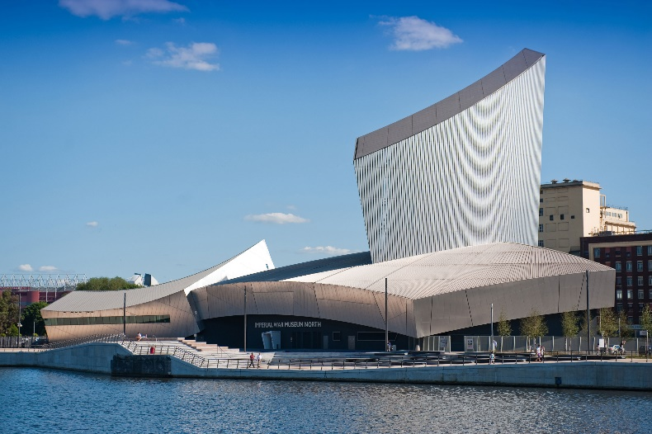

How does this example fit the scope of work:

Libeskind takes the concept of a globe (the world) which has been shattered due to wars and places these shards back together in a rudimentary manner. Three distinct shards link to land, sea and air- the three areas where conflicts can take place (RAF, Navy, Army). Libeskind is suggesting that the world (life) cannot be put back together as it was before wars.

Cultural/social factors:

Links to participants of war who fought for the British and the commonwealth

Cultural/social factors:

Links to participants of war who fought for the British and the commonwealth