|  |  |
| --- | --- |
| Artist | Eugene Delacroix |
| Title | Massacre at Chios |
| Date | 1824 |
| Medium | Oil on Canvas |
| Scale | 4.1m x 3.5m |
| Scope | Places affected by War. Participants of War |
| Patron |  |
| Location |  |
| Function |  |

Image: 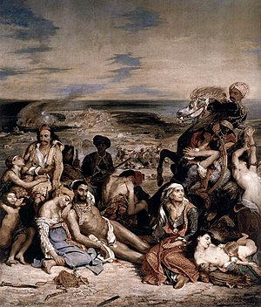

Historical context/subject of work:

Greece had been under the rule of the Ottoman Empire for centuries. However, Greek revolutionaries fought for their independence.

People of Chios (A wealthy Greek island) didn’t want to participate in the uprising against the Ottoman rule.

In March 1822, Greek insurrections from the mainland and a neighbouring island arrived at Chios to attack the Turkish troops.

Over the next four months approximately three quarters of the islands population (120,000) were killed, enslaved or died from disease.

Cultural/social factors:

The people at Chios didn’t want to be part of the fight – were severely affected.

The Greeks were clothes that are traditionally Greek. The clothes show they have been affected and the money they have is worthless.

The ottoman on the horse is richly dressed showing his power and control. Also, what he wears shows he isn’t fighting. Contrast to what the Greeks wear.

Critical text quote:

“A hymn to irremediable anguish.”

A work with ‘no reference to glory’

How does this example fit the scope of work:

Shows the realities of war as everyone is affected, we see a lot of death and injuries. The Greeks are therefore portrayed as vulnerable and weak. Showing how the work fits into the horrors of war.

Artist’s involvement:

Delacroix was outraged by the treatment of the Greeks at the hands of the Ottoman.

He created this painting as the event was fresh in the mind of the viewers.

The painting was originally called ‘Massacres at Chios, Greek families Awaiting death or slavery.’ – Title explains scene.

The whole painting doesn’t show heroism, showing Greeks of all ages, wounded and killed.

France and Delacroix were therefore sympathetic to the Greeks.

|  |  |
| --- | --- |
| Formal features | |
| Composition | All the figures are crowded in the front. The background shows Chios in ruins and the stormy sky shows they have no escape from their future. On the right to the front of the painting there is a baby holding his dead mother’s breast. There is also an old woman and reflects the child’s future – three generations of life. All figures lean on each other waiting for something to happen. Ottoman on horse – richly dressed showing his power. Horse has a wild expression – has more emotion than man killing. |
| Colour or texture | The whole piece has rich and intense colours, but is monotone painting reflecting the atmosphere of this horrific event. There is also red suggesting passion, bloodshed and rage. |
| Light & tone | There are strong shadows which add realism to the painting. Furthermore, the light emphasizes the pain and hurt on the Greeks. |
| Space & depth or relief | Chios is ruins in the background adds depth, main focus on crowd of wounded Greeks. |
| Line or brushwork | Very detailed – Romantic style. |