|  |  |
| --- | --- |
| Artist | Käthe Kollwitz |
| Title | Mother and Her Dead Son (Pietà) |
| Date | Completed 1939 |
| Medium | Bronze |
| Scale | Larger than life size |
| Scope | People affected by war in 3D |
| Patron | -- |
| Location | New Guardhouse, Berlin |
| Function | -- |

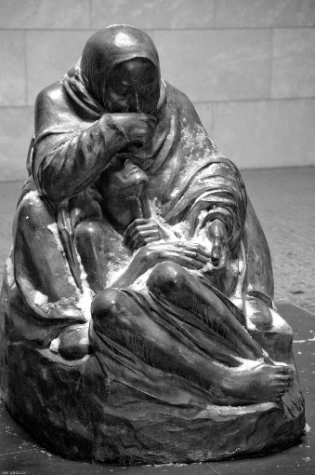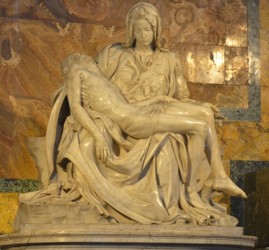

Historical context/subject of work:

* Kollwitz’s son Peter died in WW1 in 1914.
* Kollwitz had to sign to allow Peter to go to fight because he was too young to go on his own.
* Kollwitz took inspiration from ‘Pietà’, Michelangelo 1498-99 which shows Mary and her dead son Jesus.
* It is now displayed in the New Guardhouse in Berlin. This used to be in the Nazi police force and is now dedicated to victims of the wars.

Critical text quote:

How does this example fit the scope of work:

It shows a mother who has been affected by war thought the loss of her son and the son has been affected due to his death.

|  |  |
| --- | --- |
| Formal features | |
| Composition | Mother cradling her dead son |
| Colour or texture | Dark colour symbolized sad/ depressing subject  Texture of rock/ earth they are sat on is rougher then the figures making the ground and them distinct. |
| Form | Triangular form shows physical strength. Having the son lower suggests he was her base |
| Space | No negative space. Son emerges from draped clothing as if being born again.  Mother’s foot is on ground above the son suggesting the son is being put or is in a grave. |

Political factors:

1939 Hitler is in power in Germany and he views Kollwitz as a degenerate artist and anti-fascist.

Artist’s involvement:

Kathy Kollwitz is the mother featured mourning her dead son, who was killed at war.