|  |  |
| --- | --- |
| Artist | Pablo Picasso |
| Title | Guernica |
| Date | 1937 |
| Medium | Oil on canvas |
| Scale | 3.49 x 7.76 |
| Scope | War or revolution in 2D works  Places affected by war in 2D or 3D works |
| Style | Modernist |
| Patron | Spanish Republican Government |
| Location | Museo Reina Sofia, Madrid |

|  |  |
| --- | --- |
| Formal features | |
| Composition/Line/Figure Handling | Scattered and chaotic composition showing lack of control in the country and a lack of reason for this event. Line is used to illustrate the figures and forms. Overlapping figures mean there is no obvious focal point, showing this event affected a whole community, not just one person. There is no clear end from one figure to another. The stylized and distorted figures suggest the effect of war both physically and mentally. The childlike style shows the innocence of the victims and gives pathos to the scene. Necks are elongated and stretching to heaven. |
| Colour | Use of black and white creates a sombre, melancholy and miserable atmosphere. It symbolises facts and truth and not hiding in the frivolity of colours. Black and white=republicans and nationalists. Also like a photograph, this is pictorial evidence. Lack of colour symbolises that this is not something to be celebrated. |
| Subject Matter | People and animals seek shelter in a building. Civilians shown in terror. Screaming woman throws her head backwards, wailing in grief as she hold her dead child. Above her is a bull, symbolic of Spain, now under attack. On opposite side, a head looks through a window. The figure holds a lamp revealing the brutality of the attack. The look of astonishment suggest incomprehension and bewilderment at the scene. |

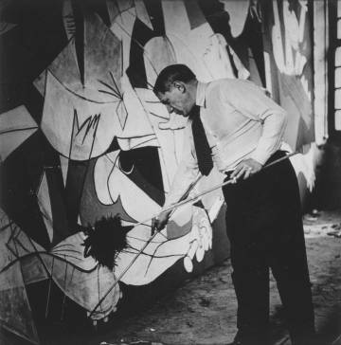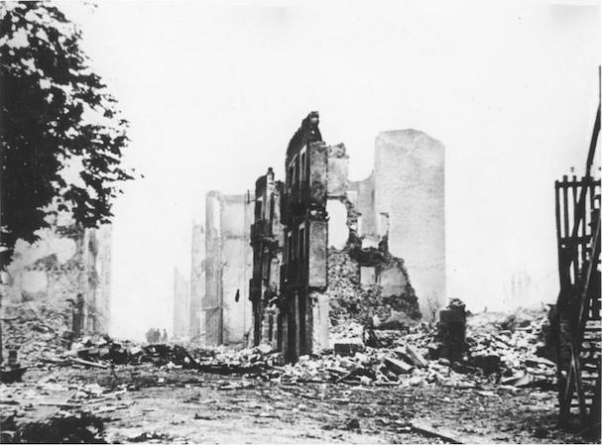

The commission

Picasso was working on a mural commission from Spanish republican government before, but due to the huge public outcry caused by the event, Picasso changed his initial plans and instead focused on Guernica. He rarely took public commissions but this one was different as he could create a work that illustrated his sympathies for his home country.

The event  
In April 1937, on the orders of Hitler, the leader of Germany at the time, who was sympathetic to the cause of the fascist dictator Franco, bombed Guernica. This town in the Basque region of Spain was considered a hotbed for Spanish republican activities and was the centre for their communications.  
At the time Spain was in the midst of a Civil war, between the republicans and the nationalist.  
Fascist-dictatorial power and forcible oppression of opposition.  
The event was covered by the press across the world and caused a worldwide outcry against the cruelty and killing of mothers and children

Critical text quote: ”In the panel on which I am working, which I call Guernica, I clearly express my abhorrence of the military caste which has sunk Spain into an ocean of pain and death- - Pablo Picasso

The public who look at the picture must interpret the symbols as they understand them.” - Pablo Picasso

Image: 