|  |  |
| --- | --- |
| Artist | Apollodorus of Damascus |
| Title | Trajan’s column |
| Date | 113 AD |
| Medium | marble |
| Scale | 125 feet (38 meters) high |
| Scope | memorial |
| Patron | Emperor Trajan |
| Location | Rome |
| Function | To honor the achievements of Trajan’s army |

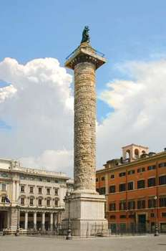

Historical context/subject of work:

* It is covered with low-relief sculpture that demonstrates a narrative of an emperor’s two campaigns in Dacia
* There is a spiral staircase within the shaft’s interior. A bronze eagle had been placed on the top of the column and after Trajan’s death a bronze statue of the deceased emperor replaced it.
* Trajan’s column is a Roman triumphal column that commemorates Emperor Trajan’s victory in the Dacian wars.
* It honoured the qualities and achievements of Emperor Trajan.
* After Trajan died a statue of St. Peter was placed on top of the column in the 1500s by Pope Sixton.

Critical text quote:

How does this example fit the scope of work:

It retells the events of the battle in a storyboard that spirals upwards. The war heroes are depicted as well as the opposition.

|  |  |
| --- | --- |
| Formal features | |
| Composition | Symmetrical, straight, spiral upwards |
| Colour or texture | White, smooth, low relief |
| Light & tone |  |
| Space & depth or relief | Low relief |
| Line or brushwork |  |

Cultural/social factors:

Placed in public for everyone to see

Political factors:

Shows the victory for Roman people and their strength.

Artist’s involvement:

Designed the drums that make up the column, probably didn’t actually construct it.