**COMPONENT 1**

**Section A: Analysing Media Language and Representation**

**Question 1**

Compare how audiences are positioned by the representations in this *Save the Children* advertisement

<https://www.bing.com/videos/search?q=save+the+children+syria+ad&view=detail&mid=8C71CB027815A5E377A38C71CB027815A5E377A3&FORM=VIRE>

and the *WaterAid* advertisement you have studied [30]

**Question 2**

How does media language incorporate viewpoints and ideologies in these front pages of the *Sun* and the *Daily Mail*? [15 marks]

[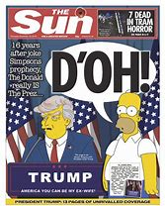](https://www.bing.com/images/search?view=detailV2&ccid=EwaggvuH&id=2738D44B5E022BAC795F97B87F517E5DC093AA6E&thid=OIP.EwaggvuHmIwUFUD3guHAvAHaJb&mediaurl=https://cdn.mpasho.co.ke/wp-content/uploads/2016/11/The-Sun.jpg&exph=1024&expw=804&q=sun+bart+simpson+and+trump+cover&simid=608004768907201523&selectedIndex=0)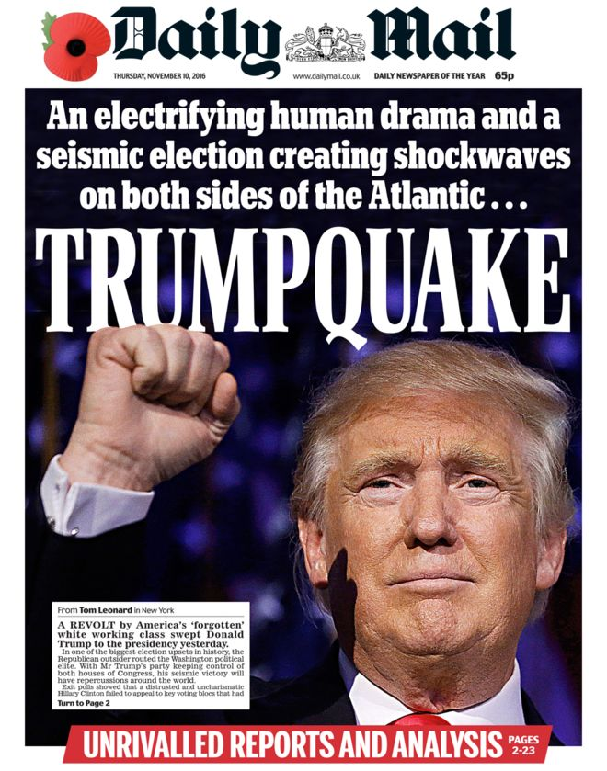

**Section B: Understanding Media Industries and Audiences**

**Question 3:**

3 (a) Briefly explain what is meant by distribution [2 marks]

3 (b) How have recent technological changes had an impact on the production and distribution of newspapers? [10 marks]

3 (c) What is a media conglomerate [1 mark]

3 (d) Explain how ownership shapes media products. Refer to the Daily Mirror to support your points. [12 marks]

**Question 4**

4(a) Explain how national and global audiences can be reached through different media technologies and platforms. Refer to Late Night Woman’s Hour to support your points [8 marks]

4(b) How do media organisations meet the needs of specialised audiences? Refer to Late Night Woman’s Hour to support your points [12 marks]

**Section A: Analysing Representation and Media Language**

**Representation**

1. Compare the ideologies conveyed through the representations in this television advertisementfor *Guinness: Compton Cowboys*(2017)

[**https://www.bing.com/videos/search?q=guinness%3a+compton+cowboys&&view=detail&mid=3821A77A988AF10B845B3821A77A988AF10B845B&&FORM=VRDGAR**](https://www.bing.com/videos/search?q=guinness%3a+compton+cowboys&&view=detail&mid=3821A77A988AF10B845B3821A77A988AF10B845B&&FORM=VRDGAR)

with *Formation.* In your answer you must:

consider how representations convey ideologies

consider the similarities and differences in the ideologies conveyed

make judgements and draw conclusions about how far social and cultural contexts affect the representations

**Media Language**

1. Explore how codes and conventions create meaning in this film poster [15 marks]



**Section B: Understanding Media Industries and Audiences**

3(a) Briefly explain what is meant by diversification in media industries [2 marks[

3(b) Explain the impact of recent technological changes on the video games industry. Refer to *Assassin’s Creed III: Liberation* to support your points [8 marks[

3© Explain how the producers of video games ensure their financial success. Refer to *Assassin’s Creed III: Liberation* to support your points (15 marks[

4(a) Explain how advertisements target audiences. Refer to the *WaterAid* advertisement you have studied to support your points [8 marks[

4(b) Explain how historical contexts influence audience interpretations of media products. Refer to the *Tide* advertisement you have studied to support your points. [12 marks]