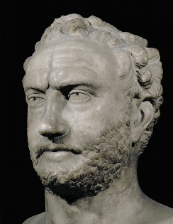**Effective Evaluation of the Primary Sources**

In total **40%** of the marks in the Ancient History A-Level are awarded for your use and evaluation of the ancient sources. This is assessed via ‘**AO3**’ (*assessment objective 3*) and for a 30 mark essay, **15** of the marks are available here.

**AO3** – ***Use, analyse and evaluate ancient sources within their historical context to make judgements and reach conclusions about:***

* ***Historical events and historical periods studied***

(Explain what this means in your own words: )

* ***How the portrayal of events by ancient writers/sources relates to the historical contexts in which they were written/produced***

(Explain what this means in your own words: )

***‘Leadership was lacking at both Athens and Sparta during the Archidamian War.’* How far do you agree with this view? [30]**

**TASK:** Complete the table below explaining Thucydides’ views on each of the leaders and why they may /may not be reliable.

|  |  |  |
| --- | --- | --- |
|  | **Thucydides’ view** | **Reliable/Unreliable** |
| **Pericles** |  |  |
| **Cleon** |  |  |
| **Brasidas** |  |  |
|  | **Aristophanes’ view** | **Reliable/Unreliable** |
| **Cleon** |  |  |

**How to evaluate the views of the sources in your essays**

When evaluating why an author or source has a particular view, or how reliable the view is, there are three ways of doing this:

1. Use your knowledge of the ***period*** to support or challenge the views or claims in the source
2. Use your knowledge of other ***sources*** to support or challenge the views or claims in the source
3. Use your knowledge of the ***provenance*** of the source to support or challenge its views

**TASK:** practice each of the three options above with the following example.

***Evaluate the view of the source using your knowledge its provenance…***

***Evaluate the view of the source using your knowledge of other sources…***

***Evaluate the view of the source using your knowledge of the period…***

“According to Thucydides the quality of Athenian leadership declined after the loss of the ‘First Citizen’, Pericles, in 429 as he was replaced by a series of less able leaders like Cleon who competed to gain personal power and abandoned Pericles’ defensive strategy.”