|  |  |
| --- | --- |
| Artist | Unknown |
| Title | **Agustus of Primaporta** |
| Date | 20BC |
| Medium | Marble |
| Scale | Life-size |
| Scope | Portrait of ruler |
| Style | Classical Roman |
| Patron | Tiberius |
| Location | Found in Primaporta palace |
| Function | Commemorate Augustus’ reign |

|  |  |
| --- | --- |
| Formal features | |
| Composition | The sculpture is composed of a 3D depiction of Augustus standing in an authoritative pose. |
| Colour or texture | The sculpture would have been painted to make it appear realistic however now the pigment has worn away, so the sculpture appears white due to the marble material it is carved out of. The sculpture is polished so has a smooth texture. |
| Space & depth or relief | This is a 3D sculpture so is carved to appear like a human figure. |
| Details | Symbols on the breast plate shows his accomplishments whilst being emperor. His face and body is idealised, and he holds senators robes to show he is a powerful leader. |

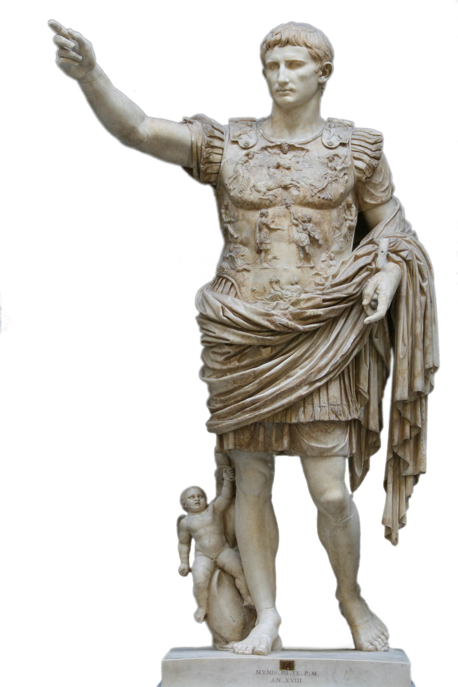

Some more details…

Ad – locutio gesture: power and appears dominant, emphasizing the image of Augustus as a powerful ruler of Rome

The face renders a youthful emperor, even though the statue was constructed when Augustus was about forty years of age

The eyebrow is a trademark of the Augustan style

The smooth face, simplistic features, and youthful look give the emperor an essence of eternal youth, even though he would have been around 40 at the time of the Parthian victory1. These facial features are reminiscent of the Doryphoros statue

his hair is capped with what is called the Primaporta hairstyle

The breastplate is covered with figures and is a complex of Augustan and Tiberian propaganda. It commemorates Augustus' victory over the Parthians in 20 BC

On Augustus' lower right side is a statue of Cupid riding a dolphin. This emphasizes Augustus' claims of divine lineage of the Julian family to Aeneas, the founder of Italy, and Venus

Both facial expressions of calm, self-control show the character of the man instead of his emotional response to the situation

Influence from political factors:

Augustus was the first emperor of Rome. HE replaced the Roman republic with an effective monarchy. His uncle – Julia Ceasar was assassinated, and Augustus fought to avenge his death. Instead of following Ceases example and making himself dictator, Augustus founded a system on monarchy. He created a standing Army for the first time and embarked upon a vigorous campaign for expansion and to make Rome safe from barbarians. He had no sons, only a daughter so his nephew Tiberius took over as his grandson passed predeceased him. Towards the end of his rule the economy became troubled and in his last years he became more dictatorial.

Influence from cultural/social factors:

The statues style reflects the political and cultural environment of the time. Unlike earlier Hellenistic statues, Augustus is reflected as calm. Even on the breastplate there is no sign of turmoil – this is in relates to the peaceful Augustian era where civil wars due to a close. The sculpture is influenced by Classical Greek design. This is seen by how Augustus’ face is idealised. The romans did this to show they could use the Greek style but better.

Use or development of materials, techniques & processes:

The sculpture was carved into marble. Marble was used due to its translucent property to make Augustus’ skin appear realistic. Marble has a low tensile strength, so the sculpture must be supported. In this case by Cupid riding the dolphin at Augustus’ feet.