|  |  |
| --- | --- |
| Artist |  |
| Title | Benin Bronzes |
| Date | 16thC-17thC |
| Medium | brass |
| Scale | Height: 51 centimetresWidth: 38 centimetresDepth: 11 centimetres |
| Scope | Ethnicity / identity in 3D |
| Patron | Oba |
| Location | British museum |
| Function |  |

Image: 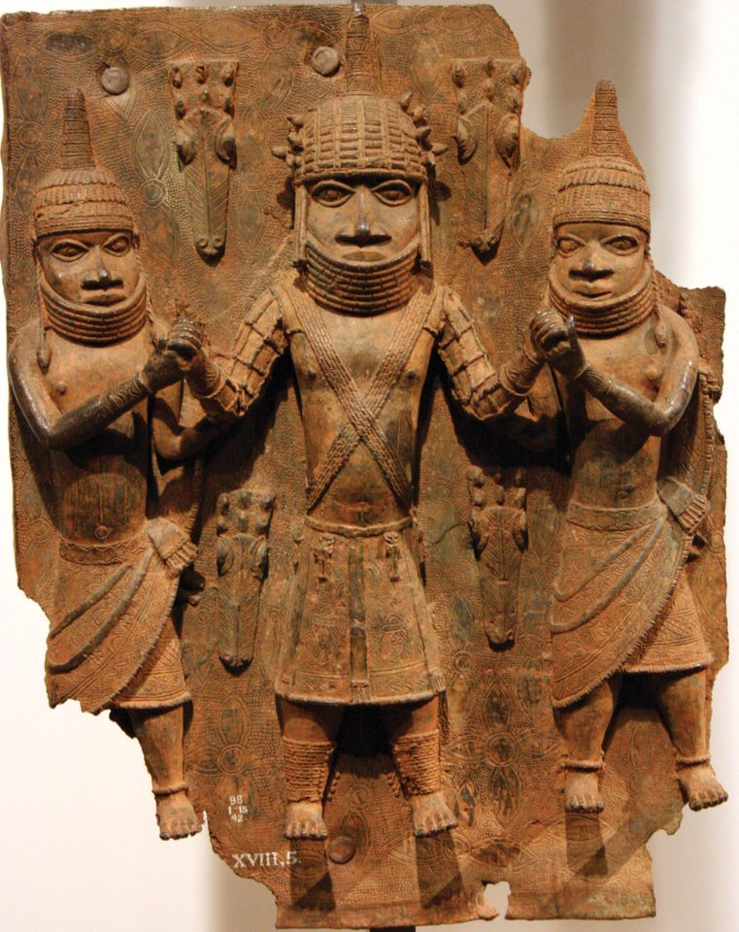

Historical context/subject of work:

The Benin Empire or Edo Empire (1440-1897) was a large pre-colonial African state of modern Nigeria. Ruled by an Oba. These plaques decorated the walls of his palace.

Only men could work the bronze and only the Oba could own them.

Critical text quote:

How does this example fit the scope of work:

It portrays soldiers of African ethnicity with features unique to their culture e.g. coral beads.

|  |  |
| --- | --- |
| Formal features | |
| Composition | Usually symmetrical, multiple figures, mostly vertical composition |
| Colour or texture | bronze |
| Light & tone |  |
| Space & depth or relief | Early bronzes are very low relief, later bronzes are much higher relief with more negative space. |
| Line or brushwork |  |

Cultural/social factors:

Features soldiers in a hierarchical order with boys on the outside and men in the middle.

The higher up soldiers are ,more heavily decorated with coral beads showing their importance.

Coral beads have connotations with the god of the river worshipped by the Benin people

Political factors:

Artist’s involvement:

The artists could only be men, they made wax moulds and cast them in bronze.