|  |  |
| --- | --- |
| Artist | Chris Ofili  Influence from cultural/social factors:   * Ofili emphasises the stereotypical features of a black women in her face – big lips/nose. Showing she is proud to be black. * She wears a ‘bib’ which is cultural of her race and allows the painting to stay relevant throughout time. |
| Title | No Women No Cry |
| Date | 1998 |
| Medium | Acrylic, Oil, Polyester resin, Pencil, Paper collage, Glitter, Map pins, Elephant dung, Linien |
| Scale | 243cm x 182cm |
| Scope | 2D Portrait – post 1850  Influence from political factors:   * Stephen was stabbed to death in 1993 at the age of 18 in an unprovoked attack, the legal system were racist towards him and didn’t arrest the attackers. * Shows the unfair legal system as emphasises in the McPherson report * This painting is a tribute to the bravery of Doreen Lawrence. |
| Style | YBA (Young British Artist) |
| Patron | -- |
| Location | -now in Tate Britain |
| Function | To educate/celebrate black culture and challenge racism |

|  |  |
| --- | --- |
| Formal features | |
| Composition | Profile portrait (queenly, iconic, dignified) of Doreen Lawrence, with her son, Stephen, shown 17 times making it an unconventional double portrait.  Seeing only her head and shoulders means she is not sexualised, unlike many women in paintings, but celebrated for the bravery and intelligence of her efforts despite her grief. |
| Colour or texture | Bright colours – cultural origins beliefs and strengths  Yellow = happy connotations, to let some good come out of Stephen’s death, a better police force. Red = blood of her son. Links with reggae/Rastafarian to celebrate black culture |
| Space & depth | The use of elephant dung creates a 3D aspect. |
| Line or brushwork | Painted in dots, use of fence in front of her challenges usual idea of setting, but highlights both her grief and the cage of racism. |

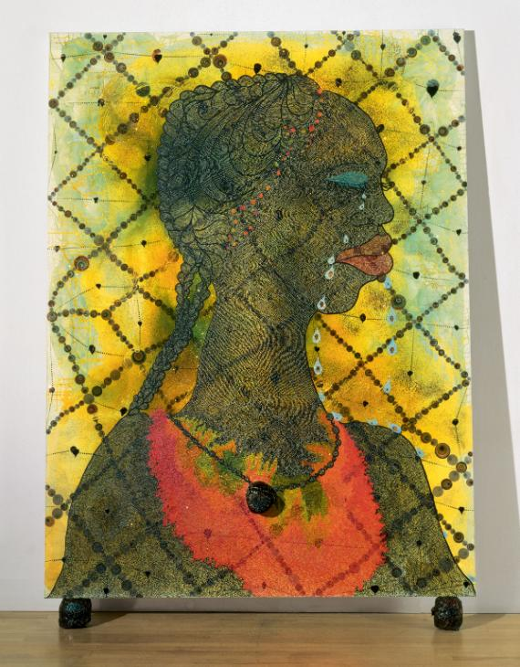

How this portrait goes against traditional aspects of portraiture:

* No frame
* Doesn’t look exactly like her (Doreen) but contains accurate images of her son as well – double portrait
* Usually portraits are named after the subject e.g. their name, but this refs Bob Marley song

Critical text quote:

“Portraits are…works of art that engage with ideas of identity as they are perceived…and understood in different times and places”– Shearer West

Influence from technological factors:

* Influenced by the media coverage of Stephen’s death and his mother fighting against a racist police force.

Use or development of materials, techniques & processes:

* Elephant dung – symbolised how badly she and other black people are treated, and shock factor.
* Fluorescent light under painting says ‘RIP (Rest in Peace) Stephen Lawrence 1974-1993’.
* Map pins, sequins both non-traditional materials, emphasises multi-media aspects to DL’s campaign

Stylistic comment and artistic influence:

The YBA had a common interest in creating a shock factor in their works. Ofili did this through the use of elephant dung as a media in this portrait, because it is a very unusual material.