|  |  |
| --- | --- |
| Artist | Graham Sutherland |
| Title | The Crucifixion |
| Date | 1946 |
| Medium | Oil on hardboard |
| Scale | 908 x 1016 mm |
| Scope | The divine |
| Patron | Sir Walter Hussey |
| Location | / |
| Function | / |

Historical context/subject of work:

The painting was produced towards the end of WW2

Spring, 1945, photographs and eyewitness accounts came out expressing the liberation of concentration camps.

Rumours of the horrors being inflicted on Jews -as well as other ‘undesirable’ people- were hence confirmed.

The endless cruelty inflicted from one human to another inspired the appearance of the figure as he connects it to the shockingly treated Jews.

The connection made an impact on victims and sympathisers.

Critical text quote:

How does this example fit the scope of work:

This work fits the category of the Divine as it shows the religious figure Jesus suffering on the cross like the bible story illustrates. There are 3 main colours in this painting, which references the holy trinity.

Image: 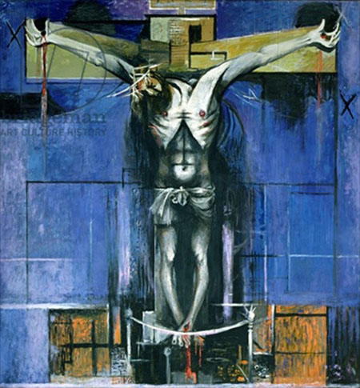

|  |  |
| --- | --- |
| Formal features | |
| Composition | The overall composition is cross shaped to represent the crucifixion from the bible story. Triangular composition by connecting the stigmata’s (nails) – holy trinity. |
| Colour or texture | Colours blue, orange and yellow have been used for the setting, contrasting the harsh black and white figure that is Jesus on the cross. |
| Light & tone | The figure is very harshly lit with white areas that highlight the dark shading which exaggerates his malnourished, skeletal figure. |
| Space & depth or relief | No space/ depth of scene. Uses a plain blue background so all focus can be on the figure. |
| Line or brushwork | Brushwork is rough and unrefined to express suffering. Black lines are used to define areas of the figure. Vertical and horizontal lines in the background create continuity and balance. |

Cultural/social factors:

Political factors:

Artist’s involvement:

The artist based the figure of Jesus off the malnourished and poorly treated Jews, giving his own touch and referencing the awful current event of war.