|  |  |
| --- | --- |
| Artist | Marc Quinn |
| Title | Self |
| Date | 1991, 1996, 2001, 2006, 2011 |
| Medium | Blood |
| Scale | Varies in each sculpture |
| Scope | Sculptures |
| Style | N/A |
| Patron | N/A |
| Location | N/A |
| Function | N/A |

|  |  |
| --- | --- |
| Formal features | |
| Composition | Created a mould of his face and using his own blood, suggests that this is the most realistic representation of him that he can create as it shows both his physical and biological identity. Every five years Quinn creates a new blood sculpture, which shows the changes in his body as he ages. |
| Colour or texture | Uneven, patchy, rough and organic due to the blood |
| Light & tone | A light above falls directly on the sculpture highlighting the shadows and tones of his face and adding depth to the mould of his face as well as highlighting the features of his face and showing the difference in his face as it ages. |
| Space & depth or relief | N/A |
| Line or brushwork | N/A |

Critical text quote: “The sculpture sits in limbo – simultaneously alive and dead, real and simulated. It is one of the uncanny works of recent contemporary practice.” – Jaklyn Babington

Quinn chose blood as his medium “to push portraiture to an extreme” and create “a representation which not only has the form of the sitter but is actually made from the sitter’s flesh”.

Influence from technological factors:

Uses electricity to retain its frozen appearance and symbolises other forms of dependence such as addiction to alcohol and drugs which Quinn experienced when he created his first work of Self. The use of electricity could also symbolise things needing to be plugged in/ connected to something to survive

Influence from political factors:

N/A

Image:

[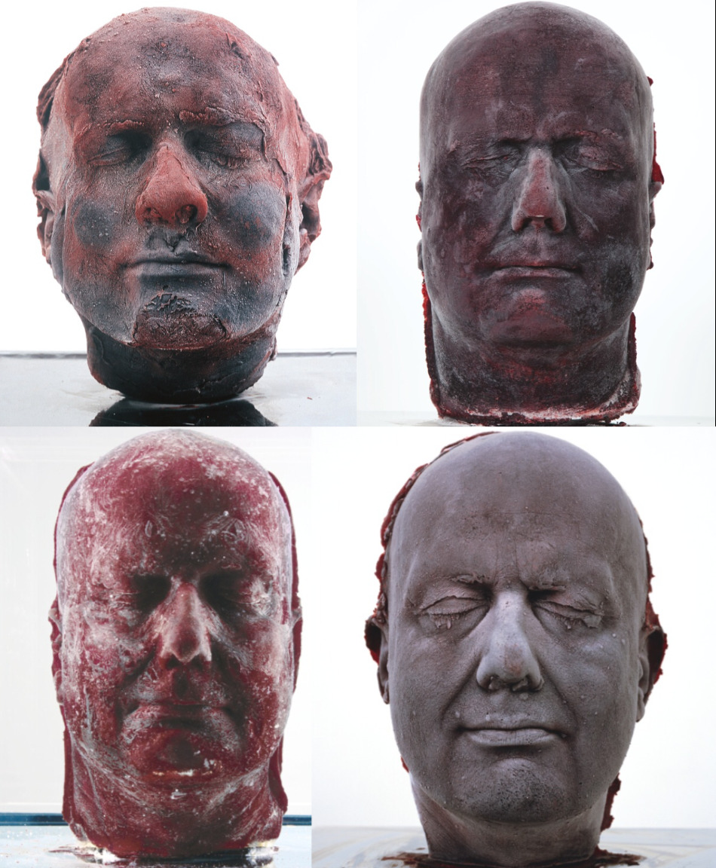](https://www.google.co.uk/url?sa=i&rct=j&q=&esrc=s&source=images&cd=&cad=rja&uact=8&ved=2ahUKEwj4hZeIyubgAhVFXhoKHTegCw0QjRx6BAgBEAU&url=https%3A%2F%2Fwww.kimballjenkins.com%2Fartistoftheday%2F2016%2F11%2F16%2Fartist-of-the-day-marc-quinn-click-on-image-to-see-more&psig=AOvVaw3qm2UMn-6bTZDcJOwm9DTl&ust=1551723340679888)

Influence from cultural/social factors:

The use of materials to express identity creates a modern and scientific approach to a self-portrait and could therefore express his exploration of how society perceive each other today. Quinn is saying that it is not our looks which make ourselves but what is inside. He is exploring a deeper meaning of ‘identity’.

Quinn explores 'what it is to be human in the world today' through subjects including the body, genetics, identity, environment and the media.

Stylistic comment and artistic influence:

Influenced by the Dutch painter Rembrandt. At University he studied Rembrandt’s self portrait during his art history course.

Inspired by Roman death masks which is where people created a mask of the face after death, specifically the death mask on display in the British museum which he had seen previously to creating this series of sculptures.

Use or development of materials, techniques & processes:

The use of materials to express identity creates a modern and scientific approach to a self-portrait and could therefore express the scientific change that has happened in the 21st century.

Marc used ten pints of his own blood, liquid silicone, stainless steel, glass, and Perspex. He uses refrigeration equipment to keep the blood frozen, which ensures that it keeps its form. If the equipment was turned off, the sculpture would melt and turn into a puddle of blood.