|  |  |
| --- | --- |
| Artist | Marc Quinn |
| Title | Alison Lapper pregnant |
| Date | 2005 |
| Medium | Marble |
| Scale | 12 meters high |
| Scope | Sculpture |
| Commissioner | Mayor of London |
| Location | 4th Plinth in London – Trafalgar square |
| Function |  |

Context/subject of work:

She is born with shortened legs and no arms as a result of phocomelia.

She is 7 months pregnant which is a mirable with her condition.

4th plinth was used to celebrate all works of modern life.

Image: 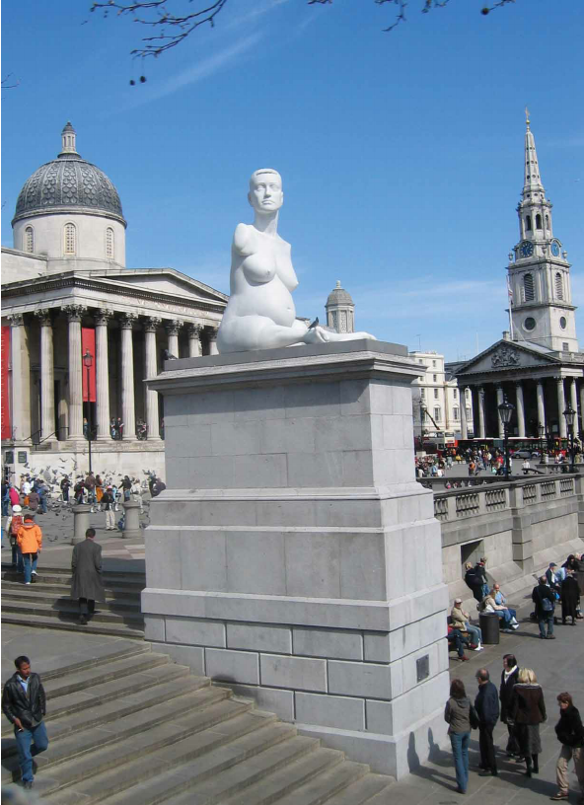

Artist’s involvement:

Marc Qunii had no involvement from others, he did it all himself.

He was inspired by her story, so took a cast of her to make her out of marble.

Cultural/social factors:

Being pregnant and disabled still wasn’t/ isn’t accepted in the eyes of society.

A sculpture depicting this had never been displayed before and it went against all the other plinths in the Trafalgar square.

Political factors:

There was another one placed in front of the Catholic Church in Venice, Italy, this caused a lot of controversy.

The priest responsible for cultural heritage matters said it “out of place”. He also said it was “removed from the context of the bulk of artworks which were being displayed.”

How does this example fit the scope of work:

it isn’t a traditional sculpture, even though it looks like it should be a classical Greek sculpture by being made of marble, it is however is not idealised in any way, it is completely realistic which contradicts the classical Greek style.

Critical text quote:

|  |  |
| --- | --- |
| Formal features | |
| Composition | The figure is 12m sitting down on the 4th Plinth. She has no arms which can be clearly seen when she is on the plinth.  Her head turns and is lifted to show she is proud. She see her in profile which is how the queen is seen in stamps. |
| Colour or texture | She is made from marble which is white as shows her beauty and purity. |
| Light & tone | The marble is polished and so becomes translucent when light shines – making it look more like skin adding realism. |
| Space & depth or relief | No negative space.  Large figure, so is imposing and people and look up and easily see her.  It creates a key message that being disabled should be just as respected by society. |
| Line or brushwork | Very detailed.  Soft curves and lines creating an elegant, calm look. |