Artist | Sonia Boyce
Title | She ain’t Holding them up, she’s Holding on: Some English Rose
Date | 1986
Medium | Crayon, chalk, black pastel and ink on paper
Scale | 218cm x 99cm
Scope | Identities in 2D
Patron
Location
Function

Historical context/subject of work:
- The work depicts a young girl who is holding up her family above her.
- This work was done in a time where black artists were just starting to gain some prominence enabling them to group together and create a movement for change.
Critical text quote:
“In those early works I was always the central figure and I was addressing the audience, so the performative element has always been there in my work.”
How does this example fit the scope of work:
It represents Black identity and how Black people felt living in Britain at the time.
Composition | A main central female figure with four more smaller figures placed above and behind her, making the central figure the main subject.  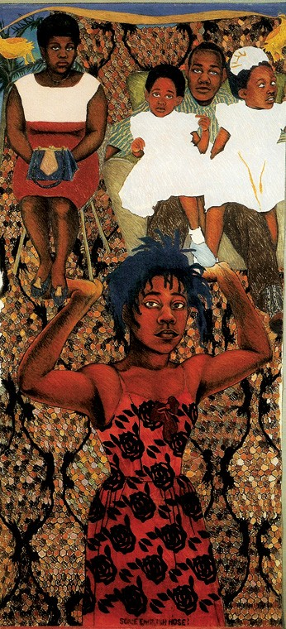
Colour or texture | The use of harsher materials comparative to paint creates a rougher texture over the work that has been layered up more over the figures
Light & tone | Shadows are played with to highlight specific sections like her arms being a main element
Space & depth or relief | A flat image with little depth done by using a background behind the figures
Line or brushwork | Harsh pastels and crayons are used to create thick strong lines and outlines

Cultural/social factors:
- This work was created as part of the up and coming British black arts movement where a community was created for change to give equality to black artists.
Political factors:
- The artists fight for political change to improve the lives of black people in Britain

Artist’s involvement:
- Boyce created the work after visiting the first national conference of Black artists in 1982 which inspired her due to discovering a welcoming community of black artists in a similar position to her, distancing her from the isolation and disconnection she previously felt.

