|  |  |
| --- | --- |
| Artist | Titian |
| Title | Venus of Urbino |
| Date | 1538 |
| Medium | Oil paint |
| Scale | 1.19 m x 1.65 m |
| Scope | Gender pre 1850 |
| Style | High renaissance |
| Patron | Duke of Urbino |
| Location |  |
| Function |  |

|  |  |
| --- | --- |
| Formal features | |
| Composition | Full length nude woman in foreground, she is the centre of the composition. A kneeling and a standing figure in the background. Curtain splits down the middle so we can see the direction of light and the other figures and understand the narrative. |
| Colour or texture | Use of red connotes to passion and love whereas the use of white implies purity, meaning she’s a virgin. |
| Light & tone | Chiascuro – allows the figures to stand out and the viewer to fixate on certain features like Venus’ profile. |
| Space & depth or relief | Orthogonal lines; linear perspective, Negative space (the curtain) |
| Line or brushwork | Soft brushwork, highly detailed textiles to emphasise the luxury she lives in |

Influence from cultural/social factors:

In this period of time the expectations for women were to be obedient and submissive to their husbands. In this depiction of Venus she lies suggestively with a coy gaze; adding to the sexual nature she is meant to show for her husband. Typically virginity was preserved for after marriage; the flower she holds having petals dropping off implies she is going to lose her virginity and since this was a wedding gift from the Duke to his wife we can see he was trying to instruct his wife on how she must act when married.

In the background the kneeling figure is looking inside a cassone which is a chest that is prepared while you are getting married.

The small dog on the bed was associated with women in paintings and represented loyalty – her loyalty to her husband.

Stylistic comment and artistic influence:

Image: 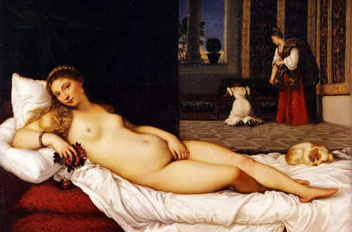

Use or development of materials, techniques & processes:

Critical text quote:

Influence from technological factors: