|  |  |
| --- | --- |
| Artist | Jan Van Eyck - Flemish |
| Title | ‘The Ghent Alterpiece’ |
| Date | c.1432 |
| Medium | Oil Paint, Wood – Tempera |
| Scale | 12 Panels – 3.4m x 4.6m |
| Scope | Divine, pre 1850 |
| Patron | Joos Vijid + Elizabeth Borlvut |

Critical text quote: ‘There is a virility (male strength) about Van Eyck’s portraits… Van Eyck is more skillful that Memling because he seems mire certain of his purpose, more confident’

Confidence in himself means he appears more skillful – the way it was made (scale), likeness and realistic

How does this example fit the scope of work:

This painting portrays the divine though its religious imagery and its purpose as a altarpiece.

Image:

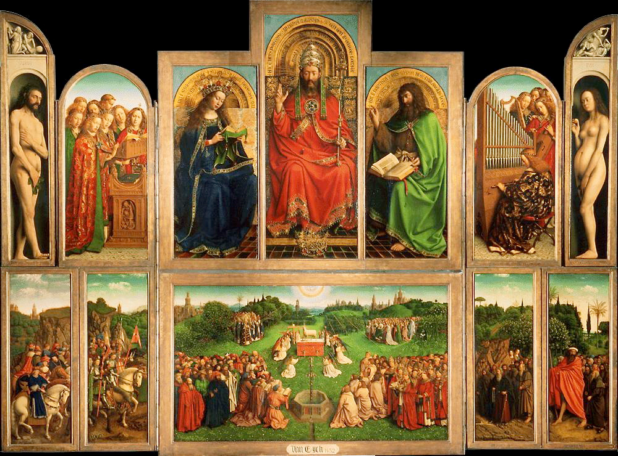

**Annotations**

Mary:

* Blue
* Virgin
* Mother of Jesus

God?

* Older – wisdom
* Papal crown – religious leadership
* Gold

Jesus?

* Brown hair – youth
* Mary is placed to the right – close relationship to mother

Lamb:

* Symbolizes Jesus being sacrificed
* Pure and innocent
* Jesus died for sins
* Fountain under contains lambs blood

|  |  |
| --- | --- |
| Northern Renaissance | To move away from classical ideas and idealized features but to still contain Gothic factors to capture small details. |
| Influences | Clous Slutter  Rome + Italy |
| Characteristics | Domestic scenes, realistic, detailed, advanced oil paint, wood carvings |
| Materials | Mixing pigments with oil and applying translucent films of paint and opaque colours which gives it depth. The oil work dry’s slow which allows it to be worked over and add detail. |

Cultural/social factors:

Ghent, was one of the three leading Flemish cities of the time and formed part of the duchy of Burgundy. Before Van Eyck there had been little large scaled paintings and the contribution Flemish painters were to make to Western art with the development of the easel painting which is owed to the tradition of manuscript of illumination and demanded the development of oil paint as a new medium.

About Van Eyck:

He was trained as a manuscript illuminator then appointed court painter to Philip the Good, Duke of Burgundy and rule of most Flanders. He then then also entrusted him with secret missions as far afield as Portugal.

Technique:

Van Eyck perfected the technique of glazing, building up the layers of transparent paint. This allowed him to create wonderfully deep colours and to work up minute detail, nobody before had mimicked reality so exquisite. His painstaking craftsmen ship was matched by rigorous observation. He was extremely sensitive to the fall of light he loved describing folds in cloth delineating the precise point at which the form turns away from the light. He also pioneers the three quarter view which allowed facial expressions to be fully investigated.