|  |  |
| --- | --- |
| Artist | Jan Van Eyck |
| Title | Arnolfini Portrait |
| Date | 1434 |
| Medium | Oil Painting on Oak Panel |
| Scale | 82 x 60 cm |
| Scope | Portrait in 2D |
| Patron | Arnolfini |



Critical text quote:

Artist’s involvement:

Van Eyck features within the painting in small details, such as his graffiti on the convex mirror and his reflection in the mirror

Van Eyck gets to display his level of skill throughout the painting in small intricate details

How does this example fit the scope of work:

Commissioned by Arnolfini, to be a portrait of him and his wife

Historical context/subject of work:

Double portrait, depict the Italian merchant Giovanni Arnolfini, and wife in their home in the city of Bruges. Formal picture of a wealthy couple holding hands in the bedchamber of their home. The painting is enriched with symbolism to depict the couple in the best light, metaphorically and literally.

Cultural/social factors:

Pictorial record of the rank and social status of the subjects, which can be seen from their formal attire and imply they are wealthy citizens of Bruges.

Image: 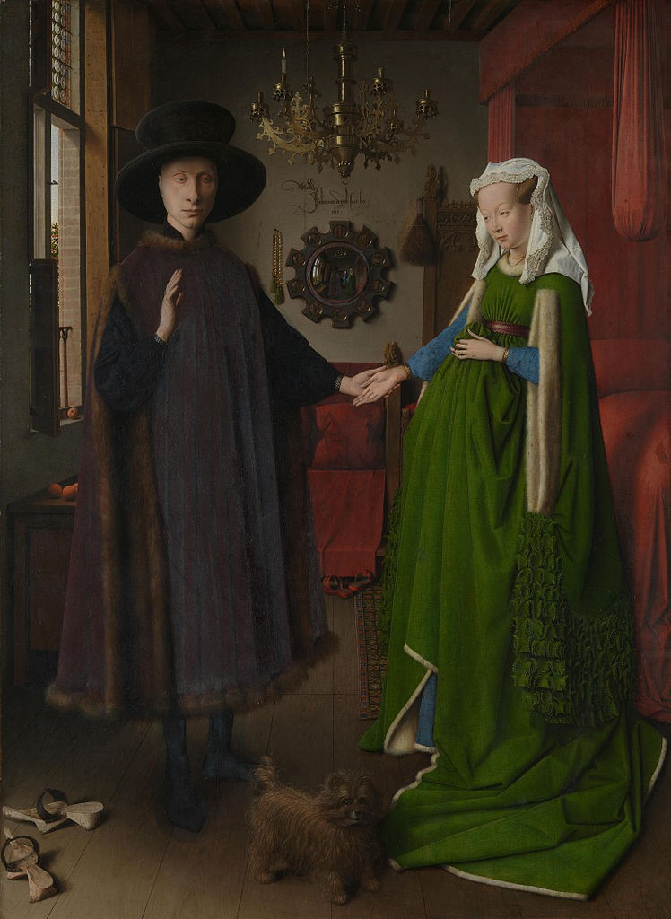

|  |  |
| --- | --- |
| Formal features:  Single candle on chandelier: unity of couple, all-seeing eye of God  Hat: represents Arnolfini’s trendsetting ways, an iconic look covering the entire forehead, to hide balding  Dog: Implies loyalty, fidelity  Convex mirror at back of room: reflects two figures in the doorway, one which is Van Eyck, the other is unknown, contains graffiti - “Jan Van Eyck was here”, and decorated with glass panels depicting the journey of Christ.  Oranges: couples affluence, wealth and symbol of fertility | |
| Composition | A man and woman centrally placed within a bedroom  Vertical lines, floor boards, windows & Horizontal lines for balance |
| Colour or texture | Figure in black, with fur edges to suggest wealth  Figure in green dress, detailed with shadows to emphasise excessive cloth – complimenting red  Bed in red, contrast – complimenting green |
| Light & tone | Natural light from the window, giving the figures a soft glow and making their facial features sharper, idealizing the figures |
| Space & depth or relief | Orthogonal perspective - floorboards  Linear perspective – directional gaze with a vanishing point |