|  |  |
| --- | --- |
| Artist | Jan Van Eyck |
| Title | The Ghent Altarpiece |
| Date | C1390-1441 |
| Medium | Tempera and oil paint on wooden panel |
| Scale | 3.35x4.57m |
| Scope | Religious painting |
| Patron | Joos Vijid and wife Elizabeth Borluut |
| Location | St Bavo Cathedral, Ghent |
| Function | Monument to god whilst also celebrating the patrons wealth |

Image: 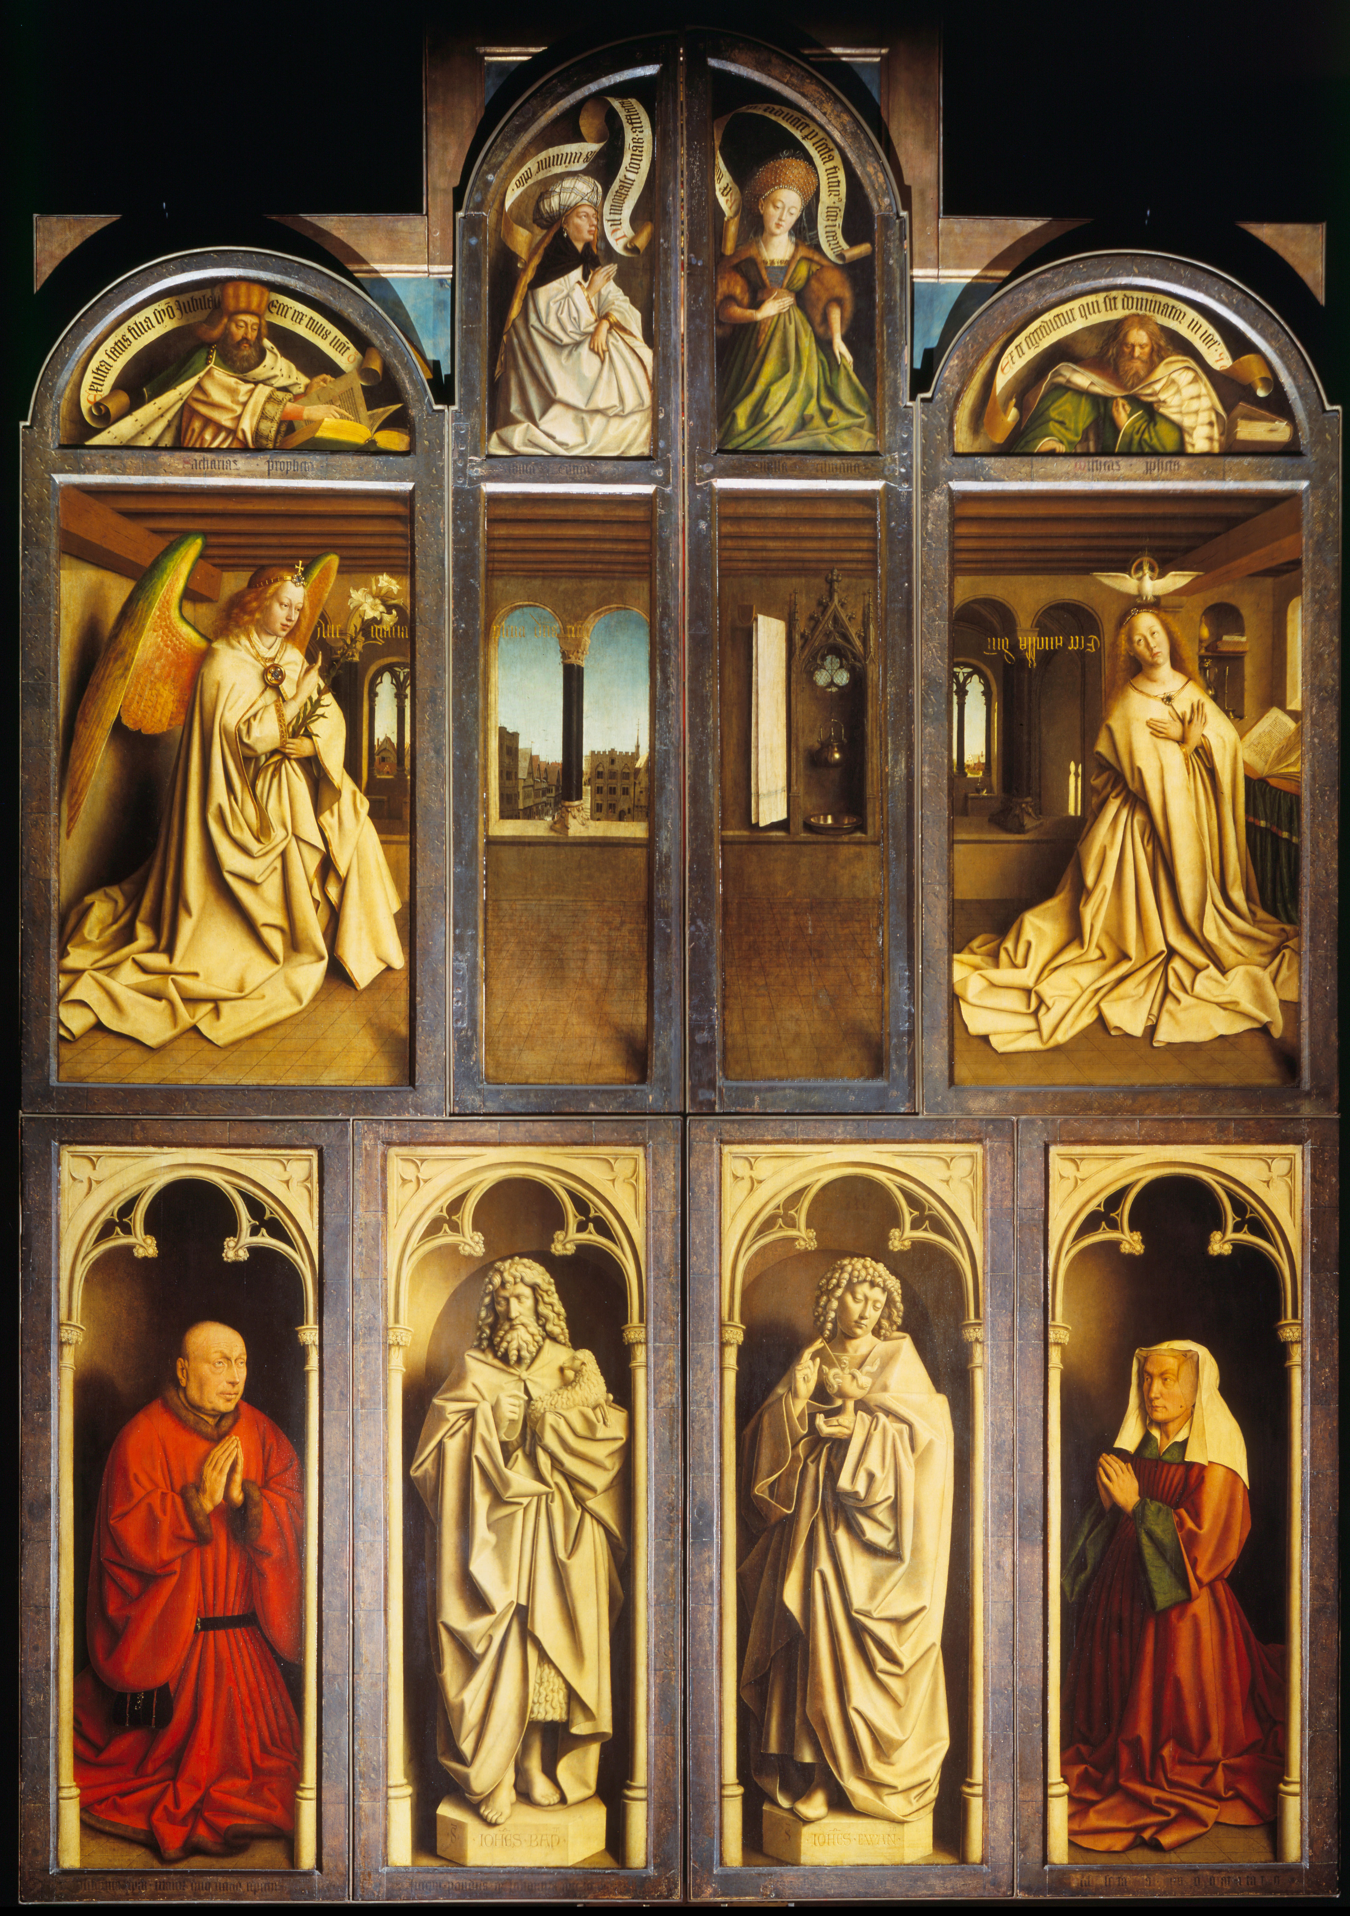

Historical context/subject of work:

The Patron, Joos Vijid, was a wealthy merchant and member of a family that was influencial in Ghent for several genterations.

Joos Vijid was the mayor of Ghent and helped manufacture the produce of cloth by wearing it, astonishing prosperity.

Joos Vijid sought to make amends the sin of being too fond of money, thus spent it on creating a monument to god, placing it in his home town.

The Mayor of Ghent also was influenced to make the city more popular, recognised in its beauty.

The painting also promotes family and community within the town, as the wife was childless and thus the money was donated to the town to be seen as a contribution to the people.

Critical text quote:

“his palette of colours is richer and more robust than that of Memling because he seems more certain of his purpose, more confident, more determined .”

How does this example fit the scope of work:

You can see his rich colors w2hich are made evident of the red, green and gold tones which represents divinity and the colours which symbolize the resurrection of Christ.

He also imitates the use of marble which is an example of naturalism.

|  |  |
| --- | --- |
| Formal features | |
| Composition | Pyramid composition which suggests stability of the structure and thus the stability of the community and religion. The inside |
| Colour or texture | Uses of reds, golds and colours to imitate the material of marble , greens and blue. |
| Light & tone | The angel's clothes, instruments and surroundings are created using extraordinary detail. Jan van Eyck's use of oil paint creates the imitation of light within the rich colors, most of which are full of symbolic significance. |
| Space & depth or relief | The use of creating the town vin the background can link to the patronage and manufacturing of cloth, however also linking to the idea that the town is ambiguous and thus can relate to anyone, making evident of the fact that Christianity is universal.. |
| Line or brushwork | Oil can create a rich and smooth texture which can be diswplayed within the colours of the robe, imitating the cloth and the way it falls on the patron and his wife. He uses a one haired brush to achieve the minute details. |

Cultural/social factors:

By creating this artwork, the town of Ghent became a larger and closer community, as the artwork created recognition in family as well as religion, influencing the love of God and Christianity to the people of Ghent.

This can also be shown by the pose of the mayor and his wife within the artwork, as they both are shown praying to god, this can make evident of the influence the mayor had on the people of ghent, influeing the town to be devoted to chrisianity too as he is seen as a role model in their town.

Political factors:

By Seeing the patron painted within the artwork, you see him and his wife posing to God, looking upwards, showing humility and respect to God.

However, seeing the red cloth that the Mayor ad his wife are wearing, it shows the promotion of the manufacturing of cloth which is what the town of Ghent was famous for. Therefore by promoting this, the Mayor being already of influence to the people of Ghent, helped boom the consumer goods of Ghent.

Artist’s involvement:

Jan Van Eyck took over from the commission of the painting after the Mayor of Ghent askef for him - from his brother, Hubert van Eyck, who had died the following year he started to create it.