|  |  |
| --- | --- |
| Artist | Zaha Hadid |
| Title | London Aquatics Centre |
| Date | 2005/2011 |
| Medium | Steel, Timber-Clad, Aluminum, Glass & Concrete |
| Scale | 45 meters high, 160 meters long, and 80 meters wide. The wave-like roof is stated to be (1,040 m2) |
| genre | Architecture |
| style | Modernism |
| Location | London, United Kingdom |
| Function | Swimming pool for Olympics and for public use |

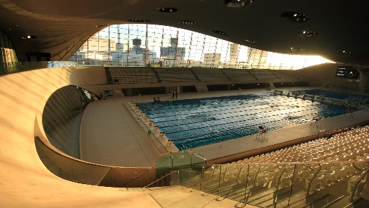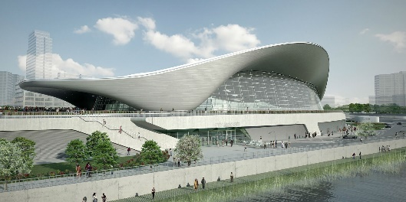

Influences from technological factors:

It has an uninterrupted, column free view of the swimming pool, which is possible through the use of three supports dotted all around the building to share the load of the huge roof.

It minimized energy use by having:

* High levels of insulation
* Low velocity ventilation systems with efficient heat recovery
* Water based heating systems with variable speed pumps

The mechanical systems have adaptable controls and the building is connected to the district heating system.

Use or development of materials, techniques and processes:

Steel and aluminum roof with double curvature parabolic arches. Curvature echoes in the diving boards and stairway as well as fenestration over the training pool. Use of precast- concrete with exposed concrete finish. The aluminum roof covering has a steel structure weighing 3,200 tones. The ceiling was built with 30,000 sections of red louro timber.

Critical text quote:

Rem Koolhas- “something really fundamentally different”

Zaha Hadid- “ can architecture… not create voids as well as solids, doubt the primacy of the right angle.”

|  |  |
| --- | --- |
| Composition | Undulating roof rests on 3 points and has a cantilevered façade giving the appearance it floats in areas. The modern building features a curtain wall, connecting natural light into the arena where there can be multiple pools found. |
| Colour or texture | The sleek & streamline building uses modern building materials such as concrete, glass & aluminum, these provide a metallic yet light appearance to the building’s exterior. |
| Light & tone | The cantilevered facades cast contoured shadows upon areas of the building, this emphasizes the sense of flow around the building’s exterior. On the interior, the main pool is lit by the curtain wall on either side of the space whilst the training pool has a series of regular tile like ceiling lights that run the course of the room. |
| line | Lyrical and curvaceous lines that link to the sweeping movement of waves in water (reflecting the buildings function/identity). These lines are juxtaposed by the structured and linear pool with its lane markings. |

Political factors:

There wasn’t much political influence, as there was only a design brief, funded and overlooked the buildings development by LOCOG.

Artist’s involvement:

Hadid decided upon the architectural concept of fluid geometry of water in motion, creating spaces and surrounding environment in sympathy with the river landscape of the Olympic park.

This is created by a parabolic roof, sweeping up from the ground like a wave, enclosing the pool with its unifying gesture of fluidity, whilst also describing the volume of the swimming pool.

Ccultural/social factors:

Temporary seating needs to be available for 17,500 people, to accommodate for the Olympic Games. For afterwards only 2,800 seats needed. Show the adaptability of the building and Hadid.

It is expected to have a positive environmental effect, 50% of the aluminium roof is made of recycled materials. The use of low fittings and recycled water means 32% less potable water used.

It is designed to reflect the riverside landscape of the Olympic park, whilst remaining modern enough to be used by the public after the games have ended.