|  |  |
| --- | --- |
| ,Artist | Zaha Hadid |
| Title | MAXXI centre |
| Date | 1998-2009 |
| Medium | Architecture (building) |
| Materials | Oblong tubes, overlapping piping, black painted steel, concrete. |
| Scope | Architecture, identities |
| Style |  |
| Patron | Italian ministry of cultural heritage |
| Location | Rome, Italy |
| Function | Museum of contemporary art |

|  |  |
| --- | --- |
| Formal features | |
| Composition | Simplified architecture, with blocky features and open areas. |
| Colour or texture | Industrial grey |
| Space & depth or relief | Spacious building, large open rooms and areas for visitors to wonder freely. |
| Line or brushwork | Use of blocky stylized designs and baroque influenced curvature. |

Critical text quote: “she shifted a culture of architecture” by Aanda levete

“questionable functionality” by Stephan Bayley

Image: 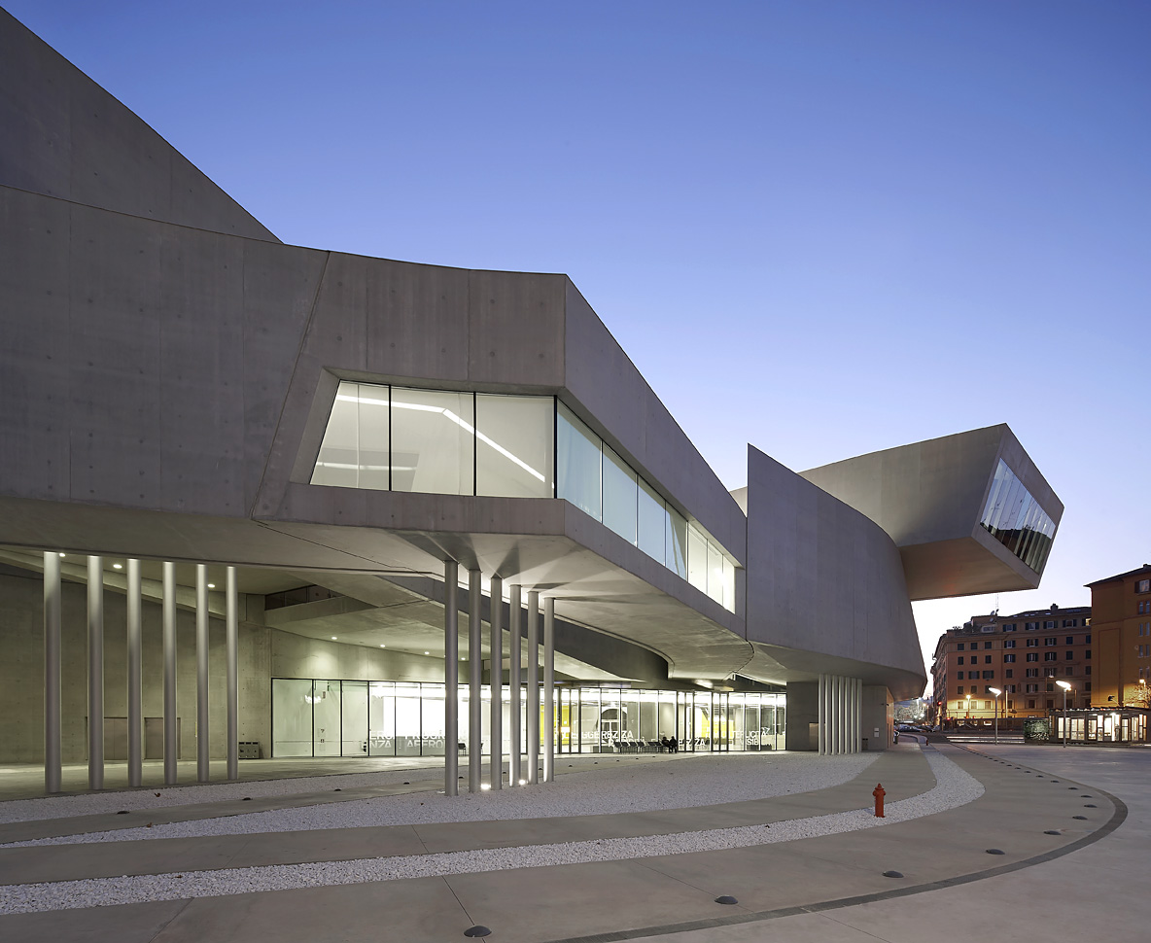

Use or development of materials, techniques & processes:

Use of concrete, this links to the classical romans. Use of open space within the building using columns.

Stylistic comment and artistic influence:

* San Carlino, by Borromini, she was known as the female Borromini due to her use of baroque features in architecture.

Influence from technological factors:

the building had to have some links to classical Rome, the MAXXI centre is made from mainly concrete with touches of steel, concrete is a light but solid material allowing parts of Hadid’s design to be free standing. This innovation was invented by the Romans.

Influence from political factors:

The MAXXI centre had to fit in with the architecture of modern day Italy and link to the classical features of classical roman architecture. The areal view of the centre resembles modern transport of trains, motor ways and canals. However it still links to the Baroque style architecture by using curves and unique forms as well as classical Roman architecture by using columns.

Influence from cultural/social factors:

It is built on top of an army barracks, Rome in the past were well known for their military success. It is also built from steel reflecting the machinery and weapons used during war.