|  |  |
| --- | --- |
| Artist | Zaha Hadid |
| Title | MAXXI |
| Date | Opened 2010 |
| Medium | Concrete, steel, glass |
| Scale | Large |
| Scope | Identities in public architecture |
| Patron | Italian Ministry of Culture |
| Location | Rome |
| Function | Museum of contemporary art |

Image:

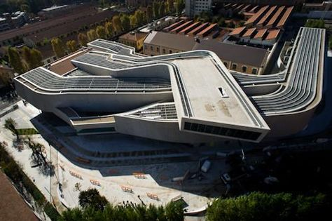

Historical context/subject of work:

Critical text quote:

‘Parametricism differentiates fields. Fields are full, as if filled with a fluid medium.’ – Philip Jodidio

How does this example fit the scope of work:

The identity of modern art and the urban environment is integrated into all aspects of the form of the building, creating a reciprocity between form and function.

|  |  |
| --- | --- |
| Formal features | |
| Composition | The building consists of overlapping and intersecting oblong tubes, creating a flow between the gallery spaces and giving it an innovative appearance in keeping with the theme of contemporary art. |
| Colour or texture | The concrete used on the façade is left unpainted, giving it an industrial appearance reflecting that of a massive transport infrastructure. |
| Light & tone | A mixture of skylights and integrated artificial lighting in gallery spaces provides appropriate lighting for exhibitions. |
| Space & depth or relief | It features intertwining space, so there are no set paths through the gallery and instead everything intersects and loops around. |
| Line or brushwork | The combination of curvilinear and rectilinear lines gives the building flow and motion. |

Cultural/social factors:

The museum fosters a unity between building and content, with the features of the design influenced by the functional practicality of displaying modern art. The surrounding complex contains buildings which link to the urban art scene, including studios and apartments for artists.

Political factors:

N/A

Artist’s involvement:

Hadid’s design won a competition and the contract was given on a design-build basis, so she had the final input on every creative decision.