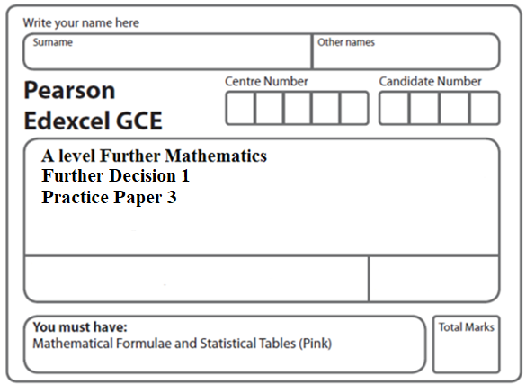**Instructions**

**Decision Mathematics 1**

**Practice Paper 3**

* Use black ink or ball-point pen.
* If pencil is used for diagrams/sketches/graphs it must be dark (HB or B).
* Fill in the boxes at the top of this page with your name, centre number and candidate number.
* Answer all the questions and ensure that your answers to parts of questions are clearly labelled.
* Answer the questions in the spaces provided – there may be more space than you need.
* You should show sufficient working to make your methods clear. Answers without working may not gain full credit.
* Inexact answers should be given to three significant figures unless otherwise stated.

**Information**

* A booklet ‘Mathematical Formulae and Statistical Tables’ is provided.
* There are **7** questions in this question paper. The total mark for this paper is **75**.
* The marks for each question are shown in brackets – use this as a guide as to how much time to spend on each question.
* Calculators must not be used for questions marked with a * sign.

**Advice**

• Read each question carefully before you start to answer it.

• Try to answer every question.

• Check your answers if you have time at the end.

• If you change your mind about an answer, cross it out and put your new answer and any working underneath.

**1.**

|  |  |  |  |  |  |  |
| --- | --- | --- | --- | --- | --- | --- |
|  | A | B | C | D | E | F |
| A | – | 83 | 75 | 82 | 69 | 97 |
| B | 83 | – | 94 | 103 | 77 | 109 |
| C | 75 | 94 | – | 97 | 120 | 115 |
| D | 82 | 103 | 97 | – | 105 | 125 |
| E | 69 | 77 | 120 | 105 | – | 88 |
| F | 97 | 109 | 115 | 125 | 88 | – |

The table above shows the least distances, in km, between six towns, A, B, C, D, E and F.

(a)Starting at A, and making your working clear, find an initial upper bound for the travelling salesperson problem for this network, using

(i) the minimum spanning tree method,

(ii) the nearest neighbour algorithm.

**(5)**

By deleting A, and all of its arcs, a lower bound for the travelling salesperson problem for this network is found to be 500 km.

By deleting B, and all of its arcs, the corresponding lower bound is found to be 474 km.

(b)Using the results from (*a*)and the given lower bounds, write down the smallest interval that you can be confident contains the solution to the travelling salesperson problem for this network.

**(2)**

**(Total 7 marks)**

**Mark scheme for Question 1**

**Examiner comment**

**2.**

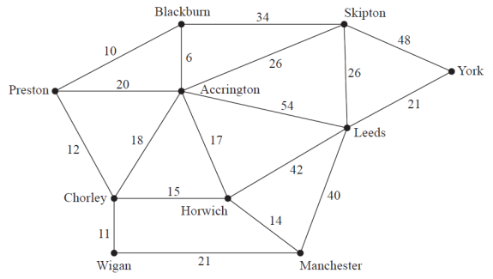

**Figure 1**

Sharon is planning a road trip from Preston to York. Figure 1 shows the network of roads that she could take on her trip. The number on each arc is the length of the corresponding road in miles.

(a) Use Dijkstra’s algorithm to find the shortest route from Preston (P) to York (Y). State the shortest route and its length.

**(6)**

Sharon has a friend, John, who lives in Manchester (M). Sharon decides to travel from Preston to York via Manchester so she can visit John. She wishes to minimise the length of her route.

(b) State the new shortest route. Hence calculate the additional distance she must travel to visit John on this trip. You must make clear the numbers you use in your calculation.

**(3)**

**(Total 9 marks)**

**Mark scheme for Question 2**

**Examiner comment**

**3.**

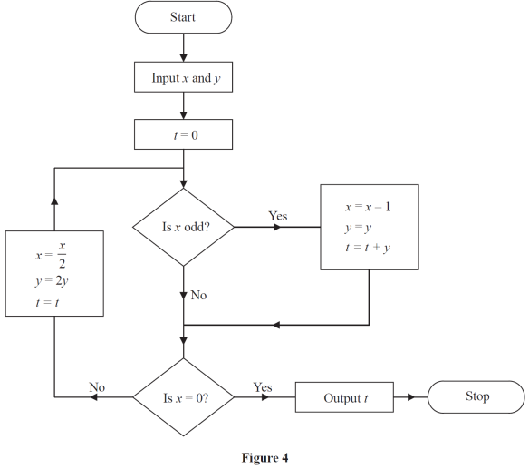

**Figure 2**

An algorithm is described by the flow chart shown in Figure 2.

Given that *x* = 27 and *y* = 5,

(a)Complete the table in the answer book to show the results obtained at each step when the

algorithm is applied. Give the final output.

**(4)**

The numbers 122 and are to be used as inputs for the algorithm described by the flow chart.



(b)(i) State, giving a reason, which number should be input as *x*.

(ii) State the output.

**(3)**

**(Total 12 marks)**

**Mark scheme for Question 3**

**Examiner comment**

**4.**

|  |  |  |  |  |  |  |  |  |  |  |
| --- | --- | --- | --- | --- | --- | --- | --- | --- | --- | --- |
| 180 | 80 | 250 | 115 | 100 | 230 | 150 | 95 | 105 | 90 | 390 |

The numbers in the list above represent the weights, in kilograms, of 11 boxes. John must transport all the boxes using his van. You may assume the van has sufficient space for any combination of boxes. Each van load of boxes must weigh at most 475 kg.

(a) Calculate a lower bound for the number of van loads needed to transport all 11 boxes.

**(2)**

(b)Use the first-fit bin packing algorithm to show how the boxes could be put into van loads. State the number of van loads needed according to this solution.

**(3)**

(c)Carry out a quick sort on the numbers in the list given above to produce a list of the weights in descending order. You should show the result of each pass and identify your pivots clearly.

**(4)**

(d)Use the first-fit decreasing bin packing algorithm on your ordered list to show how the boxes could be put into van loads. State the number of van loads needed according to this solution.

**(3)**

Due to volume restrictions, the van cannot transport more than three boxes at any one time.

(e)Show how the boxes could now be put into the minimum number of van loads.

**(2)**

**(Total 14 marks)**

**Mark scheme for Question 4**

**Examiner comment**

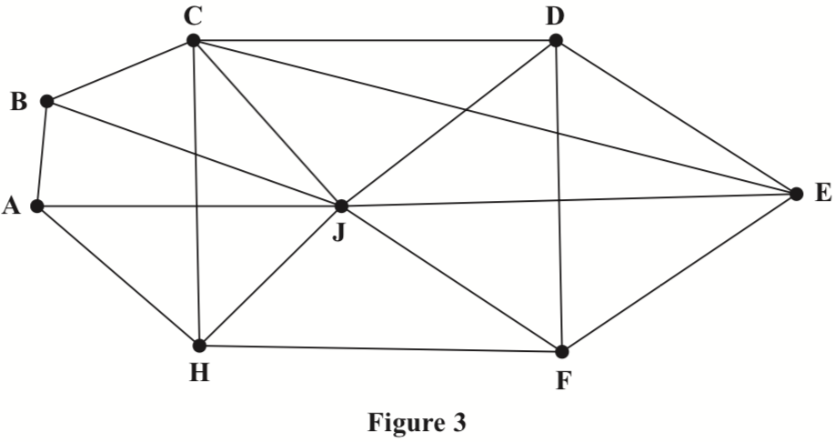**5.**

Figure 3 shows a graph G that contains 17 arcs and 8 vertices.

(a)State how many arcs there are in a spanning tree for G.

**(1)**

(b)Explain why a path on G cannot contain 10 vertices.

**(2)**

(c)Determine the number of arcs that would need to be added to G to make G a complete graph with 8 vertices.

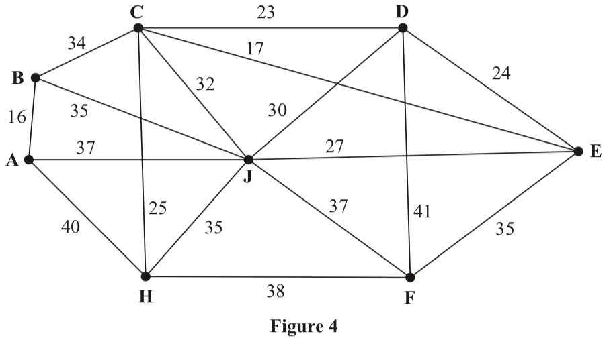**(1)**

Figure 4 shows a weighted graph.

(d)Use Prim’s algorithm, starting at C, to find the minimum spanning tree for the weighted graph. You must clearly state the order in which you select the arcs of the tree.

**(3)**

(e)State the weight of the minimum spanning tree.

**(1)**

**(Total 8 marks)**

**Mark scheme for Question 5**

**Examiner comment**

**6.**

|  |  |  |
| --- | --- | --- |
| Activity | Time taken (days) | Immediately preceding activities |
| **A** | 5 | - |
| **B** | 7 | - |
| **C** | 8 | - |
| **D** | 5 | **A** |
| **E** | 7 | **A** |
| **F** | 10 | **B**, **C** |
| **G** | 4 | **B**, **C** |
| **H** | 9 | **C** |
| **I** | 8 | **G**, **H** |
| **J** | 12 | **G**, **H** |
| **K** | 7 | **D** |
| **L** | 10 | **E**, **F**, **I**, **J** |

The table shows the activities required for the completion of a building project. For each activity the table shows the time taken, in days, and the immediately preceding activities. Each activity requires one worker. The project is to be completed in the shortest possible time.

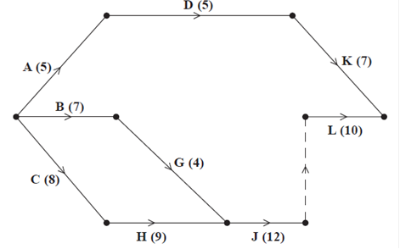

**Figure 5**

Figure 5 shows a partially completed activity network used to model the project. The activities are represented by the arcs and the numbers in brackets on the arcs are the times taken, in days, to complete each activity.

(a) Add activities, **E**, **F** and **I**, and exactly one dummy to Diagram 1 in the answer book.

**(3)**

(b) Complete Diagram 1 in the answer book to show the early event times and late event times.

**(4)**

***Question 6 continued***

(c) Calculate a lower bound for the number of workers needed to complete the project in the shortest possible time. You must show your working.

**(2)**

(d) Schedule the activities, using the minimum number of workers, so that the project is completed in the minimum time.

**(4)**

**(Total 13 marks)**

**Mark scheme for Question 6**

**Examiner comment**

**7.** The initial tableau for a linear programming problem in *x*, *y* and *z* is shown below. The objective function to be maximised is *P* = 4*x* + 2*y* + *kz*, where *k* is a positive constant.

|  |  |  |  |  |  |  |  |
| --- | --- | --- | --- | --- | --- | --- | --- |
| Basic  Variable | *x* | *y* | *z* | *r* | *s* | *t* | Value |
| *r* | −2 | −6 | 1 | 1 | 0 | 0 | 40 |
| *s* | 2 | 3 | 2 | 0 | 1 | 0 | 80 |
| *t* | 1 | 2 | 2 | 0 | 0 | 1 | 50 |
| *P* | −4 | −2 | −*k* | 0 | 0 | 0 | 0 |

(a)Using the information in the tableau, write down the three constraints as inequalities.

**(2)**

(b)By increasing *x*, perform one complete iteration of the simplex algorithm to obtain tableau *T*1 and state the row operations you use.

**(4)**

(c)Given that *T*1 is not optimal, find an inequality for the value of *k*.

**(1)**

(d)Perform a second complete iteration of the simplex algorithm to obtain tableau *T*2 and state the row operations you use.

**(4)**

(e)Given that *T*2 is optimal, find a second inequality for the value of *k*.

**(2)**

(f*)* State the final value of each variable and give an expression for the final value of *P* in terms of *k*.

**(2)**

(g)Hence find the range of possible values of *P*.

**(2)**

**(Total 17 marks)**

**Mark scheme for Question 7**

**Examiner comment**

**TOTAL FOR PAPER: 75 MARKS**

**A level Further Mathematics – Decision Mathematics 1 – Practice Paper 03 – Mark scheme –**

**Mark scheme for Question 1** **(Examiner comment)****(Return to Question 1****)**

|  |  |  |
| --- | --- | --- |
| **Question** | **Scheme** | **Marks** |
| **1(a)(i)** | A bipartite graph consists of two sets of vertices X and Y | **B1** |
| The edges only join vertices in X to vertices in Y, not vertices within a set | **B1** |
| **(a)(ii)** | A path from an unmatched vertex in one set to an unmatched vertex in the other set which alternately uses arcs not in/in the matching | **B1**  **B1** |
|  | **(4)** |
| **(b)** | Alternating path: F – 1 = A – 3 = B – 4 = D – 6 = E – 5 | **M1** |
| Change status: F = 1 – A = 3 – B = 4 – D = 6 – E = 5 | **A1** |
| Improved matching: A = 3, B = 4, (C unmatched), D = 6, E = 5, F = 1 | **A1** |
|  | **(3)** |
| **(c)** | Alternating path: C – 5 = E – 6 = D – 4 = B – 2 | **M1** |
| Change status: C = 5 – E = 6 – D = 4 – B = 2 | **A1** |
| Complete matching: A = 3, B = 2, C = 5, D = 4, E = 6, F =1 | **A1** |
|  | **(3)** |
| **(10 marks)** | | |

**Mark scheme for Question 2** **(Examiner comment)****(Return to Question 2)**

|  |  |  |
| --- | --- | --- |
| **Question** | **Scheme** | **Marks** |
| **2(a)** |  | **M1**  **A1**  **(PBCAW)**  **A1**  **(HMS)**  **A1ft**  **(LY)** |
| Shortest route: P – B – A – S – L – Y | **B1** |
| Length: 89 (miles) | **B1ft** |
|  | **(6)** |
| **(b)** | Shortest route: P – C – H – M – L – Y | **B1** |
| Difference in routes: (41 + 40 + 21) – 89 = 13 (miles) | **M1A1** |
|  | **(3)** |
| **(9 marks)** | | |

**Mark scheme for Question 3** **(Examiner comment)****(Return to Question 3)**

|  |  |  |
| --- | --- | --- |
| **Question** | **Scheme** | **Marks** |
| **3(a)** |  |  |
| 3 rows + 1st correct | **M1** |
| 2nd and 3rd rows correct | **A1** |
| 4th, 5th and 6th rows correct | **A1** |
| cso | **A1** |
|  | **(4)** |
| **(b)(i)** | *x* must be a (positive) integer and therefore *x* = 122 | **B1 dB1** |
| **(ii)** | 61 | **B1** |
|  | **(3)** |
| **(7 marks)** | | |

**Mark scheme for Question 4** **(Examiner comment)****(Return to Question 4)**

|  |  |  |
| --- | --- | --- |
| **Question** | **Scheme** | **Marks** |
| **4(a)** | so lower bound is 4 | **M1A1** |
|  | **(2)** |
| **(b)** |  | **A1**  **M1**  **A1** |
|  | **(3)** |
| **(c)** |  | **M1**  **A1**  **A1ft**  **A1** |
|  | **(4)** |
| **(d)** |  | **A1**  **M1**  **A1** |
|  | **(3)** |
| **(e)** |  | **M1**  **A1** |
|  | **(2)** |
| **(14 marks)** | | |

**Mark scheme for Question 5** **(Examiner comment)****(Return to Question 5)**

|  |  |  |
| --- | --- | --- |
| **Question** | **Scheme** | **Marks** |
| **5(a)** |  |  |
|  | **M1** |
| EBC | **A1** |
| FGD | **A1** |
| HJ | **A1ft** |
| Shortest path: ABGHJ | **A1** |
| Length: 56 (km) | **A1ft** |
|  | **(6)** |
| **(b)** | Route from D to H via A: DCBABGH | **B1** |
| Length: 80 (km) | **B1ft** |
|  | **(2)** |
| **(c)** | EF, FG, BG, CB; CD, AE; GH, HJ | **M1**  **A1**  **A1** |
|  | **(3)** |
| **(d)** | Length of MST: 89 (km) | **B1** |
|  | **(1)** |
| **(12 marks)** | | |

**Mark scheme for Question 6**  **(Examiner comment)** **(Return to Question 6)**

|  |  |  |
| --- | --- | --- |
| **Question** | **Scheme** | **Marks** |
| **6(a) and (b)** |  | **B1**  **B1**  **B1**  **(3)**  **M1**  **A1**  **M1**  **A1**  **(4)** |
|  |  | **(7)** |
| **(c)** | Lower bound =  = 2.35… so 3 workers | **M1A1** |
|  | **(2)** |
| **(d)** |  | **M1**  **A1**  **A1**  **A1** |
|  | **(4)** |
| **(13 marks)** | | |

**Mark scheme for Question 7** **(Examiner comment)**  **(****Return to Question 7)**

|  |  |  |
| --- | --- | --- |
| **Question** | **Scheme** | **Marks** |
| **7(a)** |  | **M1A1** |
|  | **(2)** |
| **(b)** | |  |  |  |  |  |  |  |  |  | | --- | --- | --- | --- | --- | --- | --- | --- | --- | | b.v | *x* | *y* | *z* | *r* | *s* | *t* | value | row ops | | *r* | 0 | –3 | 3 | 1 | 1 | 0 | 120 |  | | *x* | 1 | 3/2 | 1 | 0 | 1/2 | 0 | 40 |  | | *t* | 0 | 1/2 | 1 | 0 | –1/2 | 1 | 10 |  | | *P* | 0 | 4 |  | 0 | 2 | 0 | 160 |  | | **M1A1**  **M1A1** |
|  | **(4)** |
| **(c)** |  | **B1** |
|  | **(1)** |
| **(d)** | |  |  |  |  |  |  |  |  |  | | --- | --- | --- | --- | --- | --- | --- | --- | --- | | b.v | *x* | *y* | *z* | *r* | *s* | *t* | value | row ops | | *r* | 0 | –9/2 | 0 | 1 | 5/2 | –3 | 90 |  | | *x* | 1 | 1 | 0 | 0 | 1 | –1 | 30 |  | | *z* | 0 | 1/2 | 1 | 0 | –1/2 | 1 | 10 |  | | *P* | 0 |  | 0 | 0 |  |  |  |  | | **B1M1**  **A1A1** |
|  | **(4)** |
| **(e)** |  | **M1A1** |
|  | **(2)** |
| **(f)** |  | **B1** |
|  | **B1ft** |
|  | **(2)** |
| **(g)** |  | **M1A1** |
|  | **(2)** |
| **(17 marks)** | | |

**A level Further Mathematics – Decision Mathematics 1 – Practice Paper 03 – Examiner report –**

**Examiner comment for Question 1** **(Mark scheme)****(Return to Question 1)**

1. Examiners reported that a small number of students struggled in applying the first-fit bin packing algorithm in part (a). This was mainly down to not applying the algorithm correctly. First fit is just that; students must decide if the current item under consideration will fit in the first bin rather than the most recent bin used. In this part a number of students placed the 39 in the third bin (and not the second bin) and others did not place the 4 in the first bin.

Full marks in part (b) was rare. Some students completed the full sort rather than stopping after the fourth pass. Others completed four passes on the provided list so effectively obtaining the seventh pass. For those who did carry out the correct number of passes or who made their fourth pass clear, errors were rare. In part (ii) of (b), only the more able students were able to correctly establish that 6 comparisons were needed with most stating that   
9 comparisons were required. This demonstrated something of a lack of understanding of how the Bubble Sort works. Deducing that 2 swaps took place seemed more straightforward for most students.

Many correct solutions were seen in part (c), but a number of students did not choose their pivots consistently, switching between middle-left and middle-right pivots during the course of the quick sort algorithm. A number of students either lost an item or changed an item during the sort, and in a small number of cases only one pivot was chosen per iteration. As stated in previous examiners’ reports, in cases such as this in which the list appears to be in the correct order after three passes a fourth pass (pivoting on the 4) is required to successfully complete the algorithm. Students should be reminded that items should remain in the order from the previous pass as they move into sub-lists. Pivots were usually chosen consistently although the spacing and notation on some solutions made these difficult for examiners to follow. Some students over complicated the process by insisting on using a different ‘symbol’ to indicate the pivots for each pass. Those students who sorted into ascending order usually remembered to reverse their list at the end to gain full credit although a number of students left their list in ascending order.

The first-fit decreasing in part (d) was well carried out with only a small minority failing to attempt this part. There were a large number of wholly correct answers. A small number performed first-fit increasing therefore scoring no marks. A small minority of students lost all three marks by placing the 43 in the 3rd rather than 2nd bin (so failing to apply the algorithm at its first real test). Some students wrote totals in the bin rather than the next value. A variety of different layouts were used but in nearly all cases were easy to read and decipher.

**Examiner comment for Question 2**  **(Mark scheme)****(Return to Question 2)**

2. This question also proved to be an excellent source of marks for many candidates with the mode being full marks obtained by 30.8% of candidates and only 20% of candidates scoring 5 marks or fewer.

Part (a) was usually very well done with most candidates applying Dijkstra’s algorithm correctly. The boxes at each node in part (a) were usually completed correctly. When errors were made it was either an order of labelling error (some candidates repeated the same labelling at two different nodes) or working values were either missing, not in the correct order or simply incorrect (usually these errors occurred at nodes S, L and/or Y). The route was usually given correctly and most candidates realised that whatever their final value was at Y this was therefore the value that they should give for their route.

Part (b) was done well although many candidates failed to read the question carefully and simply calculated the length of the new shortest route without stating the increase in the distance travelled. Some failed to realise that the final value at vertex M added to the length of the arcs ML and LY would give them the required length of the new shortest route, instead many added up the length of each arc from scratch.

**Examiner comment for Question 3** **(Mark scheme)****(Return to Question 3)**

3. The majority of candidates showed a sound understanding of applying the given flow chart, scoring 3 or full marks in part (a). However a few lost all marks in part (a) for failing to fill in the first row and instead starting with the second row. Arithmetic errors were surprisingly rare. Extra "yes" and "no" entries were quite common in the fourth and fifth columns and were penalised with the final mark in this part.

Many scored the first B1 mark in part (b) for identifying that should be 122, but then lost the next mark struggling to correctly explain why. The simplest explanation that  must be an integer, was spotted by some, as was “ is neither odd nor even". However many simply focused on the, stating that the algorithm would not terminate, orwould never equal zero, but failing to explain why.

The correct answer of 61 was often seen for the final mark in part (b). Many realised that it was simply the product of the two inputs, but some wasted time working through the algorithm for a second time with the two values of 122 and .

**Examiner comment for Question 4**  **(Mark scheme)**  **(Return to Question 4)**

4. Examiner report not yet available.

**Examiner comment for Question 5** **(Mark scheme)****(Return to Question 5)**

5. Many students in (a) correctly answered the number of arcs to be 7, though some left this part blank and an answer of 17 was a popular alternative offering.

Examiners noted that a number of students made no attempt at (b). Others realised that the path could only contain 8 vertices but then failed to explicitly state that a vertex cannot appear more than once. The suggestion that a cycle would form scored no marks.

In (c) a few students gave a correct answer having calculated that the complete graph must contain 28 arcs, but others gave a wide variety of unexplained incorrect answers.

Examiners noted that a significant number of poor attempts to apply Prim’s algorithm were seen in (d). Common errors were an incorrect choice of the third arc (e.g. DE instead of CH) or the fourth arc (e.g. DJ instead of EJ) leading to an error with the weight of the tree. A few students showed explicit rejections and a small number chose to start from A, limiting themselves to one mark, out of three, at best.

**Examiner comment for Question 6** **(Mark scheme)****(Return to Question 6)**

6. In part (a) the majority of candidates were able to add the remaining three activities and the dummy successfully to their diagram. Some candidates placed the dummy correctly, but added extra event boxes to the network along with the additional activities. Some candidates drew the arcs for activities E, F and I as finishing at activity L. Arrows were usually placed correctly on the arcs, but sometimes one or more would be missing.

For part (b) the forward pass was generally completed correctly with the most common error being a value of 7 instead of 8 at the end of activity B. The backward pass was less successful with the dummies causing most of the errors, again particularly at the end of activity B, a value of 8 instead of 13 was relatively common. Candidates are advised to take time checking their values as a significant number of subsequent marks can be lost if errors are made at this stage.

Finding the lower bound in part (c) had more variable success; some did not do a calculation and tried to argue for a lower bound based on scheduling the workers despite the question asking for a calculation. Others made either arithmetical errors or conceptual errors (the most common being calculating the ratio of the earliest possible finish time (39) to the number of activities (12)) in their calculation.

For part (d) quite a few candidates drew a Gantt chart instead of a scheduling diagram, and so scored no marks. There were also quite a few instances where this part was left blank. Those that did schedule tended to make errors on activity G, which needed to take place after activities B and C. There were also errors in the duration of a number of activities meaning few scored full marks in this part. It would be advisable for candidates to check their working carefully to ensure that preceding activities are completed and that activities do not start before their earliest start time or continue beyond their latest finish time. Also it was common for at least one activity to be missing from the scheduling diagram.

**Examiner comment for Question 7 (****Mark scheme)****(Return to Question 7)**

This question discriminated between those who could do basic Simplex and those that understood what was happening as well as being able to cope with the algebra required. Few completely correct solutions were seen. As such, many students were able to complete the first iteration correctly but then struggled with the P row in the second.

Part (a) illustrated the importance of reading the question carefully. This clearly asked for three constraints to be written down as inequalities. Whilst students could gain one of the two marks for giving these correctly as equations with slack variables, students needed to write inequalities to gain both marks. It was clear that a number of students did not understand the role of slack variables, by including them in inequalities, and these students scored no marks in this part.

The first iteration in (b) was generally well done and many completely correct solutions were seen. A few students did try to pivot on a negative value resulting in the loss of all marks for this part.

For part (c), even with students having errors in (b), nearly all got this part correct.

The second iteration in (d) was not as successful, although often only the objective row was the issue, with students unable to deal with the algebra involved to include a variable in the row operation.

For (e), very few students realised that the inequality required was not strict unlike in (c). Those who had expressions in (d) generally produced an inequality compared to 0 and rearranged it to obtain an inequality for k. Some students considered all their inequalities and selected the correct upper bound but too often a strict inequality with 8 was seen.

In (f) most students obtained the second mark by reading off the values from their tableau but a few lost the mark by only listing some of the values and others gave the zero variables values from the P row. The mark for P was achieved less often mainly due to errors in (d).

Relatively few students scored both marks in (g), losing the final mark for an incorrect inequality sign, even where they had got both values of 160 and 200.