**Instructions**

**Decision Mathematics 1**

**Practice Paper 5**

* Use black ink or ball-point pen.
* If pencil is used for diagrams/sketches/graphs it must be dark (HB or B).
* Fill in the boxes at the top of this page with your name, centre number and candidate number.
* Answer all the questions and ensure that your answers to parts of questions are clearly labelled.
* Answer the questions in the spaces provided – there may be more space than you need.
* You should show sufficient working to make your methods clear. Answers without working may not gain full credit.
* Inexact answers should be given to three significant figures unless otherwise stated.

**Information**

* A booklet ‘Mathematical Formulae and Statistical Tables’ is provided.
* There are **7** questions in this question paper. The total mark for this paper is **75**.
* The marks for each question are shown in brackets – use this as a guide as to how much time to spend on each question.
* Calculators must not be used for questions marked with a * sign.

**Advice**

• Read each question carefully before you start to answer it.

• Try to answer every question.

• Check your answers if you have time at the end.

• If you change your mind about an answer, cross it out and put your new answer and any working underneath.

**1.** The table shows the least times, in seconds, that it takes a robot to travel between six points in an automated warehouse. These six points are an entrance, A, and five storage bins, B, C, D, E and F. The robot will start at A, visit each bin, and return to A. The total time taken for the robot’s route is to be minimised.

|  |  |  |  |  |  |  |
| --- | --- | --- | --- | --- | --- | --- |
|  | A | B | C | D | E | F |
| A | – | 90 | 130 | 85 | 35 | 125 |
| B | 90 | – | 80 | 100 | 83 | 88 |
| C | 130 | 80 | – | 108 | 106 | 105 |
| D | 85 | 100 | 108 | – | 110 | 88 |
| E | 35 | 83 | 106 | 110 | – | 75 |
| F | 125 | 88 | 105 | 88 | 75 | – |

(a) Show that there are two nearest neighbour routes that start from A. You must make

the routes and their lengths clear.

**(4)**

(b) Starting by deleting F, and all of its arcs, find a lower bound for the time taken for

the robot’s route.

**(3)**

(c) Use your results to write down the smallest interval which you are confident contains

the optimal time for the robot’s route.

**(3)**

**(Total 10 marks)**

**Mark scheme for Question 1**

**Examiner comment**

**2.**

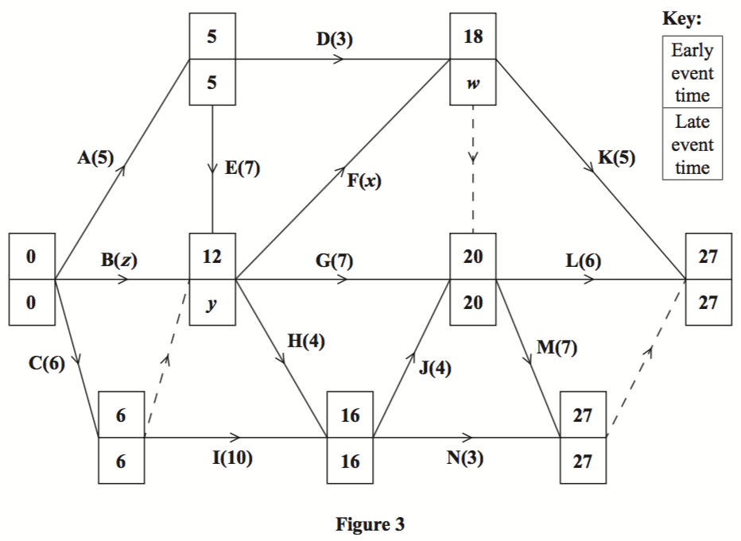

**Figure 1**

The network in Figure 1 shows the activities that need to be undertaken by a company to complete a project. Each activity is represented by an arc and the duration of the activity, in days, is shown in brackets. Each activity requires exactly one worker. The early event times and late event times are shown at each vertex.

Given that the total float on activity B is 2 days and the total float on activity F is also 2 days,

(a)find the values of *w*, *x*, *y* and *z*.

**(4)**

(b)Draw a cascade (Gantt) chart for this project on Grid 1 in the answer book.

**(4)**

(c)Use your cascade chart to determine the minimum number of workers needed to complete the project in the shortest possible time. You must make specific reference to time and activities.

(You do not need to provide a schedule of the activities.)

**(2)**

**(Total 10 marks)**

**Mark scheme for Question 2**

**Examiner comment**

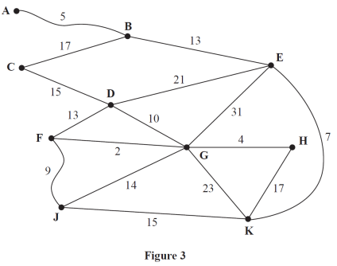**3.**

**Figure 2**

Figure 2 represents a network of tram tracks. The number on each edge represents the length,

in miles, of the corresponding track. One day, Sarah wishes to travel from **A** to **F**. She wishes to minimise the distance she travels.

(a)Use Dijkstra’s algorithm to find the shortest path from **A** to **F**. State your path and its length.

**(6)**

On another day, Sarah wishes to travel from **A** to **F** via **J**.

(b)Find a route of minimal length that goes from **A** to **F** via **J** and state its length.

**(2)**

(c)Use Prim’s algorithm, starting at **G**, to find the minimum spanning tree for the network.

You must clearly state the order in which you select the edges of your tree.

**(3)**

(d)State the length, in miles, of the minimum spanning tree.

**(1)**

**(Total 12 marks)**

**Mark scheme for Question 3**

**Examiner comment**

**4.**

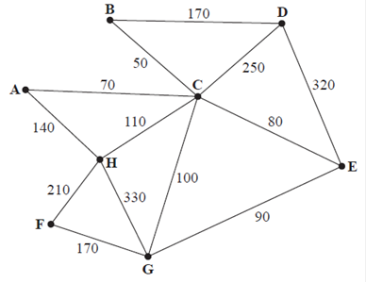

**Figure 3**

[*The total weight of the network is 2090*]

(a) Explain why a network cannot have an odd number of vertices of odd valency.

**(2)**

Figure 3 represents a network of 13 roads in a village. The number on each arc is the length, in metres, of the corresponding road. A route of minimum length that traverses each road at least once needs to be found. The route may start at any vertex and finish at any vertex.

(b) Write down the vertices at which the route will start and finish.

**(1)**

A new road, **AB**, of length 130m is built. A route of minimum length that traverses each road, including **AB**, needs to be found. The route must start and finish at **A**.

(c) Use the route inspection algorithm to find the roads that will need to be traversed twice. You must make your method and working clear.

**(4)**

(d) Calculate the length of a possible shortest inspection route.

**(2)**

It is now decided to start and finish the inspection route at two distinct vertices. A route of minimum length that traverses each road, including **AB**, needs to be found. The route must start at **A**.

(e) State the finishing point so that the length of the route is minimised. Calculate how much shorter the length of this route is compared to the length of the route in (*d*). You must make your method and calculations clear.

**(3)**

**(Total 14 marks)**

**Mark scheme for Question 4**

**Examiner comment**

**5.** The tableau below is the initial tableau for a three-variable linear programming problem in *x*, *y* and *z*. The objective is to maximise the profit, *P*.

|  |  |  |  |  |  |  |  |
| --- | --- | --- | --- | --- | --- | --- | --- |
| Basic Variable | *x* | *y* | *z* | *r* | *s* | *t* | Value |
| *r* | 5 | 3 |  | 1 | 0 | 0 | 2500 |
| *s* | 3 | 2 | 1 | 0 | 1 | 0 | 1650 |
| *t* |  | –1 | 2 | 0 | 0 | 1 | 800 |
| *P* | –40 | –50 | –35 | 0 | 0 | 0 | 0 |

(a) Taking the most negative number in the profit row to indicate the pivot column at each stage, solve this linear programming problem. Make your method clear by stating the row operations you use.

**(10)**

(b) State the final values of the objective function and each variable.

**(2)**

**(Total 12 marks)**

**Mark scheme for Question 5**

**Examiner comment**

**6.**

|  |  |  |  |  |  |  |  |  |
| --- | --- | --- | --- | --- | --- | --- | --- | --- |
| 23 | 18 | 27 | 9 | 25 | 10 | 12 | 30 | 24 |

The numbers in the list represent the weights, in kilograms, of nine suitcases. The suitcases

are to be transported in containers that will each hold a maximum weight of 45 kilograms.

(a) Calculate a lower bound for the number of containers that will be needed to transport

the suitcases.

**(2)**

(b) Use the first-fit bin packing algorithm to allocate the suitcases to the containers.

**(2)**

(c) Using the list provided, carry out a bubble sort to produce a list of the weights in

descending order. You need only give the state of the list after each complete pass.

**(4)**

(d) Use the first-fit decreasing bin packing algorithm to allocate the suitcases to the containers.

**(2)**

(e) Explain why it is not possible to transport the suitcases using fewer containers than the

number used in (*d*).

**(1)**

**(Total 11 marks)**

**Mark scheme for Question 6**

**Examiner comment**

**7.**

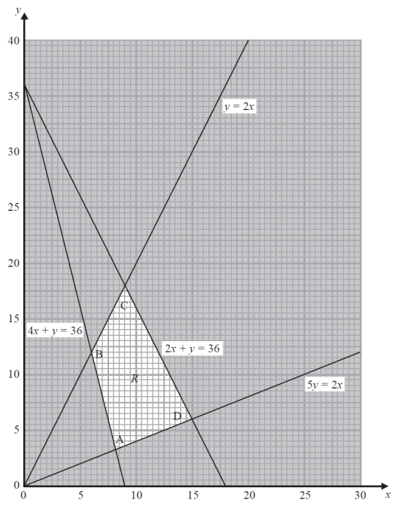

**Figure 4**

The graph in Figure 4 is being used to solve a linear programming problem. The four constraints have been drawn on the graph and the rejected regions have been shaded out. The four vertices of the feasible region *R* are labelled A, B, C and D.

(a) Write down the constraints represented on the graph.

**(2)**

***Question 7 continued***

The objective function, P, is given by

P = *x* + *ky*

where *k* is a positive constant.

The minimum value of the function P is given by the coordinates of vertex A **and** the maximum value of the function P is given by the coordinates of vertex D.

(b) Find the range of possible values for *k*. You must make your method clear.

**(6)**

**(Total 8 marks)**

**Mark scheme for Question 7**

**Examiner comment**

**TOTAL FOR PAPER: 75 MARKS**

**A level Further Mathematics – Decision Mathematics 1 – Practice Paper 05 – Mark scheme –**

**Mark scheme for Question 1** **(Examiner comment)****(Return to Question 1****)**

|  |  |  |
| --- | --- | --- |
| **Question** | **Scheme** | **Marks** |
| **1(a)** | A E F B C D A and A E F D B C A | **M1A1** |
| 35+75+88+80+108+85 = 471 35+75+88+100+80+130 = 508 | **A1A1** |
|  | **(4)** |
| **(b)** |  |  |
| RMST weight = 85 + 35 + 83 + 80 = 283 (seconds) | **M1A1** |
| Lower bound = 283 + 75 + 88 = 446 (seconds) | **A1** |
|  | **(3)** |
| **(c)** | 446  time  471 [accept 446 < time 471] | **B3,2,1,0** |
|  | **(3)** |
| **(10 marks)** | | |

**Mark scheme for Question 2** **(Examiner comment)****(Return to Question 2)**

|  |  |  |
| --- | --- | --- |
| **Question** | **Scheme** | **Marks** |
| **2(a)** | *W* = 20, *x* = 6, *y* = 12, *z* = 10 | **B4,3,2,1,0** |
|  | **(4)** |
| **(b)** |  | **M1**  **A1**  **M1**  **A1** |
|  | **(4)** |
| **(c)** | Minimum workrs is 4 activities H, I, F and G | **M1** |
| Together with 14 < time < 16 | **A1** |
|  | **(2)** |
| **(10 marks)** | | |

**Mark scheme for Question 3** **(Examiner comment)****(Return to Question 3)**

|  |  |  |
| --- | --- | --- |
| **Question** | **Scheme** | **Marks** |
| **3(a)** |  | **M1**  **A1(ABECK)**  **A1 (DJH)**  **A1ft (GF)** |
| Shortest path: A−B−E−K−H−G−F | **A1** |
| Length of shortest path: 48 (miles) | **A1ft** |
|  | **(6)** |
| **(b)** | Shortest path via J: A−B−E−K−J−F | **B1** |
| Length of shortest path via J: 49 (miles) | **B1** |
|  | **(2)** |
| **(c)** | Prim starting at G: GF, GH, FJ, DG, JK, EK, BE, AB, CD  or GF, GH, FJ, DG, CD, JK, EK, BE, AB | **M1A1A1** |
|  | **(3)** |
| **(d)** | 80 (miles) | **B1** |
|  | **(1)** |
| **(12 marks)** | | |

**Mark scheme for Question 4** **(Examiner comment)****(Return to Question 4)**

|  |  |  |
| --- | --- | --- |
| **Question** | **Scheme** | **Marks** |
| **4(a)** | E.g. (each arc contributes 1 to the orders of two nodes, and so) the sum of the orders of all the nodes is equal to twice the number of arcs | **B1** |
| Which implies that the sum of the orders of all the nodes is even and therefore there must be an even (or zero) number of vertices of odd order hence there | **B1** |
|  | **(2)** |
| **(b)** | (Start at) D and (end at) E (or vice-versa) | **B1** |
|  | **(1)** |
| **(c)** | A(C)B + D(BC)E = 120 + 300 = 420 | **M1** |
| A(CB)D + B(C)E = 290 + 130 = 420 (2 rows) | **A1** |
| A(C)E + BD = 150 + 170 = 320* (3 rows) | **A1** |
| Repeat arcs AC, CE and BD | **A1** |
|  | **(4)** |
| **(d)** | Length 2090 + 320 + 130 = 2540 (m) | **M1A1** |
|  | **(2)** |
| **(e)** | (Finishing Point is) D | **B1** |
| Difference in routes = 2540 – (2090 + 130 +130 ) = 190 (m) | **M1A1** |
|  | **(3)** |
| **(12 marks)** | | |

**Mark scheme for Question 5** **(Examiner comment)****(Return to Question 5)**

|  |  |  |  |
| --- | --- | --- | --- |
| **Question** | **Scheme** | **Marks** | |
| **5(a)** | |  |  |  |  |  |  |  |  |  | | --- | --- | --- | --- | --- | --- | --- | --- | --- | | b.v | *x* | *y* | *z* | *r* | *s* | *t* | value | θ values | | *r* | 5 | 3 | - | 1 | 0 | 0 | 2500 | 833.3 | | *s* | 3 | 2 | 1 | 0 | 1 | 0 | 1650 | 825 | | *t* |  | -1 | 2 | 0 | 0 | 1 | 800 | n/a | | *P* | -40 | -50 | -35 | 0 | 0 | 0 | 0 |  |  |  |  |  |  |  |  |  |  |  | | --- | --- | --- | --- | --- | --- | --- | --- | --- | | b.v. | *x* | *y* | *z* | *r* | *s* | *t* | value | Row ops | | *r* |  | 0 | -2 | 1 |  | 0 | 25 | R1-3R2 | | *y* |  | 1 |  | 0 |  | 0 | 825 | R22 | | *t* | 2 | 0 |  | 0 |  | 1 | 1625 | R3 + R2 | | *P* | 35 | 0 | -10 | 0 | 25 | 0 | 41250 | R4 + 50R2 |  |  |  |  |  |  |  |  |  |  | | --- | --- | --- | --- | --- | --- | --- | --- | --- | | b.v. | *x* | *y* | *z* | *r* | *S* | *t* | value | Row ops | | *r* |  | 0 | 0 | 1 | - |  | 1325 | R1 + 2R3 | | *y* |  | 1 | 0 | 0 |  |  | 500 | R2 - R3 | | *z* |  | 0 | 1 | 0 |  |  | 650 | R3 ÷ | | *P* | 43 | 0 | 0 | 0 | 27 | 4 | 47750 | R4 + 10R3 | | **M1A1**  **B1**  **M1A1**  **(5)**  **M1**  **A1ft**  **B1**  **M1A1**  **(5)** | |
|  | **(5)** | |
| **(b)** | *P* = 47750 *x* = 0 *y* = 500 *z* = 650 *r* = 1325 *s* = *t* = 0 | **B1ft**  **B1** | |
|  | **(2)** | |
| **(12 marks)** | | | |

**Mark scheme for Question 6**  **(Examiner comment)** **(Return to Question 6)**

|  |  |  |
| --- | --- | --- |
| **Question** | **Scheme** | **Marks** |
| **6(a)** | so lower bound is 4 bins | **M1A1** |
|  | **(2)** |
| **(b)** | Bin 1: 23 18  Bin 2: 27 9  Bin 3: 25 10  Bin 4: 12 30  Bin 5: 24 | M1 A1 |
|  | **(2)** |
| **(c)** | e.g. (left to right)   |  |  |  |  |  |  |  |  |  | | --- | --- | --- | --- | --- | --- | --- | --- | --- | | 23 | 18 | 27 | 9 | 25 | 10 | 12 | 30 | 24 | | 23 | 27 | 18 | 25 | 10 | 12 | 30 | 24 | **9** | | 27 | 23 | 25 | 18 | 12 | 30 | 24 | **10** | **9** | | 27 | 25 | 23 | 18 | 30 | 24 | **12** | **10** | **9** | | 27 | 25 | 23 | 30 | 24 | **18** | **12** | **10** | **9** | | 27 | 25 | 30 | 24 | **23** | **18** | **12** | **10** | **9** | | 27 | 30 | 25 | **24** | **23** | **18** | **12** | **10** | **9** | | 30 | 27 | **25** | **24** | **23** | **18** | **12** | **10** | **9** |   List in order | **M1**  **A1**  **A1ft**  **A1cso** |
|  | **(4)** |
| **(d)** | Bin 1: 30 12  Bin 2: 27 18  Bin 3: 25 10 9  Bin 4: 24  Bin 5: 23 | M1 A1 |
|  | **(2)** |
| **(e)** | e.g. 5 of the suitcases are over 22.5 (half the weight of a container). No two of these five can be paired in a bin, so at least 5 bins will be required. | **B1** |
|  | **(1)** |
| **(11 marks)** | | |

**Mark scheme for Question 7** **(Examiner comment)****(Return to Question 7)**

|  |  |  |
| --- | --- | --- |
| **Question** | **Scheme** | **Marks** |
| **7(a)** | *y*  2*x*, 5*y*  2*x*, 2*x* + *y* 36, 4*x* + *y* 36 | **B2, 1, 0** |
|  | **(2)** |
| **(b)** | B( 6, 12), C(9, 18), D(15, 6) | **B1** |
| A | **B1** |
| P at A: , or P at B: , or P at C: ,  or P at D: | **B1** |
|  | **M1** |
|  | **A1** |
|  | **A1** |
|  | **(6)** |
| **(8 marks)** | | |

**A level Further Mathematics – Decision Mathematics 1 – Practice Paper 05 – Examiner report –**

**Examiner comment for Question 1** **(Mark scheme)****(Return to Question 1)**

1. This question also proved to be a good source of marks for many candidates with the mode again being full marks obtained by 51.9% of candidates and only 23.5% scoring 6 marks or fewer.

Most candidates found both nearest neighbour routes in part (a) but some failed to return to A, or made arithmetic errors in calculating the lengths of these two routes and some incorrectly doubled the length of their routes to obtain an upper bound.

In part (b), most found a residual spanning tree, but unfortunately lost marks in this part as they did not use the correct two least lengths incident to F. A number of candidates incorrectly used both arcs of 88. A common mistake for the RST was to include arc CD. Some candidates calculated a Nearest Neighbour route for the vertices A to E rather than finding a minimum spanning tree.

In part (c) most candidates, who had obtained upper and lower bounds earlier, wrote down an interval containing these two values, although a significant number lost marks through poor notation, including writing  471. Those candidates with incorrect bounds became creative with their interval, particularly when their lower bound was greater than their upper bound.

**Examiner comment for Question 2** **(Mark scheme)****(Return to Question 2)**

2. Full marks were fairly common in part (a) although there were a number of responses which got one or two of the values incorrect, in particular *y* or *z* tended to be the ones that were most often incorrect.

In part (b), the Gantt chart was usually well attempted and errors usually arose as a result of errors in (a) or sometimes due to the omission of an activity (often N), there were also occasionally issues with the lengths of activities or floats, for example, at the ends of activities D, F and/or G. As a result the vast majority of students were able to gain the method mark and mostly the first accuracy mark too. There were very few blank attempts or scheduling responses. Occasionally a scheduling diagram was seen after a cascade chart, possibly to be used in the next part of the question despite specifically not being required. There were some cascade diagrams that were unclear and, in such cases, it was difficult for examiners to tell exactly where some activities ended and therefore were floats began. It is important to stress to students the importance of clear diagrams.

In part (c), most students were able to conclude that the minimum number of workers is 4, and were usually able to identify which activities must be occurring simultaneously. It was challenging though for some students to identify a correct time at which the four activities must be taking place. It should be noted that a reference to time which included time 14 or time 16 was not valid and a significant number of students lost a mark as their stated time intervals were ambiguous, for example, 14 - 16. Some students did not provide responses to part (c) which considered time and activities but rather carried out lower bound calculations. There were a small number of responses which provide the correct information regarding time and activities but did not provide the required number of workers.

**Examiner comment for Question 3** **(Mark scheme)****(Return to Question 3)**

3. Part (a) was usually very well done with most candidates applying Dijkstra’s algorithm correctly. The boxes at each node in part (a) were usually completed correctly. When errors were made it was either an order of labelling error (some candidates repeated the same labelling at two different nodes) or working values were either missing, not in the correct order or simply incorrect (usually these errors occurred at nodes D, G and/or F). The route was usually given correctly and most candidates realised that whatever their final value was at F, this was therefore the value that they should give for their route. As noted in previous reports because the working values are so important in judging the student’s proficiency at applying the algorithm it would be wise to avoid methods of presentation that require values to be crossed out.

Part (b) was answered well with the vast majority of candidates correctly stating the shortest path and corresponding length from A to F via J.

Part (c) was generally well answered with the majority of candidates applying Prim’s algorithm correctly starting from vertex G. A few candidates attempted to construct a table to perform Prim, clearly believing that this algorithm can only be performed when expressed in matrix form. Finally, there is still a small minority of candidates who appear to be rejecting arcs when applying Prim’s algorithm so scoring only one of the three possible marks in this part.

The vast majority of candidates correctly stated the length of the minimum spanning tree in part (d).

**Examiner comment for Question 4**  **(Mark scheme)**  **(Return to Question 4)**

4. Part (a) was found to be particularly demanding and very many candidates seem to suggest erroneous arguments along the lines of:

* ‘an extra odd node would have no other node to pair with’: These candidates often stated that an even number of vertices of odd degree were required in order to use the route inspection algorithm
* Many candidates stated that ‘an odd number of odd degrees would make it impossible to traverse the graph’: These candidates often also stated that the graph would not be semi-Eulerian and sometimes argued that there would be half an arc with no end point
* Many candidates stated simply ‘handshaking lemma’ but usually with little success as it was often accompanied by little or no supporting comment or argument
* Some candidates attempted an induction based argument stating that if there are only even degreed vertices then every arc added must create two vertices of odd degree.

Stronger candidates were able to score one of two marks – usually the first mark for stating a relationship between the number of arcs and the sum of the order of the vertices. There were also a significant minority of candidates who were able to provide clear and precise arguments and gain both marks.

Part (b) was mostly answered correctly, however, an answer of nodes A and H, appeared on more than one occasion.

Part (c) was generally answered well by most candidates with the vast majority stating the correct three distinct pairings of the correct four odd nodes. There were a few candidates who only gave two pairings of the four odd nodes or who gave several pairings but not three distinct pairings. There were however many instances where the totals were incorrect. The majority of such mistakes occurred for the two pairings of AB with DE and AD with BE. There were also some instances where no totals were given which lost candidates a significant number of marks. Candidates should be advised to be thorough when checking the shortest route between each odd pairing. Many candidates did not explicitly state the arcs that should be repeated instead stating that AE and BD should be repeated instead of the correct arcs AC, CE, BD.

Surprisingly, part (d) was rarely correct with the majority of candidates forgetting to add the 130 (from the additional arc AB) to the length of their shortest inspection route and so the incorrect answer of 2410 (rather than the correct answer of 2540) was often seen.

There were many excellent responses to part (e) with the majority of candidates realised that BE had to be repeated giving a difference in route lengths of 190. Some candidates found the right arc, BE, to repeat but then said B or E. Some candidates decided on E without considering the other options, having limited themselves to the route they picked in part (c) with an additional 320. A number of candidates worked out the new route length but then failed to answer the question which explicitly asked for the difference.

**Examiner comment for Question 5** **(Mark scheme)****(Return to Question 5)**

5. This question proved to be a good discriminator and gave rise to a good spread of marks. The mode was again full marks (obtained by 30.8% of candidates), 57.2% of candidates scored 10 marks or more although 11.1% of candidates scored no marks.

In part (a) the majority of candidates correctly identified the correct pivot and went on to divide the pivot row by 2. However a number incorrectly used the 3 in the top row as the pivot and some used the –1 in the third row. A small number of candidates decided to pivot on the *x* column or the *z*column instead of *y*, despite the question stating that the most negative number in the profit row should be used. A small number failed to change the basic variable in the pivot row. Having divided through, most candidates stated the correct row operations and applied them successfully to the table, although some numerical errors crept in. Most then went on to correctly identify the second pivot and to divide through again. Those that had a correct or virtually correct first iteration generally went on to state and apply the correct second set of row operations, ending with a correct optimal solution. However those that had made more significant errors in their first iteration often did not have the correct second set of row operations.

From time to time it was difficult to read candidates’ work due to crossings out/corrections and candidates should be reminded to make sure their work is clearly set out. Many candidates made use of only two tables, however, a significant number of candidates used several tables, often writing and rewriting elements within the table a number of times which must have taken candidates a considerable amount of time.

Part (b) was generally less successfully attempted. Of those candidates who provided an answer to this part many were able to correctly write down at least some of the values from the value column rather than from the profit row of the table. However a significant number lost marks because they did not write down all of the variables (often giving only the basic variables) or they did not write down P explicitly.

Surprisingly there was a significant number who did not attempt this part of the question or who wrote down only *P* + 43*x* + 27*s* + 4*t* = 47750.

**Examiner comment for Question 6** **(Mark scheme)****(Return to Question 6)**

6. Part (a) was generally very successfully attempted. The vast majority of candidates carried out a correct calculation and rounded their value up to give the correct lower bound. It was rare to see ‘178’ (the total of all the numbers) divided by 9 (the number of suitcases).

Part (b) was nearly always correct.

In part (c) the majority of candidates knew how to carry out a bubble sort and nearly all did so correctly. Unfortunately, many candidates did not read the question carefully and either showed each comparison and swap during the first pass or during all subsequent passes. There were occasional errors including the loss of one number or one number morphing into a different number. A few candidates did not work consistently through the list of numbers. Finally, in this part, it was common for candidates to stop after a seventh pass due to the list appearing to be in the ‘correct order’. With the bubble sort algorithm if the list finds itself ordered before the final two items in the list have been considered then either a suitable conclusion (that the list is sorted) or an additional pass is required.

In part (d), in which candidates now had to apply the first-fit decreasing algorithm to their ordered list from part (c), a significant number, who had sorted the numbers into ascending order earlier, then proceeded to attempt a “first fit increasing” method in this part. While the vast majority of candidates used the sorted list they had obtained in part (c) there were a minority of candidates who used the unsorted list. Otherwise, the most common errors were putting the 9 in either the third or fourth bin.

Part (e) was answered extremely well with the majority of candidates correctly arguing that five of the suitcases weighed more than half of the maximum weight capacity of a container and so therefore it was not possible to transport the suitcases using fewer containers than the number used in part (d).

**Examiner comment for Question 7** **(Mark scheme)****(Return to Question 7)**

7. There was possibly some evidence of candidates having insufficient time to complete the paper as there were a number of blank (or unfinished) solutions to this question. However, this was also a demanding and discriminating question which is an alternative and feasible reason for blank/incomplete responses. Only 3.9% of candidates scored full marks, the modal mark was 3 (gained by 23.9% of candidates) and only 10.1% scored 5 or more marks.

Part (a) was generally well attempted and most candidates were able to obtain at least one mark in this part. Some candidates incorrectly used strict inequalities and there were also errors in the directions of the inequalities.

Quite a few blanks responses were seen in part (b). Those that did attempt this part usually began by stating or calculating the exact coordinates of vertex D. However, many did not find the exact coordinates for vertex A, and instead either rounded their answers or read them directly from the graph. The majority of candidates then (incorrectly) went on to compare the expressions representing the value of the objective function, in terms of , at these two vertices. As a result, many scored only 1 or 2 marks in part (b). Even candidates who successfully found all 4 coordinates often compared vertices incorrectly and unnecessarily. Some compared the values from each pair of vertices in turn, achieving the method mark almost by ‘trial and error’. Other methods, based on an objective line approach, were rarely seen. When they were, candidates were more often successful, although some struggled to use ‘steeper’ and ‘shallower’ in the context of negative gradients. Others could ‘see’ the solutions but omitted to show how the gradients of the lines and the objective function were related to. Furthermore, the negative values and the negative reciprocal of  in the inequalities caused some difficulties and some used incorrect algebra to obtain an answer that looked reasonable and it was not uncommon to see the correct final answer following incorrect working. The question stated that they should make their method clear but not all candidates were able to do this.