|  |  |
| --- | --- |
| Artist | Bertelli (1900-1974) |
| Title | Continuous Profile (Head of Mussolini) |
| Date | 1933 |
| Medium | Terracotta |
| Scale | 34cm x 28cm |
| Scope | Leaders in 2D or 3D |
| Patron |  |
| Location | Imperial War Museum, London |
| Function | Propaganda |

Historical context/subject of work:

Mussolini was the founder of Fascism and leader of Italy from 1922 to 1943. He allied Italy with Nazi Germany and Japan in World War Two.

One of many portraits created during the lifetime of Il Duce (The Leader), Benito Mussolini, this work shows Mussolini’s profile continued in a 360 degree rotation. The Fascist leader appears to be wearing a military helmet and constantly surveying his surroundings whilst simultaneously avoiding our gaze. Completed a decade after he seized power Mussolini was very aware of the power of art as a tool for propaganda.

Critical text quote:

From the BBC: ‘The Futurists’ celebration of war as a means to remake Italy and their support of Italy’s entrance into World War I also constitute part of the movement’s narrative, as does the later, complicated relationship between Futurism and Italian fascism.’

How does this example fit the scope of work:

It is a 3D portrait of a leader.

Image: 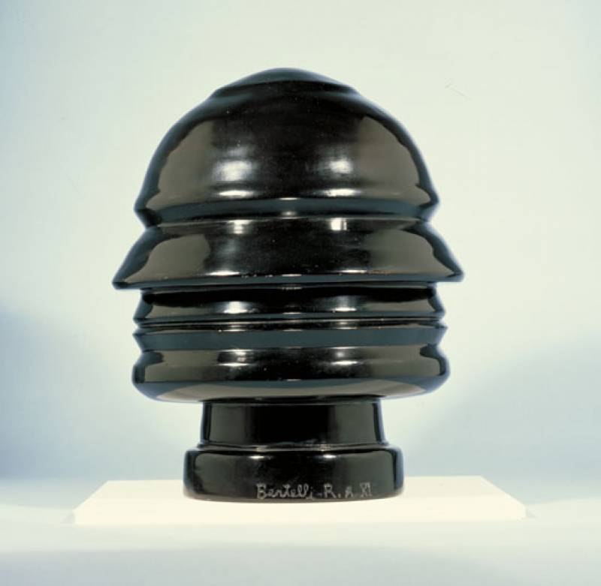

|  |  |
| --- | --- |
| Formal features | |
| Composition | The sculpture looks the same from every angle, alluding to Mussolini’s constant monitoring and observing of the nation. We make no eye contact and have no direct perspective yet we know we are being watched. |
| Colour or texture | The jet black colour is a reference to the party, who were known as The Blackshirts. We are made to associate black with the penalty of death which would arise as a result of opposition, adding to its daunting nature. |
| Figure handling | Simplified appearance – identifiable by all.  Stylised – doesn’t have to rely on accurate likeness and gives an intimidating presence |
| Form | The statue could almost resemble a bomb or bullet. Lifesize – realism. Numerous copies were created when Mussolini was in power and their presence gave an atmosphere of being watched |
| Materials | Glossy finish implies spinning. Clay comes from the Earth, which links Mussolini to the land, Italy, both literally and symbolically – patriotism. |

Political factors:

After forming the Fascist party in March 1919, Mussolini gradually dismantled the institutions of democratic government, leading a ‘march on Rome’ in 1922 and gaining one year of emergency powers which turned into a 20 year dictatorship. In 1925 made himself dictator, taking the title 'Il Duce'. He set about attempting to re-establish Italy as a great European power, opposing economic suffering through glorifying the nation’s workers. He suppressed the communists with strong state control, silencing opposition.

Artist’s involvement:

Renato Bertelli (1900-1974) was an Italian Futurist artist. This piece mirrors the Italian movement towards machinery and progress, shown through its dynamism as it appears to be spinning.

To be a Futurist in the Italy of the early 20th century was to be modern, young, and insurgent. Inspired by the markers of modernity—the industrial city, machines, speed, and flight—Futurism’s adherents exalted the new and the disruptive. They sought to revitalize what they determined to be a static, decaying culture and an impotent nation that looked to the past for its identity.

Cultural/social factors:

The statue appeals to Mussolini’s cult of personality, often seen in totalitarian or authoritarian countries, involving social engineering techniques through mass media, propaganda, the big lie, spectacle, the arts, patriotism, and government organized demonstrations and rallies to create an idealized, heroic, and worshipful image of a leader, often through unquestioning flattery and praise.