Artist | Daniel Libeskind
Title | Jewish Museum Berlin
Date | 1989-2001
Scope | Commemorative Architecture. Key architect
Patron | Berlin City Government
Location | Berlin
Function | Museum
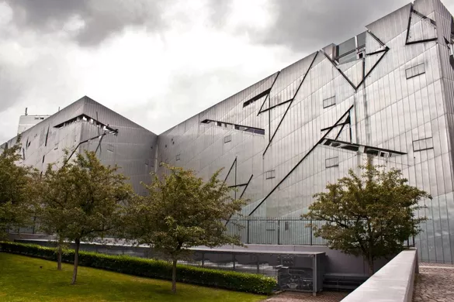
Historical context/subject of work:
- To commemorate the Holocaust and millions of Jews that were lost
- Garden of Exile – represents how lost the Jews were and how they were pushed out of society
- Void of Memory – represents the Jews who died
- Holocaust tower – represents a Gas chamber
- Materials and composition represent the concentration camps violence and coldness and make you feel uneasy
- Originally it was opened as an empty gallery to show the building as the exhibit.

How does this example fit the scope of work:
The Holocaust happened during world war 2 as resulted in the mass genocide of millions of Jews. This building commemorates that event as well as the history of the Jewish community in Berlin.
Critical text quote: 1: It is impossible to understand the history of Berlin without understanding the enormous contributions made by its Jewish citizens.
2: The meaning of the Holocaust must be integrated into the consciousness and memory of the city of Berlin; and, finally, for its future,
3: The City of Berlin and the country of Germany must acknowledge the erasure of Jewish life in its history
Formal features
Composition | - Enter the Kollegienhaus then descend the stairway through the Entry Void into the underground  - the old and new buildings are connected underground to preserve the juxtaposition, there is no doorway into the new building from the outside making it more unconventional and represent the concentration camps where the Jews didn’t see the entrance and there was no exit.  - underground the hallway divides into three corridors each telling a different story – long corridors show the long journey  - one corridor leads to a dead end – the Holocaust tower  - the second leads outside to the garden of exile and emigration to remember those who were forced to leave Berlin  - The third leads to the stair of Continuity which leads to the exhibition space and museum. End of the staircase ends in a wall to show finality  - The void cuts through the exhibition space to absence and the impenetrability of the concentration camps  - Stands out in the cityscape so unmissable like the Holocaust is unforgettable
Colour or texture | Grey metal exterior contrasts with traditional buildings surrounding it.  Scars across the side match places on the map from where Jews were taken and exiles. Dull colour is monotonous and reflects post-war depression and the effects of the Holocaust.
Materials | The metal it’s made from will erode over time so the colour will dull down and the rust colour will match the surrounding buildings.  The exterior is covered in zinc which becomes less shiny over time – represents how the Jewish community stuck out after the war and gradually blended back into society after.  All materials used are mass produced and industrial showing how the concentration camps were cheaply made and mass produced.  Garden of exile is unbalanced and disoriented – made of concrete and plants – represents how the Jews were lost
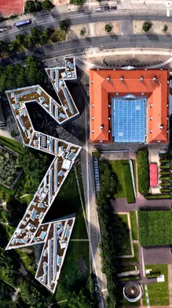
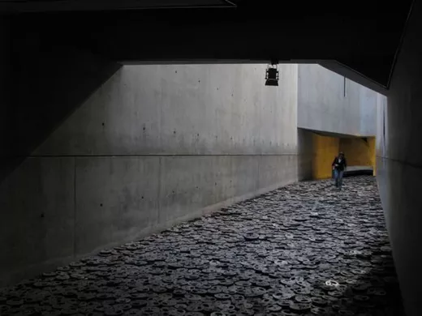
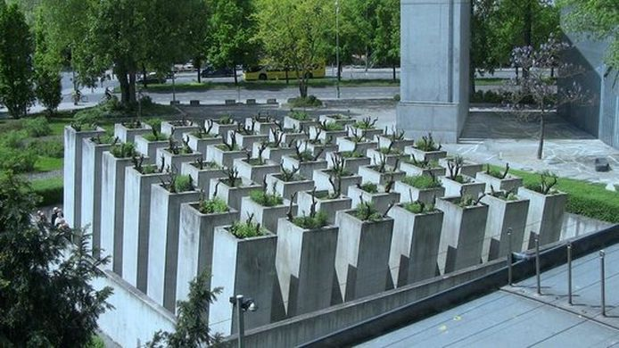
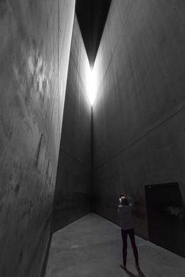
Artist’s involvement:
- Wanted to show that it is impossible to understand the history of Berlin without understanding the enormous contributions made by its Jewish citizens – the meaning of the Holocaust must be integrated into the consciousness and memory of the city of Berlin – the city of Berlin and the country of Germany must acknowledge the erasure of Jewish life in its history
- Libeskind’s parents lived through the holocaust and was Jewish all his life so wants everyone to know their history.
Political factors:
- Built next to the old Prussian Court of Justice, where they made laws to persecute the Jews so covers their whole lives, building which is now the entrance to the museum.
- Designed a year before the Berlin wall came down
- Originally the Berlin city officials didn’t like the unconventional slit windows, shape, material
Cultural/social factors:
- Represents how the Jews were treated during the Holocaust.
- Void of memory – 10,000 cast metal faces to symbolise all of the Jews who died – gives an eerie noise as you walk across it. Sounds like a rail way like what the Jews were taken on to the camps
- Holocaust tower represents gas chambers

