|  |  |
| --- | --- |
| Artist | Jeremy Deller |
| Title | ‘It Is What It Is” |
| Date | 2009 |
| Medium | Readymade: metal, car |
| Scale | Life-size (car, readymade) |
| Scope | Participants of war |
| Patron | No patron |
| Location | Toured across USA, now resides in Imperial War Museum |
| Function | To change perceptions of the US occupation of Iraq and the ‘War on Terror’ |

**Historical context/subject of work:**

In 2001, Al-Qaeda hijacked a plane which they then flew into the twin towers of the World Trade centre, killing 3000 people in a terrorist attack. This launched the “war on terror” which the governments of western countries (USA and UK mainly) fought countries in the Middle East who they thought were responsible. President George W Bush of the USA decided to declare war on Iraq in 2003 and was joined by Tony Blair, UK, under the suspicion of Iraq’s leader- Saddam Hussein housing weapons of mass destruction (which we now think was just an excuse). US and UK soldiers occupied Iraq and destabilized the country. The Iraqi citizens didn’t want to be occupied which was expressed in protests: one of them being a suicide bomber in Baghdad causing an explosion in a busy marketplace. The result was many fatalities and destruction, including this car which was completely destroyed. It was extracted from Iraq under Jeremy Deller’s request and toured around the United States in 2009, alongside an American soldier and an Iraqi citizen, inviting people in America to have a conversation and change preconceptions about the occupation of Iraq, in the midst of Islamophobia and paranoia after 9/11, stoked by the government.

**Political factors:**

* Bush Administration
* War on Terror
* US occupation of Iraq
* 9/11 terror attack

**Cultural/social factors:**

* Islamophobia and panic in the United States stoked by 9/11.
* America breeds a hostile and defensive attitude to the Middle East.

**Critical text quote:** “It also brought up a lot of questions about Domestic politics in America… what it had been like living in the US during those years in post 9/11 America”

“When it’s in a gallery you always have this problem with people thinking it’s an artwork… whereas when it’s on the road, you just accept it for what it is”

Image: 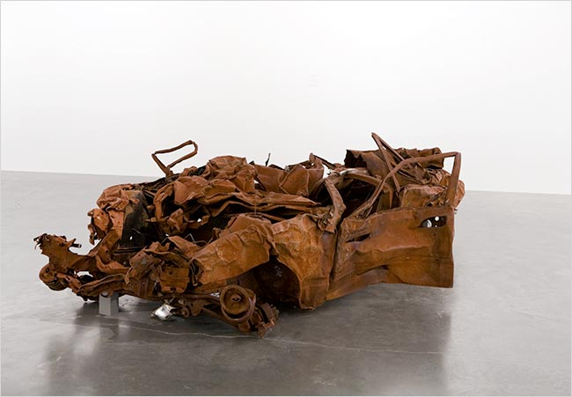

**How does this example fit the scope of work:**

Although it doesn’t depict a participant of war in the literal sense, it is a memorial and a product of the sufferers of war. The use of a readymade is completely honest and the most accurate representation of the pain suffered at the hands of military occupation. The sheer destruction of the car shows the sheer desperation and anger felt by the citizens and the power of the weapons used among them.

**Artist’s involvement:**

Jeremy Deller takes a backseat approach to this piece. He has not touched the car. He is not the one speaking to the American citizens. He uses a readymade and has the Iraqi citizen and US soldier speak. His own influence is not felt in this art piece, rather Deller just facilitates it.