|  |  |
| --- | --- |
| Artist | Jeremy Deller |
| Title | “We’re Here Because We’re Here” |
| Date | 01/07/2016 |
| Medium |  |
| Scale |  |
| Scope | Participants in war / Commemoration of War |
| Patron | 14 – 18 NOW |
| Location | British Cities |
| Function | To commemorate the soldiers of WW1 |

Image: 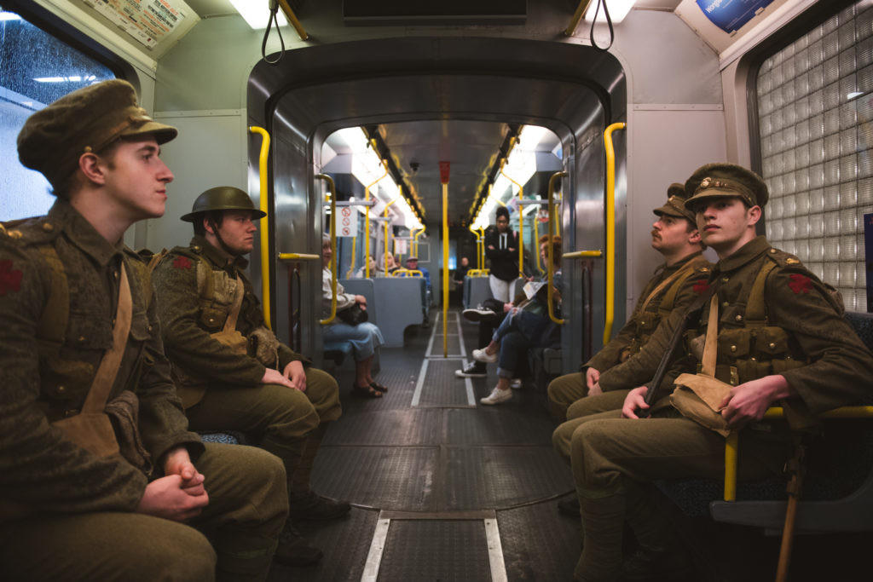

Historical context/subject of work:

* The work takes place on the centenary of the Battle of the Somme and serves to commemorate the 19,240 man that were killed on the first day of the battle – the bloodiest day in British military history.
* More than 3 million soldiers participated in this battle and it is estimated that 1 million were killed or wounded, on both sides.
* The piece was inspired by tales of sightings, during and after WW1, by people who believed they had seen a dead loved one.
* 1400 actors volunteered to portray a soldier who had died in the Somme. Each carried around small cards detailing the name, life dates and regiment of the soldier that they represented.

Critical text quote:

“I wanted to make a contemporary memorial to mark the centenary of the Somme, one that moved around the UK with an unpredictability in which the participants, by their actions, took the memorial to the public” – Jeremy Deller

How does this example fit the scope of work:

Participants and commemoration of war:

It is a memorial to the soldiers that died during the first day of the battle of the Somme and shows actors in the same attire that the soldiers would have been fighting in.

How does this example fit the scope of work:

|  |  |
| --- | --- |
| Formal features | |
| Composition |  |
| Colour or texture |  |
| Light & tone |  |
| Space & depth or relief |  |
| Line or brushwork |  |

Cultural/social factors:

It was a moving piece as it reminded people of the devastation that WW1 caused. The public were unaware that it was going to take place, therefor their reactions were raw and many were shocked. Even though the battle is over 100 years old, the atrocity is still present in the minds of the British public and this served to bring it to the forefront of their thoughts.

Political factors:

Artist’s involvement:

Jeremy Deller worked on this project with a number of different theatres across the country. It was his idea to have the actors be silent and instead give of their small cards as a method of communication with the public. He wanted to do this because it would make the piece more interactive and stop the actors from including their own personalities and views in the presentation of the soldiers. Deller himself did not want to be a part of the performance, as he did not want to centre the memorial on himself or draw attention away from the message of the piece.