|  |  |
| --- | --- |
| Artist | Rawal Jaisal/ Suther |
| Title | The Golden Fort |
| Date | 1156 |
| Medium | Sandstone |
| Scale | 1500ft long, 750ft high on a 250ft hill |
| Scope | Non-Western Architecture |
| Style |  |
| Patron | Raja (the King) |
| Location | Trikuta Kill, in the city of Jaisalmer, in the Indian state of Rajasthan |
| Function | To defend inhabitants and establish Raja as the absolute ruler |

|  |  |
| --- | --- |
| Formal features | |
| Composition | The fort is triangular in shape, because of the shape of the hill it is situated on. This hill sets the castle 250ft above the surrounding landscape. It has a horizontal emphasis, however this may be due to being practical as it is situated on a hill to build any higher would make it unstable. It has 2 concentric, crenelated (with gaps through which you can shoot) sandstone walls of surrounding the city inside. The inner wall is taller than the outer wall allowing it to be seen over the top of the outer wall. It is complete with 7 bastions and only one entry point – add protection. |
| Colour or texture | It is made out of sandstone, which gives it its Golden colour, earning it its name. The texture is much like that of sand, making it seamlessly fit into its surroundings of desert region and sand. |
| Light & tone | Is all made of one material therefore one tone, the golden sandy colour means it blends into their background- a defensive strategy. |
| Space & depth or relief | The use of crenels and merlons (merlons are the gaps in between the crenels) have both a functional and decorative purpose. The undulating shape of the fort follows the natural curves in the rock it is situated on. There are not many decorative elements on the exterior of the fort. |
| Line or brushwork | N/A |

Image: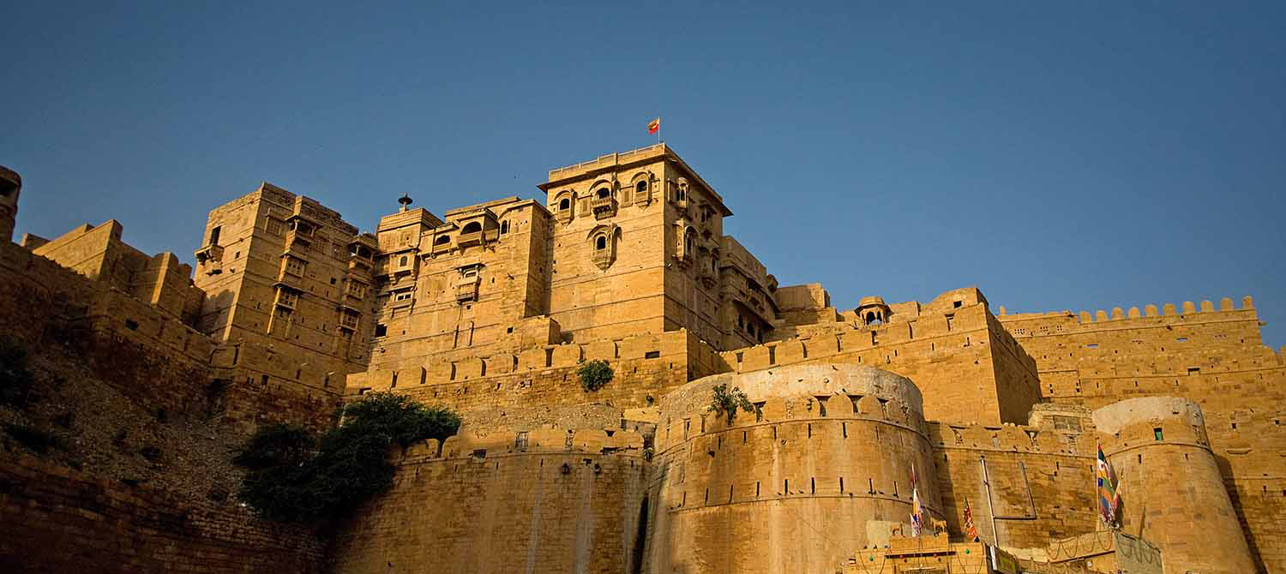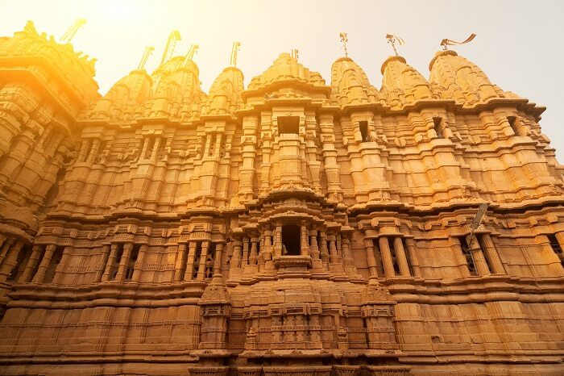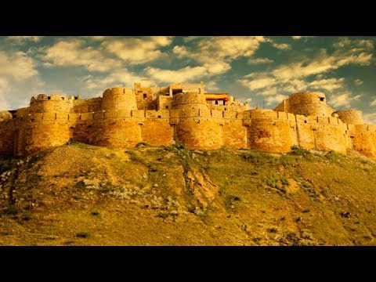

Critical text quote:

**Agarawala**- ‘Golden tiara in the morning sun’

‘a scruffy old lion waiting for its prey’

Thar desert referred to as ‘the abode of death’

Jaisalmer described as having “a spectacular skyline and balconies, kiosks, cupolas, turrets and crenulations, the product of incremental additions and accretions over many generations’

Political factors

Situated in the Thar desert- also known as “the abode of death” Jaisalmer became a main trading post between Hindustan (now recognised as India) and the West. This meant the town grew successful as it collected tolls from traders.

The Rajputs organised themselves in to a form of a feudal system, so the Raja owned the land, but leasing some out to office holders and some to peasants for cultivation.

Although the Rajputs were devout Hindu’s they still allowed Jainism worship within Jaisalmer, even building temples with in the fort for Jainism worship, the first one dating to the 12th century, called the Parshwanath temple.

Influence from cultural/social factors:

Many major aspects of Indian forts were laid out in Shastras (a Hindu or Buddhist sacred scripture) e.g. Ramayana and Mahabharata. These say how the best defence for highly populated towns are river and mountain forts. The golden fort adheres to this as its situated on a hill. Furthermore, it favours desert land to surround the fort, multiple concentric walls, ditches and poisonous bushes- this is also adhered to.

Prince Faisal insisted his architect included a temple and a palace.

Artists involvement

No architect specified more relied on the fort plans laid out in the shastras and the Kings desires.

How does this example fit the scope of work:

It is a building built for the purpose of warfare and defence- This is evident in its features built for defence:

-2 concentric, crenelated walls 4.6/15ft outer wall 9m/30ft inner wall

-when first built 7 Bastions, growing to 99

-built on a hill

-singular entrance- highly controlled

- strong teak door with iron spikes so an elephant couldn’t knock it down

-poisonous bushes planted at the base of the hill.

Historical context/subject of work:

Founded in 1156 by the Bhatti Rajput Ruler Rawal Jaisal. This was after it was prophesised by a sage that he would build a Kingdom on that hill. The Rajput (means ‘son of kings’) claimed to be protectors of the Hindu faith and had control over Northern Hindustan leading to the Brahmins gave them Royal lineage and Kshyattiya status, which meant they had to follow very strict codes of honour, meaning they wouldn’t ever accept defeat.

The Fort was protected by its remote location until 1286. In this year The Sultan Alauddin Khalji of Delhi had his treasure caravan of 3000 horses and mules attacked by a Bhati raid. The Rajputs responded to this by carrying out the scorched earth policy, rounding up a large supply of food and managed to withstand an 8-year siege. However, once the food supplies dwindled they still couldn’t admit defeat due to their Kshyattiya status. This meant that rather than surrender 3,800 warriors opened the gates and fought to their death. Inside the fort, 2, 400 women and children committed jauhaur (mass suicide by burning).