Guernica

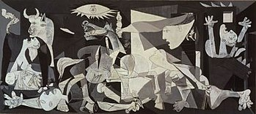

* Guernica portrays the bombing of the Basque town Guernica in northern Spain by Hitler’s Luftwaffe at the request of Spanish Nationalists including Franco during the Spanish civil war. Picasso created this work to show his anti-war stance.
* The tonal black and white colour scheme used copies the style of pictures in black and white newspapers which is how at the time people would have seen images of the event and what Picasso would have based the work on. Picasso also adds lines similar to newsprint over areas which also helps to break sections up. The lack of colour sets a sombre atmosphere.
* The many figures are depicted fleeing and crying out in pain with a mother shown clutching her dead baby. Picasso depicts several other dead figures along the bottom of the work with severed and scarred limbs showing how horrific the event was for those involved creating empathy in the viewer.
* The figures are also shown to be compacted together all overlapping each other and climbing atop one another showing the chaos and panic caused by the bombings which would have happened without warning catching the civilians off guard.
* The scene also depicts animals with a bull and horse that are important figures in Spanish culture.