|  |  |
| --- | --- |
| Artist | Unknown |
| Title | Kneeling archer from the terracotta |
| Date | C210BC |
| Medium | Terracotta |
| Scale | Life-size |
| Scope | Participants in 2d and 3d |
| Patron | Emperor Qin |
| Location | China |
| Function |  |

Image: 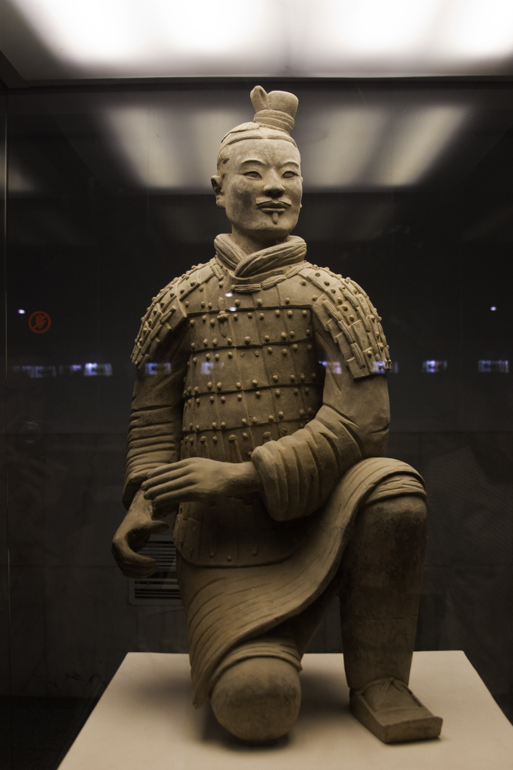

Historical context/subject of work:

Ying Zheng took the throne in 240 bc at the age of 13. By 221 bc he had unified a collection of warring kingdoms. And then took the name Emperor Qin. Qin ordered the Mausoleum’s costruction shortly after taking to the thrown and the project lasted the whole of his life and longer, with more than 70,000 workers on the project. The army of statues bears a unique testimony to military organization in China at the time of the warring Kingdoms (475-221 BCE) and that of the short-lived empire of a thousand Generation.

Critical text quote: “The direct testimony of the objects found in situ (lances, swords, axes, halberds, bows, arrows, etc.) is evident. The documentary value of a group of hyper realistic sculptures where no detail has been neglected- from the uniforms of the warriors, their arms, to even the horses’ halters – is enormous”

How does this example fit the scope of work: This depicts and archer that was part of emperor qin’s army, therefore a participant of war.

How does this example fit the scope of work:

|  |  |
| --- | --- |
| Formal features | |
| Composition | An archer kneels on the floor with one leg, the figure is compact as terracotta doesn’t have a very high tensile strength, the soldier has a lack of detail to the face to make all the soldiers look the same . |
| Colour or texture | The Sculpture was originally painted in vibrant colors of red black white and green, this was to make the soldiers look more realistic. In the areas where skin casn be seen the sculpture is very smooth, but the armour is very detailed. |
| Light & tone |  |
| Space & depth or relief | This sculpture is very compact with not a lot of open space between the limbs. The archer kneeling creates a lot of stability to the figure. |
| Line or brushwork |  |

Cultural/social factors: Qin was the first emperor of china as he unified all the kingdoms of China to make one country

Political factors:

Artist’s involvement: