|  |  |
| --- | --- |
| Artist | Unknown |
| Title | Night Attack on the Sanjô Palace |
| Date | Second half of 13th Century AD |
| Medium | Ink and colour on paper |
| Scale | 45.9 x 774.5 cm |
| Scope | Depicts horrors of war |
| Patron | Unknown |
| Location | / |
| Function | / |

Historical context/subject of work:

Sanjô Palace for former emperor, in Kyoto- capital of Japan.

He recently abdicated (for son) but he wanted to hold political influence still.

Both backed members of Fujiwara family (opposing; powerful). Involved in politics who should be emperor.

One member wanted power from current emperor. Jan 1160, he and other clan leader attacked the palace during the night.

500 men in assault; abducted retired emperor and son.

Event is one part of Heiji Insurrection: short civil war between rival factions. Outcome leads to dominance and power of shogun (military figure/ dictator) replacing emperors as leaders till 19th century.

Image: 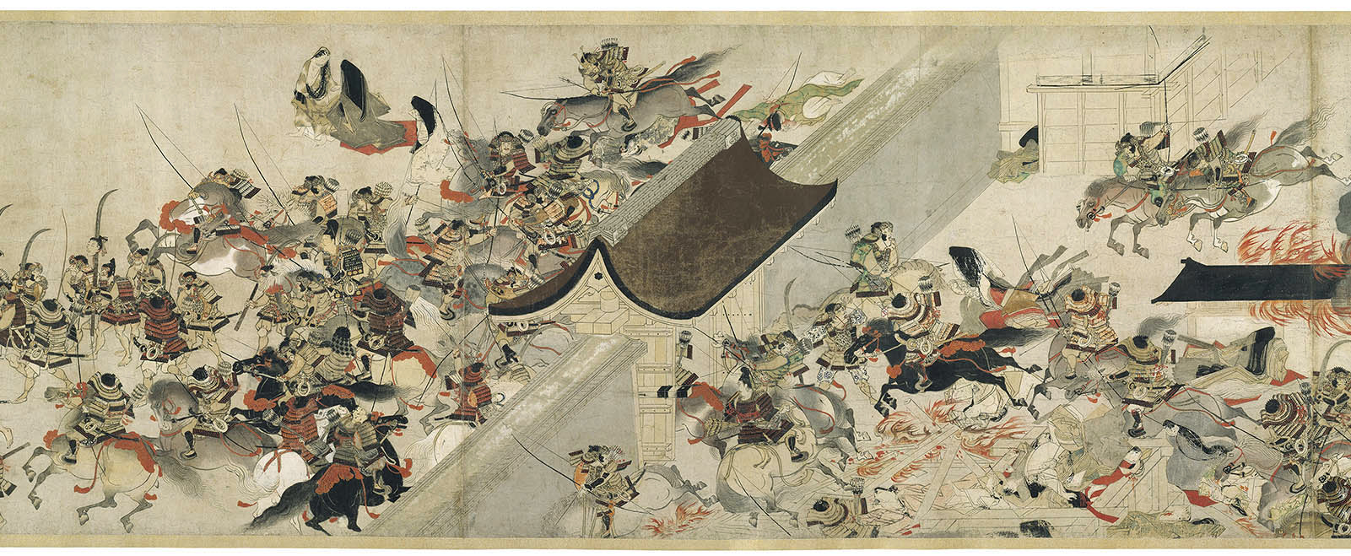

|  |  |
| --- | --- |
| Formal features | |
| Composition | Long, horizontal canvas as it is painted over the length of the scroll. Throughout the artwork, there are clusters of people fighting, which leaves negative space. |
| Colour or texture | The artwork has a limited colour palette of black, cream and red. The black is used to show form and line of figures. The red is a contrast of the monotone colours to enhance the idea of bloodshed and destruction. |
| Light & tone | The focus isn’t on the lighting/ shading of the scene, rather the quantity of people fighting the battle, and the suffering it brings. |
| Space & depth or relief | Use of orthogonals along the walls of the palace creates a sense of depth. |
| Line or brushwork | The brush strokes in areas like the fire, or the coats of the horses, are quite washy; effect achieved naturally using ink.  Figures are outlined as a stylistic choice/ to help distinguish them. |

Critical text quote:

How does this example fit the scope of work:

It depicts the horrors of war as it illustrates the rivals fighting a great, busy and bloody war.

Cultural/social factors:

We see men illustrated in traditional armour, and additionally traditional weapons.

Political factors:

The battle began because of politics surrounding who should be the emperor.

Artist’s involvement:

The artist would’ve first hand witnessed the war, the perspective seems to be from a hill, overlooking the entire length of the scene.