|  |  |
| --- | --- |
| Artist | PABLO PICASSO |
| Title | ‘Gernica’ |
| Date | 1937 |
| Medium | Oil on canvas. |
| Scale | 3.49m X 7.76M |
| Scope | Depiction of war |
| Patron | Spanish republican goverment |
| Location | Not relevant |
| Function | Not relevant |

Image: 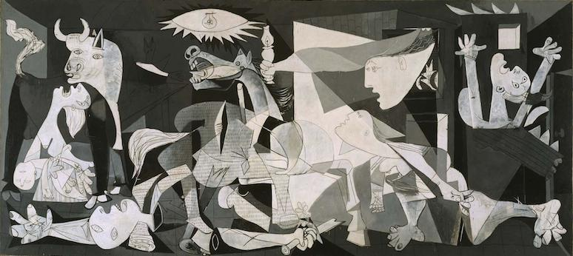

Historical context/subject of work:

Guernica was a civil war between the republicans and the Nationalists. Franco was a nationalist Hitler was a fascist same as Franco thus Hitler sympathised with Franco during the civil war.

Guernica is in the Basque region of Spain, which is where it was considered to be under republican rule. Guernica was the communication centre for the republicans

Franco allowed Hitler to practise bombing on Guernica due to the fact Guernica were populated mainly by Republicans.

This showed Franco’s military power and support. As they bombed on market day to bomb this made a bigger statement and added to the horrors of the mass murder.

It caused an international crisis.

Critical text quote:

How does this example fit the scope of work?

This painting highlighted the chaos of war and the effects it had on innocent people

|  |  |
| --- | --- |
| Formal features | |
| Composition | The main focal points is the cluster of chaotic figures and shapes as |
| Colour or texture | The colour scheme of black and white shows lack of emotion, there is no colour to create a barrier between the viewer and the scene. The colour scheme replicate newspapers and old photos-lighting how media separates the emotion form the viewers in media. |
| Light & tone | The light and tone of the light and shadows highlight the colour palette that reflects the media’s recording of the event to the public. |
| Space & depth or relief | Shows many figures overlapping each other not showing range or distance to them in the foreground or background ,to the right of the painting shows a woman screaming who looks further away this is shown by the orthogonal on the floor of the painting. |
| Line or brushwork | Very harsh lines, overlapping each other with different tones, range of horizontal and vertical lines. |

Cultural/social factors:

The war caused lots of controversy and created a lot of anger among the people, thus many people liked this painting due to its true depiction of the brutality and destruction of Guernica.

Political factors:

Victory of the Nationalist forces under Francisco was the outcome of the Spanish Civil war.

The painted was created for the republican government because they were on the side who lost the civil war, so they were more sympathetic to those depicted in the work, rather than celebrating a victory.

Artist’s involvement:

Picasso, empathized with the Republican government of his homeland, and was horrified by the devastation and death created through the war. He wanted to emphasize

Picasso wanted to use the colour palette of newspaper to highlight how the war was being depicted, with lack of emotion and created a barrier and separation between the people effected by the war and those who aren’t.