**THEORIES ACROSS ALL TOPICS: Family, Education, Crime, Stratification and general approaches**

**B Group 2019**

* Functionalism p.
* New Right p.
* Marxism p.
* Neo marxism p.
* Liberal feminism p.
* Radical feminism p.
* Marxist feminism p.
* Interactionism p.
* Weberian p.
* Postmodernism p.
* Other theories p.
* Linking theory to methods p.

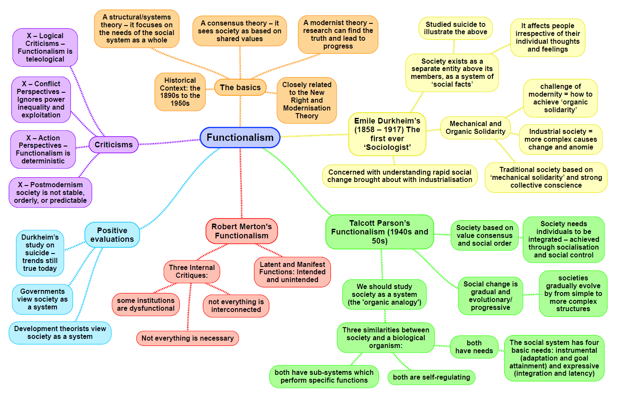

Functionalism: Sam

|  |  |
| --- | --- |
| **Theory: New Right MICRO STRUCTURE CONSENSUS** | |
| Family:  Murray - the welfare state has undermined personal responsibility and self-help as well as devaluing the value of support from families  Dennis – breakdown rates of families are higher if a couple is cohabiting with children rather than being married  Policies – protection of marriage etc  Belief of divorce being too easy to obtain, it should be made harder so that people work on their marriages  The government should discourage divorce  Children from separated families are more likely to: Under achieve at school, suffer from behavioural problems, use drugs and drink from an earlier age as well as becoming sexually active sooner  The conflict that arises during divorce can have negative mental health effects of children | Education:  Policies – 1988 Education Reform Act – marketization, parentocracy, choice and competition, national curriculum  The state cannot meet people’s needs – free market and private businesses competing is the best way to do this  League tables came from the formation of the education market  Schools should teach subjects that prepare pupils for work – education should be a tool for economic growth  Schools should transmit the same shared values – e.g. through the national curriculum as everyone is being taught the same things  Chubb and Moe - proposed the full introduction of market forces in education to raise standards. They believe that in state education students, parents and citizens have a legitimate say in how that education system should be run. They believe that vested interests tend to undermine the autonomy of schools, restricting their ability to respond to the needs and wishes of parents  State education is intended to serve wider public purposes as determined by politicians |
| Crime:  Right realism – Clarke, Murray, Wilson + Kelling  Murray – crime is linked to the unemployed, work shy underclass of society who live in broken communities with high rates of social disorder and crime. This underclass is characterised by a system of welfare dependency as well as a lack of individual responsibility and respect for authority.  Cornish and Clarke – rational choice and opportunity theory – people choose to commit crime because they decide that the benefits outweigh the potential costs  Wilson and Kelling – broken window theory- a crime is more likely to occur when a previous crime has already taken place – the damage would be seen as less because damage was already there. | Stratification:  Saunders – it doesn’t matter on a person’s circumstances because the inequalities that we see in society are mainly the result of differences in effort and intelligence rather than one’s class, gender, ethnicity, age or disability.  Societies were there are unequal rewards work best  If everyone was treated equally force would need to be used to get people to undertake difficult or unpleasant jobs – all societies need stratification to function effectively  Society works best when everyone is acting as an individually |
| General view of the theory (p.374-375 Browne):  Attitudes toward how society should work  Associated more so with political society, and the Conservative government of 1979-1997  Shares much of its views on society with Functionalism; emphasis on the importance of socialisation into shared core values to maintain social stability  Key role of traditional institutions to build shared values, condemns the threats to such values | Evaluation:  It doesn’t address the wider structural causes of crime that other theories do  Ignores white collar and corporate crime  Fails to acknowledge that unequal relationships exist in some families  Child benefits are paid to the mother – enforces the stereotype of women being the primary care giver  Competition between schools generally only benefitted the middle classes and lower classes – ethnic minorities and rural communities suffer from a lack of choice and competitiveness  Danger of schools spending money on marketing the school rather than on the education aspect of a school  Full marketization means that schools are more concerned with league tables than pupils needs |

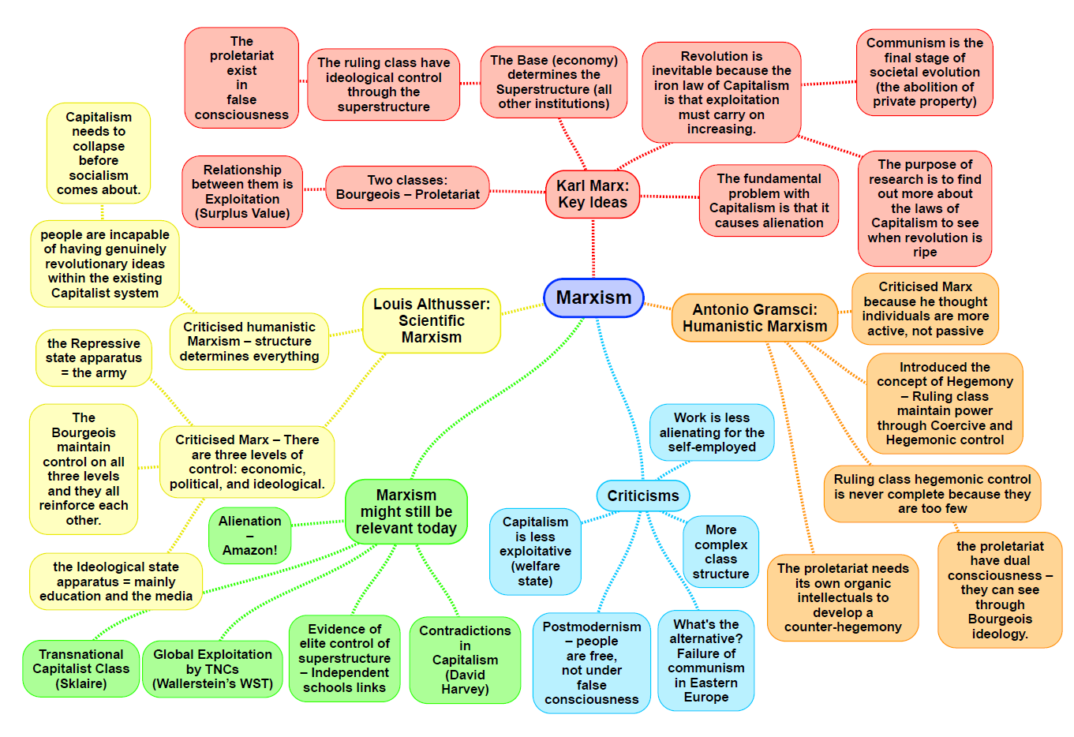

|  |  |
| --- | --- |
| **Theory: Marxism MACRO STRUCTURE CONFLICT** | |
| **Family:**  Engels: explains the nuclear family, according to Engels, the monogamous nuclear family only emerged with Capitalism. Before Capitalism, traditional, tribal societies were classless, and they practised a form of “primitive communism” in which there was no private property. In such societies, property was collectively owned, and the family structure reflected this, there were no families as such, but tribal groups held restrictions on sexual relationships. Eventually the Bourgeois started to look for ways to pass on their wealth to the next generation, rather than having it shared out amongst the masses, and this is where the monogamous nuclear family comes from. With the emergence of capitalism the Bourgeois started to look for ways to pass on their wealth to the next generation, rather than having it shared out amongst the masses, and this is where the monogamous nuclear family comes from It is the best way of guaranteeing that you are passing on your property to your son, because in a monogamous relationship you have a clear idea of who your own children are. This arrangement serves to reproduce inequality. The children of the rich grow up into wealth, while the children of the poor remain poor. Thus the nuclear family benefits the Bourgeois more than the proletariat.  Criticisms: Gender inequality clearly preceded Capitalism The vast majority of tribes in Africa and Asia are patriarchal, with women being barred from owning property, having no political power, and having to do most of the child care and hard physical labour. He also ignores feudal systems and has no evidence to support his claims about the state of tribes before the emergence of society.  Wealthy Capitalist economies such as the UK and USA have seen the fastest improvements in gender equality over the last 100 years. Capitalism, increasing wealth and gender equality within a nation seem to be correlated.  Althusser: labelled the family as part of the ideological state apparatus along with things such as education and the media. It acts to pass on the ideas of capitalism as the best ideology through socialisation. Through this the ruling class try to maintain a false class consciences by winning the hearts and minds of the working class.  Zaretsky: also emphasises the ideological role of the family in propping up capitalism. He sees the family as an escape route from oppression from oppression and exploitation at work and gives them a feeling of being in control of some aspect of their lives and being the “king of the castle”. This serves to make them more agreeable to the system of capitalism and reduce opposition. It is an interesting variation on Parsons “warm bath” theory and ties in with Fran Ansley’s idea that women are the “takers of shit.” The family can also be seen to tie workers to their jobs. If it is just themselves they have to worry about they are much more likely to walk whereas if they have to think about their children SO etc. then they might stay complicit in order to preserve their wellbeing.  However it does rely on an extremely idealised version of the family that lacks domestic squabbles and extreme male focus. | **Education:**  Bowles and Gintis: like Althusser Argue that the role of education in capitalist societies is the reproduction of labour power to form a submissive and disciplined workforce. It is produced they argue in two major ways. No1. The hidden curriculum and the correspondence between the social relationships of work and school – most notably in the way schooling mirrors “the long shadow of work”  No2. Through the role of education in legitimising or justifying inequality and the class structure.  The school helps reduce discontent and opposition to inequality by socialising people into accepting it from a young age.  They reject the functionalist view that people’s place in a capitalist society arise from a fair competition in education and instead assert that your social class, background, Gender and ethnicity play a crucial part in your success within the education system. **They see meritocracy and equality of opportunity as a myth** this acts to reinforce failure in the system as the fault of the working class despite the fact that they stood far less of a chance than white middle / upper-class men at succeeding. This failure makes the person feel like they deserve to be in that position despite the fact that they were forced there and perpetuates and masks class reproduction. (“Schooling in capitalist America” (1974))  Althusser: argued that state education formed part of the “ideological state apparatus” the government and teachers control the masses by injecting millions of children with a set of ideas which keep people unaware of their exploitation and make them easy to control. education operates as an ideological state apparatus in two ways; Firstly, it transmits a general ideology which states that capitalism is just and reasonable – the natural and fairest way of organising society, and portraying alternative systems as unnatural and irrational Secondly, schools encourage pupils to passively accept their future roles |
| **Crime:** social inequality is the drive for crime and capitalism is criminogenic.  Chambliss: laws are made to benefit the ruling class interests and are not an expression of value consensus as functionalists assert. He argues that they are instruments of the ruling class and reflect their values. At the heart of the capitalist system is the protection of private property. In his famous 1978 study of Seattle, he went further to argue that members of the ruling class were part of a crime syndicate who used their wealth and influence to bribe officials and avoid punishment. He wrote that this included politicians and business owners. His argument was that the criminal justice system was not really there to catch them; nominally universal laws were applied selectively to control the working class while protecting the rich.  Snider: argues that capitalist states will pass health and safety and environmental laws that regulate business when forced too by public crises or union aggregation. They will reluctantly strengthen them and weaken them where possible. They don’t enforce them if they can get away with it or do so as mildly as possible as no to scare away investment (globalisation?)  Tombs: Despite being more costly to society, the crimes of the elite tend to go unpunished – (research by Tombs and Whyte suggests)  Tombs and Whyte: Believe that corporate crimes aren’t newsworthy because the average non expert person wouldn’t understand the crime and they are too complicated to summarise easily, also as there is often no direct victim, there is no emotion behind it.  Gordon: claims that it is not the fact that the working class commit crime that should surprise us but rather that they don’t commit more of it due to relative deprivation and social exclusion (people being excluded from full participation in aspects of life such as education, work or community life due to certain facts such as background or they code they may speak with) | **Stratification:** They argue that class is the key to understanding absolutely everything in society. Marx argues that there are only 2 classes in society – the PROLETARIAT and the BOURGEOISIE. He believes that class is a social group who share the same relationship to the means of production.  **Class:** Marxists argue that our society is POLARISED– the gap between the rich and the poor has widened. WESTERGAARD and RESLER put forward a Marxist view that there was a ruling class in Britain consisting of the richest 5-10% of the population, who's position came from the ownership of capital.  **Gender:** ZARETSKY would argue that in the home men act as the ‘king of the castle’ as this is the only place they feel in control. This shows that patriarchy still exists in the home and therefore the home oppresses women.  ENGELS: would argue that marriage is a form of ‘Legitimised Prostitution’ meaning that women exchange their bodies in return for money and security.  **Ethnicity – Cox, Castles and Kosack :**  CASTLES AND KOSACK (1973): say that capitalism benefits from a working class divided by ethnic inequality. They argue that ethnic differences are used to distract the working class form the real cause of their problems.  E.g. they get blamed for problems such as unemployment and housing shortages. Instead of uniting to start a revolution, the working class fights amongst itself.  They say that ethnic division also creates a reserved army of relatively cheap ethnic minority labour. Capitalism therefore encourages ethnic division and disadvantage.  **Age – reserve army of labour, Philipson:** Marxists ideas of a ‘RESERVE ARMY OF LABOUR’ could be applied to some “economically disadvantaged” age groups – both the young and retired may be called upon to do jobs for relatively low wages during economic boom, buy may also be dismissed when the economy goes into slump.  PHILIPSON (1998): suggests that the logic of capitalism is about exploiting workers and consumers for profit. This is incompatible with the need of the elderly.  He says retirement from paid work often means that the elderly lose a major source of status, respect, identity, and economic secuirty. Resulting in the elderly, despite their greater needs, being neglected by the capitalist system, as they no longer have disposable income.  **Disability:** Marxists tend to see disability more as a social factor partly created by industrial capitalism. This is said by Finkelstein. |
| General view of the theory (p.375-378 Browne):  Marx – base and superstructure, private ownership, exploitation, class conflict, dominant ideology, communism  (CONFLICT STRUCTURALISM):  Classical Marxism: comes from work of Marx, who founded the political creed: Communism. Marxism, like functionalism, is a modernist theory that believed that a scientific analysis of society, and the discovery of the laws of its development, would provide the means for improving it, in this case through eventual revolution and the establishment of a communist society.  BASE AND SUPERSTRUCTURE:  Marx believed that the economy was the driving force in society, and it was this that determined the nature of social institutions, and people’s values and beliefs. Marxism sees the structure of society divided into 2 main parts.   1. The ECONOMIC BASE: underpinned and determined everything else in society.   The means of production: e.g. land, factories, technology, and labour necessary to produce society's gods.  The relationships of production: e.g. the relations between those involved in production e.g. shared ownership or private ownership, who controls production, and the relationship between owners and non-owners.  2. THE SUPERSTRUCTURE: includes society’s social institutions e.g. the family, education, the media, religion and the political system, and beliefs and values (ideology, which Marx saw as primarily determined (or influenced) by the economic system. | Evaluation (p.378 Browne):  STRENGTHS:   * Recognises the importance of the economy and how economic changes influence a wide range of other social institutions. * Recognises the importance of society's social structure, and links this to the ides, consciousness and behaviour of individuals and groups. * Remains a highly influential theory, which has had a significant influence on a range of other sociological theories e.g. those of Weber and of Marxist feminists.   WEAKNESSES:   * Classical Marxism over-emphasises the extent of conflict in society. Functionalists wold argue society is primarily stable, and there must be some shared values for social life to be possible. That Marx’s predicted revolution hasn’t succeeded in any western society reflect this. Functionalists see stratification as inevitable in a functioning society and is important for role allocation. * Over-emphasises social class as a source of inequality and conflict, and pays little attention to other sources e.g. gender, ethnicity, and age. * Classical Marxism is too deterministic, + sees individuals as simply passive products of the social system, which socializes them into conformity and controls their behaviour. It doesn’t allow for individual choice, as the social action theorists do. |

|  |  |
| --- | --- |
| **Theory: Neo Marxism MACRO/MICRO (BOTH) STRUCTURE/ACTION (BOTH) CONFLICT/CONSENSUS (BOTH)** | |
| Family  *Althusser;*  The family works as an Ideological state apparatus, alongside other institutions such as education and media, by passing on the ideology (ideas and beliefs) of the ruling class. Through socialisation, the family transmits these ideas to maintain a ‘false class consciousness’. | Education  *Willis;*  Willis studied 12 working class ‘lads’ within schools. He found that they had formed a distinct subculture to rebelling against the school. The ‘lads’ found school boring and pointless which is way they formed their subculture. The ‘lads’ identify with the manual workers who focus on jobs such as labour which gives an explanation to why they see themselves superior to everyone else.  *Bourdieu;*  Bourdieu was focused on education and privilege within society. His main focus was on the relationship between the economic capital (which is to do with wealth and ownership), social capital (which is who you know) and cultural capital (which is what you know) and how this affected people’s life chances within education.  *Althusser;*  He argued that if people were simply forced to co-operate with capitalism, that they would eventually reject the system. Therefore he argued that people are manipulated into loving the system so that they find it harder to challenge it. These are the Repressive State Apparatus (RSA) which are things like the police which keep society in check and the Ideological State Apparatus (ISA) such as the education system where students are rewarded for working hard. Althusser argues that schools prepare children for their roles in the workforce. |
| Crime  *Hall;*  Hall argues that the moral panic in the 1970s over black muggers helped capitalism. The ruling classes are normally able to rule through consent but during time of crisis of anomie, this becomes more difficult. At such times when opposition to capitalism begins to grow, the ruling class may need to use force to maintain control.  *Gilroy;*  Statistical differences are the outcome of a process of social construction that stereotypes ethnic minorities as inherently more criminal than the rest of the population. Gilroy argues that black criminality is a myth created by racist stereotypes and in reality, they are no more criminal than others. Gilroy sees ethnic minority crime as a form of political resistance against a racist society.  *Althusser;*  When society finds itself in a time of anomie, then the Repressive State Apparatus might be used however this comes with risks. The use of force needs to be seen as legitimate or it might provoke more wide spread resistance. | Stratification  *Class;*  For Neo-Marxists (such as Wright and Bourdieu), economic, cultural and social factors explain patterns and trends of social class inequality. The middle class is a permanent feature of society and enables its members to be at once the controlled and the controllers. Wright argues that the middle classes are a permanent feature of the social structure, occupying a contradictory class position, as both the exploiters (of those below) and the exploited (by those above).  *Class, Bourdieu;*  To understand an individual’s [position within society, you must consider their economic, social and cultural capital. Class inequality is reproduced by the education system which then gets projected onto our later life.  *Ethnicity, Miles;*  He argues that minority ethnic groups are a part of the same class structure as the majority group. However, they form a racialized part of it.  *Ethnicity, Hall;*  He argues that ethnic relations are historically specific and subject to change over time. His work highlights the immigration problems of the 1970s media moral panic to draw attention away from the economic recession. |
| *General view of the theory* (p.379 Browne);  Neo-Marxists are those who have further developed and modified the ideas of Marx’s classical Marxism.  *Gramsci (Humanism) – hegemony;*  Gramsci thought Marx was mistaken in giving such over-riding importance to the economy, and he saw ideology and people’s ideas having relative autonomy from the economic base. His concept on hegemony placed more emphasis than Marx did on the role of ideas rather than just the economy in maintaining ruling-class power in influencing people’s behaviour. He emphasised that people’s ideas underpin the actions they choose to make.  *Althusser;*  Althusser argued that the structure of capitalist society consist of 3 levels.   1. Economic level: consisting of the economy and production of material goods. 2. The political level: consisting of the government and organisations involved in the political control of society; this is the repressive state apparatus. 3. The ideological level: concerned with ideas, beliefs and values; this is the ideological state apparatus. | Evaluation  Neo-Marxists have tried to overcome some of the weaknesses of classical Marxism, and particularly its economic determinism in which everything is explained by the operation of the economic base. The concept of hegemony recognises the importance of people’s ideas and actions and Althusser’s concept of relative autonomy suggests that institutions in the superstructure can impact on the economy, and not simply the other way round.  However, some classical Marxists would argue the Marx himself did recognise the importance of ideas and meanings, with his discussions of class consciousness, and they also suggest that neo-Marxists can underplay the importance of the economy in shaping social reality. Gramsci has been criticized for over-emphasizing the role of ideas, and for under-emphasizing the role of material factors, like economic crisis and collapse, fear of poverty and unemployment, and state repression in preventing revolutionary action by the working class. |

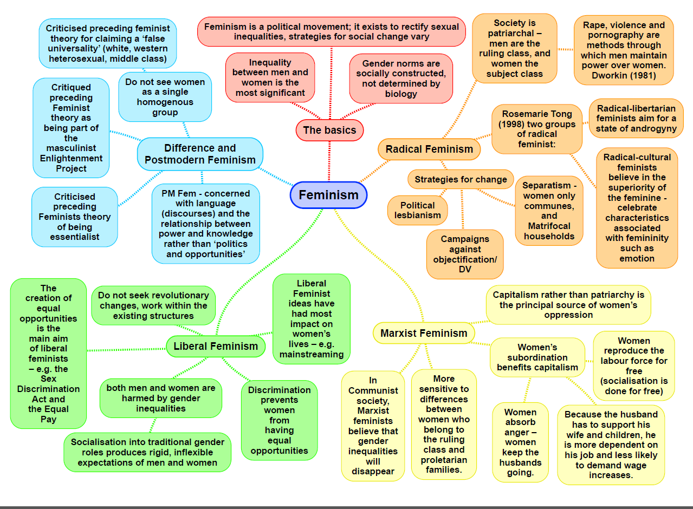

|  |  |
| --- | --- |
| **Theory: Feminism: liberal MACRO/MICRO STRUCTURE/ACTION CONFLICT (similar structure to Marxist triangle, with patriarchy being the source of power and control, but the liberal perspective is less aggressive.)** | |
| **Family:**  Feminists have been critical of most theories that have come before in explaining women’s role in the family (especially Parsons and his functionalist gender role theory), and therefore have had a significant influence in the study of the family. Liberal feminist are of the opinion that change will come gradually over time with social reform and the changing of laws.  **Oakley**  She believes that a couple can do things jointly, but until the blame for a dirty house or empty larder is taken off of women and placed on both partners in a relationship, gender roles will not be equal. Gender socialisation in the family is what reinforces gender stereotypes through canalisation (children channelled into specific gender identities by their parents) and manipulation (parents encouraging specific types of activities).  **Sharpe**  Study of women’s changing aspirations over time. (See notes in Education.) These changes were also introduced by the changing of the way girls are socialised in the family, as well as school. | **Education:**  For years boys used to outperform girls in education, however in recent years this has changed and girls have outperformed boys (however it has only been a problem once boys started to ‘underachieve’). Liberal feminists try to explain the changes and the inequalities that exist within the education system.  **Oakley**  Oakley’s arguments for education are similar in education as they are in family. Education also plays a strong role in canalisation and manipulation.  **Sharpe**  Sue Sharpe did a study to measure the changing aspirations of women. This study showed the impact of liberal feminism and identified the way changing social standards is benefitting gender stereotypes and standards. In the 70s school girls identified their aspirations and ambitions as mothers and wives, while in the 90s, they identified their aspirations as going into further education and having careers.  **Stanworth**  Study looked at gender relations in A level classes. Interviews with teachers and pupils revealed that both men and women took more interest in in their male pupils, asking them more questions and giving them more help and attention in class. Techers are more worried about boys as well as favouritising boys over girls. However, this study is out of date.  **McRobbie**  Bedroom culture study (see stratification section). |
| **Crime:**  Girls are less likely to commit, and be convicted of crimes than men are. Liberal feminists try to explain these trends.  **Carlen**  The gender and class deal. Women feel rewards from fulfilling their roles at home whilst gaining emotional and financial support from the male breadwinner. Women choose to make money through the correct means (employment0 rather than feeling the need to commit crime to make money.  **Adler – liberation thesis**  Women are steadily being liberated from patriarchal control, and as this happens the rates for women committing crime will be as equal as for man because both genders are as liberated as each other.  **Walklate**  In rape cases it is more often the female victim than the male offender who ends up on trial in rape cases. Therefore women need to establish respect from the court if their evidence is to be believed.  **Heidenson**  Control theory and rational choice. Women and controlled by brothers, fathers and other male influences in their lives, so that they are monitored and don’t have to opportunity to commit crime. Furthermore, it is in a woman’s nature to be more caring and think rationally about how the crime they want to commit will affect themselves, victims and the world around them. The justice system is also influence by the gender attitudes of society as a whole. When women deviate from sexual norms it is taken far more seriously and is seen as more controversial than if a man were to do the same. | **Stratification:**  **Gender – Oakley, Sharpe, McRobbie**  Oakley’s idea of canalisation and manipulation still stand for stratification. It introduces gender stereotypes which will create inequality through expectations. If we socialised children equally we could create symmetrical roles in society.  Sharpe’s study on the changing aspirations of girls (see education section) shows that women have not always been socialised equally or been given equal opportunities.  McRobbie talks about **‘**bedroom culture’ in which girls are limited in terms of socialising outside of the family which then meant they lacked certain skills to offer them the same opportunities as men. |
| **General view of the theory (391 Browne):**  Women’s inequality arises primarily from factors like sexist stereotyping, gender role socialisation, a lack of positive role models, responsibility for housework and childcare and sex discrimination through outdated laws and attitudes. Therefore there are a lack of equal opportunities for women. Legal, social and economic equality for women will come with gradual process of reform, enabling women to take full part in existing society on equal terms with men. | **Evaluation:**  + Liberal feminist research has produced much evidence demonstrating that gender differences are socially constructed, through prejudice and discrimination generated by the socialisation process and the legal and political system.  + It has had important effects on social policy, with the passing of anti-discrimination laws like the equal pay act (1970) and the sex discrimination act (1975).  - Liberal feminism merely deals with reducing the effects of women’s subordination, rather than challenging the fundamental causes. Radical, Marxist and dual systems feminists suggest these lie in the structures of patriarchy and/or capitalism, and women’s equality can only be brought about by revolutionary changes that overthrow these. |

|  |  |
| --- | --- |
| **Theory: Feminism: radical MACRO**  **STRUCTURE CONFLICT** | |
| Family:  Firestone – biology is the basis for women’s inequality and domination by men in society. Because women physically depend upon others, men develop physical and psychological power and control, leading to men dominating the social world. Equality between men and women can only happen when the psychological dominance of men is destroyed.  Duncombe and Marsden- long term relationships are held together by women’s emotion rather than men’s. Women are more involved with the emotional aspects of childcare, such as talking to listening to, understanding and supporting children.  Bernard  ‘being a housewife makes women sick’  Millet  Relationships of domination by men and women don’t just happen at a societal level but are occurring within the home. She argues ‘patriarchy is the most pervasive ideology of our culture, its most fundamental concept of power’. The family reinforces this. | Education:  Primary schools may be feminine but males who enter teaching dominate the top positions.  Most jobs that women have are part time and temporary. Women earn about 80% of what men earn, indicating women’s options are limited. There is a glass ceiling.  Male gaze – girls as looked up and down as sexual objects by male teachers and other students. (Mac an Ghaill 1994 (not a radical feminist)- gendered pursuit girls classroom talk and activity involved pursuit that focused on appearance and construction of femininity, such as hair make up and diet, and efforts to make them look nice to please boys. Mac an Ghail called this the ‘male gaze’ ) |
| Crime  Chivalry thesis – Males feel the tendencies to treat women in a ‘chivalrous’ manner. To protect and care for women. Thus meaning less women are arrested and convicted of crimes. Radical feminists may argue that this oppresses women. | Stratification:  Gender – see family |
| General view of the theory (Browne p.391):  Patriarchy is the most fundamental form of inequality. The world is divided into 2 sex classes women and men. Men dominate women in all areas, which men benefit from. Men are the key instruments of women’s oppression, all personal relationships with men including all relationships involve ‘sexual politics’, power struggles whereby men try and dominate and control women, and thus the personal life is also political. Patriarchal inequality is found in all public and private spheres of life.  Firestone and Ortner: link women’s subordination to women’s biology, which makes them dependant and vulnerable, and enables men to develop physical and psychological control over them. | Evaluation:   1. It assumes all women share common interests. Unlike Marxists and feminists it fails to recognise that other factors like social class and ethnicity are important source of inequality. 2. Fails to recognize that gradual reform has improved womens opportunities and weakened the significance of patriarchy without revolutionary change, as liberal feminists argue. 3. Doesn’t offer explanations or solutions for how patriarchy might be abolished |

|  |  |
| --- | --- |
| **Theory: Feminism: Marxist MACRO STRUCTURE CONFLICT** | |
| **Family:** the main cause of women’s oppression is capitalism, not men. Marxist Feminists see the family as contributing to the maintenance of capitalism in the following ways:   * Reproduction of labour power * Safety valve * Reserve army of labour   **Ansley:** states women are “TAKERS OF SHIT” who soak up the frustration that their husbands feel because of the alienation and exploitation they suffer at work. Also, they act as a “SAFETY VALVE” which is the opposite of parson’s warm bath theory.  **Beechey:** argues the housewives carry out TWO functions = To provide care for current and future workers these are their husbands and their children. The other is to be a cheap reserve army of labour.  **Breughal:** women act as a “RESERVE ARMY OF LABOUR” women’s unpaid domestic labour helps maintain capitalist exploitation by reproducing the labour force through women. | **Stratification:** they suggest that although men may sometimes be a problem, however class dimensions are more important.  **Engels:** suggest that in the past people lived in “PROMISCUOUS HORDES” where sexual relations were not fixed and property passes from mother to child. Now men are more determined to pass their property to their own offspring which leads to the MONOGAMOUS marriage and the power of men over women.  **Benston:** capitalism transmits the idea that that women’s family role as mothers and housewives is their most important function because women’s domestic labour is critical to capitalism. It does this is two ways.   * Future work force * Maintenance of present male work force   (Refer back to family) |
| **Dual systems – Walby**  This mixes Marxist and radical feminist theories together. Capitalism and patriarchy are seen as two separate systems that interact with one another to reinforce “PATRIARCHAL CAPITALISM”  Patriarchy creates women’s responsibility for housework and childcare. | **Evaluation:**  **Criticisms:**  Marxist feminists neglect the fact that patriarchy has existed in all societies not just capitalist.  It is men, not just capitalism, who benefit from women’s subordination. Men are the instruments of oppression.  It focuses on economic issues rather than biological or social factors. |
| **General view of the theory ):** Marxist feminists argue that gender inequalities arise primarily from the nature of the capitalist society, and not from an independent system of patriarchy.  For example: women are used as a cheap labour force, a reverse army of labour that can be laid off during periods of economic recession and reemployed during periods of prosperity. This all links back to the Marxists |  |

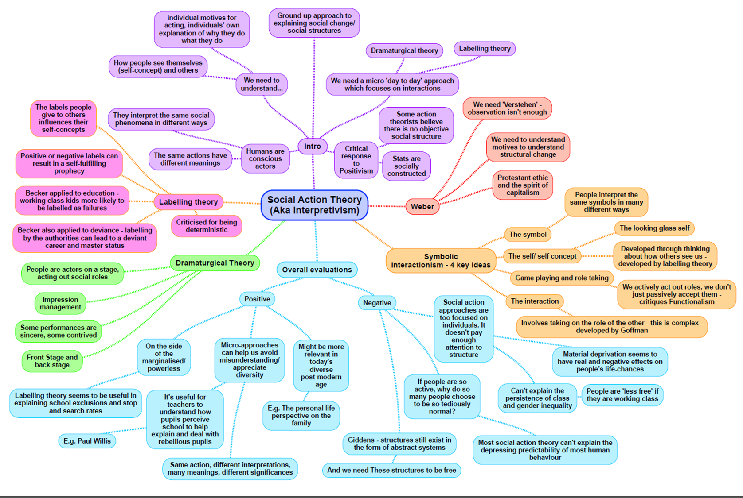

Interactionism: Darcey

|  |  |
| --- | --- |
| **Theory: Weberian MACRO/MICRO STRUCTURE/ACTION Neither conflict or consenus** | |
| Stratification:  Class   1. A persons class is determined on skills, status and party, not just economic position 2. Class is not homogenous, its fractured and broken 3. Social mobility exists   Gender  Barron and Norris (dual labour market)   1. Primary Market (High pay, secure jobs) 2. Secondary Market (Low pay, low job security)   Women are more likely to be in secondary market, especially after having children  Ethnicity  Parkin – High status privileged groups operate a system of social closure keeping ethnic minorities out of positions of authority. Refers to ethnic minorities as ‘Negatively privileged status groups’  Rex & Moore – Ethnic differences have resulted in disadvantages in labour market, poorer life chances, weaker market situation and marginalisation  Age  Parkin – Negatively privileged status groups can be applied to elderly people forced out of the labour market  Barron & Norris – Secondary Labour Market is increasingly populated by the young, as short-term, low-cost employees  Disability  Barron & Norris – Secondary Labour Market can also be applied to disabled people | Methods: Value freedom/science (p.197- 198 Webb)  Weber makes a sharp distinction between value judgements and facts so we can divide his views into 4 stages of the research process   1. Values as a guide to research 2. Data collection and hypothesis testing 3. Values in the interpretation of data 4. Values and the sociologist as a citizen |
| General view of the theory (p.387 Browne):  Weber – Focused on understanding subjective meanings and personal views   * **Verstehen** (understanding, putting yourself in their shoes)   People have choice and can act to change structures, not just puppets of industries, but also recognised that complete free choice doesn’t exist  A persons class is determined on skills, status and party, not just economic position | Evaluation:  + recognised that we need to understand individual meanings to understand how societies change (unlike Marxism)  – Still too much focus on society shaping the individual – symbolic interactionism argues that individuals have more freedom to shape their identities. |

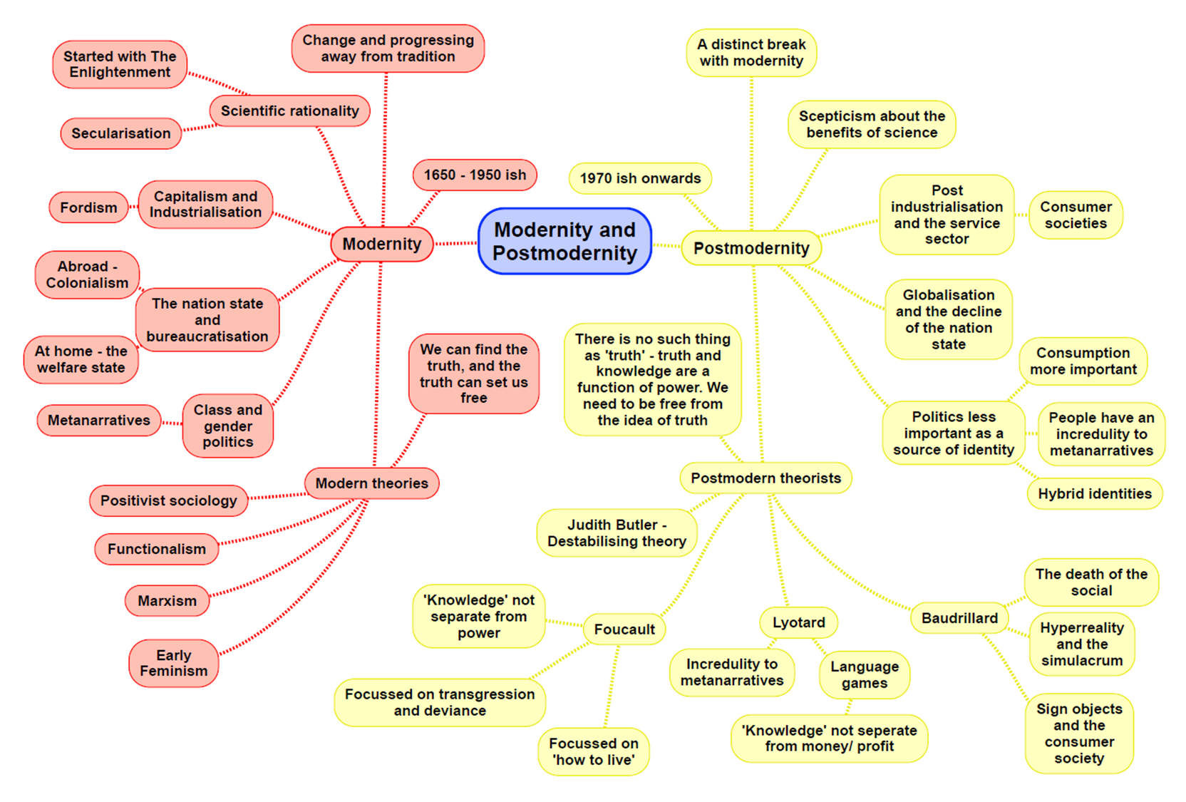

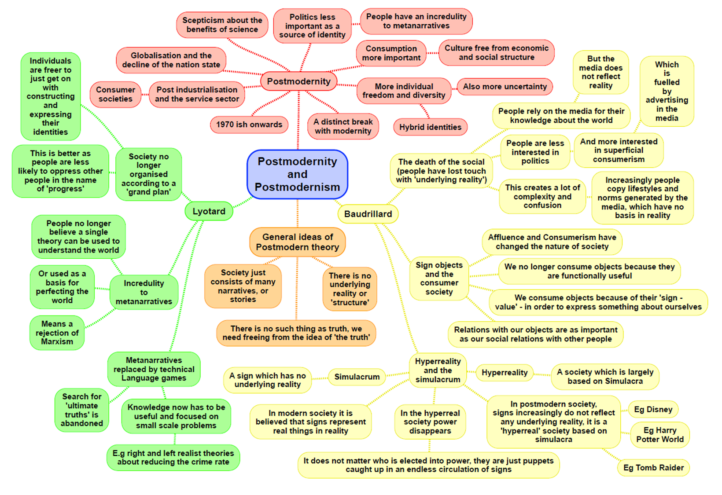

**Postmodernism: Alex and Alex**

|  |  |
| --- | --- |
| **Theory: Other random theories** | |
| **Crime:**  Left Realism: Accepts that structural inequalities, social conditions and perceptions of injustice are the major causes of crime.  People –   * Lea and Young * Lewis   Key theories –   * Relative deprivation – when people see themselves as deprived in comparison to others * Marginalisation – where some people are pushed to the edges of society by poverty, lack of education, disability, racism and experience social exclusion * Victimisation – where you are the target for offenders * Subcultures – small group forming a culture of their own if they don’t fit in with the overriding messages in society   Left realist views of tackling crime and punishment:   * Building community cohesion * Community safety partnerships – police, council, health and probation services to work together with local people to tackle crime rather than relying on the criminal justice system. * Left realists argue that the police need to be more tolerant of those with different lifestyles or non-white ethnic groups rather than harassing them * Tackling social deprivation * Getting parents to work together with youths to find solutions to crime | **Crime:**  Green criminology – the study of crimes against the environment.  Green criminologists focus on crimes which have broken environmental laws and those who damage the environment. They are also interested in the regulations concerning the environment.  Primary and secondary views:  Primary green crimes – ones which result directly from the destruction and degradation of the Earth’s resources such as crimes of air pollution, crimes of deforestation, crimes of species declining and animal abuse and crimes of water pollution  Secondary green crimes – crimes which grow out of the breaking of rules which aim to prevent and regulate environmental disasters such as state violence against oppositional groups, hazardous waste and organised crime.  Victims of green crime –   * Potter (2010) argued that current social divisions are reinforced by environmental harms with the least powerful – the working class, the poor and the minority – being the most likely victims of green crimes, in both developed and developing countries |
| **Crime:**  Victimology – the term used for the study of the impact of crime on victims, victim’s interests and patterns of victimisation.   * Attempts to understand why some are more prone than others in becoming victims of crime. * Some criminologists argue that people may become victims as their lifestyles are exposed to offenders (e.g. if victims visit dangerous/violent places regularly)   Key terms –   * Victimisation * Victim precipitation theory – some people might initiate the confrontation that eventually leads to their injury or death | **Stratification:**  Theories of disability   * Medical model – takes an individualistic approach and treats disability as a property of individuals who, because of their impairment, are unable to take advantage of the opportunities able-bodied people have. Davies argues that social factors prevent disabled people from participating in society. * Social model – the disadvantaged position of disabled people is a product of society rather than the impairment. Society excluded disabled people from full participation due to the stereotypes people hold against them – discriminatory practices. |
| **Stratification:**  Black feminism – argue that many of their problems come from being oppressed by both their gender and their race. Black feminists are very interested in the crossover between racism and sexism and black feminism formed because the general rules of feminism did not fit their lifestyle, beliefs and experiences.   * Mirza (1992) argued that although black British women share many of the same problems as white British women (sexism), they have another dimension of race to add onto their problems. Black feminists argue that most feminists are middle class white women which are who they have a problem with as matriarchal roles are much more common in black families. * Corby (1982) pointed out that black men could be victims of racism by white women whilst still containing agents of male dominance which can lead black women having divided loyalties. * Black feminism has therefore pointed out the intersections between oppressions connected with race, class and gender. | **Education:**  Social democrats –   * The government should be responsible for the welfare state – use education as a means to improve equality of opportunity which is the best way to ensure that education contributes to economic growth * Social inequality threatens the stability of society * Benefits should be available for all * The need for social cohesion * Sharon Gerwirtz (1995) – the amount of choice involved in selecting a school was limited by the ability of schools and by the ability of parents to discriminate between them, because of this parents didn’t have equal choice. * Stephen Ball (1994) – saw a shift in school attitudes, after the introduction of the 1988 Education Act: ‘there is a shift of emphasis from students’ needs to student performance: from what the school can do for the students to what the student can do for the school’. This encourages competition between local schools. |

**Writing a theory question in paper 1 and paper 3**

In the education exam (paper 1) and crime exam (paper 3) you could be asked to answer questions about sociological theories. These could take the form of:

**10 MARK THEORY QUESTIONS**

Outline and explain two [insert theory] concepts [10]

Outline and explain two arguments to suggest [insert theory] might have little to contribute to our understanding of society today [10]

Outline two reasons for the growth of globalisation [10]

Outline and explain two [insert theory] view of the nature of society today [10]

Outline and explain two criticisms of [insert theory]

Outline and explain two ways [insert theory] views social inequality today [10] – really similar to a stratification

The expectation with these questions is to use content from across all of your topics. It means there is a lot of variability in what you can write and you can use material from pretty much anywhere.

These 10 mark questions take the same format as every other one you do. They need a clearly stated point, which is explained with evidence (named people, contemporary examples, concepts) and then briefly evaluated.

**20 MARK ESSAY QUESTIONS – IN PAPER 3**

These questions have an item and will get you to do several possible things:

Evaluate the approach of a particular theory

Evaluate the contribution a theory has made to our understanding of society

Evaluate the view that conflict approaches are more useful than consensus approaches (or visa versa)

Evaluate the view that action/micro approaches are more useful than structural/macro approaches

Evaluate the contribution of modernist theories [functionalism/marxism] as compared to postmodern approaches

These questions need an introduction that clearly outlines the debate in the essay and then a range of paragraphs (suggestion of 3) that compare the approach/es in the question. Come to a conclusion. They need you to show a clear understanding of key concepts within the theory and theoretical approaches e.g. consensus vs conflict views, structure vs action, modernity vs postmodernity.

Approaches could include:

|  |  |
| --- | --- |
| **Using topics** | **Using themes from within the theory** |
| Doing a paragraph on a topic and evaluate within the topic. Pick three topics as your paragraphs and then do an additional paragraph that discusses general issues and concerns. | Each paragraph becomes a key idea from the theory that you then evaluate with issues/problems from other theories. This can draw across topics. |

