**THEORIES ACROSS ALL TOPICS: Family, Education, Crime, Stratification and general approaches**

**C GROUP 2019**

* Functionalism p.
* New Right p.
* Marxism p.
* Neo marxism p.
* Liberal feminism p.
* Radical feminism p.
* Marxist feminism p.
* Interactionism p.
* Weberian p.
* Postmodernism p.
* Other theories p.
* Linking theory to methods p.

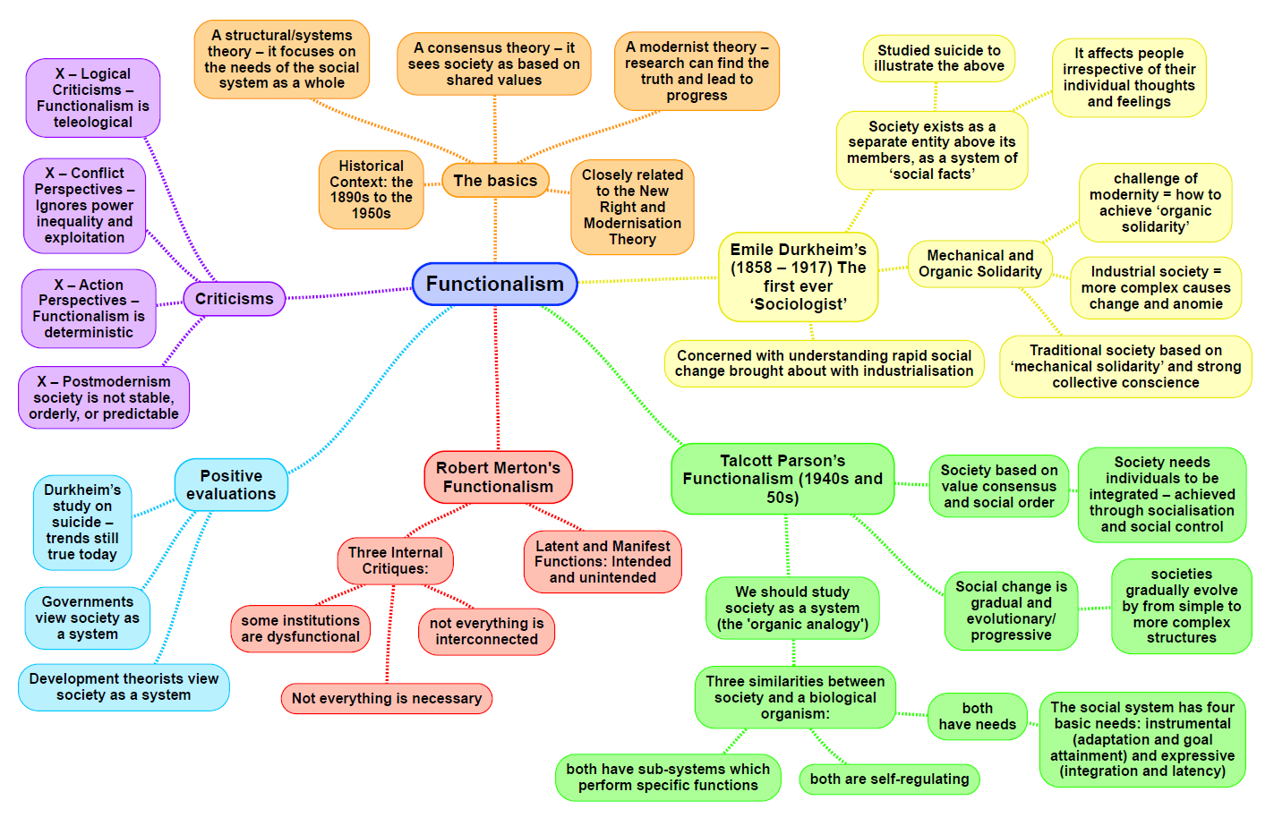

|  |  |
| --- | --- |
| **Theory: Functionalism MACRO STRUCTURE CONSENSUS** | |
| Family:  **Parsons**   * Nuclear family is the ‘best fit’ for society due to its geographical and social mobility * Family has two key functions which are ‘basic and irreducible’: the primary socialisation of children, and the stabilisation of adult personalities * Part of the stabilisation of adult personalities is the sexual division of labour; where the husband and wife have different roles, which allow them to support each other * These roles are the instrumental and expressive roles * Men take on the instrumental role: acting as the ‘breadwinner’ for his family * Women take on the expressive role: acting as an emotional support for her family * Parsons’ theory also called ‘Warm-bath theory’: women should act as a metaphorical bath when their husbands return home, greeting them with a warm welcome   **Murdock**   * Argues the nuclear family is universal, it must exist as an institution in all human societies (historically and cross-culturally) * Definition of the nuclear family: ‘*The family is a social group characterised by common residence, economic co-operation and reproduction. It includes adults of both sexes, at least two of whom maintain a socially approved sexual relationship, and one or more children, own or adopted, of the sexually cohabiting adults’* * Four principal functions of the family: sexual, reproductive, economic and educational. These functions only the family can perform but other institutions may help to fulfil them | Education:  **Durkheim**   * Education should socialise children into the norms and values agreed by society to create the value consensus * Behaving in the right way benefits everybody * Durkheim’s priority was an orderly and cohesive society and education is the most important provider of this * Education should encourage social solidarity   Egoism and Anomie   * Egoism – people pursuing their own goals rather than for the good of the community * Anomie – lack of norms and values and so feeling out of control * Therefore, education plays a vital role in preventing these things   **Parsons**   * Education is the main agent of secondary socialisation * Schools operate on meritocratic principles * Schools are a miniature version of wider society * Young people are required to act in terms of these values in the classroom, preparing them for adult life   School as a Bridge   * School acts as a bridge between the particularistic values of the family and the universalistic values of wider society * Particularistic values = status of child in the family is individual and special, their status is ascribed as a child * Universalistic values = status of the individual is achieved through universalistic rules that apply to everyone, these are meritocratic   **Davis and Moore**   * Social stratification = ensuring the most talented people fill the most functionally important roles for society * Education sifts and sorts and grades in terms of ability * They believe there is an equality of opportunity in society, meaning no matter what your background, everyone has a chance to succeed |
| Crime:  **Durkheim**   * Small amounts of crime are necessary for society to function * Crime is needed to maintain boundaries and reinforce the value consensus * Crime is inevitable – not everyone can be fully integrated into the norms and values of society * Without boundary maintenance, crime rates could increase, leading to egoism and anomie   **Merton**   * Crime occurs because of tension between people trying to achieve the shared goals of society (e.g. success) * People can respond to strain in different ways: conformity, innovation, ritualism, retreatism, rebellion   **Subcultural theories**   * Cohen, status frustration: young working class feel frustrated because they cannot achieve shared goals due to lack of opportunities, creating a ‘delinquent subculture’, within this, deviant behaviour arises * Cloward and Ohlin: 3 types of delinquent subcultures that are a response to lack of opportunity: criminal, conflict, retreatism | Stratification:  Class – social class inequality and difference are inevitable features of healthy contemporary society were talent and hard work are reward. Economic inequities ensures that the most qualified people will secure the most functionally important job in society.  They see society as meritocracy with the most talented able to justify reaping the highest rewards and gaining the higher social classes.  education/meritocracy  The educations system is a fair and meritocratic system that then allows the people who do the best to succeed later on in life. As the people who get the best grades, get the best jobs. This then creates a meritocratic society as everyone has the same chances to succeed.  Ethnicity – Parsons believes that assimilation will occur this is when the minority group slowly adapts to the majority culture over time. However to start with these differences are inevitable. Assimilation was considered as a positive outcome of racial and ethnic inequality and a means of preventing a state of anomie.  Age – Parsons concentrated on the important role that age played in the acquisition of social roles. He viewed teenage culture as a transitional stage between childhood and adulthood associating it with issues of transition as young people for fill their social role.  Eisenstadt argued at different age groups (youth, middle age, and old age) enable individuals to learn and acquire their social roles. |
| General view of the theory (p.370-373 Browne):  Comte say that sociology can be a science and that it can be a fact that can help to change social laws.    Durkheim placed great importance on the role of social institutions such as schools or the family as they socialise people into what he calls a value consensus or a collective conscience. This is a wide spread of norms, values and moral beliefs which binds people together, builds social solidarity and regulates individuals behaviour.  Merton (latent and manifest functions) suggested that there were manifest functions of an intuition, with intend and recognised consequences, but that there were also latent functions alongside them, with unintended or unrecognised consequences  Parsons (GAIL) (GAIL)- he suggests that to survive in a health state all societies have to resolve two sets of problems which are instrumental and expressive, and satisfy four functions prerequisites which are met by 4 related subsystems. This is known as GAIL which is goal maintain, adaption, integration and latency | Evaluation:   * Action theorists see functionalism as too deterministic as they see individuals as passive products of the social system * Postmodernists would argue that the functionalist theory is a metanarrative or grand theory that tries to explain everything from a single perspective * Doesn’t effectively explain social change as socialisation, value consensus and social control should limit social change |

|  |  |
| --- | --- |
| **Theory: New Right MACRO STRUCTURE CONSENSUS** | |
| **Family:**  Murray –   * Sees the traditional family to be under threat. * Made this link to the idea of this ‘dependency culture’. This is the idea of people living off benefits rather than working for money.   Dennis –  Conducted a study which consequently argued that children who grow up without a father figure in their lives are more likely to:   * Make poorer life choices * Have poorer health * Have lower educational attainment than children living in a two parent family.   Policies –  The New Right criticise many existing government policies for undermining the family. In particular, they argue that governments often weaken the family’s self-reliance by providing overly generous welfare benefits. | **Education:**  Policies –   * They introduced the 1988 Education Reform Act * Believe in Marketisation and Parentocracy within the framework of a National Curriculum and with teaching and learning monitored by Ofsted. * The most efficient way to meet people’s needs in through the free market – through private businesses competing with each other. * Created an ‘education market’ – schools were run like businesses – competing with each other for pupils and parents were given the choice over which school they send their children rather than being limited to the local school in their catchment area. This lead to the establishment of league tables. |
| **Crime: (Right Realism)**  Murray –   * He argued that generations of young boys grew up without male role models and without the example of paid employment, leading to the criminal underclass of jobless, welfare-dependent, dysfunctional people.   Wilson and Kelling –   * ‘Broken Windows’ theory was developed to stand for all the various signs of disorder and lack of concern for others that are found in some neighbourhoods (graffiti, vandalism, littering). * They argue that leaving broken windows unrepaired, tolerating aggressive behaviour etc. sends out a signal that no one cares.   Clarke –   * Developed situational crime prevention. * Refers to how, in certain situations, adaptations can be made to prevent criminal acts. It involves looking at what crimes people commit, and where they commit them, and what can be done in that situation to prevent the crimes from happening (target hardening). | **Stratification:**  Class –   * Murray said the underclass are defined by their behaviour. ‘Their homes are littered and unkempt. The men in the family are unable to hold down a job. The children grew up ill-schooled and ill-behaved and contribute to a disproportionate share of juvenile delinquents.’   Gender -   * Since meritocracy has existed and society has become fairer, gender inequality isn’t as   Ethnicity -   * New Right theorists generally see the fact of a ‘disproportionate membership’ of ethnic minorities in the underclass as evidence not of things like exploitation, discrimination and the like, but rather as evidence of various failings amongst ethnic groups. |
| **General view of the theory:**  The New right view is closely linked to Functionalism as it is based on consensus.  It is a political ideology and an approach to social and political policies that stresses individual freedom; the free market and free competition between private companies, school and other institutions; and the importance of traditional institutions and values.  They are pessimistic about modern society and want to return to the ‘golden age’ which emphasises traditional values.  The New Right bases its theories on the idea that capitalist society encourages choice as to how individuals spend and earn their money, and what services they want to pay for. | **Evaluation:**  Feminism –   * Gender roles are socially determined rather than being fixed by biology – traditional gender roles are oppressive to women. * Feminists believe that the rise in divorce rates can be beneficial to women as it means they can escape if the man is abusive.   Chester –  Argues that the New right exaggerate the extent of cohabiting and single parent families – most children still spend most of their lived in a nuclear family arrangement.  Abbott and Wallace –   * They argue that some of these policies have encouraged people to live outside of the traditional family. * Increase welfare for lone parents made it easier for lone parents to exist. |

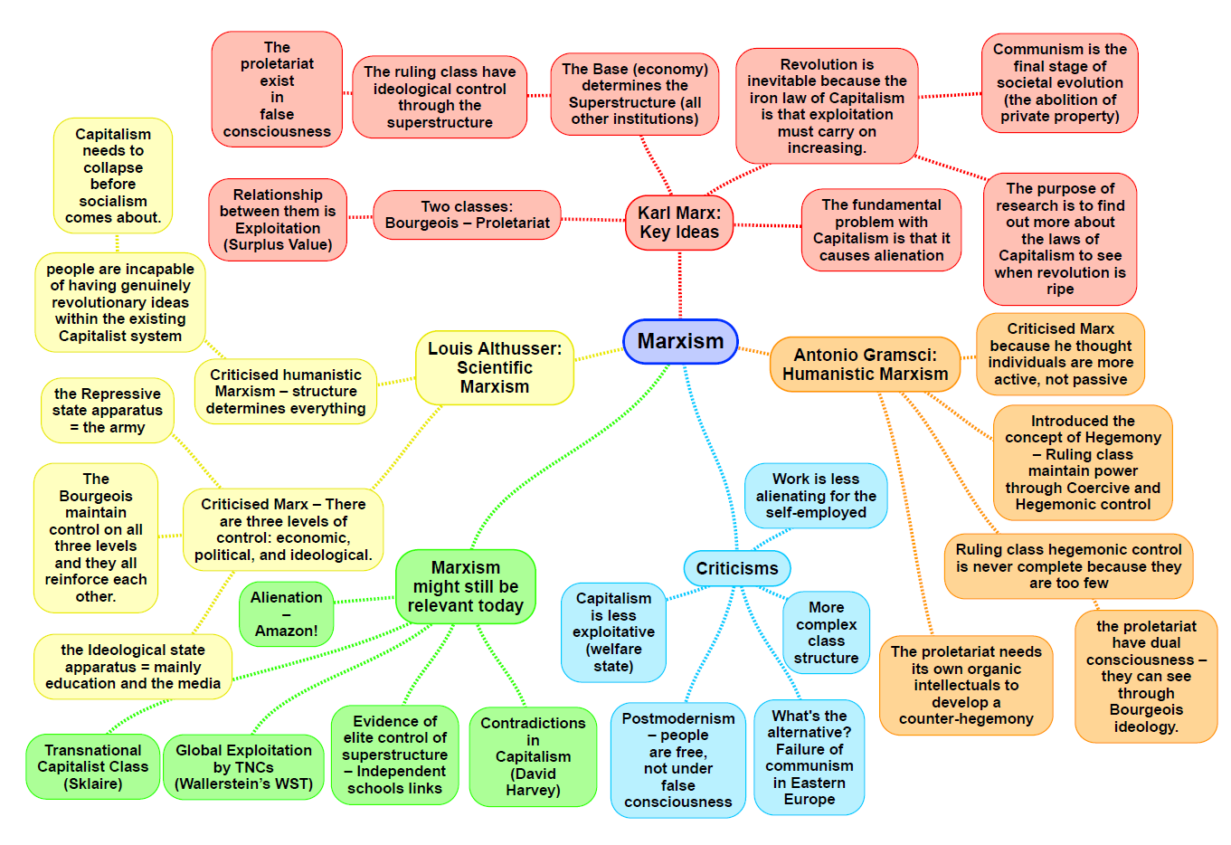

|  |  |
| --- | --- |
| **Theory: Marxism Conflict theory MACRO STRUCTURE** | |
| **Family:**  **Engels**   * Monogamous nuclear family developed as a means of passing on private property to heirs * Women were not much different to prostitutes   **Zaretsky**   * The family has an ideological role in order to prop up capitalism * Family is an escape from oppression and exploitation and helps to undermine opposition to capitalism   **Althusser**   * The family is an ideological state apparatus that helps with social control and passing on the dominant ideology of the working class. * This helps to maintain false class consciousness. | **Education:**  **Bowles and Gintis**   * The education system reproduces the ideas of the ruling class and legitimises inequality * They form the idea of the correspondence principle between school and society * Meritocracy is a myth, but they prepare students to accept inequalities   **Althusser**   * Regarded the education system as an ideological state apparatus * Schools transmit an ideology which states that capitalism is fair and just * Schools prepare pupils for their roles in the workforce by training people to accept authority * Formed the basis for Bowles and Gintis’ work |
| **Crime:**  **Chambliss**   * Laws to protect private property are the cornerstone of the capitalist economy   **Snider**   * Capitalist states will pass laws that regulate business only when forced to do so by a public crisis or union agitation * These laws are rarely enforced and are deliberately weak. * Laws that appear to benefit everyone actually do the opposite.   **Tombs**   * The difference between offences concerns who has the power to define an act as criminal and this usually comes from the powerful. * Corporate crime has enormous costs like injuries in the workplace, environmental problems like pollution and economic where is concerns consumers and workers.   **Gordon**   * Crime is a rational response to the capitalist system, and hence it is found in all social classes | **Stratification:**  **Class**   * Inequalities exist because the bourgeoisie exploit and oppress the proletariat. * Inequalities are a result of the economic arrangements people make to meet their basic needs. * Different parts of society transmit the myth of meritocracy and persuade the proletariat to accept the inequality they experience.   **Gender**   * Economic disadvantage –women still get less pay for the same jobs as men * Marxist feminists are primarily concerned with the division of labour keeping women in the domestic sphere of the family and men in the work place.   **Ethnicity**  **Cox,**   * racism was the creation of capitalism and helped to maintain it by creating divisions in the working class, thereby making working class revolt less likely   **Castles and Kosack**   * Argued that ethnic minorities form a “Reserve Army of Labour”, prepared and forced to work for lower wages than the majority white population**.** * This helped to further divide the social classes   **Age – reserve army of labour**   * Capitalism benefits from treating young workers differently because they can be paid less and hired and fired more easily than more mature workers * The elderly become irrelevant and marginalised, especially if they are poor.   **Philipson**   * The logic of capitalism is about exploiting workers and consumers for profit. This is incompatible with the need of the elderly.   **Disability**   * Marxist, Finkelstein says our negative cultural attitudes towards the disabled is due to capitalism’s emphasis on work as a source of identity, status and power |
| **General view of the theory (p.375-378 Browne):**  Marx – base and superstructure, private ownership, exploitation, class conflict, dominant ideology, communism   * Marx believed that the economy was the driving force and that it determined the nature of social institutions and peoples values and beliefs. * The exploitation of non-owners by the owners created conflict between the two classes * Workers produce more than is needed for employers to pay them their wages. This surplus value then provides profit for the employer. As workers don’t get the full value then they are being exploited. * There are two basic social classes in a capitalist industrial society, the bourgeoisie and the proletariat. * Those who own the means of production are the ruling class * The bourgeoisie hold the dominant ideas in society and the proletariat are brainwashed into a false class conscious | **Evaluation (p.378 Browne):**   * Classical Marxism over-emphasises the extent of conflict in society * It over-emphasis social class as a source of inequality and conflict and pays little attention to other sources such as ethnicity, age, and gender * Classical Marxism is too deterministic and sees individuals as passive, doesn’t allow for individual choice. * It is a Metanarrative or grand theory that tries to explain everything from a single perspective. * Marx’s two class model of inequality is inadequate, as there has been a growth in a new middle class |

* **Bourgeoisie –** the capitalist ruling class who owns the means of production
* **Proletariat –** the working class/ wage slaves
* **Ideological state apparatus –** agencies that spread the dominant ideology, without force, and justify the power of the dominant social class
* **Metanarrative/grand theory -**  a broad, all embracing big theory or story providing an explanation for how the world and societies operate

|  |  |
| --- | --- |
| ***Theory: Neo Marxism* MACRO/MICRO STRUCTURE/ACTION CONFLICT/CONSENSUS** | |
| Conflict- Structuralist Approach | ***Education:***  **Willis-** Learning to Labour, the “lads”, how working class kids get working class jobs. They saw the point of school as having a laugh as oppose to getting qualifications, and trying to survive school whilst having as much fun as possible in the meantime.  **Bourdieu-** The middle classes possess cultural capital, the skills and knowledge which can be used to get into get ahead in education. Social capital is the possession of contacts that can open doors for you. |
| ***Crime: Uses Marxist and Interactionist ideas to help ex-lain the criminalisation of ethnic minorities.***  **Hall-** Policing the Crisis which he developed during muggingsin the 1970s. The media over reporting and sensationalising black criminality let to the publics focus on black criminality as oppose to more major problems in the capitalist system such as why crime occurs in the first place.  **Gilroy-** Studied the relationship between crime and race and saw that a lot a lot of crime was politically motivated. The media creates a view that black criminals are pathological and this in turn creates a moral panic.  **Althusser-** The law is an ideological state apparatus which benefits the ruling class as it helps maintain class inequality. | ***Stratification:***  **Class-**  **- Bourdieu-** Class fractions are determined by a number of things such as varying degrees of social, economic and cultural capital  **Gender-** Capitalism causes patriarchy due to the system being biased against women.  **Ethnicity-**  Neo-Marxism draws on aspects of Marxist and Interactionist theory in order to explain the criminalisation of ethnic minorities by the media and the state  **-Hall-** ‘A Crisis of Capitalism’, the economic recession had a disproportionate effect on black people, where some black people chose to enter the world of crime (the informal economy), as oppose to doing “white mans shit work”.  **-Miles-** Racialised Class Fractions, ethnic minorities are part of every class but make up fragmented parts of them, even in the middle classes, they are subject to different treatment.  **Age-** Younger and Older people are exploited through capitalism. |
| General view of the theory (p.379 Browne):  Gramsci (Humanism) – hegemony  Althusser – RSA, ISA- **Repressive State Apparatus=** Control through the law, army and police**. Ideological State Apparatus=** Churches, family, media, education. | Evaluation: Neo-Marxists have tried to overcome the weaknesses of classical Marxism and its economic focus in which everything is explained on a financial basis. Marxists would criticise neo Marxism on the basis that it lacks economic focus. |

**Key Concepts:**

**Hegemony**- refers to the dominance in society of the ruling classes set of ideas over others and acceptance of and consent to them by the rest of society.

**Relative autonomy-** is the idea that the super structure of society has some independence from the economy rather than being directly determined by it.

**Bourgeoisie-** the capitalists class the owners of the means of production.

**Proletariat-** the working class in capitalist’s society. They own no means of production and are wage slaves.

**Repressive state apparatus-** refers to those parts of which are concerned with mainly repressive physical means of keeping a population in line eg: the criminal justice system and the armed forces.

**Ideological state apparatus-** the agencies that spreads dominant ideology and justify the power of the dominant social class

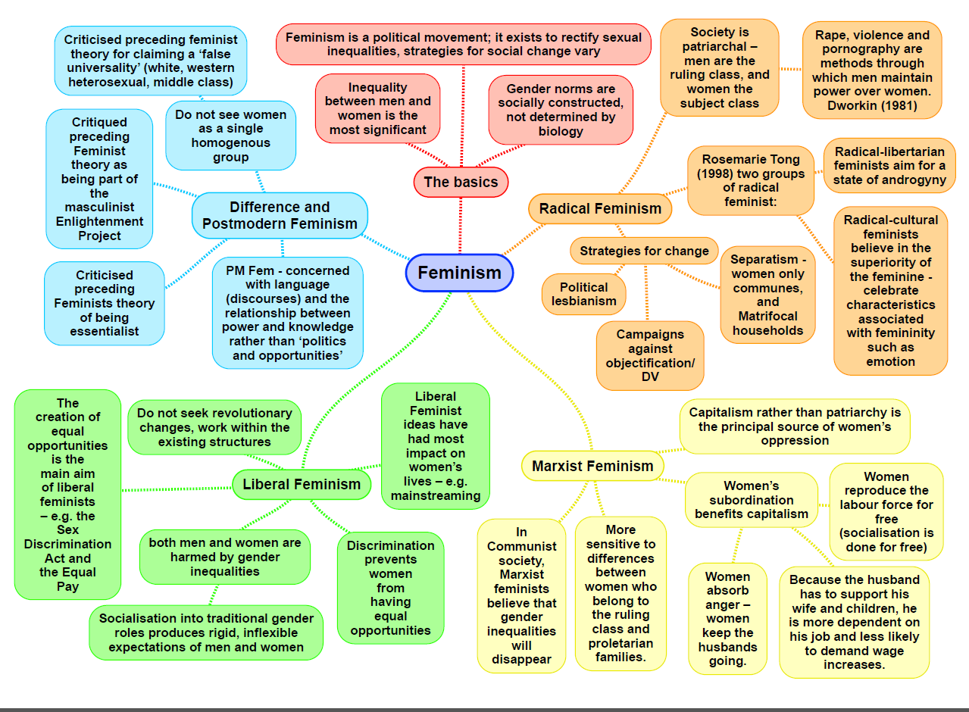

|  |  |
| --- | --- |
| **Theory: Feminism: liberal MACRO/MICRO STRUCTURE/ACTION CONFLICT/CONSENSUS** | |
| Family: Liberal feminists focus on striving for legal equality between the sexes. The family has long been a clear source of inequality. Marital rape was not formally recognised as a crime in the UK until 1991.  Oakley: Oakley’s own research (1974) found both middle and working class families had greater equality in the designation of domestic duties, but in both classes few men actually did any housework which remains an issue for many commentators today especially as it varies across different countries.  Sharpe: Early gender stereotyping in the family effects later education because means girls attach less value to education; schools push girls towards feminine subjects. | Education: Liberal feminists writing about education use concepts of equal opportunities, socialisation, sex roles and discrimination.  Oakley: In 1974, the feminist Ann Oakley examined the social construction of gender roles in Western societies She concluded that feminine behaviour was not innate but is a result of primary socialisation – canalisation and manipulation.  Sharpe: Sue Sharpe compared the attitudes of working-class girls in London schools in the early 1970's and 1990's. ... By 1990's this had changed to 'job, career and being able to support themselves' with education being the main route to a good job.  Stanworth: In the 1970s the majority of secondary school students were being educated in co-educational schools, with girls and boys getting much the same education. |
| Crime  Crime: Feminist theories are a group of related theories that share several principles in common. First, feminist theories maintain that gender.  Carlen: he conducted a study of 39 15-40 years olds working class women who are victims of crime. then did the same with the middle class and found that the working class had a higher victim rate.  Adler: argues that the changes in the structure of society have led to changes in women's offending behaviour, as patriarchal controls and discrimination have lessened as opportunities in education and work have become more equal, women have begun to adopt traditionally male roles in both legitimate activities and illegitimate activities. | Stratification:  Women’s inequality arises primarily from factors like sexist stereotyping, gender role socialisation, women’s primary responsibility for housework and childcare.  Oakley (1974) on housework on gender socialisation and education, documents these inequalities. Legal, economic and social equality for women will come through a gradual process of reform, enabling women to take part in existing society on equal terms with me |
| General view of the theory (391 Browne):  There are inequalities in power and status between men and women, with women dominated by men and subordinate to them in most areas of life.  These inequalities generate differences of interest and conflict between men and women. Gender roles and inequalities are primarily socially constructed, and not based on innate biological differences between men and women.  Walby defines patriarchy as a ‘system of social structures and practises in which men dominate, opress and exploit women. | Evaluation:  Criticised for over-optimism. They see obstacles to emancipation as simply the prejudices of individuals or irrational laws that can be gradually reformed away by the onward ‘march of progress’. They ignore the possibility that there are deep seated structures causing women’s oppression, such as capitalism or patriarchy.  Fails to recognise the underlying causes of women’s subordination and that it is naive to believe that changes in the law or attitudes will be enough to bring equality. |

**Key concepts**

**March of progress-** Liberal feminism is closely linked with the march of progress view

**Changes in socialisation and culture-** Change in the way parents socialise their children into gender roles, (canalisation and manipulation) and cultural changes regarding stereotypes of gender roles.

**Reformism**- Progress towards equal rights comes with gradual reforms within society without the need for revolution.

**The Class deal-** women who conform will be offered material rewards

**The Gender deal**- promises women material and emotional rewards for conforming to the patriarchal gender roles.

**Manipulation-** refers to the way in which parent encourage and discourage their children’s behaviour based on their gender.

**Canalisation-** Refers to the way in which parents channel children’s interests through toys and activities that are “normal for their sex”

|  |  |
| --- | --- |
| **Theory: Feminism: radical MACRO STRUCTURE CONFLICT** | |
| Family:  Firestone - original division was between 'two distinct biological classes for procreative reproduction' enabled men to exploit them.  Duncombe and Marsden – triple shift; job, emotional, house work  Bernard - men would benefit the most from marriage  Greer - marriage reinforces patriarchal relations, the ‘ghastly figure of the bride’ traditional conceptions of femininity and marriage settles into husbands spending more time outside of the home than the wife  ‘emotion work’  1 in 4 women will experience domestic violence at some point in their lifetime | Education:  Patriarchy still works through school to reinforce traditional gender norms and to disadvantage girls  Male gaze – objectification of girls, dress codes to not distract men, measuring skirts cannot show shoulders, no leggings  girls are increasingly subject to sexist bullying e.g. “you throw like a girl” |
|  | Stratification:  Gender – see family |
| General view of the theory (Browne p.391):  Want male supremacy to be eliminated in all social and economic contexts. Radical feminists view society as fundamentally a patriarchy in which men dominate and oppress women. Want men and women top live separately | Evaluation:  Wilmot and Young - the symmetrical family is ignored by radical feminists |

|  |  |
| --- | --- |
| **Theory: Feminism: Marxist MACRO STRUCTURE CONFLICT** | |
| Family: Capitalism uses the family to oppress women  Ansley: women absorb the anger that men suffer from caused by the capitalism system. Women are used to benefit the capitalist system.  Beechey: A capitalist economic system is subject to cycles of “boom” and “slump”. This is when extra workers need to be recruited/when they need to be laid off. Female labour is considered the most “flexible” form of labour - easy to hire/fire.  Ray: argued that capitalism created gender inequality from keeping women at home as unpaid labourers | Education: |
| Dual systems – Walby/Hakim – mix of Marxist and radical feminism (p.392 Browne)   * Class and gender work as dual systems of oppression - both independent and powerful. * Women are excluded from work which made them more dependent on men * 6 structures of patriarchy: paid employment, household production, childcare, horizontal/vertical segregation, sexual double standards, acts of male violence, patriarchal laws passed | Stratification:  Gender:   * Workplace:   + Pay gap: women are often paid less than men to do the same job (the overall general pay gap between men and women is 8.6% in April 2018 – however, in skilled trade occupations the pay gap can be as high as 23.9%)   + Glass ceiling: women can see managerial roles but will never reach them - contributes to the oppression of women * Home:   + Socially accepted that women stay home and look after children whilst men continue to work (link to expressive and instrumental roles – Parsons: Functionalist) – exclusion from productive labour * Politics:   + Women grossly under-represented: maintains male power (in the 2017 general election, there were 442 male MPs, but only 208 female MPs) |
| General view of the theory (p.392 Browne):   * Adapts Marxist principles * Capitalism is responsible for gender inequality * Women’s liberation can only be achieved by re-structuring the capitalist system | Evaluation:   * Not that different to Marxism: too closely linked to be seen as its own theory * Women’s oppression in the family existed before capitalism did, in communist societies. |

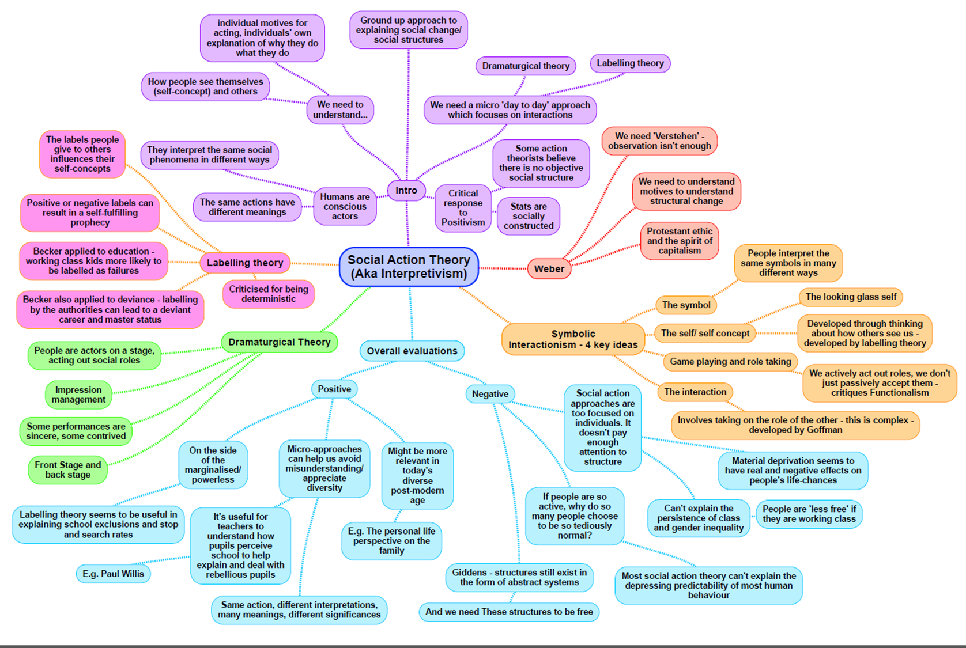

|  |  |
| --- | --- |
| **Theory: Interactionism MACRO/MICRO STRUCTURE/ACTION CONFLICT/CONSENSUS** | |
| **Family:**  Personal life perspective – Smart  Criticisms of structural perspectives;  They tend to assume the traditional nuclear family is dominant. This ignores the increased diversity of families. Compared to 50 years ago many people now live in other families, such as lone-parent families.  They assume that families and their members are simply manipulated by the structure of society to perform certain functions – e.g. to provide the economy with a mobile labour force or serve the needs of capitalism or of men  By focusing on people’s **meanings**, Carol Smart’s personal life perspective draws our attention to a range of other personal relationships that are important to people, even though they may not be conventionally defined as family. | **Education:**  Becker – middle class children were closest to the ‘**ideal pupil**’ and working classes, furthest from it.  Gillborn and Youdell – **The A-C Economy** (setting and streaming) Schools focus time/ effort on pupils that have higher potential to get good grades and boost league table position. A-C Economy produces the **educational triage** – schools categorise pupils into 3 types; those who will pass, those who need have potential and will be helped, and those who have little chance of success. Focus on first two.  Archer – **Nike identities/ universities not for me I’m a Nike person**– How working classes seek to gain status using heavily branded clothing. Appearance/ style was a way of gaining **symbolic capital** and constructing a meaningful class identity, however this often clashes with the culture of the school.  This affects WC students understanding of higher education; University was seen as ‘undesirable’ – as it would not suit their preferred style of habitus.  Ball – Found that when streaming is abolished teachers continue to categorise students and merely used more differentiation –gave different work set at different levels of ability to different students. They were still more likely to label middle class students as cooperative and able.  Woods – dividing pupil subcultures into pro school and anti-school was too simplistic – suggested there was a wider variety of responses (8 ways of adapting to school); Integration, compliance, opportunism, ritualism, retreatism, colonization, intransigence, rebellion. |
| **Crime:**  Becker - Argues there is no such thing as a deviant act - only acts which are **labelled deviant**. It is the audience of any particular act which create deviance by applying the label; the success of their application of the label will depend upon their power.  Cicourel - Police officers’ decisions to arrest are influenced by their **stereotypes** about offenders. Their typifications led them to concentrate on certain ‘types’. Resulting in law enforcement that showed class bias- WC people most closely fit the typificiations. And more focus on policing these areas, causes more arrests confirming the stereotype. He also argues that **justice is not fixed but negotiable.**  Goffman - Treatment institutions in general reinforce rather than reduce deviance; disculturation - learning new (or old) habits to survive in the new environment and the effects of the label - “ex-mental patient”, “ex-convict”  Lemert - primary and secondary deviation; Primary deviation - deviant acts before they are so labelled.  Secondary deviation - the response of the individual or the group concerned to societal reaction | **Other approaches:**  Ethnometholodgy (p.385 Browne)  Associated with work of Garfinkel – interested in discovering how individuals make sense of the social world and impose some social order on their everyday lives. Rejects the view that society has any kind of social structure, social order or patterned interaction that exists outside an individual’s own consciousness. |
| **General view of the theory** (p.382-385):  Mead and Blumer –see society as built up by interactions between people – based on meanings. Blumer suggests interactionism has 3 basic features; 1- people act in terms of symbols (that stand for something else/ have attached meanings) 2- these meanings develop out of an interaction and can change during the interaction. 3-meanings arise from an interpretive process as people try to interpret the meanings others give to their actions by imagining themselves in their position/ role.  Colley – looking glass self – the idea that our image of ourselves is reflected back to us in the views of others- as we consider this we may change our view of ourselves and our behaviour.  Goffman – impression management – the way individuals try to convince others of the identity they wish to assert by giving particular impressions of themselves. Achieved by symbols like clothing, or music.  Becker – labelling - agents of social control **label** the powerless as deviant and criminal based on stereotypical assumptions and this creates effects such as the self-fulfilling prophecy, the criminal career and deviancy amplification. | **Evaluation** (p.386 Browne):  Strengths   * Human beings create and negotiate meanings and make sense of the world through their own interaction with others. * Unlike in structuralism, to fully explain peoples actions and the creation of social order it is necessary to understand the motivation and meanings people attach to their behaviour.   Weaknesses   * Doesn’t pay sufficient attention to structures of society such as power, social class, gender/ ethnic inequalities. People do not always have free choices – different life chances. * Doesn’t really explain people’s motivations (the reasons for what people do, their aims and where they get their meanings and goals from. * Postmodernists would suggest it is as much a metanarrative as any other theory that claims to provide a full explanation of social life. |

|  |  |
| --- | --- |
| **Theory: Weberian                MACRO/MICRO** | **STRUCTURE/ACTION               CONFLICT/CONSENSUS** |
| **Stratification:**  **Class - market, party and status see below**  Goldthorpe  **Gender – Barron and Norris (dual labour market)**  Men and women are thought to occupy differential positions in the workplace in terms of position they reach and the area they are employed in. Horizontal and vertical segregation have been used as metaphors to describe omens positions in the workplace. Barron and Norris argue the dual labour market theory has been applied to women employment patterns. There are two labour markets: the primary, characterised by high pay, secure jobs with good promotion prospects and the secondary labour market with low pay, poor promotion prospects and poor job security. They suggested that women were more likely than men to be in the secondary labour market.  **Ethnicity – Parkin, Rex + Moore**  Ethnic differences may be viewed as more important than economic differences in expanding inequalities. Parkin viewed minority ethnic groups as ‘negatively privileged status groups’. He argued the concept of social closure and that the more privileged groups can operate a system of social segregation and keep minority groups out of positions of authority and pushed into the secondary market.  **Age – Parkin, Barron and Norris**  **They focus on the loss of status and power that comes with old age, largely as a result of disengagement of economic relations (this could also be a apply to the young). Frank Parkins concept of negatively privileged status groups could be applied to elderly people forced out of the labour market.**  **Disability**  Stratification is not just based on economic relationships people enter into, but the standing or status a person may have or political party or trade union. | **Methods: Value freedom/science (p.197- 198 Webb)**  Sees values as relevant to the sociologist in choosing what to research, in interpreting the data collected and in deciding the use to which the findings should be put. But a sociologists values must be kept out of the actual process of fact gathering.  Makes a clear distinction between values and facts, and we cannot derive the one from the other. E.gh. research might show that divorcees are, more likely to commit suicide. However, this fact does not demonstrate the truth of the value judgement that we should make divorce obtain. |
| **General view of the theory (p.387 Browne):**  **Weber – market, party, status**  Income and wealth confer status, however a person can possess wealth but lack status e.g. a lottery winner. Or possess high status but little wealth e.g. church minister.  High status groups will rarely let wealth alone be sufficient grounds for entry into that social group and can use social closure to exclude wealthy individuals.  Social closure allows the dominant groups to retain their wealth and privileges through excluding people on the basis of some kind of criteria e.g. skin colour, gender or sexuality. | **Evaluation:**  Theory ignores the power of the bourgeoisie, there is a difficulty distinguishing social classes.  Marxists outline how power and status are subsidiary to class, however Weberian’s argue that class, status and party are all aspects of the unequal distribution of power.  Feminists argue that the theory is too patriarchal, excluding women. |

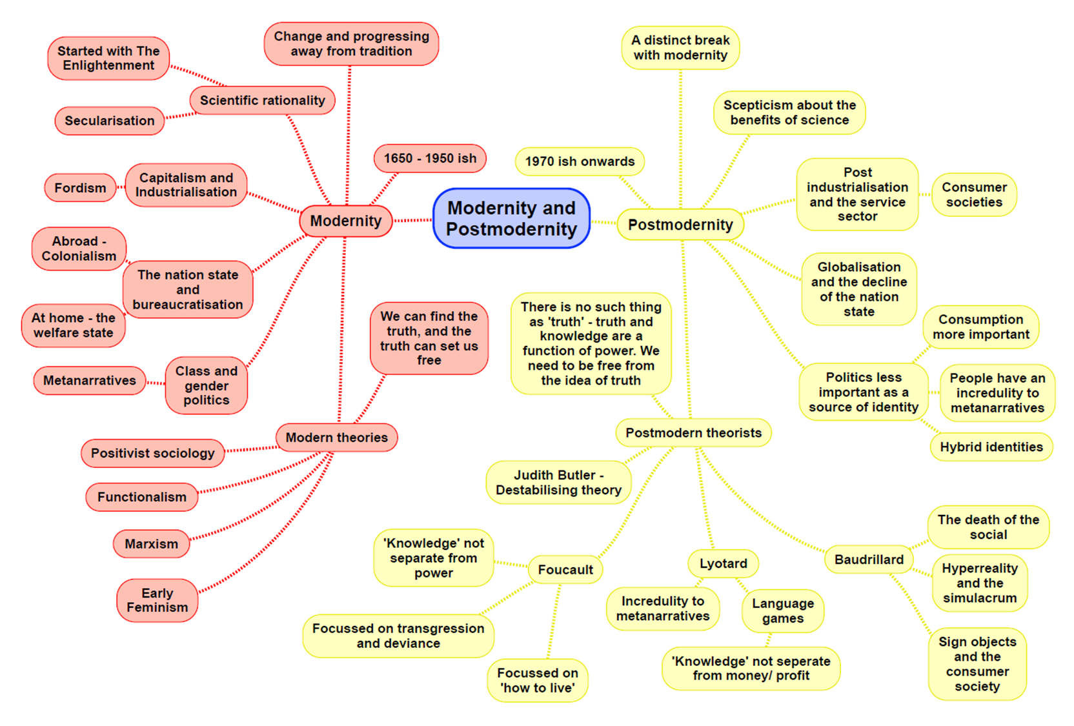

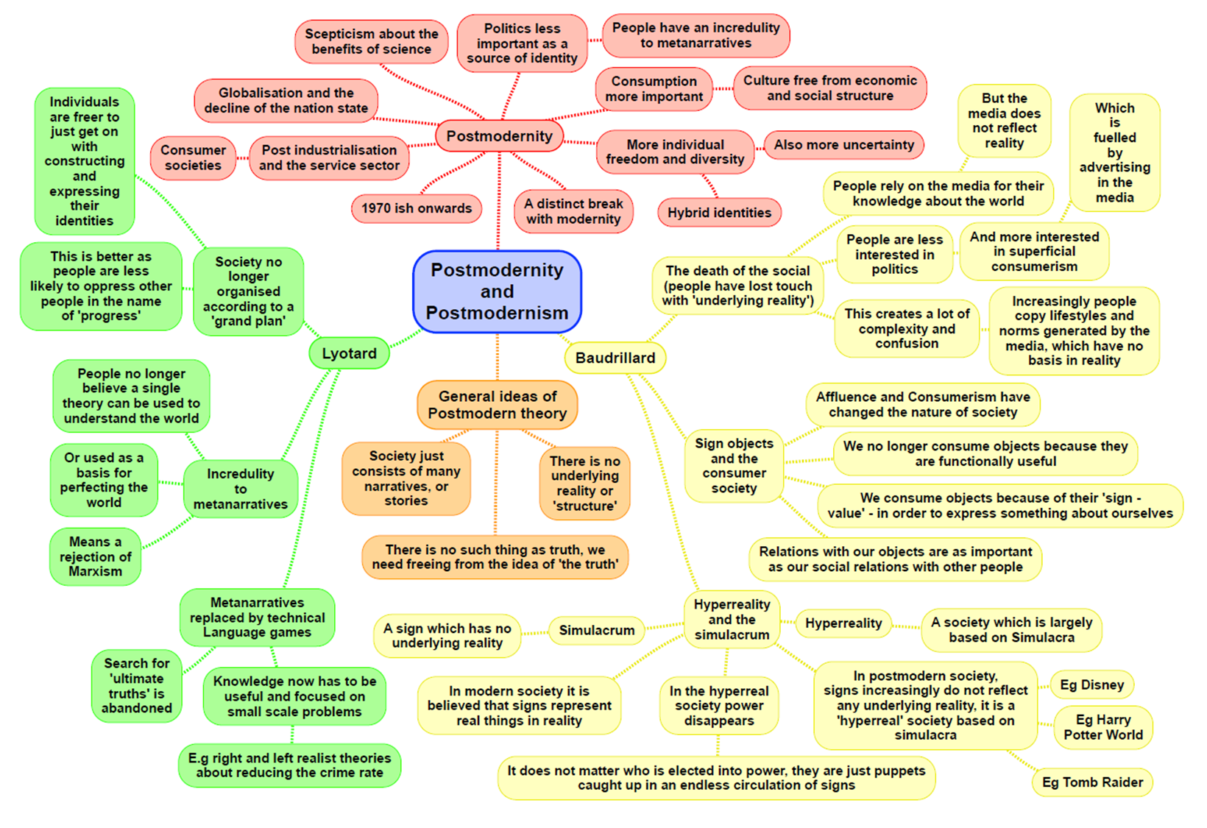

|  |  |
| --- | --- |
| **Theory: Postmodernism MACRO/MICRO STRUCTURE/ACTION CONFLICT/CONSENSUS**   * Postmodernists do not apply themselves to the above | |
| **Family:**  **Alan & Crow** – Our families are based on choice. We choose how to live and what the relationships are like  **Rapoport & Rapoport** – Moving away from traditional nuclear family  **Beck & Beck-Gernsheim** – Choice is a part of our everyday lives (individualisation) | **Difference feminism**   * Suggests that other variants of feminism viewed women’s subordination through the eyes of white middle class women. * Oppression can take very diverse forms in different social contexts in different groups * Weakening of social structures, like gender and social class, as sources of identity allows people to ‘pick n mix’ their identities. * Reflected in the diversity of meaning attached to women in contemporary western society. |
| **Crime:**  **Lyotard** – Crime is the result of individualism so there are no crime patterns as there are many causes of crime  **Messerchmidt** – Masculinity is a social construct to which men try to live up to. This masculine image causes men to commit crime  **Lyng & Katz** – Crime is committed because it provides excitement and thrill  **Hobbs & Dunningham** – Crime works as a ‘glocal’ system – it is locally based, but with global connections | **Stratification:**  **Class: Pakulski & Waters** – Status based consumption is now the main form of stratification in modern society. The idea of class has died out.  **Beck** – We have moved on from simple modernity to late modernity. We live in a ‘risk society’ (full of uncertainty).  **Robinson** – Changes due to globalisation/capitalism no longer based nationally but now organised on a global scale with transnational corporations.  **Sklair** – We now live in a transnational capitalist society divided into owners and controllers  **Gender:**  **Alan & Crow** – Families are characterised by choice, roles are now chosen by couple s  **Beck** – There are no longer clear norms of what a modern relationship consists of; this is due to the increase in diversity  **Hakim** (preference theory) – not all women are disadvantaged; women do exercise choice in relation to their position in the home and workplace  **Ethnicity:**  **Modood**- Ethnic minorities are being ‘lumped’ together for sharing the same disadvantages. They are over-emphasised as being victims  **Age:**  **Featherstone & Hepworth –** Individual choice and the “de-structuring” of society has made age a fragmented and diverse social category; referred to as de-differentiation  **Mannheim** – There is currently a lack of common generational identity  **Disability:**  Experiences are more individualised in modern society |
| **General view of the theory:**  Changes in society – chaos, uncertainty  **Bauman** – lives gain meaning through consumption choices influenced by designer labels  **Giddens** – Globalisation means national differences are becoming less significant – increased interconnectedness. Peoples no longer rooted (embedded) in local contexts, but are lived in and influenced by the global framework; this is known as disembedding  **Lyotard** – individuals lost faith in progression and in metanarratives (‘big stories’) giving explanations about the world  **Baudrillard** – Post-modern era dominated by media imagery that it has become media saturated. Images distort how we see the world. Simulacra is where the media presents images of the real world but have no basis in reality | **Evaluation**:   * It exaggerates the scale of social change * Over emphasises the influence of the media and assumes people are passive * Challenges current metanarratives * We are living in a risk society full of uncertainty therefore we cannot make absolute statements about the future of society * Marxists argue that globalisation is a new way of opening markets and sources of profit to benefit the ruling class |

|  |  |
| --- | --- |
| **Theory: Other random theories** | |
| **Crime:**  Left Realism-  Believe that a cause of crime is relative deprivation due to the capitalist society which encourages consumerism. It can lead to subcultures and marginalisation.  Subcultures are formed as a response to relative deprivation and marginalisation.  Young: argues that this has created a bulimic society where people gorge on media images and vomit the expectations.  Social changes have increased the number of potential victims such as increase in car ownership, so more people are out.  Their solution is a more democratic approach that involves the community. | **Crime**:  Green criminology-  Beck- manufactured risks are dangers that we have never faced before involving harm to the environment and its consequences to humanity.  White 2008- any action that harms the physical environment and/or human and non-human animals. Many of the worst environment harms are not illegal.  Primary- green crimes would be those crimes where the environment itself is damaged.  Secondary- further crime that grows out of flouting rules relating to the environment e.g. violence against environmental groups. |
| **Crime:**  Victimology  Corcoran et al. based on data from the CSEW for 2012/13 to 2014/15 estimates that there is an average of 106,000 incidents of racially motivated hate crime per year.  Miers (1989) defines positivist victimology as having three main features:   * Aims to identify the factors that produce patterns in victimisation especially those that make some individuals or groups more likely to be victims. * It focuses on interpersonal crimes of violence. * It aims to identify victims who have contributed to their own victimisation.   Walklate- Argues in rape cases it is not the defendant that is on trial but the victim, since she has to prove her respectability in order to have her evidence accepted. | **Stratification:**  Theories of disability  **Medical model:**  Davies- argues social barriers prevent the disabled from fully participating in society.  Best- Defines disability based on a person’s inability to fully participate in everyday activities.  **Social model:**  Shearer- argues disability is imposed by the patterns and social expectations from the none disabled.  Shakespeare- argues bodies should be seen as part of a continuum rather than disabled or not.  Oliver- argues most people have some sort of impairment e.g. glasses or false teeth but they are not labelled as disabled. |
| **Stratification:**  Black feminism  Mirza (1992)- argued that a lot of black British women suffer from similar problems to white British women, but they have the enhancement of racism to contend with and therefore their experiences of life is different. | **Education:**  Social democrats  Halsey after the 1944 Education Act middle class pupils achieved better qualifications and were more likely to go to university than working class pupils (was supposed to have provided equal opportunities for all). |

**Writing a theory question in paper 1 and paper 3**

In the education exam (paper 1) and crime exam (paper 3) you could be asked to answer questions about sociological theories. These could take the form of:

**10 MARK THEORY QUESTIONS**

Outline and explain two [insert theory] concepts [10]

Outline and explain two arguments to suggest [insert theory] might have little to contribute to our understanding of society today [10]

Outline two reasons for the growth of globalisation [10]

Outline and explain two [insert theory] view of the nature of society today [10]

Outline and explain two criticisms of [insert theory]

Outline and explain two ways [insert theory] views social inequality today [10] – really similar to a stratification

The expectation with these questions is to use content from across all of your topics. It means there is a lot of variability in what you can write and you can use material from pretty much anywhere.

These 10 mark questions take the same format as every other one you do. They need a clearly stated point, which is explained with evidence (named people, contemporary examples, concepts) and then briefly evaluated.

**20 MARK ESSAY QUESTIONS – IN PAPER 3**

These questions have an item and will get you to do several possible things:

Evaluate the approach of a particular theory

Evaluate the contribution a theory has made to our understanding of society

Evaluate the view that conflict approaches are more useful than consensus approaches (or visa versa)

Evaluate the view that action/micro approaches are more useful than structural/macro approaches

Evaluate the contribution of modernist theories [functionalism/marxism] as compared to postmodern approaches

These questions need an introduction that clearly outlines the debate in the essay and then a range of paragraphs (suggestion of 3) that compare the approach/es in the question. Come to a conclusion. They need you to show a clear understanding of key concepts within the theory and theoretical approaches e.g. consensus vs conflict views, structure vs action, modernity vs postmodernity.

Approaches could include:

|  |  |
| --- | --- |
| **Using topics** | **Using themes from within the theory** |
| Doing a paragraph on a topic and evaluate within the topic. Pick three topics as your paragraphs and then do an additional paragraph that discusses general issues and concerns. | Each paragraph becomes a key idea from the theory that you then evaluate with issues/problems from other theories. This can draw across topics. |

