**THEORIES ACROSS ALL TOPICS: Family, Education, Crime, Stratification and general approaches**

* Functionalism p.2-6
* New Right p.7
* Marxism p.8-12
* Neo marxism p.13
* Liberal feminism p.14-16
* Radical feminism p.17
* Marxist feminism p.18
* Interactionism p.19-22
* Weberian p.23-24
* Postmodernism p.26-29
* Other theories p.30
* Linking theory to methods p.31

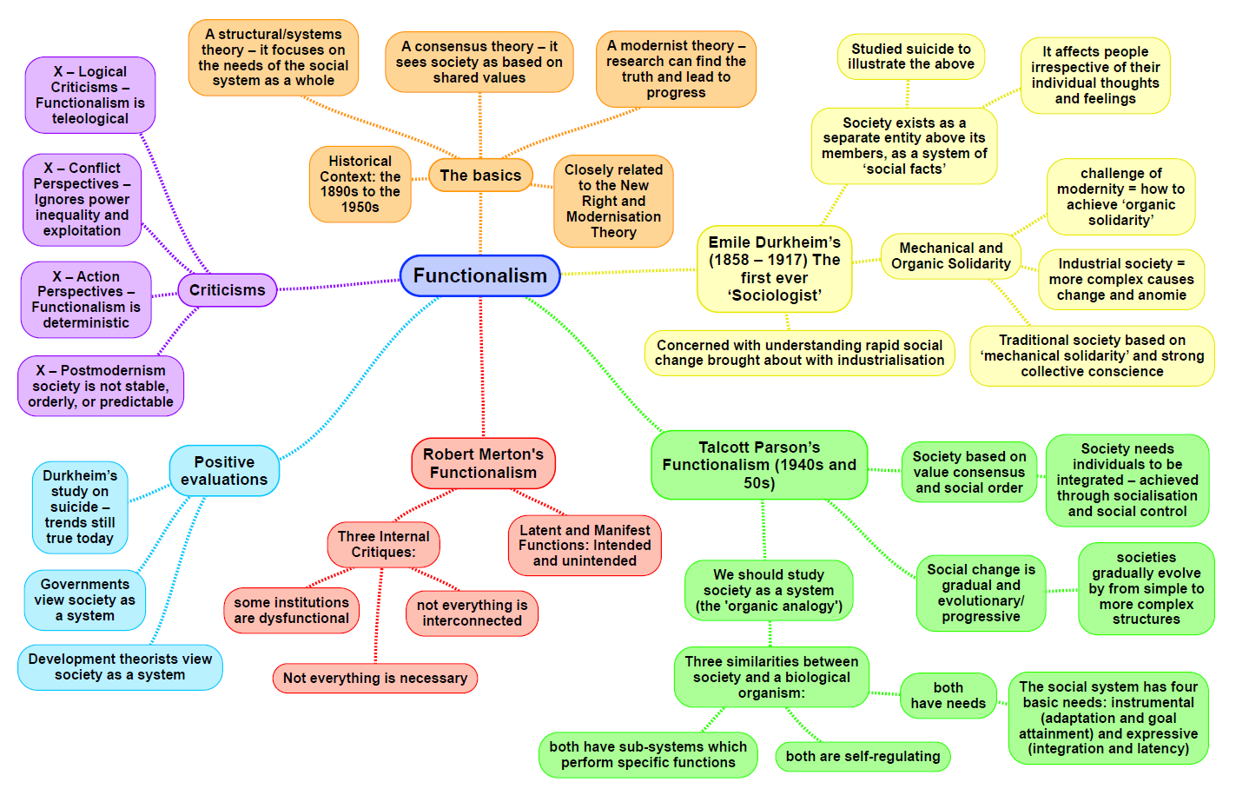

|  |  |
| --- | --- |
| **Theory: Functionalism MACRO/MICRO STRUCTURE/ACTION CONFLICT/CONSENSUS** | |
| Family:  **Parsons**: Functions of the family:  Socialisation (**primary and secondary**.)  **Gender Role Socialisation**: The nuclear family is still responsible for teaching children the norms and values of society.  **Functional Fit Theory**: the pre industrial family (most commonly extended family) has evolved into the industrial family (nuclear.) Nuclear families fit industrial societies because it required a **mobile workforce**. The extended family was too difficult to move when families needed to move to find work to meet the requirements of a changing economy. There was also less need for the extended family as health and education, gradually came to be carried out by the state.    **Criticisms** of Parsons: It is ‘too neat’- social change doesn’t happen in an orderly manner- Young and Wilmott found that extended kin networks were still strong in East London as late as the 1970’s.  **Murdock**: Functions of the family:   1. Sexual-Stable satisfaction of the sex drive within monogamous relationships. 2. Reproductive-Biological reproduction of the next generation. 3. Educational-Socialisation of the young. 4. Economic-Meeting member’s economic needs e.g. food, shelter.   **Criticisms** of Murdock: Feminists would argue that the family is ideological because traditional family structures disadvantage women. | Education:  **Durkheim**: **Social Solidarity**- school makes us feel like we are part of something bigger (it give us a shared sense of identity.)  School is a society in miniature- preparing us for life in wider society e.g. in school and at work we have to cooperate with people who are neither friends or family – which gets us ready for dealing with people at work in later life. He also noted that an advanced industrial economy required a massive and complex **Division of Labour**. At school, individuals learn the diverse skills necessary for this to take place. For example, we may all start off learning the same subjects, but later on we specialize when we do GCSEs.  **Parsons**: School plays the central role in the process of **secondary socialisation**, taking over from **primary socialisation**. He argued this was necessary because the family and the wider society work in different principles and children need to adapt if they re to cope In the wider world.  **Davis and Moore**: Education allocates people to the most appropriate job for their talents using examinations and qualifications. This ensures that the most talented are allocated to the occupations that are most important for society. This is seen to be fair because there is equality of opportunity – everyone has a chance of success and it is the most able who succeed through their own efforts (Linking to Parson’s **Meritocracy**.)  **Criticisms:**  Marxists argue the education system is not meritocratic – e.g. private schools benefit the wealthy. Functionalism also ignores the negative sides of school – e.g. bullying.  Postmodernists argue that ‘teaching to the test’ kills creativity.  Overall, Functionalism reflects the views of the powerful – the education system tends to work for them and they suggests there is nothing to criticise. |
| Crime:  **Durkheim-** Overall argues that all social change begins with some form of deviance. Not every member of society can be equally committed to the **collective sentiments** (the shared values and moral beliefs of society). He also studied **Anomie-** which means a moment of instability in society resulting from a breakdown of values and standards. When a social system is in a state of anomie, common values are no longer understood or accepted.  **Criticisms of Durkheim**:  Durkheim talks about crime in very general terms. He theorizes that ‘crime’ is necessary and even functional but **fails** to distinguish between different types of crime. It could be that some crimes may be so harmful that they will always be dysfunctional rather than functional.  **Interactionists** would suggest that whether or not a crime is functional cannot be determined objectively; surely it depends on an individual’s relationship to the crime.  **Merton** – argued against the concept of the **‘American Dream’** –meaning that anyone could achieve success in wealth/material possessions regardless of who they were (like **Meritocracy**.) People were expected to pursue this **goal** through legitimate **means** such as education and work. If you are ambitious, talented and work hard, you will achieve income and wealth.  Merton pointed out that these goals were not attainable by all due to the social structure of the USA. As a response, he developed Durkheim’s concept of **Anomie** to describe this imbalance goals and means. He argued that an imbalanced society produces anomie – there is a **strain** or tension between the goals and means.  Merton argued that when individuals face a gap between their goals and means, strain occurs. Then, people have five ways to **adapt**:  1. **Conformity**: pursing goals through socially approved means.  2. **Innovation**: using socially unapproved means to achieve socially approved goals e.g. dealing drugs or stealing for financial gain.  3. **Ritualism**: using the same socially approved means to achieve less elusive goals (more modest and humble).  4. **Retreatism**: to reject both the cultural goals and the means to achieve it and find a way to escape it.  5. **Rebellion**: to reject the cultural goals and means, then work to replace them.  **Criticisms of Merton:**  Not all working class individuals turn to crime, so another concept is needed to explain this. Subcultural theorists argued that the role of working class subcultures solves this– deviant subcultures provide rewards for individuals who commit crime.  Strain theory only really explains economic (utilitarian) crime, it doesn’t really explain violent and non-utilitarian crime.  **Subcultural theories:**  **A Cohen:** Due to educational failure and jobs, working class boys have little chance of achieving goals. This results in **status frustration**, the boys are at the bottom of the social structure and have little chance of gaining a higher status in society. This is similar to **Merton’s** theory, however Cohen said that instead of turning to crime as Merton said, they reject the norms and values of mainstream society and instead turn to the norms and values of a delinquent subculture. In this subculture the boys can achieve success because the social group has **different** norms and values from the rest of society. So in this culture a high value is placed upon criminal acts such as stealing and vandalism which are rejected by mainstream society.  Because the crimes reward the individual with respect there is not always the need for a monetary value to commit a crime, so the subcultural perspective explains why people commit **non-utilitarian** crimes.  **Cloward** **and** **Ohlin**:  There are **three** different types of **subcultures** that young people might enter into:   1. **Criminal** **subcultures**: tend to emerge in areas where there is a lot of organised adult crime, here there are criminal role models for young people, and they learn how to commit criminal acts. In these subcultures the young people can climb up the ladder by committing more crimes. These subcultures are normally concerned with utilitarian crimes, which yield financial reward. 2. **Conflict** **subcultures**: tend to emerge in areas where there is little organised adult crime, so instead of learning how to commit serious monetary crimes the young people instead focus on gaining respect through gang violence. 3. **Retreatist** **subcultures**: are for young people who have even failed in the criminal subcultures, these people are ‘double failures’. They tend to retreat to drugs and alcohol abuse to deal with the fact that they have been rejected from other subcultures.   **Matza:** Delinquents aren’t actually in opposition to society’s norms and values. He said that society has a strong moral hold on them and this prevents them from engaging in delinquent activities for most of the time, he said that the fact that these people often show remorse for their actions later in life support this view. Instead he said these young delinquents are involved in crime only occasionally as part-time law breakers.  They convince themselves they are not breaking the law, and this allows them to commit crimes whilst still accepting society’s norms and values. However, Matza said that within mainstream societies values there are ‘subterranean values’ which promote the ideas of acting in the spur of the moment for excitement and thrills. Although the subterranean values are within mainstream societies set of values, they could encourage behaviour which breaks the law and are then seen by mainstream society as criminal or deviant.  Through this theory of ‘delinquency drift’ Matza explains how he thinks young people within a subculture can break the values of society without really recognising that they are doing so, and then later in life drift back into mainstream society as these subterranean values become less important to the individual. | Stratification:  **Durkheim**: Did not directly confront the issue of why social stratification existed, but did live in a time of **class** inequality, so was obliged to address them.  Societies, like humans, could exist and thrive only if their various elements (body parts) work in harmony.  He states that social life couldn’t exist without conflict.  Social Solidarity- the unification of diverse groups so they feel that they have a common sense of interest.  ‘Social inequalities express natural inequalities.’  **Parsons:** stated that **class** conflict was no more than a by-product of social stratification. Parsons’ definition of social stratification = ‘a ranking system based on moral evaluation.’ He stated that Social systems need to be hierarchal to accomplish order and ranking.  **Gender**: He argued that because females carry out the ‘**expressive** role’ in the family which involved them caring for their children and looking after the emotional needs of their husbands, that girls grew up to internalise such values as caring and empathy, both of which reduce the likelihood of someone committing crime simply because a caring and empathetic attitude towards others means you are less likely to harm others.  The child caring role also means that women are also effectively more attached to their families and wider communities than men – It is traditionally women who keep in touch with relatives and get to know their children’s friends families and thus bond local communities together. In terms of bonds of attachment theory, women are thus more attached to wider society and thus less likely to commit crime.  Similarly, because traditional female gender roles involve women being busier than men, especially since they have taken on the ‘**dual burden**’ or a **‘triple shift**’ in recent decades, this reduces the opportunities for women to commit crime.  **Ethnicity**: Ethnic inequalities are temporary and based on cultural differences between ethnic groups and their host nation. Minority groups slowly adapt to majority culture and a process of assimilation occurs – minority ethnic groups give up their own culture and adopt majority culture. Parsons predicted that black Americans would gradually be assimilated and would eventually play a full role in a meritocratic society  **Criticisms**: Evidence for assimilation is limited e.g. Britain continues to be culturally diverse and ethnic inequalities continue to exist  **Davis and Moore:** set out to explain how inequality benefits society. (They assume it is beneficial then try to explain how it must be beneficial.)  They ask: Why are some positions in society higher than others? Why do the higher positions carry more status and rewards? The answer they come up with is this:  1. Societies are stratified because inequality fulfils an important need of all social systems.  2. Society must distribute its members among the various positions in society.  3. People have to be motivated to fill certain positions and perform their duties.  4. Filling the positions within a social structure is a basic need of any society. This is accomplished through the unequal distribution of rewards.  **Criticisms of Davis and Moore**: They claimed that their theory was applicable to all forms of society. Critics of the Davis-Moore viewpoint argued that it did not make much sense in non-competitive societies--for example feudalism, where all positions are distributed not by merit but by birth. And, more importantly what about those aspects of a class society that do not operate like merit systems?  The issue of ascribed vs. achieved status. The distribution of positions cannot be understood merely by achievement but achievement itself is conditioned by ascription of status. Weber’s concept of life chances is relevant here. Opportunities for achievement are not distributed equally.  **Age**:  **Parsons** argues the period of youth can be functional to help let off steam before taking on responsibilities in later life.  **Eisenstadt** argues different age groups enable people to learn new social roles and therefore contribute to social solidarity |
| General ideas:  **Comte:** One of the founding fathers of Sociology. He attempted, alongside Durkheim, Marx and Weber to apply similar **scientific** principles in understanding the natural world to understanding the development/organisation of human societies.  Durkheim (value consensus, collective conscience, social solidarity): He placed great importance on the role of social institutions, such as family and education, in socializing people into the **value consensus/collective conscience.** This is a collective agreement on values/norms which binds people together.  **Merton** (latent and manifest functions): Merton criticised Parson’s for his assumption that all social institutions provided benefits for everyone. He introduced the idea of **dysfunction** to describe social institutions not performing their intended function. He suggested that there were **Manifest Functions** of an institution (intended/recognized consequences) but also **Latent Functions** (unintended/unrecognized consequences.)  **Parsons** (**GAIL** Model):  **Adaptation**: the environment to meet people’s needs (food and shelter), met by the economic subsystem.  **Goal attainment**: society needs to set goals and means to attain them as well as the ability to make the decisions e.g. political parties do this.  **Integration**: Different parts of the system must integrate to pursue shared goals, the religion, education and media subsystems.  **Latency**: society needs to be maintained over time. The kinship and friendship subsystem provides 'pattern’ maintenance’ and 'tension management’, ensuring individuals feel motivated to continue their roles. | **Overall Evaluation of Functionalism:**  **Strengths:**   1. It provides a general theory of a functional society. 2. It shows the prevalence of **social structure** in society and how major social institutions e.g. education have an impact on us. 3. Provides an explanation for social order and stability.   **Weaknesses:**   1. Seen as too **deterministic-** sees individuals as passive products of the social system, which socializes them into conformity. It doesn’t allow for individual choice. 2. It is a **metanarrative-** it tries to explain everything from a single perspective. Postmodernists would argue that this can no longer explain contemporary societies. 3. It does not explain social change effectively, as social solidarity, value consensus etc. should limit change. 4. It emphasizes the benefits of social institutions but **ignores** the harmful effects of them. 5. It over emphasizes harmony and **downplays** the idea of conflict. 6. It has no sense of life chance inequalities and how these might generate social conflict. |

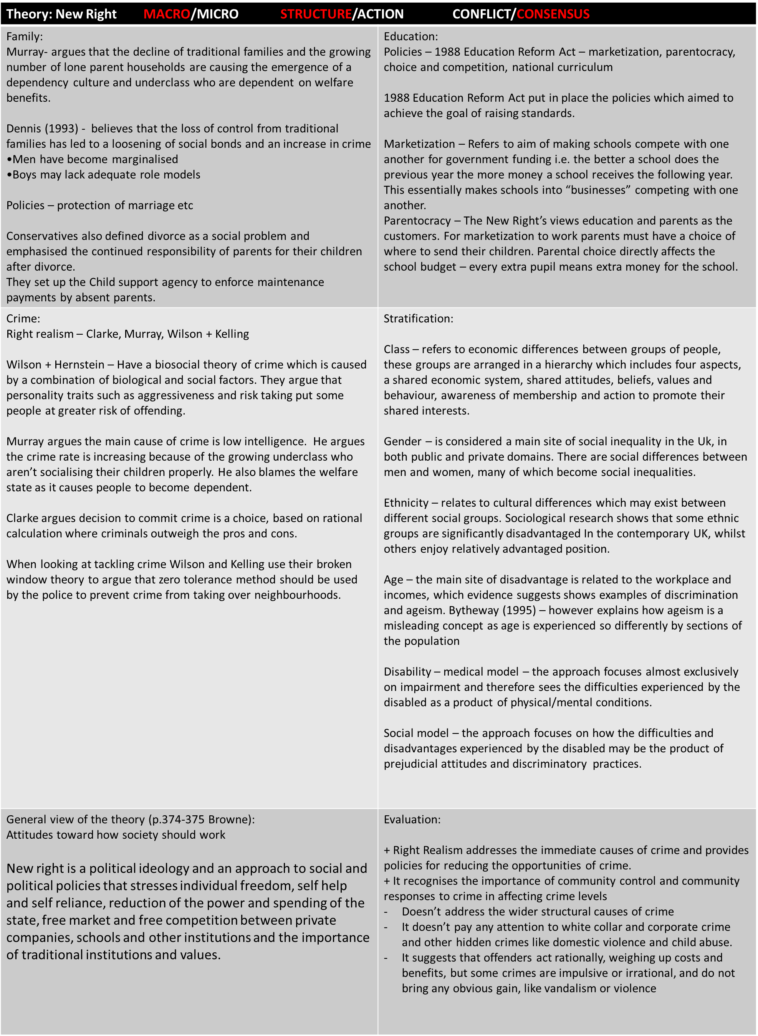

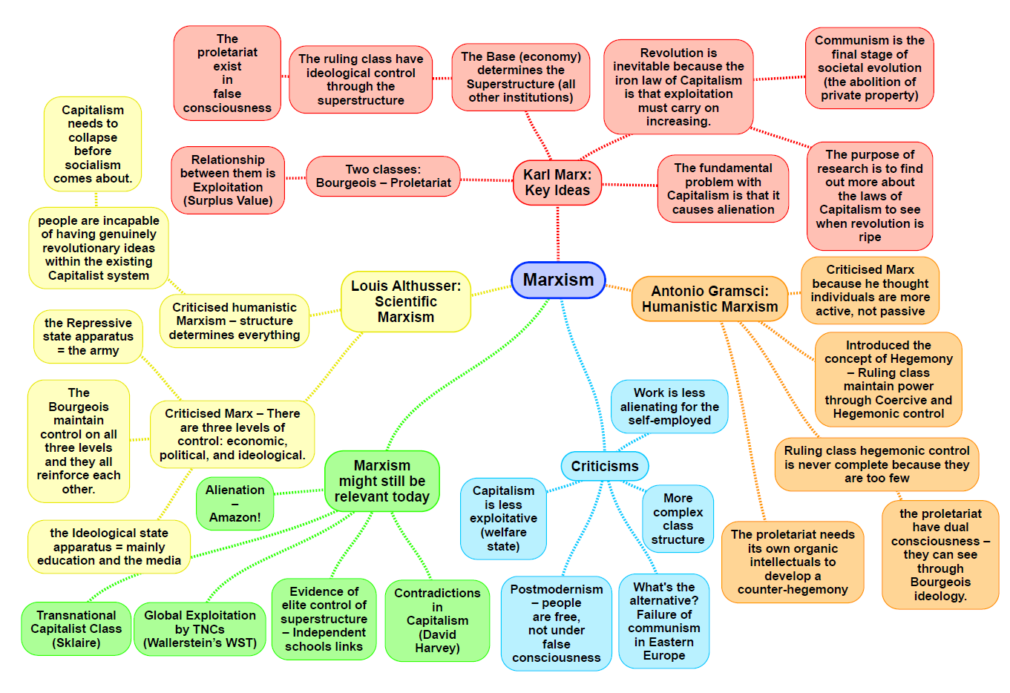

|  |  |
| --- | --- |
| **Theory: Marxism MACRO STRUCTURE CONFLICT** | |
| **Family:** The family upholds and maintains capitalism.  **Engels:** Explains how the family maintains wealth among the ruling class, through inheritance rules. He suggested marriage in capitalist society results in women being perceived as the private property of their husbands – legitimised prostitution**.**  **Zaretsky:** Family represents a place where men vent their frustration with the capitalist system on their wives: prevents them from posing a legitimate threat to capitalism. Women provide a reserve army of labour – meaning when the economy requires it, women are called out of the family back to work. (Can make links to Marxist feminism here)  **Althusser:** the family is part of the IDEOLOGICAL STATE APPARATUS which encourages individuals to conform and except capitalist ideology which in turn supports the economy. The family teaches the children to submit to capitalism. | **Education:** The education system maintains the capitalist system by making sure there are lots of willing workers and a small ruling class. The education system creates a myth of meritocracy.  **Bowles and Gintis:**  The CORRESPONDENCE PRINCIPLE. They argue that the school teaches a hidden curriculum to tack pupils to accept hierarchy and competition. This prepares working class pupils to accept their role as a exploited workers. They do this through the MYTH OF MERITOCRACY.  Example of the correspondence principle:   * Have to obey your boss at work, or your teacher at school. * Have to follow rules at wok in the same way that you have to follow the rules at school   Examples of Hidden Curriculum:   * Being encouraged to be obedient and not challenging the system * Accepting the authority of teachers and accepting the values of the school e.g.: being hard working.   **Althusser:** People are manipulated into loving the system – schools is part of IDEOLOGICAL STATE APPARATUS.   * Schools transmit ideology that capitalism is fair and just. * Schools prepare children for their roles in the workforce – taught to accept future exploitation.   **Bourdieu:** Key role of education system is to Legitimise and reproduce the existing class structure. Those from middle/upper class possess CULTURAL CAPITAL – (more access to the experience and knowledge needed to succeed in the education system). These groups also have higher social and economic capital.  **Stephen Ball:** Marketization reproduces inequality because middle- class parents have the CULTURAL CAPITAL to get their children into good schools. This is the myth of parentocracy.  **Rikowski:** is critical of marketization policies and the way they have led to a business takeover in schools. |
| **Crime:**   * Deviance is the product of unequal power relations and inequality in general. Its an ‘understandable response to the situation of poverty.’ * See power as largely being held by those who own the factors of production. * The superstructure serves the ruling classes * Laws passed reflect the wishes and ideologies of the ruling classes. * ‘Capitalism is CRIMINOGENIC’ – Its inherently criminal – its conditions create crime- due to the exploitation within it. * People have unequal access to the law – having money to hire a good lawyer can mean the difference between guilty and not guilty.   **Chambliss:** Law benefits ruling class because it protects property rights above others.  **Snider:** Ruling class make the laws which enables them to protect their own interests. Says that capitalistic state is often reluctant to pass laws which regulate big business concerns,. Which might threaten profitability.  Suggests the state is unwilling to enforce laws against pollution, workers health and safety or monopolies. Argues that crimes of the powerful exert a greater economic toll on society.  **Tombs:** Despite being more costly to society, the crimes of the elite tend to go unpunished – (research by Tombs and Whyte suggests)  Tombs and Whyte: Believe that corporate crimes aren’t newsworthy because the average non expert person wouldn’t understand the crime and they are too complicated to summarise easily, also as there is often no direct victim, there is no emotion behind it.  **Gordon:** Argues that crime is a rational response to the capitalist system and hence its found in all social classes – even though the official statistics make it appear to be a largely working class phenomenon.  People have unequal access to the law – Having money to hire a good lawyer can mean the difference between being found guilty or not guilty.  **Newburn**: notes that the sociology of crime and deviance has tended to focus on crimes of the powerless rather than the powerful. He notes that official statistics show w/c people as the main offenders. While powerless groups such as the w/c and ethnic minorities are criminalised, the police and courts tend to ignore the crimes of the powerful – which can be seen as SELECTIVE ENFORCEMENT.  **Sutherland:** First coined the term ‘corporate crime’ to describe a crime committed by someone with high power, status and wealth, in the course of his occupation.  Types: Financial crimes, Crimes against consumers, crimes against employees, crimes against the environment (green crime).  Issues: Less visible, not as easy to investigate, companies can employ lawyers, hard to prosecute companies / individuals within companies.  Crime is a behaviour learnt from others. If a company’s culture justifies committing crimes, employees will be socialised into this criminality. | **Stratification:** They argue that class is the key to understanding absolutely everything in society. Marx argues that there are only 2 classes in society – the PROLETARIAT and the BOURGEOISIE. He believes that class is a social group who share the same relationship to the means of production.  **Class:** Marxists argue that our society is POLARISED– the gap between the rich and the poor has widened. WESTERGAARD and RESLER put forward a Marxist view that there was a ruling class in Britain consisting of the richest 5-10% of the population, who's position came from the ownership of capital.  **Gender:** ZARETSKY would argue that in the home men act as the ‘king of the castle’ as this is the only place they feel in control. This shows that patriarchy still exists in the home and therefore the home oppresses women.  ENGELS: would argue that marriage is a form of ‘Legitimised Prostitution’ meaning that women exchange their bodies in return for money and security.  **Ethnicity – Cox, Castles and Kosack :**  CASTLES AND KOSACK (1973): say that capitalism benefits from a working class divided by ethnic inequality. They argue that ethnic differences are used to distract the working class form the real cause of their problems.  E.g. they get blamed for problems such as unemployment and housing shortages. Instead of uniting to start a revolution, the working class fights amongst itself.  They say that ethnic division also creates a reserved army of relatively cheap ethnic minority labour. Capitalism therefore encourages ethnic division and disadvantage.  **Age – reserve army of labour, Philipson:** Marxists ideas of a ‘RESERVE ARMY OF LABOUR’ could be applied to some “economically disadvantaged” age groups – both the young and retired may be called upon to do jobs for relatively low wages during economic boom, buy may also be dismissed when the economy goes into slump.  PHILIPSON (1998): suggests that the logic of capitalism is about exploiting workers and consumers for profit. This is incompatible with the need of the elderly.  He says retirement from paid work often means that the elderly lose a major source of status, respect, identity, and economic secuirty. Resulting in the elderly, despite their greater needs, being neglected by the capitalist system, as they no longer have disposable income.  **Disability:** Marxists tend to see disability more as a social factor partly created by industrial capitalism. This is said by Finkelstein. |
| General view of the theory (p.375-378 Browne):  Marx – base and superstructure, private ownership, exploitation, class conflict, dominant ideology, communism  (CONFLICT STRUCTURALISM):  Classical Marxism: comes from work of Marx, who founded the political creed: Communism. Marxism, like functionalism, is a modernist theory that believed that a scientific analysis of society, and the discovery of the laws of its development, would provide the means for improving it, in this case through eventual revolution and the establishment of a communist society.  BASEE AND SUPERSTRUCTURE:  Marx believed that the economy was the driving force in society, and it was this that determined the nature of social institutions, and people’s values and beliefs. Marxism sees the structure of society divided into 2 main parts.   1. The ECONOMIC BASE: underpinned and determined everything else in society.   The means of production: e.g. land, factories, technology, and labour necessary to produce society's gods.  The relationships of production: e.g. the relations between those involved in production e.g. shared ownership or private ownership, who controls production, and the relationship between owners and non-owners.  2. THE SUPERSTRUCTURE: includes society’s social institutions e.g. the family, education, the media, religion and the political system, and beliefs and values (ideology, which Marx saw as primarily determined (or influenced) by the economic system. | Evaluation (p.378 Browne):  STRENGTHS:   * Recognises the importance of the economy and how economic changes influence a wide range of other social institutions. * Recognises the importance of society's social structure, and links this to the ides, consciousness and behaviour of individuals and groups. * Remains a highly influential theory, which has had a significant influence on a range of other sociological theories e.g. those of Weber and of Marxist feminists.   WEAKNESSES:   * Classical Marxism over-emphasises the extent of conflict in society. Functionalists wold argue society is primarily stable, and there must be some shared values for social life to be possible. That Marx’s predicted revolution hasn’t succeeded in any western society reflect this. Functionalists see stratification as inevitable in a functioning society and is important for role allocation. * Over-emphasises social class as a source of inequality and conflict, and pays little attention to other sources e.g. gender, ethnicity, and age. * Classical Marxism is too deterministic, + sees individuals as simply passive products of the social system, which socializes them into conformity and controls their behaviour. It doesn’t allow for individual choice, as the social action theorists do. |

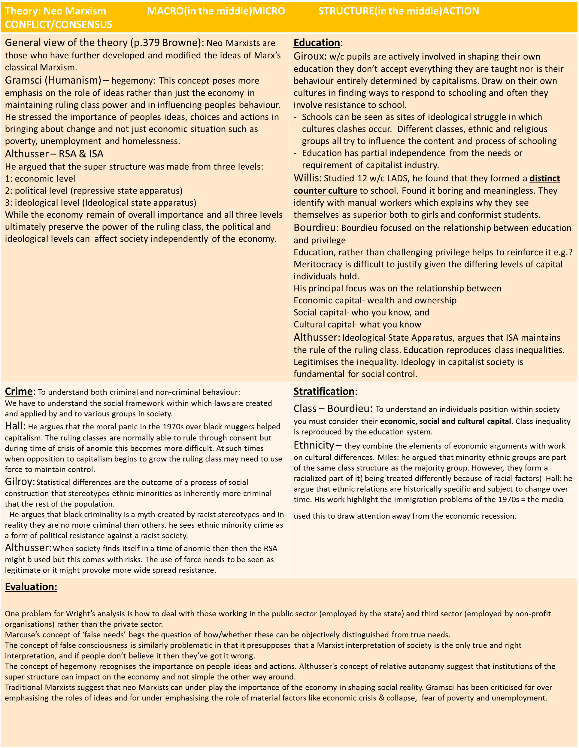**Key Concepts:**

**Hegemony**- refers to the dominance in society of the ruling classes set of ideas over others and acceptance of and consent to them by the rest of society.

**Relative autonomy-** is the idea that the super structure of society has some independence from the economy rather than being directly determined by it.

**Bourgeoisie-** the capitalists class the owners of the means of production.

**Proletariat-** the working class in capitalist’s society. They own no means of production and are wage slaves.

**Repressive state apparatus-** refers to those parts of which are concerned with mainly repressive physical means of keeping a population in line eg: the criminal justice system and the armed forces.

**Ideological state apparatus-** the agencies that spreads dominant ideology and justify the power of the dominant social class

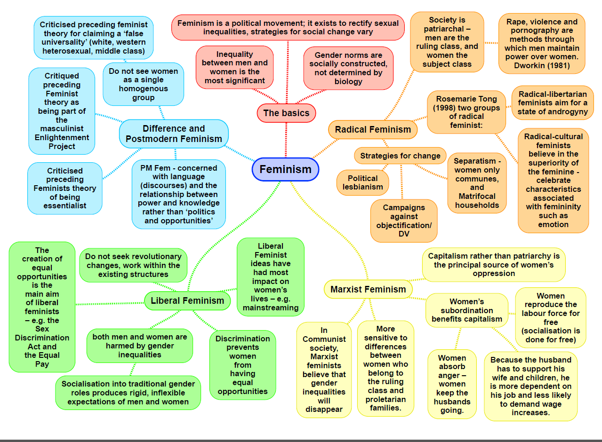

|  |  |
| --- | --- |
| **Theory: Feminism: liberal MACRO & MICRO STRUCTURE & ACTION CONFLICT** | |
| **Family**: Liberal feminists do not believe full gender quality has been achieved in the family however they argue there has been a gradual progress. For example some studies show men are doing more domestic labour, while the way parents are socialising their sons and daughters is much more equal and they now have similar aspirations regardless of their gender.  Oakley – Oakley found some evidence of men helping more with domestic labour however found no evidence of gender roles within the family being symmetrical.  She argues that from an early age people are trained to conform to their gender through socialisation, two processes in which she discusses in-   * Manipulation- refers to the way in which parents encourage or discourage behaviour on basis of their child's gender. * Canalisation- refers to the way in which parents channel children's interests into toys and activities that are seen as “normal for their sex”   Sharpe- Women’s aspirations have changed and they are now less likely to become housewives and more likely to have career of their own.  Evidence- Ann Oakley found that only 15% of husbands had a high level of participation in housework and 25% had a high level of participation in childcare. | **Education**: Liberal feminists celebrate the progress made so far in improving achievement. They believe that further progress will be made by the continuing development of equal opportunities policies, encouraging positive role models and overcoming sexist’s attitudes and stereotypes.  Oakley- education plays a role in canalisation and manipulation of gender roles. Socialises us into traditional roles.  Sharpe- Sue Sharpe found that girls are now more likely to see their future as independent women with a career that as dependant of their husbands and their income. Changes in the educations curriculum have contributed meaning girls and boys are doing the exact same subjects regardless of their gender.  Stanworth- Conducted interviews with A-level students and teachers and students, she found that teachers whether male or female expressed more concern for boys and it was boys who were expected to do well in exams.  Lobban – reading schemes maintain stereotypes about male/female gender roles. |
| **Crime:** Women should reviews them same treatment as men, they argue the difference between men and women offending is due to the lack of female opportunities in education, employment and other institutions compared to males.  Carlen- Working class women are generally led to conform through the promise of two “promises”-  **The class deal**, women who work will be offered material rewards  **The Gender deal**, promises women material and emotional rewards from the family for conforming to the patriarchal Gender roles.  Adler – liberation thesis= Patriarchal society exercises control over women to prevent them from deviating therefore if society becomes less patriarchal women's crime rate will become similar to men's. Changes in education and work opportunities for women have become more equal, women have begun to adopt traditionally “male” roles is both legitimate activity (work) and illegitimate activity (crime).  Walklate- In rape cases it is not the offender that is put on trial but the victim, since she has to prove her respectability in order to have her evidence accepted.  Heidenson- Her approach combines the feminist approach with the control theory. Patriarchal controls prevent women from committing deviating. | **Stratification:**  Gender – liberal feminists take account the structural constraints women face in the workplace but are not great at exploring differences of experience based on ethnicity.  Oakley- Argues that the dominant patriarchal ideology means women are perceived as wives and mothers and are therefore as secondary in the job market.  Sharpe- Women’s aspirations are changing they do not have the same aspirations as they did in the 1970s.  McRobie- Gender roles are represented differently in the media, the media influences us as humans on what to do and what not to do based on our gender.  Somerville- Women are better off now they can get divorced, have access to jobs, obtain as good education and have control over their fertility. This does not only disadvantage them in the education system but also prepares them to accept their later loss status. |
| **General view of the theory** (391 Browne):  Liberal feminists are concerned with human and civil rights and freedom of the individual. They believe all humans regardless of gender should be equal.  **Reformism** is the idea that progress towards equal rights can be achieved through gradual reforms within society without the need for revolution.  **Laws and policies** against sex discrimination in employment and education can secure equal opportunities for women.  **Cultural change** needs to happen**,** traditional prejudices and stereotypes are barriers to gender equality.  Liberal feminist reject the idea that biological differences make women less competent or rational than men   * **Changes in socialisation and culture** are gradually leading to more rational attitudes to gender and overcoming ignorance and prejudice. * **Political action to introduce anti-discriminatory laws and policies** is steadily bringing about progress to fairer society in which a person’s gender in no longer important.   Liberal feminism challenges the functionalist view of the division between instrumental and expressive roles, and argues these gender roles are prevent both men and women from leading fulfilling lives. | **Evaluation**:   * Studies conducted by liberal feminists have produced evidence documenting the extent of gender inequality and discrimination, and has legitimised the demand for reform in areas such as the workplace and the media. * The liberal feminist theory has helped demonstrate that gender differences are not inborn but are the result of different treatment and socialisation patterns. * Liberal feminists are criticised for over-optimism they see obstacles causing gender inequality as just prejudices or irrational laws, they ignore the possibility that there are deep-rooted structures causing women's oppression such as capitalism or patriarchy. * Sylvia Walby (1997) argues, they offer no explanation for the overall structure of gender inequality. * Marxists feminist and radical feminists argue that liberal feminism fails to recognise the underlying cause of women's subordination and that it is naive to believe that changes to the la or attitudes will be enough to bring gender inequality and far-reaching and revolutionary changes need to be made. Although liberal feminists have had a massive impact on policy especially in the workplace and education. |

**Key concepts**

**March of progress-** Liberal feminism is closely linked with the march of progress view

**Changes in socialisation and culture-** Change in the way parents socialise their children into gender roles, (canalisation and manipulation) and cultural changes regarding stereotypes of gender roles.

**Reformism**- Progress towards equal rights comes with gradual reforms within society without the need for revolution.

**The Class deal-** women who conform will be offered material rewards

**The Gender deal**- promises women material and emotional rewards for conforming to the patriarchal gender roles.

**Manipulation-** refers to the way in which parent encourage and discourage their children’s behaviour based on their gender.

**Canalisation-** Refers to the way in which parents channel children’s interests through toys and activities that are “normal for their sex”

|  |  |
| --- | --- |
| **Theory: Feminism: radical MACRO STRUCTURE CONFLICT** | |
| **Family:** Say that all societies have been founded on patriarchy and are ruled by men. The key division in society is between men and women   * See men’s physical dominance as the main women for women’s oppression and exploitation. * Family and marriage key institution of this exploitation   **Firestone**  Women's oppression originated from their biology, particularly due to the fact they give birth. Rape and male violence towards women are methods of maintaining and securing their power  **Duncombe and Marsden**  1995- argue that women have to perform a triple shift of housework, paid work and emotional work  **Bernard**  Being a housewife makes a women sick in terms of the workload they have – (can link back to triple shift)  **Millet**  Argue that all societies are founded on patriarchy, it’s the most fundamental concept of power and that the family reinforces this | **Education:**  Patriarchy is still built into the education system, this can be seen through the fact that the majority of head teachers are male  **Stratification:**  **Firestone** argues biology is the basis for women's inequality and domination by men in all societies.  This strand of feminism is seen as the most anti men though this is not necessarily true |
| **General view of the theory**  Radical feminists regard patriarchy as they most fundamental form of inequality, the world divided into 2 sex classes of men and women. With men dominating women in all areas | **Evaluation:**  It assumes all women share common interests. It fails to recognise as Marxist and other feminists do that other factors such as social class and ethnicity are important sources of inequality |

|  |  |
| --- | --- |
| **Theory: Feminism: marxist MACRO STRUCTURE CONFLICT** | |
| **Family:** argue that the main cause of women's oppression in the family is not men, but capitalism. They see the family and particularly women's work in the family as contributing to the maintenance of capitalism in the following ways:   * Reproduce the labour force * Absorb anger (safety valve) * Are a reserve army of cheap labour   **Ansley**  Women absorb anger that would otherwise be directed at capitalism. Wives are the ‘takers of shit’ who soak up the frustration of their husbands feel because of the alienation and exploitation the suffer at work  **Beechey**  Believes that housewives carry out two functions. To provide care for current and future workers other is to be a cheap reserve of army labour.  **Breughal**  Women's unpaid domestic labour helps maintain capitalist exploitation by reproducing the labour force at no cost to the employer, women act as a reserve army of labour | **Stratification:**  Suggest that although men may sometimes be the problem, that class dimensions are more important.  Engels – suggests that in the past people lived in ‘promiscuous hordes’ where sexual relations were not fixed and property passed from mother to child. Now men are more determined to pass their property to their own offspring thus leading to the monogamous marriage and the power of men over women |
| **Dual systems – Walby**  Blends Marxist and radical feminist theory together. Capitalism and patriarchy are seen as 2 separate systems that interact with and reinforce one another in the form of patriarchal capitalism.  For example patriarchy creates women's responsibility for housework and childcare and related economic dependence on and subordination to men | **Evaluation:**  Don’t explain the fact that patriarchy has existed in all societies, not just capitalist societies which radical feminists point out.  It is men not just capitalism that benefit from women's subordination, and is men who are the instruments of oppression.  Focus on economic issues rather than biological or social factors |
| **General view of the theory (p.392 Browne):**  Marxist feminists argue that gender inequality arises primarily from the nature of capitalist society, not from and independent system of patriarchy.  For example women are used as a cheap labour force, as a reserve army of labour that can be sacked during periods of economic recession and reemployed during periods of prosperity (links back to traditional marxism) |  |

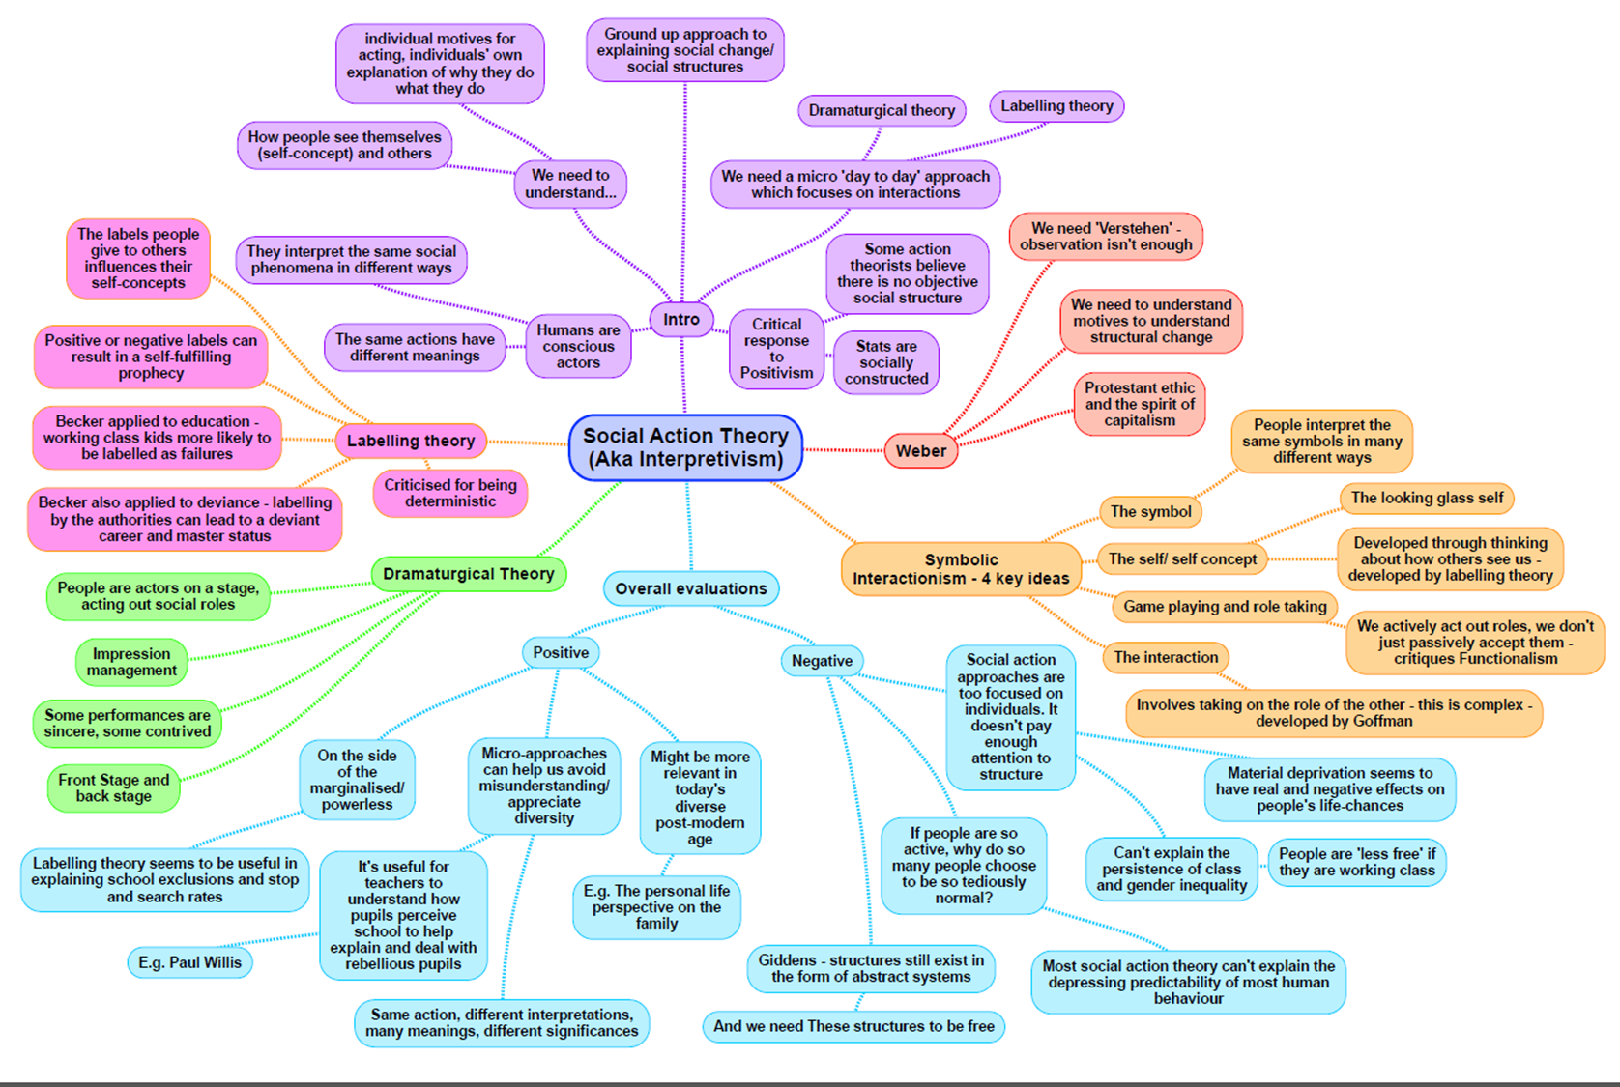

|  |  |
| --- | --- |
| **Theory: Interactionism MICRO ACTION** | |
| *Family:*  Personal life perspective on families:  **Smart-** Sociologists influenced by interactionist perspectives reject the structural view- they argue that structural theories ignore the fact we have some choice in creating our family relationships and that to understand the family today, we must focus on the meanings its members give to their relationships and situations , rather than on the family’s supposed ‘functions’.  Personal life perspective shares the ‘bottom up’ approach of interactionism. ‘Beyond ties of blood and marriage’: also takes a wider view of relationships than just traditional ‘family’ relationships based on blood or marriage.  -By focusing on people’s meanings, the personal life perspectives draws our attention to a range of other personal or intimate relationships that are important to people even though they may not be conventionally defined as ’family’.  These include all kinds of relationships that individuals see as significant and that give them a sense of identity, belonging or relatedness, such as:   * Relationships with friends * Fictive kin: close friends treated as relatives * Gay and lesbian ‘chosen families’ * Relationships with dead relatives * Even relationships with pets   **Nordqvist and Smart’s** (2014) research on donor-conceived children explores “what counts as family when your child shares a genetic link with a ‘relative stranger’ but not with your partner?” | *Education:*  **Becker:** ‘Ideal pupil’  -He discovered that teachers evaluate pupils in relations to their stereotypes of the ideal pupil which set the standard for teachers’ judgment of the quality of young people as pupils.  -Labelling Theory: Becker carried out an important interactionist study of labelling- based on interviews with 60 Chicago high school teachers and found that they judged pupils according to how closely they fitted an image of the ‘ideal pupil’.  -Streaming: Becker shows that teachers do not usually see w/c children as ideal pupils. They tend to see them as lacking ability and have low expectations of them. As a result, w/c children are more likely to find themselves put in a lower stream.  **Gillborn and Youdell:** Streaming and the A-C economy  -A study of two London secondary schools by Gillborn and Youdell shows how teachers use stereotypical notions of ‘ability’ to stream pupils. They found that teachers are less likely to see w/c (and black) pupils as having ability. As a result, these pupils are more likely to be placed in lower streams and entered for lower-tier GCSES. This denies them the knowledge and opportunity needed to gain good grades and widens the class gap in achievement.  -Publishing league tables creates what they call an ‘A-C economy’ in schools. This is a system in which schools focus their time, effort and resources on those pupils they see as having the potential to get 5 grade Cs and so boost the school’s league table position.  **Archer:** ‘Nike’ identities  -Archer argues that the school’s m/c habitus stigmatises w/c pupil’s identities. The pupils’ performances of style are a struggle for recognition: while the m/c see their ‘Nike’ identities as tasteless, to the young people they are a means of generating symbolic capital and self-worth.  **Ball:** ‘Beachside comprehensive’  **-**Examines the internal organisation of the comprehensive school  -Found that teachers had high expectations of those children in the top sets or streams and so they pushed or warmed up the children placed in these top sets/streams even more  -As a consequence, those students in the top sets or streams achieved better grades and go to university  -Those in the lower sets or streams get fewer qualifications or there was greater focus on vocational courses  **Woods:** Teacher responses  -Suggested that dividing pupils subcultures into two poles  -Also suggested that students don’t usually split into subcultures easily  -Instead he suggested there is a wide variety of response to school and pupils can switch between adaptions as they progress through their school careers |
| *Crime:*  **Lemert:** distinguishes between primary and secondary deviance. He argues that it’s pointless to seek the causes of primary deviance since it is so widespread and that it is unlikely to have a single cause.  -Primary deviance refers to deviant acts that have not been publically labelled  -Secondary deviance is the result of societal reaction (labelling). Once an individual is labelled, others may see them only in terms of the label, which becomes their ‘master-status’.  **Becker (1963):** Labelling Theory  -Deviance is in the eye of the beholder: a deviant is someone to whom the label has been successfully applied, and deviant behaviour is simply behaviour that people so label.  -’Moral entrepreneurs’: people who lead a moral ‘crusade’ to change the law.  However, Becker argues that this new law has two effects:  1. The creation of a new group of ‘outsiders’-outlaws or deviants who break the new rule  2. The creation or expansion of a social control agency to enforce the rule and impose labels on offenders.  Becker notes that social control agencies themselves may also campaign for a change in the law to increase their own power.  **Cicourel:** The negotiation of justice  -Officers’ decisions to arrest are influenced by their stereotypes about offenders.  -Cicourel found that officers’ typifications- their common-sense theories or stereotypes of what the typical delinquent is like- led them to concentrate on certain ‘types’. Resulted in law enforcement showing a class bias, in that w/c areas and people fitted the police typification most closely.  -Also found that other agents of social control within the CJS reinforced this bias- in his view, justice is not fixed but negotiable.  **Goffman:** study ‘Asylums’ shows some of the possible effects of being admitted to a ‘total institution’ such as psychiatric hospital. He notes the similarities with other total institutions such as army, prisons, and boarding schools. Shows that whilst some inmates become institutionalised, internalising their new identity and unable to readjust to the outside world, others adopt various forms of resistance or accommodation to their new situation. | *Other approaches:*  **Ethnometholodgy (p.385 Browne)**  **-**Associated with the work of Garfinkel (1967) and refers to the description of the methods or interpretive procedures which people use to make sense of and construct order in their everyday social world.  -It rejects the view that society has any kind of social structure, social order or patterned interactions that exists outside of individuals’ consciousness.  -Social order is an illusion, and only appears to exist because members of society create it in their own minds and impose a sense of order using their own common-sense procedures and culturally embedded rules and assumptions  -Society only retains some semblance of stability and order because people share these assumptions  *Key concepts:*  -Labelling theory  -Ethnomethodology  -The ’Looking-glass self’  - Symbols  - Meaning  - Dramaturgical analogy#  - Typificiation  - Self-fulfilling prophecy  - Master status |
| *General view of the theory (p.382-385):*  **Mead and Blumer – symbols, meanings**  **-**Mead was the founder of symbolic interactionism, though it was Blumer (follower of Mead) who actually first used the term.  -Symbolic interactionism has 3 basic features: people act in terms of symbols, meanings develop out of the interaction of an individual and can change; and meanings arise from an interpretive process.  **Cooley –** looking glass self  -Developed the concept of the ‘looking-glass self’ to describe this process of negotiated interaction.  -The idea that our image of ourselves is reflected back to us in the views of others (like a mirror)  -As we consider the image of ourselves reflected in the reactions of other people to us, we may modify and change our view of ourselves and our behaviour**.**  **Goffman** – impression management, dramaturgical analogy  -Studied the ways people construct meanings and interpretations in the process of interactions, using what has been described as a dramaturgical model, based on the idea of society being like a stage. | *Evaluation of social action theory (p.386 Browne):*  **Strengths:**  **-**It shows that human beings create and negotiate meanings and make sense of the world either through interaction with others or by drawing on their own common-sense understandings  -It recognises that to fully explain peoples actions and the creation of social order, it is necessary to understand the motivations and meanings people attach to their behaviour and how they come to share these  -It provides insights to how the social construction of meanings through interactions has consequences for individuals  -The interpretivist approach and use of qualitative methods mean research findings often have high levels of validity.  **Weaknesses:**  -It doesn’t pay a sufficient attention to the structures of society  -It does not really explain peoples motivations  -It tends to underestimate or ignore the distribution of power in society  -Postmodernists would suggest that action theory is much a metanarrative as any other theory that claims to provide a full explanation of social life. |

|  |  |
| --- | --- |
| **Theory: Weberian MACRO/MICRO = both STRUCTURE/ACTION = both** | |
| Stratification:  Marx Weber has been described as the ghost of Marx. He agreed with Marx that the ownership of property and capital were important dimensions of privilege within society, however not the only dimensions.  Class  They argue that the ‘old rich’ who gain their wealth and status from property are so insignificant in number that they should not be considered as a meaningful category in their own right. For Goldthorpe at al, the upper class has changed and its power and prestige has been diluted.  Weber did not see power as class based, but argued that it was widely distributed across society.  Weberian theory has been the most influential in explaining the changing nature of the middle class. Roberts et al showed how the middle classes have splintered into different groups. Roberts uses the concept of fragmentation to describe the division within the middle class into different sections. Ties to the embourgeoisement theory.  Gender – Barron and Norris (dual labour market)  Dual labour market theory- there are two labour markets:  Primary- characterised by high pay, secure jobs and good promotion prospects  Secondary- low pay, poor promotion prospects, low job security.  They suggest women are more likely to be in the secondary market, particularly after having children and that there is a problem of moving between the two.  Ethnicity – Parkin, Rex + Moore  Weberianism suggests that ethnic inequalities cannot be explained just in terms of economic class. More cultural factors such as status are important to consider  Parkin (1968) suggests high status, privileged groups (e.g. political elites, judiciary) operate a system of social closure, keeping ethnic minorities out of positions of authority. He refers to ethnic minorities as “negatively privileged status groups”  Rex & Moore (1967) argue that racial/ethnic differences have resulted in severe disadvantages in the labour market, poorer life chances, weaker market situation and marginalisation for some ethnic minorities.  Age – Parkin, Barron and Norris  Focus on the loss of status and power that comes with old age largely as a result of disengagement from economic relations  Frank Parkin’s concept of negatively privileged status groups could be applied to elderly people forced out of the labour market  The secondary labour market (Barron and Norris) may be increasingly populated by the young, even among the middle class, e.g.  Students are a useful source of short-term low cost employees  Internships may be used for no-cost workers in high demand industries, e.g., the media.  Workfare may drive down available wage rates for the young even while providing important experience for those engaged  Equally with the delay of entitlement to state pension for the older worker, the early retired may well appear within the labour market outside full-time employment | Methods: Value freedom/science (p.197- 198 Webb)  Max Weber makes a sharp distinction between value judgements and facts and he argues that we cannot derive the one from another.  The issue of commitment that weber raised has remained at the centre of debates about the place of sociologists values in research. For example, some modern positivists have shied away from any value commitments.  By contrast, Marxists, interactionists and feminists have argued for a ‘committed sociology’ in which the sociologist spells out the importance of their values to their research.  **Concepts**  Fragmentation – describes the division within the middle class into different sections.  Dual labour market theory- there are two labour markets:  • Primary- characterised by high pay, secure jobs and good promotion prospects  • Secondary- low pay, poor promotion prospects, low job security.  Committed sociology - in which the sociologist spells out the importance of their values to their research.  Class is not the sole determinant of status, it is made up of:   1. Class - economic conditions such as income, wealth and occupation. 2. Status - a person’s social standing within a society or community. Status was therefore connected to social dimensions. 3. Party - political dimensions and issues of power. |
| General view of the theory (p.387 Browne):  Weber – market, party, status  Weber’s sociology does not fit neatly into either structuralist or action approaches. He is often regarded as the original social action theorist, and he was the first sociologist to emphasise the importance of understanding the subjective meanings people held and how they viewed the world.  Weber argued that social inequality was largely a product of three dimensions; class status and party.  By class, weber referred to economic conditions such as income, wealth and occupation.  By status he meant a person’s social standing within a society or community. Status was therefore connected to social dimensions.  By party, he was referring to political dimensions and issues of power. | Evaluation:  Weber suggests that stratification is somewhat more complicated than Marx indicated. Weber suggests that there is a need to distinguish between class, status and party. All three aspects of stratification are related to aspects of power.  Society was therefore fundamentally unstable as individuals and groups struggled with one another as they perused their competing interests. |

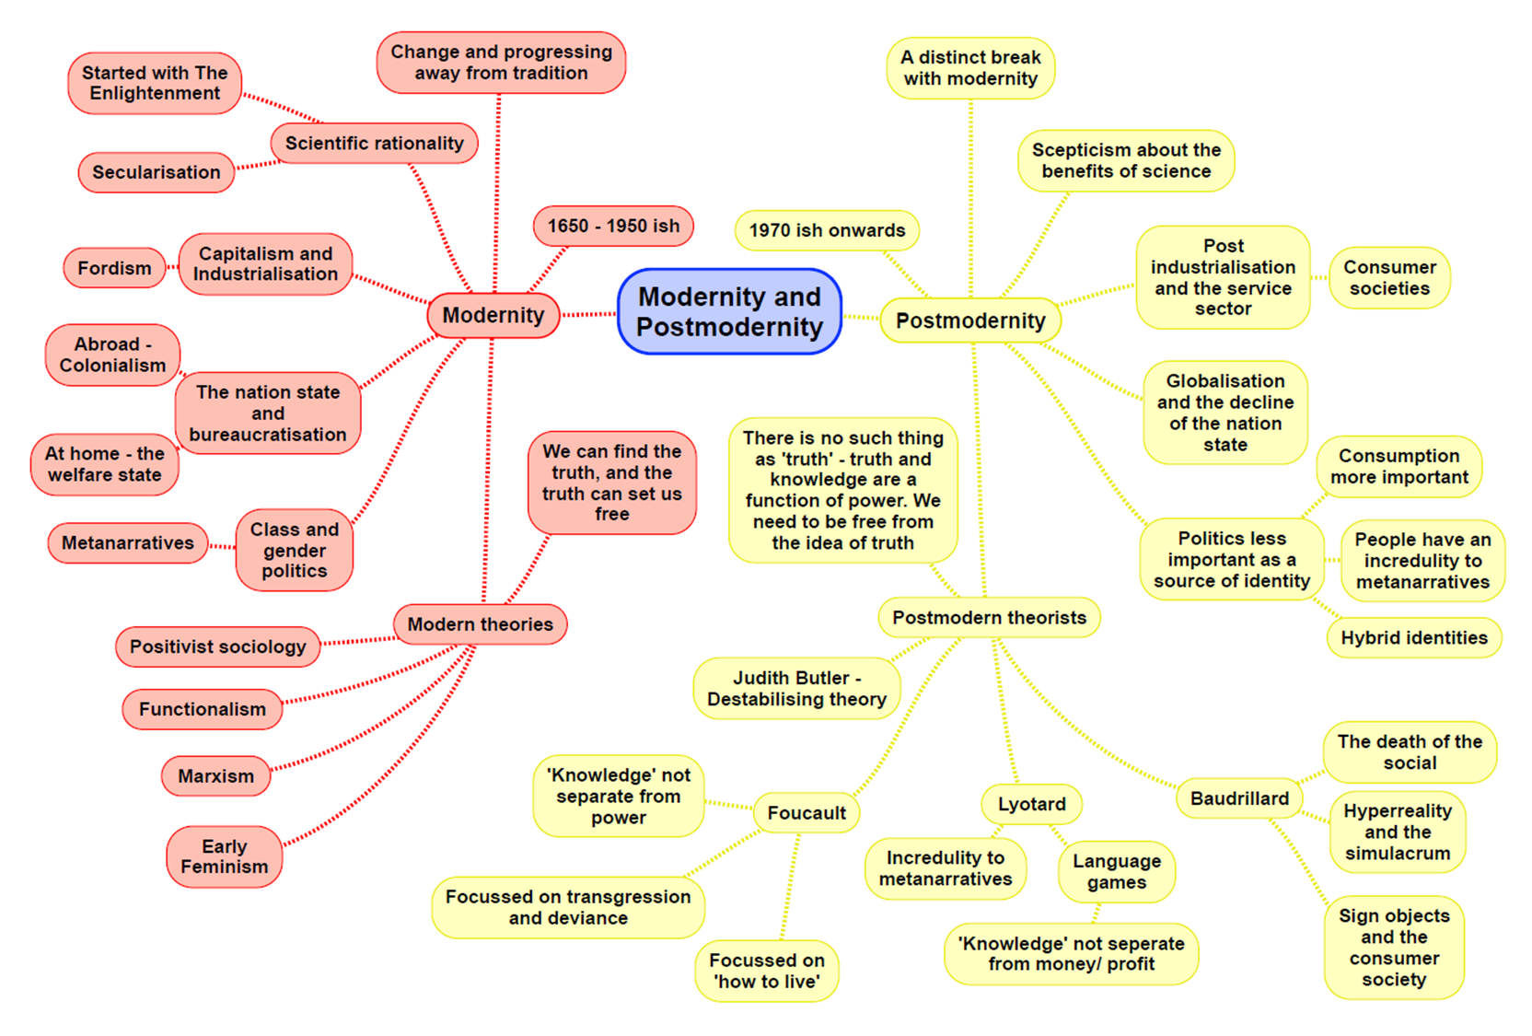

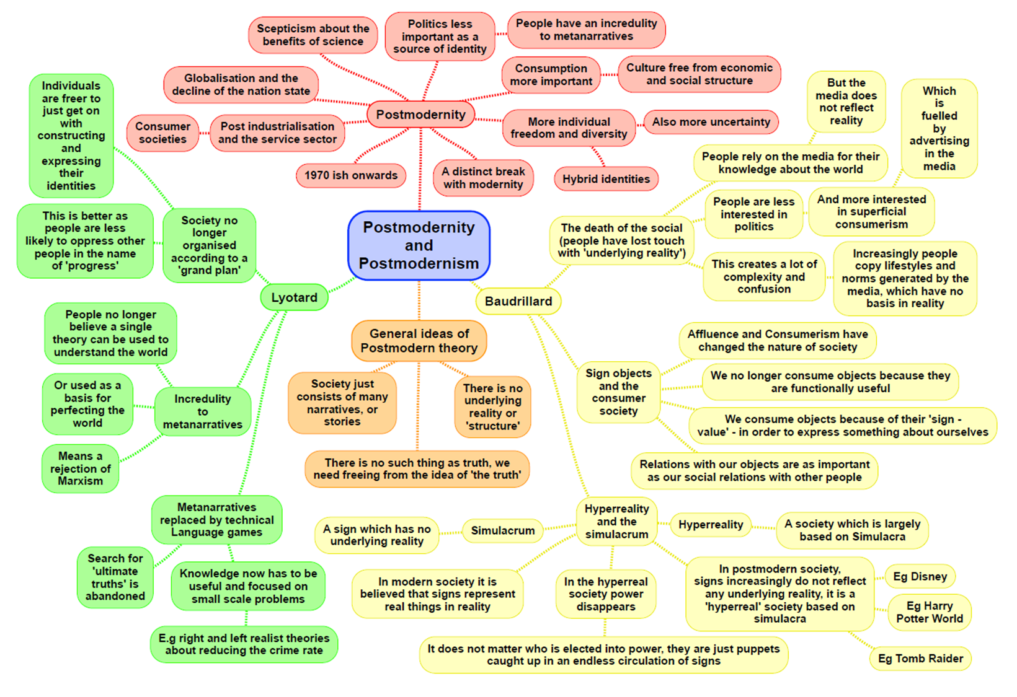

|  |  |
| --- | --- |
| **Theory: Postmodernism MACRO/MICRO STRUCTURE/ACTION CONFLICT/CONSENSUS – NEITHER** | |
| **Family**: **based on choice, more individualistic**  It is nonsense to talk of an institution of a family because people now live in such a wide range of ever changing personal relationships e.g. lone parent, hetero sexual, dual income.  In postmodern society, family structures are varied and individuals have much more freedom of choice in aspects of their life such as lifestyles, personal relationships and family arrangements. There is no longer one dominant family type e.g. nuclear family, meaning it is no longer possible to make generalisations about society the same way modern theorists such as Parsons and Marx did. Society is fragmenting into a mass of individuals and groups with a wide diversity of interests and lifestyles.  **Alan and Crow** - the family passes through a **lifecycle-** we are not in one type of family all the time.  Our families are increasingly based on **choice-** we choose how to live and what the relationships are like.  **Rapoport and Rapoport** – identify 5 types of family diversity:   1. Organisational diversity 2. Social class diversity 3. Cultural diversity 4. Life cycle diversity 5. Family life course diversity   **Beck and Beck-Gernsheim** - because of individualisation (where individuals, not communities choose how to live) choice is a part of our everyday lives. | **Difference feminism** (p.393 Browne)  Suggests that other variants of feminisms particularly in the 1960s and 70s viewed women's subordination through the eyes of white middle class women. They emphasise that while all women suffer many of the same problems, not all women are in the same position. The subordination of women and their experiences of oppression can take very diverse forms in different contexts and among different social groups, which is particularly prevalent in postmodern societies. Postmodernists claim there has been a weakening of structures like gender, social class and ethnicity as sources of identity and people “pick and mix” and choice identities and lifestyles from the wide range available in a media saturated, consumer based society. This is reflected in a diversity of meanings attached to being a women in contemporary western societies. |
| **Crime**: Postmodernists see crime a social construction based on a narrow legal definition which reflects an outdated metanarrative of the law that fails to reflect the diversity of postmodern society. They do not seek structural explanations as there are new forms of crime – due to the rise of globalisation  **Lyotard** - post-modern approaches to crime reject the idea that a grand theory or grand narrative can explain crime. Instead they look for “local truths” and see each crime as a unique event. They also see that criminals have selected a particular lifestyles e.g. bank robber , ticket tout etc  **Messerchmidt –** Young men want to conform to the dominant form of masculinity which he called ‘hegemonic masculinity’ – Work in the paid labour market, the subordination of women, heterosexism and the uncontrollable sexuality of men.  **Lyng (1990)** – developed the concept of ‘edgework’, this is when people may get a thrill from engaging in risk taking behaviour going right to the edge of acceptable behaviour and challenging the rules. We can see this as an outgrowth of postmodern society which encourages and rewards risk taking behaviour.  **Katz (1988)** – Argues that people get drawn into crime because it is seductive and thrilling. They interpret this simply as part of postmodern society which calls on us to enjoy our leisure time for example the London riots.  [**Hobbs + Dunningham**] – Argue that changes associated with globalisation have led to patterns of crime, for example, the shift from hierarchal gang culture to loose, flexible networks.  [**Glenny**] – Drug trafficking, money laundering are the networks that form a global criminal economy which accounts for 15% of global trade, he terms this the ‘McMafia’ | **Stratification:**  Class –  **Pakulski + Waters -** Class is dead. People are no longer concerned in the social and economic relationships of class. Individuals can belong to different groups at different times.  **Beck** – Argues that the changing logic of distribution and the individualisation of social processes in reflexive modernity have killed off the concept of social class and rendered the analysis of its effects a floored endeavour. Class society 🡪 individualised society.  **Sklair –** Globalisation and the global system have produced a transnational capitalist class associated with major transnational corporations. Members of this class are not loyal to particular countries, they see their interests in terms of the capitalist system as a whole.  Gender  **Alan** **+** **Crow** – Even though an increasing number of women work at some point in their lives, with men helping to do more domestic chores, Alan and Crow found men's contribution around the house is limited with women having to work full time and do the housework.  **Hakim** (**preference** **theory**) – Women have a free choice in their roles (post feminist)  Ethnicity  **Modood (2008)** – The UK is now a ‘super diversity’ as a result of the range of ethnic groups living in Britain.  Age  **Featherstone** **+** **Hepworth** (**1999**) – There is a constant bombardment of messages from the media to try and stay young, they see this as the ‘mask of ageing’. On the other hand, children are being encouraged by the media to take on adult behaviours. |
| **General view of the theory:** p.396-401 Browne  Changes in society – Society is essentially chaotic  **Bauman** – stressed that society is now in such a state of constant change that it’s unpredictable and marked by chaos and uncertainty, a state that is referred to as liquid modernity, where social structures such as the nation state, family and social class are breaking down.  **Giddens** – The nation state and national differences are becoming less significant in people’s lives and the world is becoming increasingly interconnected. People’s lives are no longer rooted in and confined to local contexts, but are lived in and influenced within the global network which is unlimited by time or place. His perspective called this ‘disembedding’ e.g./ the internet – we may interact with others or do online shopping regardless of physical location or time.  **Lyotard** – describes postmodernism as an incredulity towards metanarratives and people no longer believe in the myth of truths. Because society is changing so constantly and quickly, societies can no longer be understood through the application of metanarratives.  Metanarratives – big theories such as Marxism and Functionalism which seek to explain society as a whole but these no longer apply according to Postmodernists because society has become fragmented into so many groups, interests and lifestyles that are constantly changing.  **Baudrillard** – Sees life in the postmodern era as so dominated by media imagery that it has become what he called ‘media saturated’. The mass media used more or less to reflect some basic reality but media images now dominate and distort the way we see the world.  Simulacra – images which appear to reflect events in the real world but have no basis in reality and which are viewed simultaneously across the world.  Hyper reality – the media image of an event becoming more real than the reality it is meant to be depicting as it tries to make viewers feel they are experiencing an event. | **Evaluation** (p.401-402 Browne):  **Strengths:**   1. Has highlighted some important cultural changes particularly in the areas of the media, culture and identity. 2. It emphasises that the construction of identity has become a more fluid and complex process with people having more choices to pick and mix identities based on consumer lifestyles and global media imagery and cannot be reduced to simply a response to social-structural factors. 3. It provides insight into most contemporary social changes such as growing risk and uncertainty, globalisation and the growing power of the media. 4. In challenging sociological metanarratives, it has perhaps encourages sociologists to reflect more upon some of their assumptions, how they set about their research and the meaning of some contemporary social changes. This is reflected for example in the difference of feminism.   **Criticisms:**   1. It is all criticism and sees no knowledge or vision as any better than any other theories. It lacks any values or visions for improving society. 2. It over emphasises the influence of the media and tends to assume people are passive. 3. Exaggerates the scale of social change, such as that cultural distinctions are blurred and that there is a global culture 4. Too voluntaristic in that it assumes that all individuals are free to act a they wish and can create, pick and choose and change identities at will 5. Postmodernism is itself a metanarrative and if metanarratives are dismissed by postmodernists then it has in effect dismissed itself and having anything to say that is any more valid than anything else. |

**Key Concepts:**

Globalisation - the process by which the world is becoming increasingly interconnected as a result of massively increased trade and cultural exchange.

Risk society - the manner in which modern society organizes in response to risk.

Individualism – individuals are becoming increasingly free of structural constraints and are as a result, better able to create not only themselves, but also the societies in which they live.

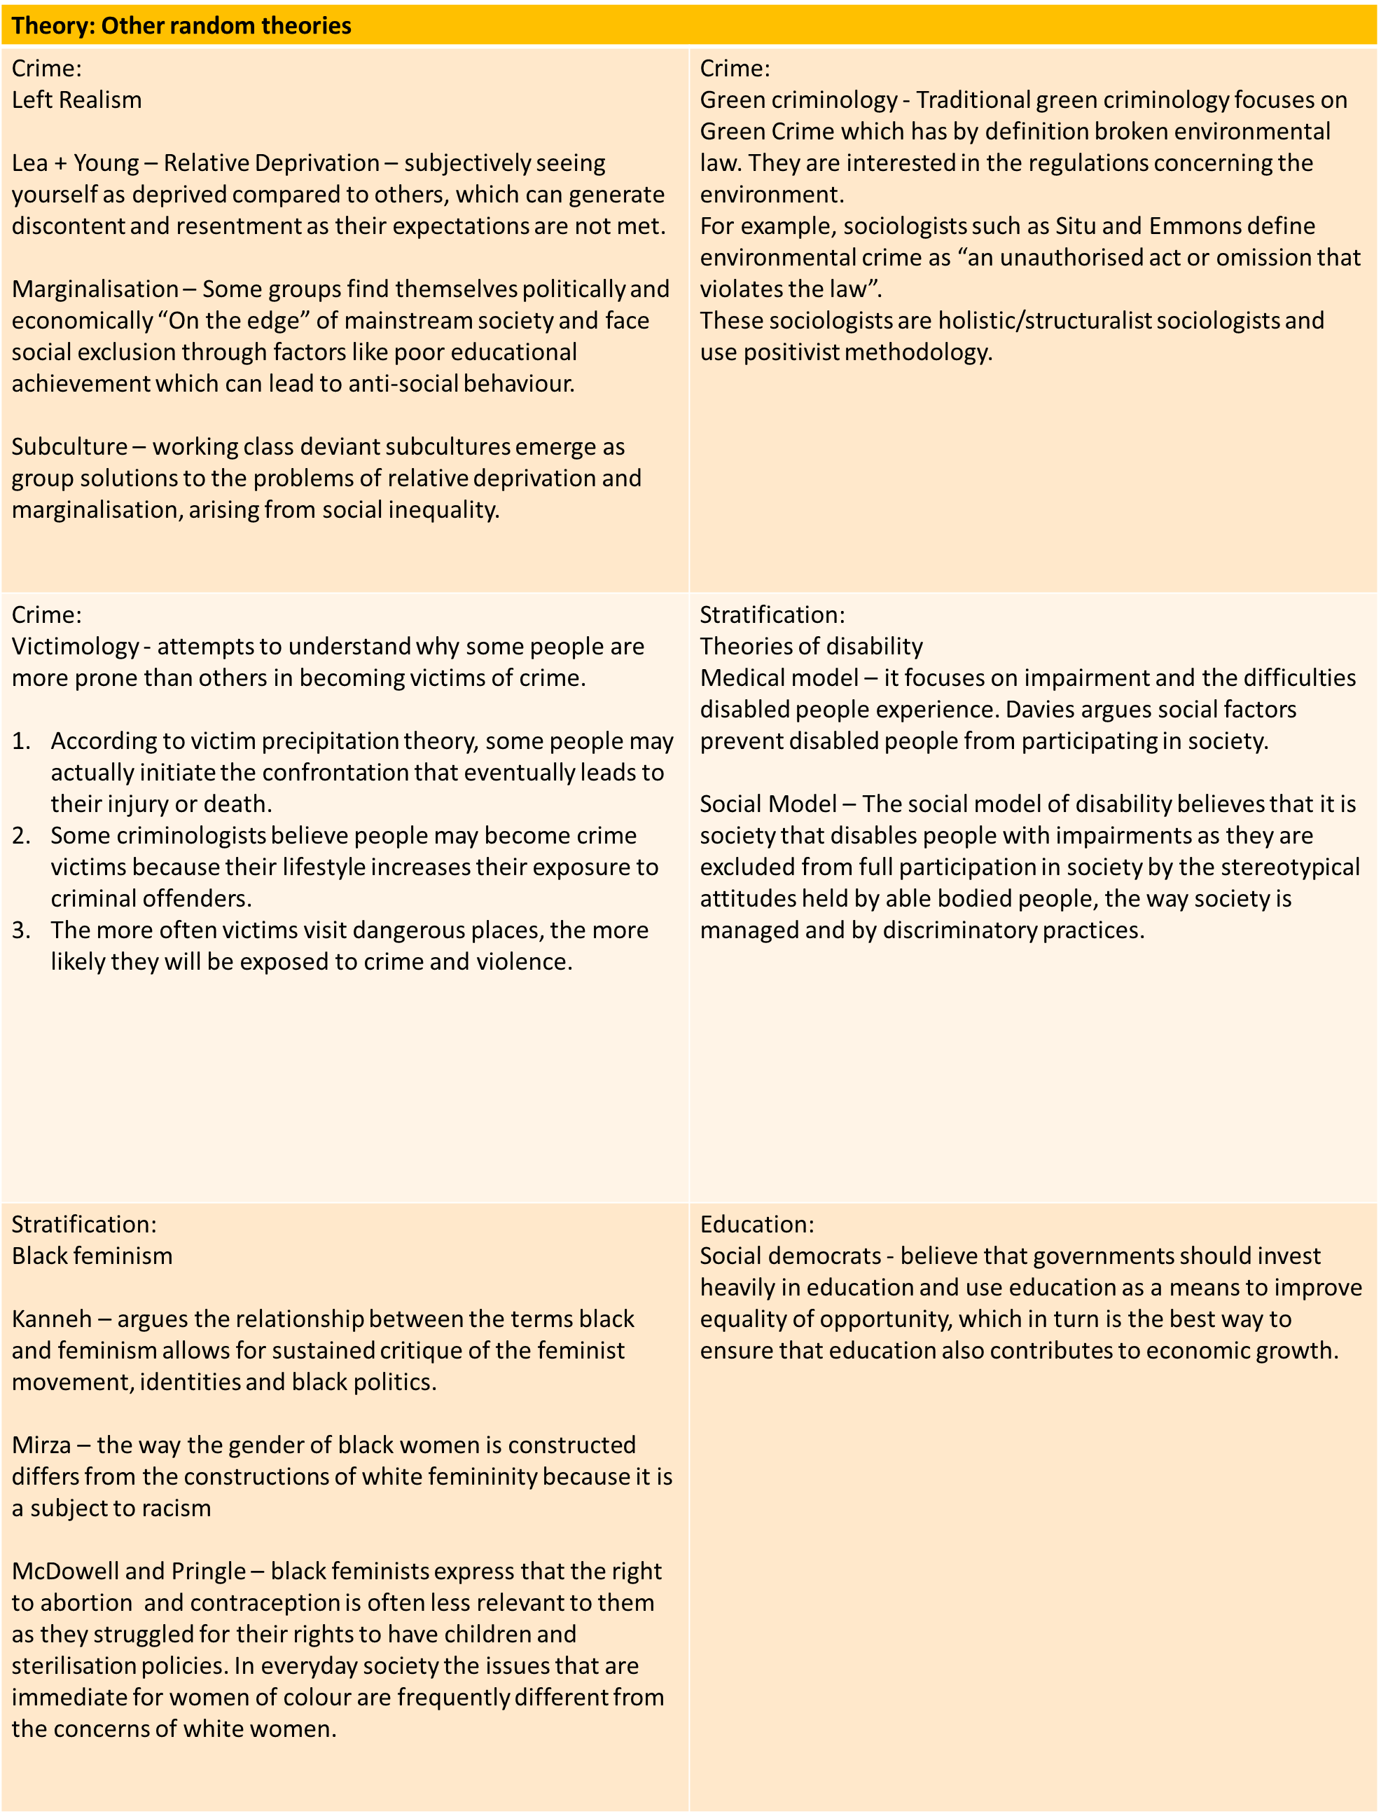

**Writing a theory question in paper 1 and paper 3**

In the education exam (paper 1) and crime exam (paper 3) you could be asked to answer questions about sociological theories. These could take the form of:

**10 MARK THEORY QUESTIONS**

Outline and explain two [insert theory] concepts [10]

Outline and explain two arguments to suggest [insert theory] might have little to contribute to our understanding of society today [10]

Outline two reasons for the growth of globalisation [10]

Outline and explain two [insert theory] view of the nature of society today [10]

Outline and explain two criticisms of [insert theory]

Outline and explain two ways [insert theory] views social inequality today [10] – really similar to a stratification

The expectation with these questions is to use content from across all of your topics. It means there is a lot of variability in what you can write and you can use material from pretty much anywhere.

These 10 mark questions take the same format as every other one you do. They need a clearly stated point, which is explained with evidence (named people, contemporary examples, concepts) and then briefly evaluated.

**20 MARK ESSAY QUESTIONS – IN PAPER 3**

These questions have an item and will get you to do several possible things:

Evaluate the approach of a particular theory

Evaluate the contribution a theory has made to our understanding of society

Evaluate the view that conflict approaches are more useful than consensus approaches (or visa versa)

Evaluate the view that action/micro approaches are more useful than structural/macro approaches

Evaluate the contribution of modernist theories [functionalism/marxism] as compared to postmodern approaches

These questions need an introduction that clearly outlines the debate in the essay and then a range of paragraphs (suggestion of 3) that compare the approach/es in the question. Come to a conclusion. They need you to show a clear understanding of key concepts within the theory and theoretical approaches e.g. consensus vs conflict views, structure vs action, modernity vs postmodernity.

Approaches could include:

|  |  |
| --- | --- |
| **Using topics** | **Using themes from within the theory** |
| Doing a paragraph on a topic and evaluate within the topic. Pick three topics as your paragraphs and then do an additional paragraph that discusses general issues and concerns. | Each paragraph becomes a key idea from the theory that you then evaluate with issues/problems from other theories. This can draw across topics. |

